UNITED STATES

SECURITIES AND EXCHANGE COMMISSION

WASHINGTON, D.C. 20549

SCHEDULE TO

Tender Offer Statement Under Section 14(d)(1) or 13(e)(1)

of the Securities Exchange Act of 1934

RENT THE RUNWAY, INC.

(Name of Subject Company (Issuer) and Filing Person (Offeror))

Options to Purchase Class A Common Stock, Par Value $0.001 Per Share Options to Purchase Class B Common Stock, Par Value $0.001 Per Share (Title of Class of Securities)

76010Y103 (Class A Common Stock)

N/A (Class B Common Stock)

(CUSIP Number of Class of Securities)

Jennifer Y. Hyman

Co-Founder, Chief Executive Officer and Chair

Rent the Runway, Inc.

10 Jay Street

Brooklyn, New York 11201

(212) 524-6860

(Name, Address and Telephone Number of Person Authorized To Receive Notices and Communications on Behalf of the Filing

Person)

Copy to:

Marc D. Jaffe, Esq.

Jenna B. Cooper, Esq.

Latham & Watkins LLP

1271 Avenue of the Americas

New York, New York 10020

  - 906-1200

- ​ ​ Check the box if the filing relates solely to preliminary communications made before the commencement of a tender offer. Check the appropriate boxes below to designate any transactions to which the statement relates:
​ | ​ | ☐ ​ | ​ | third-party tender offer subject to Rule 14d-1.
​ | ​ | ☒ ​ | ​ | issuer tender offer subject to Rule 13e-4.
​ | ​ | ☐ ​ | ​ | going-private transaction subject to Rule 13e-3.
​ | ​ | ☐ ​ | ​ | amendment to Schedule 13D under Rule 13d-2.

 | ​ | ​ | ☐ ​ | ​ | Rule 13e-4(i) (Cross-Border Issuer Tender Offer).
 | ​ | ​ | ☐ ​ | ​ | Rule 14d-1(d) (Cross-Border Third-Party Tender Offer).

Item 1. Summary Term Sheet.

The information set forth under “Summary Term Sheet and Questions and Answers” in the Offer to Exchange Certain Eligible Outstanding Options for a Number of Replacement Restricted Stock Units, dated June 9, 2023 (the “Offer to Exchange”), attached hereto as Exhibit (a)(1)(i), is incorporated herein by reference.

Item 2. Subject Company Information.

- Name and Address. The issuer is Rent the Runway, Inc., a Delaware corporation (“Rent the Runway,” “RTR” or the “Company”). The Company’s principal executive offices are located at 10 Jay Street, Brooklyn, New York 11201, and the telephone number of its principal executive offices is (212)-524-6860. The information set forth in the Offer to Exchange under “The Option Exchange – Section 9 (Information Concerning Rent the Runway)” is incorporated herein by reference.

- Securities. This Tender Offer Statement on Schedule TO relates to an offer by the Company to exchange (the “Option Exchange”) outstanding eligible options to purchase the Company’s Class A common stock or Class B common stock, as applicable, par value $0.001 per share, respectively, that are held by active U.S.-based employees, including the Company’s named executive officers, individual consultants or non-employee directors on the date the Option Exchange commences, for replacement restricted stock units (“replacement RSUs”) to be granted under the Amended and Restated 2021 Incentive Award Plan (the “2021 Plan”), upon the terms and subject to the conditions set forth in the Offer to Exchange, and the related Terms of Election (the “Terms of Election”), attached hereto as Exhibit (a)(1)(i) and Exhibit (a)(1) (iii), respectively. Each option holder that elects to exchange options pursuant to the Option Exchange must submit their election via the option exchange website and agree to the Terms of Election and will be granted replacement RSUs. As of June 2, 2023, there were outstanding eligible options to purchase an aggregate of approximately 3,888,155 shares of Class A common stock of the Company. As of June 2, 2023, there were outstanding eligible options held by Jennifer Y. Hyman, our Co-Founder, Chief Executive Officer and Chair, to purchase an aggregate of approximately 3,057,017 shares of Class B common stock of the Company.

The information set forth in the Offer to Exchange under “Summary Term Sheet and Questions and Answers,” “The Option Exchange – Section 1 (Eligibility; Number of Options; Expiration Time),” “The Option Exchange – Section 5 (Acceptance of Options for Exchange; Grant of Replacement RSUs),” and “The Option Exchange – Section 8 (Source and Amount of Consideration; Terms of Replacement RSUs)” is incorporated herein by reference.

- Trading Market and Price. The information set forth in the Offer to Exchange under “The Option Exchange – Section 7 (Price Range of Class A Common Stock Underlying the Options)” is incorporated herein by reference.

Item 3. Identity and Background of Filing Person.

- Name and Address. The Company is both the subject company and the filing person. The information set forth under Item 2(a) above and in the Offer to Exchange under “The Option Exchange – Section 10 (Interests of Directors, Officers and Affiliates; Transactions and Arrangements Concerning our Securities)” is incorporated herein by reference.

Item 4. Terms of the Transaction.

- Material Terms. The information set forth in the Offer to Exchange under “Summary Term Sheet and Questions and Answers” and the sections under “The Option Exchange” titled “Section 1 (Eligibility; Number of Options; Expiration Time),” “Section 3 (Procedures for Electing to Exchange Options),” “Section 4 (Withdrawal Rights),” “Section 5 (Acceptance of Options for Exchange; Grant of Replacement RSUs),” “Section 6 (Conditions of the Option Exchange),” “Section 7 (Price Range of Class A Common Stock Underlying the Options),” “Section 8 (Source and Amount of Consideration; Terms of Replacement RSUs),” “Section 9 (Information Concerning Rent the Runway),” “Section 11 (Status of Options Acquired by Us in the Option Exchange; Accounting Consequences of the Option Exchange),” “Section 12 (Agreements; Legal Matters; Regulatory Approvals),” “Section 13 (Material U.S. Federal Income Tax Consequences),” and “Section 14 (Extension of the Option Exchange; Termination; Amendment)” is incorporated herein by reference.

- Purchases. The information set forth in the Offer to Exchange under “The Option Exchange – Section 10 (Interests of Directors, Officers and Affiliates; Transactions and Arrangements Concerning our Securities)” is incorporated herein by reference.

Item 5. Past Contacts, Transactions, Negotiations and Agreements.

- Agreements Involving the Subject Company’s Securities. The information set forth in the Offer to Exchange under “The Option Exchange – Section 10 (Interests of Directors, Officers and Affiliates; Transactions and Arrangements our Securities)” is incorporated herein by reference. The documents incorporated herein by reference as Exhibit (d)(1) through Exhibit (d)(5) also contain information regarding agreements relating to securities of the Company.

Item 6. Purposes of the Transaction and Plans or Proposals.

- Purposes. The information set forth in the Offer to Exchange under “Summary Term Sheet and Questions and Answers” and “The Option Exchange – Section 2 (Purpose of the Option Exchange)” is incorporated herein by reference.

- Use of Securities Acquired. The information set forth in the Offer to Exchange under “The Option Exchange – Section 5 (Acceptance of Options for Exchange; Grant of Replacement RSUs),” and “The Option Exchange – Section 11 (Status of Options Acquired by Us in the Option Exchange; Accounting Consequences of the Option Exchange)” is incorporated herein by reference.

- Plans. The information set forth in the Offer to Exchange under “Summary Term Sheet” and “The Option Exchange – Section 2 (Purpose of the Option Exchange)” is incorporated herein by reference.

Item 7. Source and Amount of Funds or Other Consideration.

- Source of Funds. The information set forth in the Offer to Exchange under “The Option Exchange – Section 8 (Source and Amount of Consideration; Terms of Replacement RSUs)” and “The Option Exchange – Section 15 (Fees and Expenses)” is incorporated herein by reference.

- Conditions. The information set forth in the Offer to Exchange under “The Option Exchange – Section 6 (Conditions of the Option Exchange)” is incorporated herein by reference. There are no alternative financing arrangements or financing plans for the Option Exchange.

(d) Borrowed Funds. Not applicable.

Item 8. Interest in Securities of the Subject Company.

- Securities Ownership. The information set forth in the Offer to Exchange under “The Option Exchange – Section 10 (Interests of Directors, Officers and Affiliates; Transactions and Arrangements Concerning our

Securities)” is incorporated herein by reference.

- Securities Transactions. The information set forth in the Offer to Exchange under “The Option Exchange – Section 10 (Interests of Directors, Officers and Affiliates; Transactions and Arrangements Concerning our Securities)” is incorporated herein by reference.

Item 9. Persons/Assets, Retained, Employed, Compensated or Used.

(a) Solicitations or Recommendations. Not applicable.

Item 10. Financial Statements.

- Financial Information. The information set forth in the Offer to Exchange under “The Option Exchange – Section 9 (Information Concerning Rent the Runway)” and “The Option Exchange – Section 16 (Additional Information)” is incorporated herein by reference. Our Annual Report on Form 10-K for the fiscal year ended January 31, 2023, filed with the Securities and Exchange Commission (the “SEC”) on April 13, 2023, including the financial information set forth in Item 8 – Financial Statements and Supplementary Data therein, and our Quarterly Report on Form 10-Q for the fiscal quarter ended April 30,

2023, filed with the SEC on June 8, 2023, including the financial information set forth in Item 1 – Financial Statements (unaudited) therein are incorporated herein by reference. Our Annual Report on Form 10-K and Quarterly Report on Form 10-Q are available electronically on the SEC’s website at http://www.sec.gov.

(b) Pro Forma Financial Information. Not applicable.

Item 11. Additional Information.

- Agreements, Regulatory Requirements and Legal Proceedings. The information set forth in the Offer to Exchange under “Risk Factors,” “The Option Exchange – Section 10 (Interests of Directors, Officers and Affiliates; Transactions and Arrangements Concerning our Securities),” and “The Option Exchange – Section 12 (Agreements; Legal Matters; Regulatory Approvals)” is incorporated herein by reference.

(c) Other Material Information. Not applicable.

Item 12. Exhibits.

The Exhibit Index attached to this Schedule TO is incorporated herein by reference.

Item 13. Information Required by Schedule 13E-3.

Not applicable.

SIGNATURE

After due inquiry and to the best of my knowledge and belief, I certify that the information set forth in this statement is true, complete and correct.

Dated: June 9, 2023 | ​ | RENT THE RUNWAY, INC.
 | ​ | ​ | ​
 | ​ | By:​ | ​ | /s/ Jennifer Y. Hyman
 | ​ | ​ | ​ | Name: Jennifer Y. Hyman
 | ​ | ​ | ​ | Title: Chief Executive Officer

 |  |  |  |  |  |  |  |  |  | EXHIBIT INDEX
Exhibit |  |  |  |  |  |  | ​ ​ |  |  | Exhibit Description
Number |  |  |  |  |  |  |  |  |  | Exhibit Description
(a)(1)(i) |  |  |  |  |  |  | ​ ​ |  | Offer to Exchange Certain Eligible Outstanding Options for a Number of Replacement
 |  |  |  |  |  |  |  |  | Restricted Stock Units, dated June 9, 2023
(a)(1)(ii) |  |  |  |  |  |  | ​ ​ Email to all Eligible Service Providers from Chief Executive Officer
(a)(1)(iii) |  |  |  |  |  |  | ​ ​ Form of Terms of Election
(a)(1)(iv) |  |  |  |  |  |  | ​ ​ Form of Announcement Email
(a)(1)(v) |  |  |  |  |  |  | ​ ​ Form of Reminder Email
(a)(1)(vi) |  |  |  |  |  |  | ​ ​ Form of Email Confirmation
(a)(1)(vii) |  |  |  |  |  |  | ​ ​ Form of Email Regarding Final Exchange Ratio
(a)(1)(viii) |  |  |  |  |  |  | ​ ​ Screen Shots of Option Exchange Website
(a)(1)(ix) |  |  |  |  |  |  | ​ ​ Option Exchange Frequently Asked Questions
(a)(1)(x) |  |  |  |  |  |  | ​ ​ Option Exchange Presentation for Eligible Service Providers
(a)(2) |  |  |  |  |  |  | ​ ​ |  | Not applicable
(a)(3) |  |  |  |  |  |  | ​ ​ |  | Not applicable
(a)(4) |  |  |  |  |  |  | ​ ​ |  | Not applicable
(a)(5) |  |  |  |  |  |  | ​ ​ |  | Not applicable
(b) |  |  |  |  |  |  | ​ ​ |  | Not applicable
(d)(1) |  |  |  |  |  |  |  |  | Amended and Restated 2021 Incentive Award Plan (incorporated herein by reference to Exhibit
 |  |  |  |  |  |  | ​ ​ 10.8 to the Company’s Annual Report on Form 10-K (File No. 001-40958), filed with the SEC
 |  |  |  |  |  |  |  |  | on April 13, 2023)

(d)(2) Form of Stock Option Agreement (2021 Plan) (incorporated herein by reference to Exhibit 10.9

- ​ to the Company’s Annual Report on Form 10-K (File No. 001-40958), filed with the SEC on April 13, 2023)

(d)(3) Form of Restricted Stock Unit Agreement (2021 Plan) (incorporated herein by reference to

- ​ Exhibit 10.10 to the Company’s Annual Report on Form 10-K (File No. 001-40958), filed with the SEC on April 13, 2023)

(d)(4)

(d)(5)

- ​ Form of Restricted Stock Unit Agreement (2021 Plan) (Mandatory Sell-to-Cover Election)

Transition Agreement, between the Company and Scarlett O’Sullivan, dated April 11, 2023

- ​ (incorporated herein by reference to Exhibit 10.2 to the Company’s Current Report on Form 8-K (File No. 001-40958), filed with the SEC on April 12, 2023)

(g) | ​ ​ Not applicable
(h) | ​ ​ Not applicable
(b) | ​ ​ Filing Fee Table

TABLE OF CONTENTS

Exhibit (a)(1)(i)

RENT THE RUNWAY, INC.

OFFER TO EXCHANGE CERTAIN ELIGIBLE OUTSTANDING OPTIONS FOR A NUMBER OF REPLACEMENT RESTRICTED STOCK UNITS

THE OPTION EXCHANGE AND WITHDRAWAL RIGHTS EXPIRE AT 11:59 P.M. U.S. EASTERN TIME ON MONDAY, JULY 10, 2023 UNLESS THE OPTION EXCHANGE IS EXTENDED

Rent the Runway, Inc. which is referred to as the “Company,” “Rent the Runway,” “RTR,” “our,” “us,” or “we,” is offering eligible employees, individual consultants and non-employee directors the opportunity to exchange certain outstanding options to purchase our Class A common stock or Class B common stock, as applicable, for new restricted stock units under our Amended and Restated 2021 Incentive Award Plan (the “2021 Plan”), each representing the right to receive one share of our Class A common stock (“replacement RSUs”), calculated in accordance with a specified exchange ratio. We expect to grant the replacement RSUs on the date on which we cancel the options accepted for exchange, which will be the first business day following the completion date of this exchange offer. We are making this exchange offer upon the terms, and subject to the conditions, set forth in this Offer to Exchange Certain Eligible Outstanding Options for a Number of Replacement Restricted Stock Units (this “Offer to Exchange”) and in the related Terms of Election (the “Terms of Election”). We refer to this exchange offer made pursuant to this Offer to Exchange, together with the Terms of Election, as they may be amended from time to time, as the “Option Exchange.”

Expiration Time. The Expiration Time of the Option Exchange is 11:59 P.M. U.S. Eastern Time on Monday, July 10, 2023. If we extend the period of time during which the Option Exchange remains open, the term “Expiration Time” will refer to the last time and date on which the Option Exchange expires. All eligible options that we accept pursuant to the Option Exchange will be cancelled on the first business day following the Expiration Time, and eligible options elected for exchange will no longer be exercisable after that time. We expect to grant the replacement RSUs on the first business day following the Expiration Time, with the date of grant for the replacement RSUs referred to in the Option Exchange as the “replacement RSUs grant date.”

Eligibility. Only eligible options may be exchanged pursuant to the Option Exchange. For these purposes, “eligible options” are those options under our 2021 Plan, 2019 Stock Incentive Plan (as amended from time to time, “2019 Plan”) and 2009 Stock Incentive Plan (as amended from time to time, the “2009 Plan”, and collectively with the 2021 Plan and the 2019 Plan, the “equity incentive plans”) that remain outstanding and unexercised prior to the completion of the Option Exchange.

Options that expire pursuant to their terms prior to the completion of the Option Exchange are forfeited and not eligible to be exchanged for replacement RSUs.

You are eligible to participate in the Option Exchange only if you:

- are an active U.S.-based employee, individual consultant or non-employee director (each, a “service provider”) of the Company on the date the Option Exchange commences and remain an active service provider through the completion of the Option Exchange; and

- hold at least one eligible option as of the commencement of the Option Exchange.

If you are no longer employed by or engaged as a service provider to Rent the Runway, whether your termination is voluntary, involuntary, or for any other reason as of the completion of the Option Exchange, you will not be able to participate in the Option Exchange.

The outstanding options that you hold under our equity incentive plans give you the right to purchase our Class A common stock or Class B common stock, as applicable, once those options vest by paying the applicable exercise price (and satisfying any applicable tax withholding obligations). Thus, when we use the term “option” in this Offer to Exchange, we refer to the actual options you hold to purchase our Class A common stock or Class B common stock, as applicable, and not the shares of Class A common stock or Class B common stock underlying those options.

Terms of Replacement RSUs. We will grant the replacement RSUs under the 2021 Plan on the replacement RSUs grant date, which will be the date on which we cancel the eligible options accepted for exchange, which we expect will be the first business day following the expiration date of this Option Exchange. Those options accepted for exchange will no longer be exercisable after this date. In order to be granted a replacement RSU, you must continue to be an active service provider of the Company through the replacement RSUs grant date.

1

TABLE OF CONTENTS

The replacement RSUs:

- will not have an exercise or purchase price. Each replacement RSU will represent your right to receive one share of our Class A common stock for each replacement RSU that vests in the future;

- the number of replacement RSUs will be determined using an exchange ratio that takes into account the fair value of the tendered eligible options. The applicable exchange ratio is further discussed below;

- will generally be unvested on the replacement RSUs grant date and will vest in eight equal quarterly installments over two years on November 1, 2023, February 1, 2024, May 1, 2024, August 1, 2024, November 1, 2024, February 1, 2025, May 1, 2025, and August 1, 2025 (which vesting dates may change if the Expiration Time is extended), subject to your continued employment or service through the applicable vesting dates (see also Transition Agreement described below); and

- will have the terms and be subject to the conditions as provided for in the 2021 Plan and the restricted stock unit award agreement (“RSU Agreement”) entered into between you and RTR.

Exchange Ratio. The exchange ratio in the Option Exchange represents the number of Class A common stock or Class B common stock, as applicable, underlying an eligible option that a service provider must surrender in order to receive one replacement RSU. The same exchange ratio will be applied to all eligible options and will represent an amount that would result, as of the close of trading on July 7, 2023, the last business day prior to the Expiration Time (the “determination time”), in the issuance of a number of replacement RSUs that would have an aggregate fair value equal to a specific amount between 90% to 100% of the aggregate fair value of all eligible options, and not on a grant-by-grant basis (assuming all eligible options are exchanged and calculated using a Black-Scholes valuation model), which we refer to as a “value-for-value” exchange. The specific final exchange ratio will be determined by the Compensation Committee of our Board of Directors at determination time. After the final exchange ratio is established, the Company intends to allow a reasonable amount of time for eligible participants to make a decision whether to participate in the Option Exchange. The exchange ratio cannot be calculated as of the date of the Option Exchange because the ratio will be based in part on the 20-Day VWAP (defined below) and is intended, to the extent practicable, to include more current assumptions for Black-Scholes valuation model than are currently available.

We currently expect that an exchange ratio between 2.0 and 3.8 to 1.0 will be selected by the Compensation Committee using a Black-Scholes valuation model and after evaluating the compensatory goals of the Option Exchange. For illustrative purposes only, below is a table setting forth the number of replacement RSUs you could receive in exchange for an eligible option to purchase 1,000 shares, at various exchange ratios within the currently expected range. However, because the exchange ratio will be based in part on the future value of our Class A common stock, which is inherently difficult to predict, the final exchange ratio selected by the Compensation Committee could fall outside of this range. For example, if the 20-Day VWAP is between $1.00 - $2.00, the exchange ratio could potentially fall within a range as high as 2.5-4.1 to 1.0 and, conversely, if the 20-Day VWAP is between $4.00 - $5.00, the exchange ratio could potentially fall within a range as low as 1.7-2.1 to 1.0. The number of replacement RSUs will be rounded down to the nearest whole share on a grant-by-grant basis. Fractional replacement RSUs will not be granted in the Option Exchange.

 | Hypothetical Exchange Ratios for Eligible Options
Number of |  | Exchange |  | Number of
Eligible | ​ ​ | Exchange | ​ ​ | Replacement
Options |  | Ratio |  | RSUs

1,000

1,000

1,000

1,000

1,000

1,000

1,000

​ ​

​ ​

​ ​

​ ​

​ ​

​ ​

​ ​

2.0 : 1.0

2.3 : 1.0

2.6 : 1.0

2.9 : 1.0

3.2 : 1.0

3.5 : 1.0

3.8 : 1.0

​ ​

​ ​

​ ​

​ ​

​ ​

​ ​

​ ​

500

434

384

344

312

285

263

After the close of trading, U.S. Eastern Time, on July 7, 2023, we will distribute by email to all holders the exact exchange ratio to be used in the Option Exchange with respect to all eligible options.

2

TABLE OF CONTENTS

See Section 1 (“Eligibility; Number of Options; Expiration Time”), Section 7 (“Price Range of Class A Common Stock Underlying the Options”) and Section 9 (“Information Concerning Rent the Runway”) of this Offer to Exchange for additional information.

Process to Participate. The commencement date of the Option Exchange is Friday, June 9, 2023. Participation in the Option Exchange is voluntary. If you are eligible to participate in the Option Exchange, you can exchange your eligible options on a grant-by-grant basis, i.e., based on the original grant date and exercise price of the eligible option (referred to herein as a “separate option grant”). No partial exchanges of separate option grants will be permitted; however, you can choose to exchange one or more of your eligible separate option grants without having to exchange all of your eligible separate option grants. If you have previously exercised a portion of an eligible separate option grant, only the portion of the eligible separate option grant which has not yet been exercised will be eligible to be exchanged.

If you wish to participate in the Option Exchange, you must log on to the option exchange website at www.myoptionexchange.com and elect to participate on or before 11:59 P.M. U.S. Eastern Time, on Monday, July 10, 2023 (or such later time and date as may apply if the Option Exchange is extended). Election submissions that are received after this deadline will not be accepted. In order to participate in the Option Exchange and submit your election, you will be required to acknowledge your agreement to all of the terms and conditions of this Offer to Exchange as set forth in the Option Exchange documents.

Elections submitted by any other means, including email, facsimile, hand delivery, interoffice, United States mail (or other post) and Federal Express (or similar delivery service), are not permitted and will not be accepted by us.

You should direct questions about the Option Exchange and requests for additional copies of this Offer to Exchange and the other Option Exchange documents by emailing legal@renttherunway.com.

Although our Board of Directors and stockholders have approved the Option Exchange, neither we nor our Board of Directors make any recommendation as to whether you should elect to exchange or refrain from electing to exchange all or any of your eligible options. You must make your own decision regarding whether to elect to exchange all or any of your eligible options.

The Option Exchange is not conditioned upon a minimum aggregate number of eligible options being surrendered for exchange. The Option Exchange is subject to certain conditions which we describe in Section 6 of this Offer to Exchange (“Conditions of the Option Exchange”) and the terms described in this Offer to Exchange.

Our Class A common stock are listed on the Nasdaq Global Select Market (the “Nasdaq”) under the symbol “RENT.” On June 8, 2023, the closing price of our Class A common stock on Nasdaq was $2.45 per share. We recommend that you consider the current stock price for our Class A common stock before deciding whether to elect to exchange your eligible options.

As of June 2, 2023, eligible options outstanding under our existing equity incentive plans were exercisable for approximately 3,888,155 shares of Class A common stock and approximately 3,057,017 shares of Class B common stock.

CFO Transition Agreement

In the interest of facilitating a smooth transition of the role of Chief Financial Officer and in light of her significant contributions to our Company, we have agreed with Scarlett O’Sullivan, pursuant to the terms of a Transition Agreement dated April 11, 2023, that she will be eligible to participate in the Option Exchange so long as she continues to provide employment or consulting services to us. Only Ms. O’Sullivan’s options that are vested as of the commencement of the Option Exchange will be eligible to participate and any replacement RSUs received as part of the Option Exchange will be fully vested upon issuance.

IMPORTANT

We are offering the Option Exchange upon the terms and subject to the conditions described in this Offer to Exchange and in the related Election Form available at www.myoptionexchange.com.

The statements in this document concerning the eligible options, the equity incentive plans and the replacement RSUs are summaries of the material terms but are not complete descriptions thereof. The full text of these documents has been filed with the U.S. Securities and Exchange Commission (the “SEC”) and we strongly encourage you to review such documents. See Section 16 of this Offer to Exchange (“Additional Information”) below for additional information regarding the Schedule TO.

3

TABLE OF CONTENTS

We are not offering the Option Exchange to, nor will we accept any election to exchange options from or on behalf of, option holders in any jurisdiction in which the Option Exchange or the acceptance of any election to exchange options would not be in compliance with the laws of that jurisdiction. However, we may, at our discretion, take any actions necessary or desirable for us to offer the Option Exchange to option holders in any such jurisdiction.

THIS OPTION EXCHANGE DOCUMENT HAS NOT BEEN APPROVED OR DISAPPROVED BY THE SEC OR ANY STATE OR FOREIGN SECURITIES COMMISSION NOR HAS THE SEC OR ANY STATE OR FOREIGN SECURITIES COMMISSION PASSED UPON THE FAIRNESS OR MERITS OF THE OPTION EXCHANGE OR UPON THE ACCURACY OR ADEQUACY OF THE INFORMATION CONTAINED IN THIS DOCUMENT. ANY REPRESENTATION TO THE CONTRARY IS A CRIMINAL OFFENSE.

RENT THE RUNWAY HAS NOT AUTHORIZED ANY PERSON TO MAKE ANY RECOMMENDATION ON OUR BEHALF AS TO WHETHER YOU SHOULD ELECT TO EXCHANGE OR REFRAIN FROM ELECTING TO EXCHANGE YOUR OPTIONS PURSUANT TO THE OPTION EXCHANGE. YOU SHOULD RELY ONLY ON THE INFORMATION CONTAINED IN THIS DOCUMENT OR OTHER INFORMATION TO WHICH WE HAVE REFERRED YOU. RENT THE RUNWAY HAS NOT AUTHORIZED ANYONE TO GIVE YOU ANY INFORMATION OR TO MAKE ANY REPRESENTATION IN CONNECTION WITH THE OPTION EXCHANGE OTHER THAN THE INFORMATION AND REPRESENTATIONS CONTAINED IN THIS DOCUMENT OR IN THE RELATED TERMS OF ELECTION. IF ANYONE MAKES ANY RECOMMENDATION OR REPRESENTATION TO YOU OR GIVES YOU ANY INFORMATION, YOU MUST NOT RELY UPON THAT RECOMMENDATION, REPRESENTATION OR INFORMATION AS HAVING BEEN AUTHORIZED BY RENT THE RUNWAY.

NOTHING IN THIS DOCUMENT SHALL BE CONSTRUED TO GIVE ANY PERSON THE RIGHT TO REMAIN IN THE EMPLOYMENT OR SERVICE OF RENT THE RUNWAY OR TO AFFECT OUR RIGHT TO TERMINATE THE EMPLOYMENT OR SERVICE OF ANY PERSON AT ANY TIME WITH OR WITHOUT CAUSE TO THE EXTENT PERMITTED UNDER LAW. NOTHING IN THIS DOCUMENT SHOULD BE CONSIDERED A CONTRACT OR GUARANTEE OF WAGES OR COMPENSATION.

RENT THE RUNWAY RESERVES THE RIGHT TO AMEND OR TERMINATE THE 2021 PLAN AT ANY TIME, AND THE GRANT OF A RESTRICTED STOCK UNIT UNDER THE 2021 PLAN OR THE OPTION EXCHANGE DOES NOT IN ANY WAY OBLIGATE RENT THE RUNWAY TO GRANT ADDITIONAL RESTRICTED STOCK UNITS OR OFFER FURTHER OPPORTUNITIES TO PARTICIPATE IN ANY OPTION EXCHANGE IN ANY FUTURE YEAR. THE GRANT OF A RESTRICTED STOCK UNIT AND ANY FUTURE RESTRICTED STOCK UNITS GRANTED UNDER THE 2021 PLAN OR IN RELATION TO THE OPTION EXCHANGE IS WHOLLY DISCRETIONARY IN NATURE AND IS NOT TO BE CONSIDERED PART OF ANY NORMAL OR EXPECTED COMPENSATION THAT IS OR WOULD BE SUBJECT TO SEVERANCE, RESIGNATION, REDUNDANCY, TERMINATION OR SIMILAR PAY, OTHER THAN TO THE EXTENT REQUIRED BY LOCAL LAW.

4

TABLE OF CONTENTS

OPTION EXCHANGE

TABLE OF CONTENTS

Summary Term Sheet and Questions and Answers |  |  |  |  |  |  |  |  |  |  |  |  |  |  |  |  |  |  |  |  |  |  |  |  |  |  | ​ ​
Risk Factors |  |  |  |  |  |  |  |  |  |  |  |  |  |  |  |  |  |  |  |  |  |  |  |  |  |  | ​ ​
The Option Exchange |  |  |  |  |  |  |  |  |  |  |  |  |  |  |  |  |  |  |  |  |  |  |  |  |  |  | ​ ​
1. |  | ​ ​ |  | Eligibility; Number of Options; Expiration Time |  |  |  |  |  |  |  |  |  |  |  |  |  |  |  |  |  |  |  |  |  |  | ​ ​
2. |  | ​ ​ |  | Purpose of the Option Exchange |  |  |  |  |  |  |  |  |  |  |  |  |  |  |  |  |  |  |  |  |  |  | ​ ​
3. |  | ​ ​ |  | Procedures for Electing to Exchange Options |  |  |  |  |  |  |  |  |  |  |  |  |  |  |  |  |  |  |  |  |  |  | ​ ​
4. |  | ​ ​ |  | Withdrawal Rights |  |  |  |  |  |  |  |  |  |  |  |  |  |  |  |  |  |  |  |  |  |  | ​ ​
5. |  | ​ ​ |  | Acceptance of Options for Exchange; Grant of Replacement RSUs |  |  |  |  |  |  |  |  |  |  |  |  |  |  |  |  |  |  |  |  |  |  | ​ ​
6. |  | ​ ​ |  | Conditions of the Option Exchange |  |  |  |  |  |  |  |  |  |  |  |  |  |  |  |  |  |  |  |  |  |  | ​ ​
7. |  | ​ ​ |  | Price Range of Class A Common Stock Underlying the Options |  |  |  |  |  |  |  |  |  |  |  |  |  |  |  |  |  |  |  |  |  |  | ​ ​
8. |  | ​ ​ |  | Source and Amount of Consideration; Terms of Replacement RSUs |  |  |  |  |  |  |  |  |  |  |  |  |  |  |  |  |  |  |  |  |  |  | ​ ​
9. |  | ​ ​ |  | Information Concerning Rent the Runway |  |  |  |  |  |  |  |  |  |  |  |  |  |  |  |  |  |  |  |  |  |  | ​ ​
10. |  |  |  |  | Interests of Directors, Officers and Affiliates; Transactions and Arrangements Concerning our |  |  |  |  |  |  |  |  |  |  |  |  |  |  |  |  |  |  |  |  |  | ​ ​
 |  |  | ​ ​ | Securities |  |  |  |  |  |  |  |  |  |  |  |  |  |  |  |  |  |  |  |  |  |  | ​ ​
11. |  | ​ ​ |  |  | Status of Options Acquired by Us in the Option Exchange; Accounting Consequences of the Option |  |  |  |  |  |  |  |  |  |  |  |  |  |  |  |  |  |  |  |  |  | ​ ​
 |  |  |  | Exchange |  |  |  |  |  |  |  |  |  |  |  |  |  |  |  |  |  |  |  |  |  |  | ​ ​
12.​ ​ |  |  |  | Agreements; Legal Matters; Regulatory Approvals |  |  |  |  |  |  |  |  |  |  |  |  |  |  |  |  |  |  |  |  |  |  | ​ ​
13.​ ​ |  |  |  | Material U.S. Federal Income Tax Consequences |  |  |  |  |  |  |  |  |  |  |  |  |  |  |  |  |  |  |  |  |  |  | ​ ​
14.​ ​ |  |  |  | Extension of the Option Exchange; Termination; Amendment |  |  |  |  |  |  |  |  |  |  |  |  |  |  |  |  |  |  |  |  |  |  | ​ ​
15.​ ​ |  |  |  | Fees and Expenses |  |  |  |  |  |  |  |  |  |  |  |  |  |  |  |  |  |  |  |  |  |  | ​ ​
16.​ ​ |  |  |  | Additional Information |  |  |  |  |  |  |  |  |  |  |  |  |  |  |  |  |  |  |  |  |  |  | ​ ​
17.​ ​ |  |  |  | Miscellaneous |  |  |  |  |  |  |  |  |  |  |  |  |  |  |  |  |  |  |  |  |  |  | ​ ​
Schedule A Information Concerning the Directors and Executive Officers of Rent the Runway, Inc. |  |  |  |  |  |  |  |  |  |  |  |  |  |  |  |  |  |  |  |  |  |  |  |  |  |  | ​ ​
 |  |  |  | 5

6

16

18

18

20

21

22

23

23

25

25

29

31

32

32

32

33

34

34

35

36

TABLE OF CONTENTS


SUMMARY TERM SHEET AND QUESTIONS AND ANSWERS

The following are answers to some of the questions that you may have about the Option Exchange. We urge you to read them carefully, as well as the remainder of this Offer to Exchange. Where applicable, we have included section references to the remainder of this Offer to Exchange where you can find a more complete description of the topics in this question and answer summary. We suggest that you consult with your personal financial, legal and tax advisors before deciding whether to participate in the Option Exchange. Please review this summary term sheet and questions and answers, and the remainder of this Offer to Exchange and the Terms of Election to ensure that you are making an informed decision regarding your participation in the Option Exchange. This summary is not intended to reflect any specific terms that relate to options held by our former Chief Financial Officer, that were agreed to pursuant to the terms of her Transition Agreement.

The questions have been separated into three sections:

- Exchange Design.

- Administrative/Timing.

- Other Important Questions.

Exchange Design

- What is the Option Exchange?

The Option Exchange is being offered by Rent the Runway to allow eligible active service providers of Rent the Runway to exchange their outstanding options that remain outstanding and unexercised prior to the completion of the Option Exchange for new restricted stock units, each representing the right to receive one share of our Class A common stock, which we refer to as replacement RSUs.

The number of eligible options to be surrendered in exchange for each replacement RSU will be determined by the exchange ratio described below under question 3. The replacement RSUs will be granted under the 2021 Plan on the replacement RSUs grant date, which will be the date on which we cancel the eligible options accepted for exchange, which we expect will be the first business day following the expiration date of the Option Exchange. The replacement RSUs will have the terms and be subject to the conditions as provided for in the 2021 Plan and RSU Agreement entered into between you and RTR.

- Why are we offering the Option Exchange?

An objective of our equity incentive programs has been, and continues to be, to provide us with a competitive advantage, particularly in our efforts to hire and retain top talent, and we believe that the Option Exchange is an important component in our efforts to achieve that goal. We are implementing the Option Exchange using an exchange ratio designed to result in potential grants of replacement RSUs with an aggregate fair value that will be between 90% to 100% of the aggregate fair value of the eligible options that are surrendered in the Option Exchange.

A significant majority of our service providers’ options have exercise prices that exceed, in some cases significantly, the trading prices of our Class A common stock over the past year. We believe these underwater options are no longer effective as incentives to motivate and retain our service providers. In the face of a competitive market for exceptional service providers, the need for adequate and appropriate incentives and retention tools remains strong. The Option Exchange will also allow our eligible non-employee directors to be fairly compensated for their service on our Board of Directors.

As of June 2, 2023, we had an aggregate of 11,092,146 shares of Class A common stock and Class B common stock available for issuance subject to outstanding options and restricted stock units under our equity incentive plans or available for issuance under the 2021 Plan, which we collectively refer to as our “overhang.” As of June 2, 2023, eligible options outstanding under our existing equity incentive plans were exercisable for approximately 3,888,155 shares of Class A common stock and approximately 3,057,017 shares of Class B common stock.

Eligible options remain outstanding and contribute to overhang until such time as they expire or are otherwise cancelled. Although eligible options are not likely to be exercised as long as our share price is lower than the applicable exercise price, they will remain on our financial statements with the potential to dilute shareholders’ interests for up to the full term of the options, while delivering relatively little retentive or incentive value, unless they are surrendered or cancelled. For illustrative purposes, if all of these eligible stock options are exchanged and

6

TABLE OF CONTENTS


replaced by replacement RSUs at an exchange ratio of 2.9 to 1, which is the midpoint of the range of our expected exchange ratio, there would be a net reduction in the overhang of our equity awards by approximately 4,550,285 shares subject to outstanding options. We believe that the replacement RSUs will drive service provider retention as they have inherent value and are more motivational than current underwater options. The Option Exchange gives eligible service providers an opportunity to exchange certain options that are significantly “underwater” as of the commencement date for replacement RSUs that may provide value to eligible service providers, even if our stock price does not increase. Further, surrendered eligible options will be cancelled and returned to the pool of shares reserved for future grant under the 2021 Plan.

The Option Exchange is voluntary and will allow eligible service providers to choose whether to keep their existing options at existing exercise prices and vesting schedules or to exchange those options for replacement RSUs. We intend the Option Exchange to enable eligible service providers to restore equity value so they are further motivated to deliver the important strategic and operational initiatives of our Company.

Subject to the limitations set forth in Section 6 of this Offer to Exchange (“Conditions of the Option Exchange”) and Section 14 of this Offer to Exchange (“Extension of the Option Exchange; Termination; Amendment”), respectively, we reserve the right before the Expiration Time, to terminate or amend the Option Exchange and to postpone our acceptance and cancellation of any options elected for exchange, if at any time on or after the date of commencement of the Option Exchange and prior to the Expiration Time certain events have occurred, including any increase or decrease of greater than 33% of the market price of our Class A common stock that occurs during the tender offer as measured from $2.45, which was the closing price of our Class A common stock on Nasdaq on June 8, 2023.

- How do RSUs differ from stock options?

The table below outlines some key differences between stock options and RSUs:

​

What they are

​

Stock Options | ​ | RSUs
The right to purchase a fixed number of |  | The right to receive shares of Rent the
shares of Rent the Runway Class A common |  | Runway Class A common stock in the future
stock or Class B common stock, as | ​at no exercise or purchase price.
applicable, at a fixed exercise price for a
fixed period of time.

​ |  | ​
How they work | Once a stock option grant vests, you can | Once an RSU vests, a share of Rent the
 | exercise the vested portion at any time until | Runway Class A common stock is issued to
 | the expiration date of that option. Exercising | you and at no cost to you, other than any
 | means you buy the stock at the exercise | applicable withholding taxes associated with
 | price set on the date of grant. | the RSU. The value you receive for an RSU
 |  | upon issuance of the Class A common stock
 | If the price of our Class A common stock or | will be based on the then-current Rent the
 | Class B common stock is greater than the | Runway stock price. Once our stock is
​ | exercise price when you exercise and sell | ​ issued to you following the vesting of the
 | the shares, you receive the gain (after | RSU, you can either keep it as an investment
 | payment of applicable taxes). | or sell it.
 | However, when our stock price is less than
 | the exercise price, the stock option has no
 | intrinsic value and is considered to be
 | underwater.

- Will my replacement RSUs have an exercise or purchase price? What will their terms and conditions be?

Your replacement RSUs will not have an exercise or purchase price. Each replacement RSU will represent your right to receive one share of our Class A common stock upon vesting for each replacement RSU that vests in the future. See Section 1 of this Offer to Exchange (“Eligibility; Number of Options; Expiration Time”) below for additional information. You do not have to make a cash payment to RTR to receive a grant of replacement RSUs in exchange for your exchanged eligible options or pay RTR to receive the shares of Class A common stock that become issuable

7

TABLE OF CONTENTS


to you if your replacement RSUs vest though you may have taxes due on the vesting or settlement of the RSUs. Generally, replacement RSUs that do not vest will be forfeited to RTR, as determined in accordance with the 2021 Plan and applicable RSU Agreement.

See Section 7 of this Offer to Exchange (“Price Range of Class A Common Stock Underlying the Options”) for information concerning our historical Class A common stock prices.

Replacement RSUs will have the terms and be subject to the conditions as provided for in the 2021 Plan and the RSU Agreement. In addition, the number of shares subject to the replacement RSUs and the replacement RSUs’ vesting dates will be different from the terms that are applicable to eligible options.

You are encouraged to consult the 2021 Plan and RSU Agreement for complete information about the terms of the replacement RSUs, which are available through the option exchange website.

- How does the Option Exchange work?

We are offering eligible service providers the opportunity to exchange eligible options that remain outstanding and unexercised prior to the completion of the Option Exchange for a number of replacement RSUs, based on the exchange ratio described below. The outstanding options that you hold give you the right to purchase a fixed number of Rent the Runway Class A common stock or Class B common stock, as applicable, once you exercise those options by paying the applicable exercise price of those options (and satisfying any applicable tax withholding obligations). Thus, when we use the term “options” in this Option Exchange, we refer to the actual options you hold to purchase our Class A common stock or Class B common stock, as applicable, and not the shares of Class A common stock or Class B common stock underlying those options.

Participating in the Option Exchange requires an eligible service provider to make a voluntary election to tender eligible options on or before 11:59 P.M. U.S. Eastern Time on Monday, July 10, 2023, unless the Option Exchange is extended, after which time such election will be irrevocable.

Unless prevented by law or applicable regulations, eligible options accepted for exchange will be cancelled, and replacement RSUs will be granted under our 2021 Plan.

Examples

To illustrate how the exchange ratio works, assume that:

- You are an active service provider.

- You have an eligible option to purchase 1,000 shares.

- The exchange ratio is determined to be 2.9 to 1.

- The replacement RSUs grant date is July 11, 2023.

If you elect to participate in the Option Exchange, you would receive 344 replacement RSUs for the eligible option to purchase 1,000 shares (i.e., 1,000 ÷ 2.9) (with any fractional RSUs rounded down to the nearest whole share).

Replacement RSUs will vest in eight equal quarterly installments over two years on November 1, 2023, February 1, 2024, May 1, 2024, August 1, 2024, November 1, 2024, February 1, 2025, May 1, 2025, and August 1, 2025 (which vesting dates may change if the Expiration Time is extended), subject to your continued employment or service through the applicable vesting dates, regardless of whether any of the surrendered eligible options are vested as of July 10, 2023. This means that each replacement RSU will generally be completely unvested on July 11, 2023 (the replacement RSUs grant date in this example), regardless of whether the surrendered option was wholly or partially vested on such date.

- What does the exchange ratio mean and what will it be?

The exchange ratio in the Option Exchange represents the number of Class A common stock or Class B common stock, as applicable, underlying an eligible option that a service provider must surrender in order to receive one Class A common stock underlying a replacement RSU. The exchange ratio for the Option Exchange cannot be calculated as of the date of the Option Exchange because the ratio will be based in part on the 20-Day VWAP. The same exchange ratio will be applied to all eligible options and will represent an amount that would result, as of the determination time, in the issuance of a number of replacement RSUs that would have an aggregate fair value equal

8

TABLE OF CONTENTS


to a specific amount between 90% to 100% of the aggregate fair value of all eligible options, and not on a grant-by-grant basis (assuming all eligible options are exchanged and calculated using a Black-Scholes valuation model), which we refer to as a “value-for-value” exchange. As such, on an individual grant basis, the number of replacement RSUs that you receive may not have a fair value equal to 90% to 100% of the fair value of the eligible options that you exchanged.

The exchange ratio will be determined using the Black-Scholes valuation model and will be based on, among other things, the price of our Class A common stock, the volatility of the stock price of our peers and us, and the strike price and remaining term of the eligible stock options in order to balance the compensatory goals of the Option Exchange and the interests of our shareholders, including reducing our total number of common stock underlying outstanding options, avoiding further dilution to our shareholders and minimizing the share compensation expense of the grants of replacement RSUs. For the purposes of determining the fair value of eligible options, the fair market value of a share of our Class A common stock will be determined based on the trailing 20-Day volume weighted average price, or “20-Day VWAP”. The 20-Day VWAP means the simple arithmetic average of the Daily VWAPs (as defined below) over the 20 consecutive trading days up to and including July 7, 2023. The “Daily VWAP” means, for any trading day, the per share volume-weighted average price of our Class A common stock on Nasdaq, as displayed under the heading “Bloomberg VWAP” on Bloomberg page “RENT <equity> AQR” (or its equivalent successor if such page is not available), in respect of the period from the scheduled open of trading until the scheduled close of trading of the primary trading session of Nasdaq on such trading day (or if such volume-weighted average price is unavailable, the market value of one share of our Class A common stock on such trading day determined, using a volume-weighted average method, by a nationally recognized independent investment banking firm retained for this purpose by us). The Daily VWAP will be determined without regard to pre-market hours or after-hours trading or any other trading outside of the regular trading session trading hours.

Because the methodology used to calculate the final exchange ratio will include the Black-Scholes value of the eligible options and the replacement RSUs, the exact exchange ratio will not be known until shortly after the close of trading, U.S. Eastern Time, on July 7, 2023. After the close of trading, U.S. Eastern Time, on July 7, 2023, we will distribute by email to all holders the exact exchange ratio to be used in the Option Exchange with respect to all eligible options.

For illustrative purposes only, below is a table setting forth the number of replacement RSUs you could receive in exchange for an eligible option to purchase 1,000 shares, at various exchange ratios within the currently expected range. However, because the exchange ratio will be based in part on the future value of our Class A common stock, which is inherently difficult to predict, the final exchange ratio selected by the Compensation Committee could fall outside of this range. For example, if the 20-Day VWAP is between $1.00 - $2.00, the exchange ratio could potentially fall within a range as high as 2.5-4.1 to 1.0 and, conversely, if the 20-Day VWAP is between $4.00 - $5.00, the exchange ratio could potentially fall within a range as low as 1.7-2.1 to 1.0.

 | Hypothetical Exchange Ratios for Eligible Options
Number of |  |  | Exchange |  |  | Number of
Eligible | ​ ​ |  | Exchange | ​ ​ |  | Replacement
Options |  |  | Ratio |  |  | RSUs

1,000

1,000

1,000

1,000

1,000

1,000

1,000

​ ​

​ ​

​ ​

​ ​

​ ​

​ ​

​ ​

2.0 : 1.0

2.3 : 1.0

2.6 : 1.0

2.9 : 1.0

3.2 : 1.0

3.5 : 1.0

3.8 : 1.0

​ ​

​ ​

​ ​

​ ​

​ ​

​ ​

​ ​

500

434

384

344

312

285

263

- Which options are eligible for the Option Exchange?

Options eligible for exchange are those held by active service providers that remain outstanding and unexercised prior to the completion of the Option Exchange.

Additionally, options that expire pursuant to their terms prior to the completion of the Option Exchange will be forfeited and will not eligible to be exchanged for replacement RSUs.

9

TABLE OF CONTENTS


- Who is eligible to participate in the Option Exchange?

You are eligible to participate in the Option Exchange only if (i) you are an active U.S.-based employee, individual consultant or non-employee director (each, a “service provider”) of Rent the Runway as of the date this Option Exchange commences and remain an active service provider through the completion of the Option Exchange and (ii) you hold at least one eligible option as of the commencement of the Option Exchange.

If you are no longer employed by or engaged as a service provider to Rent the Runway, whether your termination is voluntary, involuntary, or for any other reason as of the completion of the Option Exchange, you will not be able to participate in the Option Exchange.

ACCORDINGLY, IF YOU ARE NOT AN ELIGIBLE SERVICE PROVIDER OF RENT THE RUNWAY AT THE EXPIRATION TIME, EVEN IF YOU HAD ELECTED TO PARTICIPATE IN THE OPTION EXCHANGE AND HAD TENDERED SOME OR ALL OF YOUR OPTIONS FOR EXCHANGE, YOUR TENDER WILL AUTOMATICALLY BE DEEMED WITHDRAWN AND YOU WILL NOT PARTICIPATE IN THE OPTION EXCHANGE, AND YOU WILL RETAIN YOUR OUTSTANDING OPTION(S) IN ACCORDANCE WITH THEIR CURRENT TERMS AND CONDITIONS. IN THE CASE OF A TERMINATION OF YOUR EMPLOYMENT OR SERVICE, YOU MAY BE ENTITLED TO EXERCISE YOUR OUTSTANDING OPTION(S) DURING A LIMITED PERIOD OF TIME FOLLOWING THE TERMINATION OF EMPLOYMENT OR SERVICE IN ACCORDANCE WITH THEIR TERMS TO THE EXTENT THAT THEY ARE VESTED AS OF SUCH TERMINATION OF EMPLOYMENT OR SERVICE. See Section 1 of this Offer to Exchange (“Eligibility; Number of Options; Expiration Time”) and Section 5 of this Offer to Exchange (“Acceptance of Options for Exchange; Grant of Replacement RSUs”) below for additional information.

- Why isn’t the exchange ratio set at one-for-one?

The exchange ratio will be calculated to result in an aggregate fair value, for accounting purposes, of the replacement RSUs that will be between 90% to 100% of the aggregate fair value of the eligible options they replace, and not on a grant-by-grant basis (assuming all eligible options are exchanged and calculated using a Black-Scholes valuation model), calculated as of July 7, 2023, in order to balance the compensatory goals of the option exchange and the interests of our shareholders, including reducing our total number of common stock underlying outstanding options, avoiding further dilution to our shareholders and minimizing the share-based compensation expense of the grants of replacement RSUs.

10. If I participate, what will happen to my exchanged options?

Eligible options that you elect to exchange will be cancelled on the first business day following the expiration date of the Option Exchange, which is currently scheduled for 11:59 P.M. U.S. Eastern Time on Monday, July 10, 2023, unless the Option Exchange is extended.

- Can I select which of my eligible options to exchange? If I elect to exchange some of my eligible options, do I have to elect to exchange all of my eligible options?

If you hold more than one eligible separate option grant, you may choose to elect to exchange your eligible options on a grant-by-grant basis (determined based on options having the same grant date and exercise price), without having to exchange all of your eligible separate option grants. If you elect to exchange any portion of an eligible separate option grant in the Option Exchange, you must elect to exchange that entire eligible separate option grant. No partial exchanges of separate option grants will be permitted.

12. What happens to eligible options that I choose not to exchange or that you do not accept for exchange?

Eligible options that you choose not to exchange or that we do not accept for exchange will remain outstanding and will retain their existing terms, exercise prices and vesting schedules.

- What happens if I have an eligible option grant that is subject to a domestic relations order or comparable legal document as the result of the end of a marriage?

If you have an eligible separate option grant that is subject to a domestic relations order (or comparable legal document as the result of the end of a marriage) and a person who is not an eligible service provider beneficially owns a portion of that eligible separate option grant, then in order to participate in the Option Exchange with respect to

10

TABLE OF CONTENTS

such eligible separate option grant, you may accept this Option Exchange with respect to the entire remaining outstanding portion of the eligible separate option grant, including the portion beneficially owned by the other person, as long as you are the legal owner of the eligible separate option grant. We are not accepting partial tenders of an eligible separate option grant, so you may not accept this Option Exchange with respect to a portion of an eligible separate option grant that is beneficially owned by you while rejecting it with respect to the portion beneficially owned by someone else. As you are the legal owner of the eligible separate option grant, we will respect an election properly made by you, but will not be responsible to you or the beneficial owner of the eligible separate option grant for any errors made by you with respect to such eligible separate option grant.

14. What are the conditions to the Option Exchange?

The Option Exchange is subject to the conditions described in Section 6 of this Offer to Exchange (“Conditions of the Option Exchange”). The Option Exchange is not conditioned upon a minimum aggregate number of options being elected for exchange. See Section 6 of this Offer to Exchange (“Conditions of the Option Exchange”) below for additional information.

Administrative/Timing

15. How do I participate in the Option Exchange?

If you choose to participate in the Option Exchange, you must take the following action on or before 11:59 P.M., U.S. Eastern Time, on Monday, July 10, 2023:

- Use your user log-in ID and password (which you will set up using instructions that will be emailed to you) to access the option exchange website at www.myoptionexchange.com; and

- Properly complete and submit your election via the option exchange website by (a) navigating to the Election Form page, (b) indicating which eligible options you wish to exchange by selecting “Exchange” or “Do Not Exchange” in the Election column and “Next” at the bottom of the page, and (c) after reading all of the offering documents, checking the appropriate boxes, typing your electronic signature, and selecting “Submit.” By selecting the “Submit” button you are acknowledging and agreeing to the Terms of Election.

Rent the Runway must receive your properly completed submission on or before 11:59 P.M. U.S. Eastern Time on Monday, July 10, 2023, unless extended by us.

You can change your election any time on or after the commencement of the Option Exchange and prior to the Expiration Time; however, the last election that you make, if any, on or prior to 11:59 P.M. U.S. Eastern Time on Monday, July 10, 2023 will be final and irrevocable.

If you elect to exchange an eligible separate option grant, you must elect to exchange that entire eligible option grant. If you hold more than one eligible separate option grant, however, you may choose to exchange separate eligible option grants, on a grant-by-grant basis, without having to exchange all of your eligible option grants. No partial exchanges of separate option grants will be permitted. If you are eligible to participate in the Option Exchange, the option exchange website will list all of your eligible separate option grants.

Confirmation statements for submissions through the option exchange website will be emailed directly to you, and you may also obtain a confirmation from the option exchange website after submitting your election or withdrawal. You should print and save a copy of the confirmation for your records.

Elections submitted by any other means, including email, facsimile, hand delivery, interoffice, United States mail (or other post) and Federal Express (or similar delivery service), are not permitted, and will not be accepted.

16. How do I find out the details about my existing options?

Information on your eligible options will be provided to you with the Option Exchange on the option exchange website located at www.myoptionexchange.com.

17. What will happen if I do not submit my election by the deadline?

If you do not submit your election by the deadline, then you will not participate in the Option Exchange, and all options currently held by you will remain intact at their original exercise price and subject to their original terms and conditions. (See “Risk Factors” below for additional information).

11

TABLE OF CONTENTS


18. How will we determine whether an eligible option has been properly tendered?

We will determine, in our sole discretion, all questions as to the validity, form, eligibility (including time of receipt) and acceptance of any eligible option grants. We reserve the right to reject any election or any eligible option elected to be exchanged that we determine are not in appropriate form or that we determine are unlawful to accept or not timely made. Neither we nor any other person is obligated to give notice of any defects or irregularities in any election, nor will anyone incur any liability for failure to give any notice. No surrender of eligible options will be deemed to have been properly made until all defects or irregularities have been cured by the tendering holder of the eligible options or waived by us. Subject to any order or decision by a court or arbitrator of competent jurisdiction, our determination of these matters will be final and binding on all parties. Subject to Rule 13e-4 under the Exchange Act we also reserve the right to waive any of the conditions of the Option Exchange or any defect or irregularity in any surrender with respect to any particular eligible options or any particular eligible service provider.

See also Section 3 of this Offer to Exchange (“Procedures for Electing to Exchange Options”) below for additional information.

IF YOU FAIL TO PROPERLY SUBMIT YOUR ELECTION BY THE DEADLINE, YOU WILL NOT BE PERMITTED TO PARTICIPATE IN THE OPTION EXCHANGE.

19. During what period of time can I withdraw or change my previous elections?

You can withdraw or change your previously submitted election to exchange or not exchange eligible options at any time on or before 11:59 P.M. U.S. Eastern Time on Monday, July 10, 2023, unless extended by us. If the Option Exchange is extended beyond July 10, 2023, you can withdraw or change your election at any time until the extended expiration of the Option Exchange. To change your previously submitted election, you must submit a new election in the same manner described in Question 13 before the election deadline. To withdraw your previously submitted election, submit a new election before the election deadline, and select “No” in the election column for the particular option(s) you wish to withdraw. It is your responsibility to confirm that we have received your correct election before the deadline. In all cases, the last election submitted and received prior to the deadline will be final and irrevocable. See Section 4 of this Offer to Exchange (“Withdrawal Rights”) below for additional information.

AFTER THE DEADLINE TO WITHDRAW OR CHANGE YOUR ELECTION HAS OCCURRED, YOU WILL NOT BE PERMITTED TO WITHDRAW OR CHANGE YOUR ELECTION.

- Can I exchange the remaining portion of an eligible separate option grant that I have already partially exercised?

Yes, any unexercised portion of an eligible separate option grant can be exchanged. If you have previously exercised a portion of an eligible separate option grant, only the portion of that separate option grant that has not yet been exercised will be eligible to be exchanged. Any portion of a separate option grant that has been exercised is not eligible to participate in the Option Exchange. The replacement RSUs will only replace the portion of eligible separate option grant that is cancelled upon the expiration of the Option Exchange.

21. Can I exchange both vested and unvested eligible options?

Yes. You can exchange eligible options regardless of whether they are vested or unvested. However, you will not be able to choose to only exchange the vested or unvested portion of a particular option grant. If you choose to exchange a particular option grant, you must exchange all of the unexercised portion of such grant.

As a reminder, each replacement RSU will generally be completely unvested on the replacement RSUs grant date, regardless of whether the surrendered eligible option was wholly or partially vested.

22. Will I be required to give up all of my rights under the exchanged options?

Yes. Once RTR has accepted your exchanged options, your exchanged options will be cancelled and you will no longer have any rights under those exchanged options. RTR will cancel all exchanged options on the first business day following the Expiration Time. We expect to grant the replacement RSUs on the first business day following the Expiration Time. See Section 8 of this Offer to Exchange (“Source and Amount of Consideration; Terms of Replacement RSUs”) below for additional information. Once your exchanged options have been cancelled, you do not need to take additional action in order to receive your replacement RSUs.

12

TABLE OF CONTENTS


23. When will the replacement RSUs vest?

Replacement RSUs will generally be unvested on the replacement RSUs grant date and will vest in eight equal quarterly installments over two years on November 1, 2023, February 1, 2024, May 1, 2024, August 1, 2024, November 1, 2024, February 1, 2025, May 1, 2025, and August 1, 2025 (which vesting dates may change if the Expiration Time is extended), subject to your continued employment or service through the applicable vesting dates.

Like all of our outstanding options and restricted stock units, the vesting of the replacement RSUs is dependent upon continued employment with Rent the Runway (if you are an employee) or continued service with Rent the Runway (if you are an individual consultant or non-employee director) through the applicable vesting date. Replacement RSUs are subject to the terms and conditions as provided for in the 2021 Plan and the RSU Agreement and may be forfeited if not vested at the time of a termination of service. See Section 8 of this Offer to Exchange (“Source and Amount of Consideration; Terms of Replacement RSUs”) below for additional information.

- What if my employment or service with Rent the Runway is terminated after the replacement RSUs are granted?

If your employment or service is terminated for any reason after the replacement RSUs has been granted, replacement RSUs will generally be forfeited if not vested at the time of a termination of employment or service. See Section 8 of this Offer to Exchange (“Source and Amount of Consideration; Terms of Replacement RSUs”) below for additional information.

- What happens if Rent the Runway is subject to a change in control BEFORE the replacement RSUs are granted?

Although we are not currently contemplating a merger or similar transaction that could result in a change in control of our Company, we reserve the right, in the event of a merger or similar transaction, to take any actions that we deem necessary or appropriate to complete a transaction that our Board of Directors believes is in the best interest of our Company and our shareholders. This could include terminating the Option Exchange and/or your right to receive replacement RSUs under the Option Exchange.

Any change in control transaction, or announcement of such transaction, could have a substantial effect on our share price.

26. Are there other circumstances where I would not be granted replacement RSUs?

Yes. Even if we accept your tendered options, we will not grant replacement RSUs to you if we are prohibited by applicable law or regulations from doing so, or until all necessary government approvals have been obtained. We will use reasonable efforts to avoid a prohibition, but if prohibited by applicable law or regulation on the date of Expiration Time, you will not be granted replacement RSUs, if at all, until all necessary government approvals have been obtained. In addition, we will not grant replacement RSUs to you if you are not an eligible service provider on the replacement RSUs grant date. See Section 12 of this Offer to Exchange (“Agreements; Legal Matters; Regulatory Approvals”) below for additional information.

- Will my decision to participate in the Option Exchange have an impact on my ability to receive options or other equity awards in the future?

No. Your election to participate or abstain from participating in the Option Exchange will have no effect on our making future grants of options, other equity awards, or any other rights to you or anyone else.

Other Important Questions

28. What are the U.S. Federal tax consequences of my participation in the Option Exchange?

If you accept the Option Exchange and reside and work in the United States, under current U.S. law, you generally will not recognize income for federal income tax purposes either at the time your exchanged options are cancelled or when the replacement RSUs are granted. You generally will recognize income for income tax and other tax purposes when the replacement RSUs vest and the shares underlying the replacement RSUs are issued to you. If you are subject to the tax laws of a country other than the United States, even if you are a resident of the United States, you should be aware that there may be other tax consequences that may apply to you. Tax consequences may vary

13

TABLE OF CONTENTS


depending on each individual’s circumstances. Included as part of this Option Exchange are disclosures regarding the expected material federal tax consequences of the Option Exchange in the United States. You should review these disclosures carefully before deciding whether or not to participate in the Option Exchange.

29. How should I decide whether or not to participate?

The decision to participate must be each individual’s personal decision and will depend largely on each individual’s assumptions about the future of our business, our share price, the overall economic environment, and the performance of publicly traded stocks generally. Please review all of the materials provided to you in connection with the Option Exchange, including this Offer to Exchange, Summary Term Sheet and Questions and Answers. These materials can all be found on the Option Exchange website and in, or filed as exhibits to, a document filed by RTR with the SEC called a “Schedule TO,” which is available on the SEC website at http://www.sec.gov.

In addition to reviewing the materials provided, please note the following:

- The number of shares issuable under your replacement RSUs will be determined based on an exchange ratio that will not be known until July 7, 2023, the last business day prior to the Expiration Time. You will likely receive fewer shares subject to your replacement RSUs than underlying your eligible options that you surrender for exchange.

- Options generally provide value upon exercise only if our common stock price increases after its grant date. RSUs provide value upon vesting even if our Class A common stock price does not increase after its grant date. However, because the exchange ratio for the Option Exchange is value-based upon the aggregate fair value of all eligible options, and not on a grant-by-grant basis (assuming all eligible options are exchanged), and will likely be less than one-for-one replacement RSUs to options, it is possible that, at some point in the future, eligible options you choose to exchange could be economically more valuable than the replacement RSUs received by you pursuant to the Option Exchange.

- Replacement RSUs granted in the Option Exchange are subject to new vesting schedules, even if the eligible options you exchange were fully vested.

- You should carefully consider the tax consequences of the replacement RSUs. In general, the replacement RSUs will be taxed when they vest and shares are issued to you. If you are a resident of or subject to the tax laws in more than one country, you should be aware that there may be additional or different tax consequences that may apply to you. You are strongly encouraged to consult with your personal legal counsel, accountant, financial and/or tax advisor(s) for advice on these matters.

Please also note that no one from RTR is, or will be, authorized to provide you with advice or recommendations or to provide you additional information not included in this Offer to Exchange or the documents referenced in this Offer to Exchange. You must make your own personal decision as to whether or not to participate in the Option Exchange. You are strongly encouraged to consult with your personal legal counsel, accountant, financial, and/or tax advisor(s) for further advice.

Please also review the “Risk Factors” that appear following this Summary Term Sheet and Questions and Answers.

We understand that this will be a challenging decision for all eligible individuals. THE OPTION EXCHANGE CARRIES CONSIDERABLE RISK, AND THERE ARE NO GUARANTEES OF OUR FUTURE SHARE PERFORMANCE OR THE PRICE OF OUR CLASS A COMMON STOCK AT THE EXPIRATION TIME. See Section 17 of this Offer to Exchange (“Miscellaneous”) below for additional information.

- What do we think of the Option Exchange? Who can I contact to help me decide whether or not I should exchange my eligible options?

Although our Board of Directors and stockholders have approved the Option Exchange, neither RTR nor our executive officers or members of our Board of Directors make any recommendation as to whether you should elect to exchange or refrain from exchanging your eligible options. No one from RTR is, or will be, authorized to provide you with advice or recommendations or to provide you additional information not included in this Offer to Exchange or the documents referenced in this Offer to Exchange. You must make your own personal decision as to whether or not to participate in the Option Exchange. Please contact your personal financial, legal and tax advisors to assist you in determining if you should exchange your eligible options and for further advice.

14

TABLE OF CONTENTS


31. To whom should I ask questions regarding the Option Exchange?

If you have questions regarding the Option Exchange or have requests for assistance (including requests for additional copies of this Offer to Exchange document or other documents relating to the Option Exchange), please email legal@renttherunway.com.

RENT THE RUNWAY MAKES NO RECOMMENDATION AS TO WHETHER YOU SHOULD PARTICIPATE IN THE OPTION EXCHANGE. YOU MUST MAKE YOUR OWN DECISION WHETHER AND TO WHAT EXTENT TO PARTICIPATE. WE ENCOURAGE YOU TO SPEAK WITH YOUR FINANCIAL, LEGAL AND/OR TAX ADVISORS, AS NECESSARY, BEFORE DECIDING WHETHER TO PARTICIPATE IN THE OPTION EXCHANGE.

15

TABLE OF CONTENTS

RISK FACTORS

Participation in the Option Exchange involves a number of potential risks and uncertainties, including those described below. This list and the risk factors set forth under the heading entitled “Risk Factors” in our Quarterly Report on Form 10-Q for the quarter ended April 30, 2023, and our Annual Report on Form 10-K for the year ended January 31, 2023, filed with the SEC, highlight the material risks related to Rent the Runway which may impact your decision of participating in the Option Exchange. You should carefully consider these risks and we encourage you to speak with your financial, legal and/or tax advisors before deciding whether to participate in the Option Exchange. In addition, we strongly urge you to read the sections in this Offer to Exchange discussing the tax consequences of participating in the Option Exchange, as well as the rest of this Offer to Exchange for a more in-depth discussion of the risks that may apply to you.

In addition, this Offer to Exchange and our SEC reports referred to above include “forward-looking statements” that involve risks and uncertainties, as well as assumptions that, if they never materialize or prove incorrect, could cause our results to differ materially from those expressed or implied by such forward-looking statements. All statements other than statements of historical fact contained in this Option Exchange and our SEC reports referred to above may be forward-looking statements. In some cases, you can identify forward-looking statements by terms such as “may,” “will,” “should,” “expects,” “plans,” “anticipates,” “could,” “intends,” “targets,” “projects,” “contemplates,” “believes,” “estimates,” “forecasts,” “predicts,” “potential” or “continue” or the negative of these terms or other similar expressions. These statements are based on the beliefs and assumptions of our management based on information currently available to management. Such forward-looking statements are subject to risks, uncertainties and other important factors that could cause actual results and the timing of certain events to differ materially from future results expressed or implied by such forward-looking statements. Factors that could cause or contribute to such differences include, but are not limited to, those identified below and those discussed in the section titled “Risk Factors” included in our Quarterly Report on Form 10-Q for the quarter ended April 30, 2023 and our Annual Report on Form 10-K for the year ended January 31, 2023. Furthermore, such forward-looking statements speak only as of the date of this Option Exchange or our SEC reports referred to above, as applicable. Except as required by applicable law, we do not plan to publicly update or revise any forward-looking statements contained in this Option Exchange or our SEC reports referred to above, whether as a result of any new information, future events or otherwise.

The safe harbor provided in the Private Securities Litigation Reform Act of 1995, by its terms, does not apply to statements made in connection with the Option Exchange.

Risks Related to the Option Exchange

The exchange ratio used in the Option Exchange may not accurately reflect the value of your eligible options at the time of their exchange.

The calculation of the exchange ratio for the eligible options in the Option Exchange is based on the Black-Scholes valuation model and relies on numerous assumptions and inputs, including the price of our Class A common stock, which is inherently difficult to predict. If a different method or different assumptions are used, or if the exchange ratio is calculated as of a different date, the exchange ratio may vary. The valuation method that we use for establishing the exchange ratio is designed to estimate an aggregate fair value of all eligible options (assuming all eligible options are exchanged) as of the date the exchange ratio is calculated and not on a grant-by-grant basis of eligible stock options. As such, on an individual grant basis, the number of replacement RSUs that you receive may not have a fair value equal to 90% to 100% of the fair value of the eligible options that you exchanged. Further, it is not a prediction of the future value that might be realized through any individual grant of eligible options or replacement RSUs.

You should be aware that option valuation is inherently difficult to estimate and imprecise. Although the Black-Scholes valuation model is a standard and accepted model for determining the value of options, the utilization of different assumptions in the Black-Scholes valuation model can produce significantly different results for the ultimate value of an option.

Moreover, even experts can disagree on the assumptions to use for any particular option valuation exercise. The assumptions we use for purposes of the Option Exchange may not be the same as those used by others and, therefore, our valuation of the eligible options, the replacement RSUs and/or the exchange ratio may not be consistent with those obtained using other valuation techniques or input assumptions and may not reflect the actual value of these options.

16

TABLE OF CONTENTS

Your cancelled eligible options may be worth more than the replacement RSUs that you receive in exchange for them.

If the price of our Class A common stock increases after the date on which your exchanged options are cancelled, your exchanged options might be worth more than the replacement RSUs that you receive in exchange for them.

Because the exchange ratio of the Option Exchange is not one-for-one with respect to exchanged options, it is possible that, at some point in the future, due to increases in our stock price, those eligible options would have been economically more valuable than the replacement RSUs granted pursuant to the Option Exchange.

Whether you will be in a better position if you surrender your eligible options for replacement RSUs instead of retaining your eligible options depends on many factors, including the number of eligible options you hold, the number of replacement RSUs that you would receive in exchange for your eligible options, the exercise price of your eligible options, the value of our Class A common stock in the future, which is inherently difficult to predict, how long you remain employed by or continue providing services to Rent the Runway, and the expiration date of your eligible options. We encourage you to consult with your financial, tax, legal and other advisors when determining whether to participate in the Option Exchange.

Any replacement RSUs you receive in the Option Exchange will have different vesting terms than those of the related eligible options you are surrendering. This means that if your employment or service, as applicable, with us terminates during the new vesting period, or if the replacement RSUs otherwise terminates prior to your being fully vested in it, you might have been better off if you had continued holding the eligible option rather than exchanging it for a replacement RSU.

If you elect to participate in the Option Exchange, each replacement RSU granted to you will generally be unvested on the replacement RSUs grant date and will vest in eight equal quarterly installments over two years on November 1, 2023 (which vesting dates may change if the Expiration Time is extended), February 1, 2024, May 1, 2024, August 1, 2024, November 1, 2024, February 1, 2025, May 1, 2025, and August 1, 2025, subject to your continued employment or service through the applicable vesting dates, regardless of whether and to the extent that any of the surrendered eligible options are vested. This means that you will be required to continue employment or service, as applicable, with Rent the Runway until August 1, 2025 in order to be vested in whole in the replacement RSUs. If your employment or service, as applicable, terminates for any reason prior to vesting of your replacement RSUs, you will forfeit the then-unvested portion of your replacement RSUs. As a result, you may not receive any value from your new RSUs.

You should carefully consider the relative benefit to you if the vesting of your eligible options has already occurred, compared to the benefit of replacement RSUs with a longer vesting period.

Nothing in the Option Exchange should be construed to confer upon you the right to remain a service provider of Rent the Runway. The terms of your employment or service with us remain unchanged. We cannot guarantee or provide you with any assurance that you will not be subject to involuntary termination or that you will otherwise remain in our employ or service until the grant date for the replacement RSUs or thereafter.

You may incur additional taxes in connection with the replacement RSUs for U.S. tax purposes.

If you are a U.S. taxpayer and participate in the Option Exchange, you will not be required under current U.S. law to recognize income for U.S. federal income tax purposes at the time of the exchange and, with respect to new RSUs, on the grant date. However, you generally will have taxable ordinary income when the new RSUs vest and the shares underlying your new RSUs are issued to you, at which time Rent the Runway generally also will have a tax withholding obligation. We will satisfy all tax withholding obligations in the manner specified in your RSU Agreement. You also may have taxable capital gains when you sell the shares underlying the new RSUs. Note that the tax treatment of new RSUs differs significantly from the tax treatment of your exchanged options, and as a result of your participation in the Option Exchange, your tax liability could be higher than if you had kept your exchanged options. See Section 13 of this Offer to Exchange (“Material U.S. Federal Income Tax Consequences”) for a discussion of the general tax consequences associated with replacement RSUs.

17

TABLE OF CONTENTS

For more detailed information regarding the tax treatment of stock options (incentive stock options and nonstatutory stock options) and restricted stock units, see Section 13 of this Offer to Exchange (“Material U.S. Federal Income Tax Consequences”).

If you are subject to foreign tax laws, even if you are a resident of the United States, there may be tax and social insurance consequences relating to the Option Exchange.

If you are subject to the tax laws of another country, even if you are a resident of the United States, you should be aware that there may be other tax and social insurance consequences that may apply to you. You should be certain to consult your own tax advisors to discuss these consequences.

Risks Related to Our Business and Class A Common Stock

You should carefully review the risk factors contained in our Quarterly Reports on Form 10-Q for the quarter ended April 30, 2023, and our Annual Report on Form 10-K for the year ended January 31, 2023, and also the other information provided in this Option Exchange and the other materials that we have filed with the SEC, before making a decision on whether or not to tender your eligible options. You may access these filings electronically at the SEC’s website at http://www.sec.gov. In addition, we will provide without charge to you, upon your request, a copy of any or all of the documents to which we have referred you. See Section 16 of this Offer to Exchange (“Additional Information”) for additional information regarding reports we file with the SEC and how to obtain copies of or otherwise review these reports. These reports can also be accessed free of charge at https://investors.renttherunway.com.

The Option Exchange

- Eligibility; Number of Options; Expiration Time.

Upon the terms and subject to the conditions of this Option Exchange, we are offering eligible service providers the opportunity to exchange certain outstanding eligible options to purchase our Class A common stock or Class B common stock, as applicable, for new restricted stock units, each representing the right to receive one share of our Class A common stock (“replacement RSUs”), calculated in accordance with a specified exchange ratio. We will grant the replacement RSUs on the date on which we cancel the options accepted for exchange, which will be the first business day following the Expiration Time (the “replacement RSUs grant date”).

The term “Expiration Time” means 11:59 P.M. U.S. Eastern Time on Monday, July 10, 2023, unless and until we, in our discretion, extend the period of time during which the Option Exchange will remain open, in which event the term “Expiration Time” refers to the latest time and date at which the Option Exchange, as so extended, expires. See Section 14 of this Offer to Exchange (“Extension of the Option Exchange; Termination; Amendment”) for a description of our rights to extend, delay, terminate and amend the Option Exchange.

Only eligible options may be exchanged pursuant to the Option Exchange. For these purposes, “eligible options” are those options under our equity incentive plans that remain outstanding and unexercised prior to the completion of the Option Exchange. Options that expire pursuant to their terms prior to the completion of the Option Exchange are forfeited and not eligible to be exchanged for replacement RSUs.

You are eligible to participate in the Option Exchange only if you:

- are an active U.S.-based employee, individual consultant or non-employee director (each, a “service provider”) of the Company on the date the Option Exchange commences and remain an active service provider through the completion of the Option Exchange; and

- hold at least one eligible option as of the commencement of the Option Exchange.

If you are no longer employed by or engaged as a service provider to Rent the Runway, whether your termination is voluntary, involuntary, or for any other reason as of the completion of the Option Exchange, you will not be able to participate in the Option Exchange.

The outstanding options that you hold give you the right to purchase our Class A common stock or Class B common stock, as applicable, once you exercise those options by paying the applicable exercise price of those options (and satisfying any applicable tax withholding obligations). Thus, when we use the term “options” in this Offer to Exchange, we refer to the actual options you hold to purchase our Class A common stock or Class B common stock, as applicable, and not the shares of Class A common stock or Class B common stock underlying those options.

18

TABLE OF CONTENTS

ACCORDINGLY, IF YOU ARE NOT AN ELIGIBLE SERVICE PROVIDER OF RENT THE RUNWAY AT THE EXPIRATION TIME, EVEN IF YOU HAD ELECTED TO PARTICIPATE IN THE OPTION EXCHANGE AND HAD TENDERED SOME OR ALL OF YOUR ELIGIBLE OPTIONS FOR EXCHANGE, YOUR TENDER WILL AUTOMATICALLY BE DEEMED WITHDRAWN AND YOU WILL NOT PARTICIPATE IN THE OPTION EXCHANGE, AND YOU WILL RETAIN YOUR OUTSTANDING OPTIONS IN ACCORDANCE WITH THEIR CURRENT TERMS AND CONDITIONS. IN THE CASE OF A TERMINATION OF YOUR SERVICE, YOU MAY EXERCISE YOUR OUTSTANDING OPTIONS DURING A LIMITED PERIOD OF TIME FOLLOWING THE TERMINATION OF EMPLOYMENT OR SERVICE IN ACCORDANCE WITH THEIR TERMS TO THE EXTENT THAT THEY ARE VESTED AS OF SUCH TERMINATION OF SERVICE.

If you are eligible to participate in the Option Exchange, you can exchange your eligible options on a grant-by-grant basis, based on the original grant date and exercise price of the eligible option (referred to herein as a “separate option grant”). No partial exchanges of separate option grants will be permitted; however, you can choose to exchange one or more of your eligible separate option grants without having to exchange all of your eligible separate option grants. If you have previously exercised a portion of an eligible separate option grant, only the portion of the eligible separate option grant which has not yet been exercised will be eligible to be exchanged.

If you properly tender your eligible options and such tendered options are accepted for exchange, the tendered options will be cancelled and, subject to the terms of this Offer to Exchange, you will be entitled to receive replacement RSUs that represent that number of Class A common stock determined using the exchange ratio set forth in the table below, subject to adjustments for any future stock splits, stock dividends and similar events, in accordance with the terms and conditions of the 2021 Plan and RSU Agreement.

The exchange ratio in the Option Exchange represents the number of Class A common stock or Class B common stock, as applicable, underlying an eligible option that a service provider must surrender in order to receive one Class A common stock underlying a replacement RSU. The exchange ratio will be determined using the Black-Scholes valuation model and will be based on, among other things, the 20-Day VWAP, the exercise prices of the options eligible for exchange and the remaining terms of the eligible options and the replacement RSUs.

The exchange ratio for each eligible option cannot be calculated as of the date of the Option Exchange because the ratio will be based in part on the 20-Day VWAP. The same exchange ratio will be applied to all eligible options and will represent an amount that would result, as of the determination time, in the issuance of a number of replacement RSUs that would have an aggregate fair value equal to a specific amount between 90% to 100% of the aggregate fair value of all eligible options, and not on a grant-by-grant basis (assuming all eligible options are exchanged and calculated using a Black-Scholes valuation model), which we refer to as a “value-for-value” exchange.

After the close of trading, U.S. Eastern Time, on July 7, 2023, we will distribute by email to all holders the exact exchange ratio to be used in the Option Exchange with respect to all eligible options.

For illustrative purposes only, below is a table setting forth the number of replacement RSUs you could receive in exchange for an eligible option to purchase 1,000 shares, at various exchange ratios within the currently expected range. However, because the exchange ratio will be based in part on the future value of our Class A common stock, which is inherently difficult to predict, the final exchange ratio selected by the Compensation Committee could fall outside of this range. For example, if the 20-Day VWAP is between $1.00 - $2.00, the exchange ratio could potentially fall within a range as high as 2.5-4.1 to 1.0 and, conversely, if the 20-Day VWAP is between $4.00 - $5.00, the exchange ratio could potentially fall within a range as low as 1.7-2.1 to 1.0.

 | Hypothetical Exchange Ratios for Eligible Options
Number of |  |  | Exchange |  |  | Number of
Eligible | ​ ​ |  | Exchange | ​ ​ |  | Replacement
Options |  |  | Ratio |  |  | RSUs

1,000

1,000

1,000

1,000

1,000

1,000

1,000

​ ​

​ ​

​ ​

​ ​

​ ​

​ ​

​ ​

2.0 : 1.0

2.3 : 1.0

2.6 : 1.0

2.9 : 1.0

3.2 : 1.0

3.5 : 1.0

3.8 : 1.0

​ ​

​ ​

​ ​

​ ​

​ ​

​ ​

​ ​

500

434

384

344

312

285

263

19

TABLE OF CONTENTS

We will not grant any replacement RSUs representing fractional shares and we will not pay cash for fractional shares. Instead, if the exchange ratio yields a fractional amount of shares, we will round down to the nearest whole number of shares with respect to each replacement RSU on a grant-by-grant basis.

Unless prevented by applicable law or regulations, replacement RSUs will be granted under the 2021 Plan. The replacement RSUs will have the terms and be subject to the conditions as provided for in the 2021 Plan and RSU Agreement.

For purposes of this Offer to Exchange, a “business day” means any day other than a Saturday, a Sunday or a U.S. federal holiday and consists of the time period from 12:01 a.m. through 12:00 midnight, Eastern Time of each such day.

- Purpose of the Option Exchange.

An objective of our equity incentive programs has been, and continues to be, to provide us with a competitive advantage, particularly in our efforts to hire and retain top talent, and we believe that the Option Exchange is an important component in our efforts to achieve that goal. We are implementing the Option Exchange using an exchange ratio designed to result in potential grants of replacement RSUs with an aggregate fair value that will be between 90% to 100% of the aggregate fair value of the eligible options that are surrendered in the Option Exchange, and not on a grant-by-grant basis (assuming all eligible options are exchanged and calculated using a Black-Scholes valuation model).

A significant majority of our service providers’ options have exercise prices that exceed, in some cases significantly, the trading prices of our Class A common stock over the past year. We believe these underwater options are no longer effective as incentives to motivate and retain our service providers. In the face of a competitive market for exceptional service providers, the need for adequate and appropriate incentives and retention tools remains strong. The Option Exchange will also allow our eligible non-employee directors to be fairly compensated for their service on our Board of Directors.

As of June 2, 2023, we had an aggregate of 11,092,146 shares of Class A common stock and Class B common stock available for issuance subject to outstanding options and restricted stock units under our equity incentive plans or available for issuance under the 2021 Plan, which we collectively refer to as our “overhang.” As of June 2, 2023, eligible options outstanding under our existing equity incentive plans were exercisable for approximately 3,888,155 shares of Class A common stock and approximately 3,057,017 shares of Class B common stock.

Eligible options remain outstanding and contribute to overhang until such time as they expire or are otherwise cancelled. Although eligible options are not likely to be exercised as long as our share price is lower than the applicable exercise price, they will remain on our financial statements with the potential to dilute shareholders’ interests for up to the full term of the options, while delivering relatively little retentive or incentive value, unless they are surrendered or cancelled. For illustrative purposes, if all of these eligible stock options are exchanged and replaced by replacement RSUs, assuming a ratio of 2.9 to 1, which is the midpoint of the range of our expected exchange ratio, there would be a net reduction in the overhang of our equity awards by approximately 4,550,285 shares subject to outstanding options. We believe that the replacement RSUs will drive service provider retention as they have inherent value and are more motivational than current underwater options. The Option Exchange gives eligible service providers an opportunity to exchange certain options that are significantly “underwater” as of the commencement date for replacement RSUs that may provide value to eligible service providers, even if our stock price does not increase. Further, surrendered eligible options will be cancelled and returned to the pool of shares reserved for future grant under the 2021 Plan.

Although we are not currently contemplating a merger or similar transaction that could result in a change in control of our Company, we are reserving the right, in the event of a merger or similar transaction, to take any actions we deem necessary or appropriate to complete a transaction that our Board of Directors believes is in the best interest of our Company and our shareholders. This could include terminating the Option Exchange and/or your right to receive replacement RSUs under the Option Exchange.

Subject to the foregoing, and except as otherwise disclosed in this Option Exchange or in our filings with the SEC that are incorporated by reference, as of the date hereof, we have no plans, proposals or negotiations (although we often consider such matters in the ordinary course of our business and intend to continue to do so in the future) that relate to or would result in:

- any extraordinary transaction, such as a merger, reorganization or liquidation, involving us or our subsidiaries;

20

TABLE OF CONTENTS

- any purchase, sale or transfer of a material amount of our assets or the assets of our subsidiaries;

- any material change in our present dividend rate or policy, or our indebtedness or capitalization;

- any change in our present Board of Directors or management, including, but not limited to, any plans or proposals to change the number or the terms of directors or to fill any existing Board vacancies or to change any material term of the employment contract of any executive officer;

- any other material change in our corporate structure or business;

- our Class A common stock being delisted from any national securities exchange or ceasing to be authorized for quotation in an automated quotation system operated by a national securities association;

- our Class A common stock becoming eligible for termination of registration pursuant to Section 12(g)(4) of the Securities Exchange Act of 1934, as amended (the “Exchange Act”);

- the suspension of our obligation to file reports pursuant to Section 15(d) of the Exchange Act;

- the acquisition by any person of an additional amount of our securities or the disposition of an amount of any of our securities; or

- any change in our certificate of incorporation or bylaws, or any actions which could impede the acquisition of control of us by any person.

NEITHER WE NOR OUR BOARD OF DIRECTORS MAKES ANY RECOMMENDATION AS TO WHETHER YOU SHOULD ELECT TO EXCHANGE YOUR OPTIONS, NOR HAVE WE AUTHORIZED ANY PERSON TO MAKE ANY SUCH RECOMMENDATION. YOU ARE URGED TO EVALUATE CAREFULLY ALL OF THE INFORMATION PROVIDED IN CONNECTION WITH THE OPTION EXCHANGE. YOU MUST MAKE YOUR OWN DECISION WHETHER TO ELECT TO EXCHANGE YOUR OPTIONS.

- Procedures for Electing to Exchange Options.

Proper exchange of options. Participation in the Option Exchange is voluntary. If you choose to participate in the Option Exchange, you must do the following on or before the Expiration Time, which is expected to be 11:59 P.M. U.S. Eastern Time, on Monday, July 10, 2023.

- Use your user log-in ID and password (which you will set up using instructions that will be emailed to you) to access the option exchange website at www.myoptionexchange.com; and

- Properly complete and submit your election via the option exchange website by (a) navigating to the Election Form page, (b) indicating which eligible options you wish to exchange by selecting “Exchange” or “Do Not Exchange” in the Election column and “Next” at the bottom of the page and (c) after reading all of the offering documents, checking the appropriate boxes, typing your electronic signature, and selecting “Submit.” By selecting the “Submit” button you are acknowledging and agreeing to the Terms of Election.

Rent the Runway must receive your properly completed submission on or before 11:59 P.M. U.S. Eastern Time, on Monday, July 10, 2023, unless extended by us.

If you elect to exchange any portion of an eligible separate option grant in this Option Exchange, you must elect to exchange that entire eligible separate option grant. No partial exchanges of separate option grants will be permitted. If you hold more than one eligible separate option grant, however, you may choose to elect to exchange your eligible option grants on a grant-by-grant basis (determined based on options having the same grant date and exercise price), without having to exchange all of your eligible separate option grants. For a summary of your eligible options please refer to the option exchange website, which, among other things, lists your eligible options, the grant date of your eligible options, the exercise price(s) of your eligible options, the number of outstanding shares subject to your eligible options and the number of shares subject to replacement RSUs you would receive in exchange for each eligible option.

Your election to participate becomes irrevocable after the Expiration Time, which is 11:59 P.M. U.S. Eastern Time on Monday, July 10, 2023, unless the Option Exchange is extended, in which case your election will become irrevocable after the new Expiration Time. You may change your mind after you have submitted an election and withdraw from the Option Exchange at any time on or before 11:59 P.M. U.S. Eastern Time on Monday, July 10,

21

TABLE OF CONTENTS

2023, as described in Section 4 of this Offer to Exchange (“Withdrawal Rights”). You may change your mind as many times as you wish, but you will be bound by the last properly submitted election we receive on or before 11:59 P.M. U.S. Eastern Time on Monday, July 10, 2023.

Confirmation statements for submissions through the option exchange website will be emailed to you, and you may also obtain a confirmation from the site after submitting your election. You should print and save a copy of the confirmation for your records.

Only elections that are complete and actually received by Rent the Runway on or before 11:59 P.M. U.S. Eastern Time on the day of the Expiration Time will be accepted. Elections may be submitted only via the option exchange website. Elections submitted by any other means, including email, facsimile, hand delivery, interoffice, United States mail (or other post) and Federal Express (or similar delivery service), are not permitted and will not be accepted.

We will strictly enforce the offering period, subject only to any extension, which we may grant in our sole discretion.

Our receipt of your election is not by itself an acceptance of your eligible options for exchange. For purposes of the Option Exchange, we will be deemed to have accepted eligible options for exchange that are validly elected to be exchanged and are not properly withdrawn as of the time when we give written notice to the option holders generally of our acceptance of eligible options for exchange. We may issue this notice of acceptance by press release, email or other form of written communication. Eligible options accepted for exchange will be cancelled on the first business day following the Expiration Time.

If you do not submit your election on or before 11:59 P.M. U.S. Eastern Time on the day of the Expiration Time, then you will not participate in the Option Exchange, and all options currently held by you will remain intact at their original exercise price and with their original terms.

Subject to our rights to extend, terminate and amend the Option Exchange, we currently expect that we will accept promptly after 11:59 P.M. U.S. Eastern Time on Monday, July 10, 2023 all properly elected eligible options that have not been validly withdrawn. We will determine, in our sole discretion, all questions as to the validity, form, eligibility (including time of receipt) and acceptance of any eligible option grants. We reserve the right to reject any election or any eligible option elected to be exchanged that we determine are not in appropriate form or that we determine are unlawful to accept or not timely made. Neither we nor any other person is obligated to give notice of any defects or irregularities in any election, nor will anyone incur any liability for failure to give any notice. No surrender of eligible options will be deemed to have been properly made until all defects or irregularities have been cured by the tendering holder of the eligible options or waived by us. Subject to any order or decision by a court or arbitrator of competent jurisdiction, our determination of these matters will be final and binding on all parties. Subject to Rule 13e-4 under the Exchange Act we also reserve the right to waive any of the conditions of the Option Exchange or any defect or irregularity in any surrender with respect to any particular eligible options or any particular eligible service provider.

Our acceptance constitutes an agreement.

Your election to exchange eligible options through the procedures described above constitutes your acceptance of the terms and conditions of the Option Exchange, and will be controlling, absolute and final, subject to your withdrawal rights under the Option Exchange as described in Section 4 of this Offer to Exchange (“Withdrawal Rights”) and our acceptance of your tendered eligible options in accordance with the Option Exchange as described in Section 5 of this Offer to Exchange (“Acceptance of Options for Exchange; Grant of Replacement RSUs”). Our acceptance of your eligible options for exchange will constitute a binding agreement between Rent the Runway and you upon the terms and subject to the conditions of the Option Exchange.

- Withdrawal Rights.

You can only withdraw your elected options in accordance with the provisions of this Section 4.

You can withdraw your elected options at any time on or before 11:59 P.M. U.S. Eastern Time on Monday, July 10, 2023. If the Expiration Time is extended by us, you can withdraw your elected options at any time until 11:59 P.M. U.S. Eastern Time on the day of the Expiration Time (as extended).

22

TABLE OF CONTENTS

To validly withdraw elected options via the option exchange website, you must submit a new election via the option exchange website and select “Do Not Exchange” in the election column for the particular eligible option(s) you wish to withdraw. You must submit the new election on or before 11:59 P.M. U.S. Eastern Time on the day of the Expiration Time.

It is your responsibility to confirm that we received your new election indicating the withdrawal of your elected options before the Expiration Time. If you elect to withdraw options, you must withdraw all of your eligible options on a grant-by-grant basis.

You cannot rescind any withdrawal, and your eligible options will thereafter be deemed not properly elected for exchange for purposes of the Option Exchange unless you properly re-elect to exchange all of your eligible options before the Expiration Time by following the procedures described in Section 3 of this Offer to Exchange (“Procedures for Electing to Exchange Options”).

Neither Rent the Runway nor any other person is obligated to give notice of any defects or irregularities in any election withdrawal, nor will anyone incur any liability for failure to give any such notice. We will determine, in our discretion, all questions as to the form and validity, including time of receipt, of notices or elections of withdrawal. Subject to any order or decision by a court or arbitrator of competent jurisdiction, our determination of these matters will be final and binding.

- Acceptance of Options for Exchange; Grant of Replacement RSUs.

Upon the terms and subject to the conditions of the Option Exchange listed in Section 6 of this Offer to Exchange (“Conditions of the Option Exchange”) below, and promptly following the expiration of the Option Exchange, we will accept for exchange and cancel options properly elected for exchange and not validly withdrawn before the Expiration Time. Once your options have been accepted for exchange, you will receive a confirmation notice promptly following the expiration of the Option Exchange confirming that your options have been accepted for exchange and will be cancelled.

If your options are properly elected for exchange and accepted by us, we will cancel your options on the first business day following the Expiration Time, and you will also be granted replacement RSUs on the replacement RSUs grant date, which is expected to occur on the first business day following the Expiration Time.

Our receipt of your election is not by itself an acceptance of your eligible options for exchange. For purposes of the Option Exchange, we will be deemed to have accepted eligible options for exchange that are validly elected to be exchanged and are not properly withdrawn as of the time when we give written notice to the option holders generally of our acceptance of eligible options for exchange. We may issue this notice of acceptance by press release, email or other form of written communication.

- Conditions of the Option Exchange.

Notwithstanding any other provision of the Option Exchange, we will not be required to accept any options elected for exchange, and we may terminate or amend the Option Exchange, or postpone our acceptance and cancellation of any options elected for exchange, in each case subject to certain limitations, if at any time on or after the date of commencement of the Option Exchange and prior to the Expiration Time any of the following events has occurred, or in our reasonable judgment, has been determined by us to have occurred:

- there shall have been threatened or instituted or be pending any action or proceeding by any government or governmental, regulatory or administrative agency, authority or tribunal or any other person, domestic or foreign, before any court, authority, agency or tribunal that directly or indirectly challenges the making of the Option Exchange, the acquisition of some or all of the options elected for exchange pursuant to the Option Exchange or the issuance of replacement RSUs;

- there shall have been any action threatened, pending or taken, or approval withheld, or any statute, rule, regulation, judgment, order or injunction threatened, proposed, sought, promulgated, enacted, entered, amended, enforced or deemed to be applicable to the Option Exchange or us, by any court or any authority, agency or tribunal that would or might directly or indirectly:

  - make the acceptance for exchange of, or issuance of replacement RSUs for, some or all of the options elected for exchange illegal or otherwise restrict or prohibit consummation of the Option Exchange;

23

TABLE OF CONTENTS

  - delay or restrict our ability, or render us unable, to accept for exchange or grant replacement RSUs for some or all of the options elected for exchange; or

  - materially and adversely affect the business, condition (financial or other), income, operations or prospects of Rent the Runway;

- there shall have occurred:

  - any general suspension of trading in, or limitation on prices for, securities on any national securities exchange or in the over-the-counter market;

  - the declaration of a banking moratorium or any suspension of payments in respect of banks in the United States, whether or not mandatory;

  - the commencement or escalation of a war, armed hostilities or other international or national crisis directly or indirectly involving the United States;

  - any limitation, whether or not mandatory, by any governmental, regulatory or administrative agency or authority on, or any event that might affect, the extension of credit by banks or other lending institutions in the United States;

  - any change in the general political, market, economic or financial conditions in the United States or abroad that could have a material adverse effect on the business, condition (financial or other), operations or prospects of Rent the Runway or on the trading in our Class A common stock;

  - in the case of any of the foregoing existing at the time of the commencement of the Option Exchange, a material acceleration or worsening thereof;

  - any increase or decrease of greater than 33% of the market price of our Class A common stock that occurs during the tender offer as measured from $2.45, which was the closing price of our Class A common stock on Nasdaq on June 8, 2023; or

(viii)any decline in either the Nasdaq Composite Index or the Standard and Poor’s Index of 500 Companies by an amount in excess of 10% measured during any time period after the close of business on the date of commencement of the Option Exchange; or

- a tender or exchange offer with respect to some or all of our Class A common stock, or a merger or acquisition proposal for us, shall have been proposed, announced or made by another person or entity or shall have been publicly disclosed, or we shall have learned that:

  - any person, entity or group within the meaning of Section 13(d)(3) of the Exchange Act, shall have acquired or proposed to acquire beneficial ownership of more than 5% of our outstanding Class A common stock, or any new group shall have been formed that beneficially owns more than 5% of our outstanding Class A common stock, other than any such person, entity or group that has filed a Schedule 13D or Schedule 13G with the SEC on or before the date of commencement of the Option Exchange;

  - any such person, entity or group that has filed a Schedule 13D or Schedule 13G with the SEC on or before the date of commencement of the Option Exchange shall have acquired or proposed to acquire beneficial ownership of an additional 2% or more of the outstanding shares of our Class A common stock; or

  - any person, entity or group shall have filed a Notification and Report Form under the Hart-Scott-Rodino Antitrust Improvements Act of 1976, as amended, or made a public announcement reflecting an intent to acquire us or any of the assets or securities of us;

- any of the situations described above existed at the time of commencement of the Option Exchange and that situation, in our reasonable judgment, deteriorates materially after commencement of the Option Exchange; or

- any change or changes shall have occurred in the business, condition (financial or other), assets, income, operations, prospects or share ownership of Rent the Runway that, in our reasonable judgment, is or may have a material adverse effect on Rent the Runway.

24

TABLE OF CONTENTS

The conditions to the Option Exchange are for our benefit. We may waive them, in whole or in part, at any time and from time to time prior to the Expiration Time, in our reasonable discretion, whether or not we waive any other condition to the Option Exchange. Our failure at any time to exercise any of these rights will not be deemed a waiver of any such rights. The waiver of any of these rights with respect to particular facts and circumstances will not be deemed a waiver with respect to any other facts and circumstances. Subject to any order or decision by a court or arbitrator of competent jurisdiction, any determination we make concerning the events described in this Section 6 will be final and binding upon all persons.

- Price Range of Class A Common Stock Underlying the Options.

Our Class A common stock are listed on the Nasdaq under the symbol “RENT.” The following table shows, for the periods indicated, the high and low closing sales prices of our Class A common stock as listed on the Nasdaq.

​ ​ HIGH​ LOW

Fiscal Year Ending January 31, 2024

​ ​ ​

Second Quarter (through June 8, 2023) | ​ | ​ | $2.80​ | $2,00
First Quarter | ​ | ​ | $4.54​ | $2.29

Fiscal Year Ending January 31, 2023

​ ​ ​

Fourth Quarter | ​ | ​ | $4.29​ | $1.17
Third Quarter | ​ | ​ | $5.71​ | $1.72
Second Quarter | ​ | ​ | $6.64​ | $3.07
First Quarter | ​ | ​ | $6.89​ | $4.90

Fiscal Year Ended January 31, 2022

​ ​ ​ ​

Fourth Quarter | ​ | ​ | $18.18​ | ​ | $ 4.73
Third Quarter (from October 26, 2021) | ​ | ​ | $21.00​ | ​ | $17.25

As of June 8, 2023, the last reported sale price of our Class A common stock on the Nasdaq was $2.45 per share.

WE RECOMMEND THAT YOU CONSIDER CURRENT STOCK MARKET PRICES FOR OUR CLASS A COMMON STOCK BEFORE DECIDING WHETHER TO ELECT TO EXCHANGE YOUR OPTIONS. THE PRICE OF OUR CLASS A COMMON STOCK HAS BEEN, AND IN THE FUTURE MAY BE, VOLATILE AND COULD DECLINE. THE TRADING PRICE OF OUR CLASS A COMMON STOCK HAS FLUCTUATED IN THE PAST AND IS EXPECTED TO CONTINUE TO DO SO IN THE FUTURE AS A RESULT OF A NUMBER OF FACTORS, MANY OF WHICH ARE OUTSIDE OUR CONTROL. IN ADDITION, THE STOCK MARKET HAS EXPERIENCED EXTREME PRICE AND VOLUME FLUCTUATIONS THAT HAVE AFFECTED THE MARKET PRICES OF MANY COMPANIES AND THAT HAVE OFTEN BEEN UNRELATED OR DISPROPORTIONATE TO THE OPERATING PERFORMANCE OF THOSE COMPANIES.

- Source and Amount of Consideration; Terms of Replacement RSUs. Consideration

We will grant replacement RSUs, subject to applicable laws and regulations, in exchange for eligible options properly elected to be exchanged by you and accepted by us for exchange. The number of our Class A common stock subject to the replacement RSUs will be determined as follows, subject to adjustments for any stock splits, stock dividends and similar events affecting the Class A common stock, in accordance with the terms of the 2021 Plan and RSU Agreement.

The exchange ratio in the Option Exchange represents the number of Class A common stock or Class B common stock, as applicable, underlying an eligible option that you must exchange for each Class A common stock underlying a replacement RSU. The exchange ratio will be determined using the Black-Scholes valuation model and will be based on, among other things, the 20-Day VWAP, the exercise prices of the eligible options and the remaining terms of the eligible options and the replacement RSUs.

For illustrative purposes only, below is a table setting forth the number of replacement RSUs you could receive in exchange for an eligible option to purchase 1,000 shares, at various exchange ratios within the currently expected range. However, because the exchange ratio will be based in part on the future value of our Class A common stock, which is inherently difficult to predict, the final exchange ratio selected by the Compensation Committee could fall

25

TABLE OF CONTENTS

outside of this range. For example, if the 20-Day VWAP is between $1.00 - $2.00, the exchange ratio could potentially fall within a range as high as 2.5-4.1 to 1.0 and, conversely, if the 20-Day VWAP is between $4.00 - $5.00, the exchange ratio could potentially fall within a range as low as 1.7-2.1 to 1.0.

 | Hypothetical Exchange Ratios for Eligible Options
Number of |  |  | Exchange |  |  | Number of
Eligible | ​ ​ |  | Exchange | ​ ​ |  | Replacement
Options |  |  | Ratio |  |  | RSUs

1,000

1,000

1,000

1,000

1,000

1,000

1,000

​ ​

​ ​

​ ​

​ ​

​ ​

​ ​

​ ​

2.0 : 1.0

2.3 : 1.0

2.6 : 1.0

2.9 : 1.0

3.2 : 1.0

3.5 : 1.0

3.8 : 1.0

​ ​

​ ​

​ ​

​ ​

​ ​

​ ​

​ ​

500

434

384

344

312

285

263

The same exchange ratio will be applied to all eligible options and will represent an amount that would result, as of the determination time, in the issuance of a number of replacement RSUs that would have an aggregate fair value equal to a specific amount between 90% to 100% of the aggregate fair value of all eligible options, and not a grant-by-grant basis (assuming all eligible options are exchanged and calculated using a Black-Scholes valuation model), which we refer to as a “value-for-value” exchange. The specific final exchange ratio will be determined by the Compensation Committee of our Board of Directors at the close of trading on July 7, 2023, the last business day prior to the Expiration Time. After the final exchange ratio is established, the Company intends to allow a reasonable amount of time for eligible participants to make a decision whether to participate in the Option Exchange. The exchange ratio cannot be calculated as of the date of the Option Exchange because the ratio will be based in part on the 20-Day VWAP and is intended, to the extent practicable, to include more current assumptions for Black-Scholes valuation model than are currently available.

We will not grant any replacement RSUs representing fractional shares and we will not pay cash for fractional shares. Instead, if the exchange ratio yields a fractional amount of shares, we will round down to the nearest whole number of shares with respect to each RSU on a grant-by-grant basis.

As of June 2, 2023, there were outstanding eligible options to purchase an aggregate of 6,945,172 of the Company’s Class A common stock and Class B common stock. If 100% of eligible options were to be exchanged and replacement RSUs granted in accordance with the exchange ratio set out above, the number of Class A common stock underlying such replacement RSUs would be approximately 2,394,887 shares.

Terms of Replacement RSUs

The terms and conditions of your existing options are set forth in the applicable equity incentive plan and applicable award agreement under which they were granted. The replacement RSUs will have the terms and be subject to the conditions as provided for in the 2021 Plan and the RSU Agreement. Each replacement RSU will generally be unvested on the replacement RSUs grant date and will vest in eight equal quarterly installments over two years on November 1, 2023, February 1, 2024, May 1, 2024, August 1, 2024, November 1, 2024, February 1, 2025, May 1, 2025, and August 1, 2025 (which vesting dates may change if the Expiration Time is extended), subject to your continued employment (if you are an employee) or service (if you are an individual consultant or a non-employee director) through the applicable vesting dates.

The description of the 2021 Plan set forth herein is only a summary of some of the material provisions of the 2021 Plan, but is not complete. These descriptions are subject to, and qualified in their entirety by reference to, the actual provisions of the 2021 Plan. Information regarding our equity incentive plans may be found in the S-8 Registration Statements and related prospectuses prepared by us in connection with each of the equity incentive plans. Copies of the equity incentive plans and prospectuses are available through the option exchange website or upon request by emailing legal@renttherunway.com. Copies will be provided promptly at our expense.

Vesting of Replacement RSUs

The replacement RSUs will be unvested on the replacement RSUs grant date and will vest in eight equal quarterly installments over two years on November 1, 2023, February 1, 2024, May 1, 2024, August 1, 2024, November 1, 2024, February 1, 2025, May 1, 2025, and August 1, 2025 (which vesting dates may change if the Expiration Time

26

TABLE OF CONTENTS

is extended), subject to your continued employment or service through the applicable vesting dates, regardless of whether and to the extent that any of the surrendered eligible options are vested. This means that all replacement RSUs will generally be completely unvested on the replacement RSUs grant date, regardless of whether the surrendered option was partially vested.

Vesting and settlement of replacement RSUs are dependent upon continued employment with Rent the Runway (for employees) or continued service with Rent the Runway (for individual consultants and non-employee directors). If your employment or service is terminated for any reason after the replacement RSUs has been granted, replacement RSUs will generally be forfeited if not vested at the time of a termination of employment or service.

SUBJECT TO APPLICABLE LAW, NOTHING IN THIS DOCUMENT SHOULD BE CONSTRUED TO CONFER UPON YOU THE RIGHT TO REMAIN A SERVICE PROVIDER OF THE COMPANY. THE TERMS OF YOUR EMPLOYMENT OR SERVICE WITH US REMAIN UNCHANGED. WE CANNOT GUARANTEE OR PROVIDE YOU WITH ANY ASSURANCE THAT YOU WILL NOT BE SUBJECT TO INVOLUNTARY TERMINATION OR THAT YOU WILL OTHERWISE REMAIN IN OUR EMPLOY OR SERVICE UNTIL THE REPLACEMENT RSUS GRANT DATE OR AFTER THAT DATE.

IF YOU EXCHANGE ELIGIBLE OPTIONS FOR REPLACEMENT RSUS AND YOU CEASE TO BE A SERVICE PROVIDER OF THE COMPANY BEFORE THE REPLACEMENT RSUS ARE FULLY VESTED, YOU WILL FORFEIT ANY UNVESTED PORTION OF YOUR REPLACEMENT RSUS.

U.S. Federal Income Tax Consequences of RSUs

You should refer to Section 13 of this Offer to Exchange (“Material U.S. Federal Income Tax Consequences”) for a discussion of material U.S. federal income tax consequences of the replacement RSUs, as well as the consequences of accepting or rejecting the Option Exchange.

Registration of Option Shares and Restricted Stock Units

All Class A common stock issuable upon exercise of options under our equity incentive plans, and the shares that underlie all replacement RSUs, have been registered under the Securities Act of 1933, as amended (the “Securities Act”), on one or more registration statements on Form S-8 filed with the SEC. Unless you are considered an “affiliate” of Rent the Runway (as defined under the Exchange Act), you will be able to sell your replacement RSUs free of any transfer restrictions under SEC Rule 144 promulgated under the Securities Act.

Rent the Runway, Inc. Amended and Restated 2021 Incentive Award Plan

Eligibility and Administration. Our employees, individual consultants and directors, and employees, individual consultants and directors of our subsidiaries are eligible to receive awards under the 2021 Plan. The 2021 Plan is expected to be initially administered by our Board of Directors, which may delegate its duties and responsibilities to committees of our directors and/or officers (referred to collectively as the plan administrator below), subject to certain limitations that may be imposed under Section 16 of the Exchange Act, and/or stock exchange rules, as applicable. The plan administrator has the authority to make all determinations and interpretations under, prescribe all forms for use with, and adopt rules for the administration of, the 2021 Plan, subject to its express terms and conditions. The plan administrator will also set the terms and conditions of all awards under the 2021 Plan, including any vesting and vesting acceleration conditions.

Limitation on Awards and Shares Available.

Our Board of Directors originally approved the 2021 Plan to initially reserve 5,154,006 shares of our common stock for issuance of awards under the plan, which shares of common stock would include Class A common stock or, if determined by the plan administrator, Class B common stock. However, shortly after such approval, our Board of Directors approved an amendment and restatement of the 2021 Plan to allow only for grants of awards with respect to shares of Class A common stock, other than for an award of 67,842 shares of Class B common stock to Jennifer Hyman on (or within 30 days following) the effective date of the 2021 Plan. As amended, the maximum number of shares of our common stock available for issuance under the 2021 Plan is equal to the sum of (i) 5,154,006, plus

- an annual increase on the first day of each year beginning in 2022 and ending in and including 2031, equal to the lesser of (A) five percent (5%) of the outstanding shares of our common stock on the last day of the immediately preceding fiscal year and (B) such lesser amount as determined by our Board of Directors, plus (iii) 67,842 shares

27

TABLE OF CONTENTS

of our Class B common stock for an award to Jennifer Hyman and plus (iv) any shares of our common stock available for issuance under the 2009 Stock Incentive Plan, as amended (the “2009 Plan”) and the 2019 Stock Incentive Plan, as amended (the “2019 Plan”) as of the effective date of the 2021 Plan or that are subject to awards under the 2009 Plan and the 2019 Plan which are forfeited or lapse unexercised and which following the effective date of the 2021 Plan are not issued under such prior plans (which would become available as shares of our Class A common stock); provided, however, no more than 15,665,544 shares may be issued upon the exercise of incentive stock options, or ISOs. The share reserve formula under the 2021 Plan is intended to provide us with the continuing ability to grant equity awards to eligible employees, directors and individual consultants for the ten-year term of the 2021 Plan.

Awards granted under the 2021 Plan upon the assumption of, or in substitution for, outstanding equity awards previously granted by an entity in connection with a corporate transaction with us, such as a merger, combination, consolidation or acquisition of property or stock will not reduce the shares authorized for grant under the 2021 Plan. The maximum grant date fair value of cash and equity awards granted to any non-employee director pursuant to the 2021 Plan during any calendar year is $750,000, increased to $1,000,000 for the non-employee director’s initial year of service as a non-employee director.

Awards. The 2021 Plan provides for the grant of stock options, including ISOs and nonqualified stock options, or NSOs, stock appreciation rights, or SARS, restricted stock, restricted stock units or RSUs, other stock or cash based awards, and dividend equivalents. No determination has been made as to the types or amounts of awards that will be granted to certain individuals pursuant to the 2021 Plan. Certain awards under the 2021 Plan may constitute or provide for a deferral of compensation, subject to Section 409A of the Code, which may impose additional requirements on the terms and conditions of such awards. All awards under the 2021 Plan will be set forth in award agreements, which will detail all terms and conditions of the awards, including any applicable vesting and payment terms and post-termination exercise limitations. Awards other than cash awards generally will be settled in shares of our common stock, but the plan administrator may provide for cash settlement of any award. A brief description of each award type follows.

Stock Options. Stock options provide for the purchase of shares of our common stock in the future at an exercise price set on the grant date. ISOs, by contrast to NSOs, may provide tax deferral beyond exercise and favorable capital gains tax treatment to their holders if certain holding period and other requirements of the Code are satisfied. The exercise price of a stock option may not be less than 100% of the fair market value of the underlying share on the date of grant (or 110% in the case of ISOs granted to certain significant stockholders), except with respect to certain substitute options granted in connection with a corporate transaction. The term of a stock option may not be longer than ten years (or five years in the case of ISOs granted to certain significant stockholders).

SARs. SARs entitle their holder, upon exercise, to receive from us an amount equal to the appreciation of the shares subject to the award between the grant date and the exercise date. The exercise price of a SAR may not be less than 100% of the fair market value of the underlying share on the date of grant (except with respect to certain substitute SARs granted in connection with a corporate transaction). The term of a SAR may not be longer than ten years.

Restricted Stock and RSUs. Restricted stock is an award of nontransferable shares of our common stock that remain forfeitable unless and until specified conditions are met, and which may be subject to a purchase price. RSUs are contractual promises to deliver shares of our common stock in the future, which may also remain forfeitable unless and until specified conditions are met. Delivery of the shares underlying RSUs may be deferred under the terms of the award or at the election of the participant, if the plan administrator permits such a deferral.

Stock Payments, Other Incentive Awards and Cash Awards. Stock payments are awards of fully vested shares of our common stock that may, but need not, be made in lieu of base salary, bonus, fees or other cash compensation otherwise payable to any individual who is eligible to receive awards. Other incentive awards are awards other than those enumerated in this summary that are denominated in, linked to or derived from shares of our common stock or value metrics related to our shares, and may remain forfeitable unless and until specified conditions are met. Cash awards are cash incentive bonuses subject to performance goals.

Dividend Equivalents. Dividend equivalents represent the right to receive the equivalent value of dividends paid on shares of our common stock and may be granted alone or in tandem with awards other than stock options or SARs. Dividend equivalents may be paid concurrently or credited as of dividend record dates during the period between the date an award is granted and the date such award vests, is exercised, is distributed or expires, as determined by the plan administrator.

28

TABLE OF CONTENTS

Certain Transactions. The plan administrator has broad discretion to take action under the 2021 Plan, as well as make adjustments to the terms and conditions of existing and future awards, to prevent the dilution or enlargement of intended benefits, facilitate the transaction, or give effect to changes in applicable law or accounting principles, in connection with certain transactions and events affecting our common stock, such as a change in control, stock dividends, mergers, consolidations and other corporate transactions. This includes cancelling awards for cash or property, accelerating the vesting of awards, providing for the assumption or substitution of awards by a successor entity, adjusting the number and type of shares subject to outstanding awards and/or with respect to which awards may be granted under the 2021 Plan and replacing or terminating awards under the 2021 Plan. In addition, in the event of certain non-reciprocal transactions with our stockholders known as “equity restructurings,” the plan administrator will make equitable adjustments to the 2021 Plan and outstanding awards. In the event of a “change in control” of our company (as defined in the 2021 Plan), to the extent that the surviving entity declines to continue, convert, assume or replace outstanding awards, then all such awards may become fully vested and exercisable in connection with the transaction. Individual award agreements may provide for additional accelerated vesting and payment provisions.

Non-U.S. Participants, Claw-Back Provisions, Transferability, and Participant Payments. The plan administrator may modify award terms, establish subplans and/or adjust other terms and conditions of awards, subject to the share limits described above, in order to facilitate grants of awards subject to the laws and/or stock exchange rules of countries outside of the United States. All awards will be subject to the provisions of any claw-back policy implemented by us to the extent set forth in such claw-back policy and/or in the applicable award agreement. With limited exceptions for estate planning, domestic relations orders, certain beneficiary designations and the laws of descent and distribution, awards under the 2021 Plan are generally non-transferable, and are exercisable only by the participant. With regard to tax withholding, exercise price and purchase price obligations arising in connection with awards under the 2021 Plan, the plan administrator may, in its discretion, accept cash, wire transfer or check, provide for net withholding of shares, allow tender of shares of our common stock that meet specified conditions, allow a “market sell order” or such other consideration as it deems suitable.

Amendment and Termination. Our Board of Directors may amend or terminate the 2021 Plan at any time; however, except in connection with certain changes in our capital structure, the participant’s consent will be required for any amendment that may materially and adversely affect any award outstanding at the time of such amendment, other than increases to the number of shares available under the 2021 Plan. No award may be granted pursuant to the 2021 Plan after the tenth anniversary of the earlier of (i) the date on which our board of directors adopts the 2021 Plan and (ii) the date on which our stockholders approve the 2021 Plan.

IMPORTANT NOTE. THE STATEMENTS IN THIS OFFER TO EXCHANGE CONCERNING THE 2021 PLAN AND THE REPLACEMENT RSUS ARE MERELY A SUMMARY AND DO NOT PURPORT TO BE COMPLETE. THE STATEMENTS ARE SUBJECT TO, AND ARE QUALIFIED IN THEIR ENTIRETY BY REFERENCE TO, ALL PROVISIONS OF THE 2021 PLAN. COPIES OF THE 2021 PLAN AND PROSPECTUS ARE AVAILABLE THROUGH THE OPTION EXCHANGE WEBSITE OR UPON REQUEST BY EMAILING LEGAL@RENTTHERUNWAY.COM.

- Information Concerning Rent the Runway.

We have built the world’s first and largest shared designer closet with tens of thousands of styles by hundreds of brand partners. We give customers access to our “unlimited closet” through our subscription offering (“Subscription”) or the ability to rent a-la-carte through our reserve offering (“Reserve”). We also give our subscribers and customers the ability to buy our products through our Resale offering. Our Closet in the Cloud offers a wide assortment of items for every occasion, from evening wear and accessories to ready-to-wear, workwear, denim, casual, maternity, outerwear, blouses, knitwear, loungewear, jewelry, handbags, activewear and ski wear.

We were incorporated as Rent the Runway, Inc. in Delaware on March 3, 2009. Our principal executive offices are located at 10 Jay Street, Brooklyn, New York 11201, and our telephone number is (212) 524-6860. Our principal website address is www.renttherunway.com. Information contained on our website does not constitute part of, and is not incorporated by reference into, this Offer to Exchange.

We have presented below a summary of our consolidated financial data. The following summary consolidated financial data should be read in conjunction with the “Management’s Discussion and Analysis of Financial Condition and Results of Operations” and the consolidated financial statements and the notes thereto included in our Annual Report on Form 10-K for the fiscal year ended January 31, 2023, and our Quarterly Report on Form 10-Q for the

29

TABLE OF CONTENTS

fiscal quarter ended April 30, 2023, which are incorporated herein by reference. The selected consolidated statements of operations data for the fiscal years ended January 31, 2023, and January 31, 2022, and the selected consolidated balance sheet data as of January 31, 2023, and January 31, 2022, are derived from our audited consolidated financial statements that are included in our Annual Report on Form 10-K for the fiscal year ended January 31, 2023. The selected consolidated statements of operations data for the three month periods ended April 30, 2023 and April 30, 2022, and the selected consolidated balance sheet data as of April 30, 2023, are derived from our unaudited condensed consolidated financial statements included in our Quarterly Report on Form 10-Q for the fiscal quarter ended April 30, 2023. Our interim results are not necessarily indicative of results for the full fiscal year, and our historical results are not necessarily indicative of the results to be expected in any future period.

More complete financial information may be obtained by accessing our public filings with the SEC by following the instructions in Section 16 of this Offer to Exchange (“Additional Information”). We recommend that you review the materials that we have filed with the SEC before making a decision on whether or not to surrender your eligible stock options for exchange.

Summary Consolidated Statements of Operations and Balance Sheets (amounts in millions, except per share data):

 | ​ ​ |  | Year Ended January 31, |  |  |  | ​ ​ |  | Three Months Ended
 |  |  |  |  |  |  |  |  |  | April 30,
 | ​ ​ |  | 2023 | ​ ​ |  | 2022 | ​ ​ |  | 2023 |  | ​ ​ |  | 2022
Total revenue, net | ​ ​ | $ | 296.4 ​ ​ $ |  |  | 203.3 ​ ​ $ |  |  | 74.2 ​ ​ $ |  |  |  | 67.1
Operating loss | ​ ​ | $ | (103.6)​ ​ $ |  |  | (125.9)​ ​ $ |  |  | (21.3)​ ​ $ |  |  |  | (33.2)
Net loss before income tax benefit / (expense) | ​ ​ | $ | (138.9)​ ​ $ |  |  | (212.1)​ ​ $ |  |  | (30.1)​ ​ $ |  |  |  | (42.5)
Net loss | ​ ​ | $ | (138.7)​ ​ $ |  |  | (211.8)​ ​ $ |  |  | (30.1)​ ​ $ |  |  |  | (42.5)

Net loss per share attributable to common stockholders, basic and diluted

​ ​ | (2.16) | ​ ​ | (8.51) | ​ ​ | (0.46) | ​ ​ | (0.67)
$ | (2.16) | $ | (8.51) | $ | (0.46) | $ | (0.67)

Weighted-average shares used in computing net loss per
share attributable to common stockholders, basic and ​ ​ | ​ ​ |  | ​ ​ |  | ​ ​
diluted | 64,254,930 |  | 24,874,061 | 65,865,906 |  | 63,431,165
 | ​ | ​ | January 31,​ | ​ | January 31,​ | ​ | April 30,
 |  |  | 2023 |  | 2022 |  | 2023

Total current assets | ​ | ​ | $172.1 | ​ | ​ | $264.7
Total assets | ​ | ​ | $336.2 | ​ | ​ | $447.5
Total current liabilities | ​ | ​ | $ 60.0 | ​ | ​ | $ | 68.8
Total liabilities | ​ | ​ | $371.5 | ​ | ​ | $376.4
Total stockholders’ equity (deficit) | ​ | ​ | $ (35.3) ​ |  | ​ | $ | 71.1

​ ​

​ ​

​ ​

​ ​

​ ​

$158.5

$327.4

- 65.2 $384.0
- (56.6)

We had a net tangible book value (deficit) of $(0.85) per share as of April 30, 2023, our latest balance sheet date. This value was calculated using the net tangible book value (deficit) of $(56.6) million as of April 30, 2023, divided by the number of outstanding shares of 66,681,142 as of April 30, 2023.

30

TABLE OF CONTENTS

- Interests of Directors, Officers and Affiliates; Transactions and Arrangements Concerning our Securities. Interests of our Directors, Officers and Affiliates

A list of our current directors and executive officers is attached to this Option Exchange as Schedule A.

Our executive officers and members of our Board of Directors are eligible to participate in the Option Exchange on the same terms as all other individuals who hold eligible options.

The following table sets forth the Company’s executive officers and non-employee directors who are eligible to participate in the Option Exchange (if they hold at least one eligible option as of the commencement of the Option Exchange), the number of eligible options they beneficially own, and the percentage of total eligible options outstanding beneficially owned by them, as of June 2, 2023. Unless otherwise noted, the address of each of the persons set forth below is c/o Rent the Runway, Inc., 10 Jay Street, Brooklyn, New York, 11201.

 | Number of
​​ | Eligible Options | ​​ | Percentage of
Name | Beneficially |  | All Eligible
Name | Owned |  | Options

Non-Employee Directors

Tim Bixby

Jennifer Fleiss

Scott Friend

Melanie Harris

Beth Kaplan

Emil Michael

Dan Nova

Gwyneth Paltrow

Carley Roney

Mike Roth

Executive Officers

Jennifer Y. Hyman

Siddharth Thacker

Anushka Salinas

Brian Donato

Drew Rau

Cara Schembri

Larry Steinberg

Sarah Tam

All current executive officers and directors as a group (18 persons)

​​ |  | ​​
​​ | — ​ ​ |  | —
​​ | — ​ ​ |  | —
​​ | — ​ ​ |  | —
​​ | — ​ ​ |  | —
​​ | 55,167 | ​​ | *
​​ | — ​ ​ |  | —
​​ | — ​ ​ |  | —
​​ | — ​ ​ |  | —
​​ | — ​ ​ |  | —
​​ | — ​ ​ |  | —
​​ |  | ​​
​​ | 3,057,017 | ​​ | 44.0%
​​ | — ​ ​ |  | —
​​ | 793,500 | ​​ | 11.4%
​​ | 67,800 | ​​ | *
​​ | 24,423 | ​​ | *
​​ | 246,000 | ​​ | 3.5%
​​ | 237,400 | ​​ | 3.4%
​​ | 310,700 | ​​ | 4.5%
​​ | 4,792,007 | ​​ | 69.0%

- Represents beneficial ownership of less than 1%.

Note: Percentages may not sum due to rounding.

Transactions and Arrangements Concerning our Securities

Other than outstanding options granted to our directors, executive officers and other service providers pursuant to our various equity incentive plans, which are described in the notes to our financial statements as set forth in our most recently filed Annual Report and Quarterly Report, neither Rent the Runway nor, to our knowledge, any of our executive officers or directors, any person controlling Rent the Runway or any executive officer or director of such control person, is a party to any agreement, arrangement or understanding with respect to any of our securities, including any agreement, arrangement or understanding concerning the transfer or the voting of any of our securities, joint ventures, loan or option arrangements, puts or calls, guarantees of loans, guarantees against loss or the giving or withholding of proxies, consents or authorizations.

During the 60-day period prior to the date of the Option Exchange, we have not granted any options that are eligible options, and no eligible options have been exercised. During such 60-day period, neither we, nor, to the best of our

31

TABLE OF CONTENTS

knowledge, any member of our Board of Directors or any of our executive officers, nor any of our affiliates, has engaged in any transaction involving the eligible options. For more detailed information on the beneficial ownership of our Class A common stock, you can consult our definitive proxy statement for our 2023 annual meeting of shareholders, which we filed with the SEC on Schedule 14A on May 25, 2023.

- Status of Options Acquired by Us in the Option Exchange; Accounting Consequences of the Option Exchange.

Options we acquire pursuant to the Option Exchange will be cancelled on the first business day following the Expiration Time.

We have adopted the provisions of Accounting Standards Codification (ASC) 718 “Compensation – Stock Compensation.” Under ASC 718, we expect to recognize the incremental compensation cost, if any, of the replacement RSUs granted in the Option Exchange. The incremental compensation cost will be measured as the excess, if any, of the fair value of each replacement RSU granted to service providers in exchange for surrendered options, measured as of the date such awards are granted, over the fair value of the option surrendered in exchange for such awards, measured immediately before the exchange. The incremental and remaining compensation expense associated with the Option Exchange will be recognized in share-based compensation expense ratably over the vesting period of the replacement RSUs. If any portion of the replacement RSUs granted is forfeited prior to the completion of the service condition due to a termination of service, the compensation cost for the forfeited portion of the award will not be recognized.

The amount of compensation cost will depend on a number of factors, including the level of participation in the Option Exchange and the exercise price per share of eligible options, as applicable, exchanged pursuant to the Option Exchange. Since these factors cannot be predicted with any certainty at this time and will not be known until the expiration of the Option Exchange, we cannot predict the exact amount of the charge that would result from the Option Exchange.

Section 162(m) of the Internal Revenue Code limits the extent to which a company can take an income tax deduction for ordinary income recognized as a result of compensation paid to certain of its top executive officers, to the extent such officer’s compensation exceeds $1 million per year. The exemption from the deduction limit under Section 162(m) of the Code for “performance-based compensation” has been repealed, effective for taxable years beginning after December 31, 2017, such that compensation paid to our “covered employees” in excess of $1 million per year will not be deductible unless it qualifies for transition relief applicable to certain arrangements in place as of November 2, 2017. As a result, Rent the Runway will not be entitled to an income tax deduction for any compensation paid pursuant to the replacement RSUs to “covered employees” under Section 162(m) that is in excess of $1 million per year.

12. Agreements; Legal Matters; Regulatory Approvals.

We are not aware of any material pending or threatened legal actions or proceedings relating to the Option Exchange. We are not aware of any margin requirements or anti-trust laws applicable to the Option Exchange. We are not aware of any license or regulatory permit that appears to be material to our business that might be adversely affected by our exchange of options and grant of replacement RSUs as contemplated by the Option Exchange. If any approval or other action by any government or governmental, administrative or regulatory authority or agency, domestic or foreign is required for the acquisition or ownership of our options and a procedure for obtaining such approval is practically available, as contemplated herein, we presently contemplate that we will undertake commercially reasonable steps to obtain such approval or take such other action. We are unable to predict whether we may in the future determine that we are required to delay the acceptance of options or not accept options for exchange pending the outcome of any such matter. We cannot assure you that any such approval or other action, if needed, would be obtained or would be obtained without substantial conditions or that the failure to obtain any such approval or other action might not result in adverse consequences to our business. Our obligation under the Option Exchange to accept options tendered for exchange and to grant replacement RSUs for options tendered as part of the exchange is subject to conditions, including the conditions described in Section 6 of this Offer to Exchange (“Conditions of the Option Exchange”).

13. Material U.S. Federal Income Tax Consequences.

The following is a summary of the material U.S. federal income tax consequences of the exchange of eligible options for replacement RSUs pursuant to the Option Exchange for those eligible service providers subject to

32

TABLE OF CONTENTS

U.S. federal income tax. This discussion is based on the United States Internal Revenue Code of 1986, as amended, its legislative history, treasury regulations promulgated thereunder, and administrative and judicial interpretations as of the date of this Offer to Exchange, all of which are subject to change, possibly on a retroactive basis. This summary does not discuss all of the tax consequences that may be relevant to you in light of your particular circumstances, nor is it intended to be applicable in all respects to all categories of eligible service providers. This summary does not address applicable state or local taxes to which you may be subject.

If you are a citizen or resident of, or are otherwise subject to the tax laws of, another country, or change your residence or citizenship during the term of the Option Exchange, the information contained in this discussion may not be applicable to you. You are strongly advised to seek appropriate professional advice as to how the tax or other laws in the United States apply to your specific situation.

If you are an eligible option holder who chooses to exchange outstanding stock options for replacement RSUs, you should not be required to recognize income for U.S. federal income tax purposes at the time of the exchange. If you are a U.S. taxpayer, you generally will not have taxable income at the time you are granted an RSU. Instead, you will recognize ordinary income as the RSUs vest and we deliver the shares to you, at which time RTR generally will have an obligation to withhold applicable federal and state income taxes as well as social security taxes. The amount of ordinary income you recognize will equal the fair market value of the shares delivered to you. We will satisfy all tax withholding obligations in the manner specified in your RSU Agreement. Any gain or loss you recognize upon the sale or exchange of shares that you acquire through a grant of RSUs generally will be treated as capital gain or loss and will be long-term or short-term depending upon how long you hold the shares. Shares held more than 12 months are subject to long-term capital gain or loss, while shares held 12 months or less are subject to short-term capital gain or loss.

We strongly recommend that you consult your personal legal counsel, accountant, financial, and/or tax advisor(s) with respect to the federal, state, and local tax consequences of participating in the Option Exchange.

In addition, if you are a resident of more than one country, you should be aware that there might be tax consequences for more than one country that may apply to you.

14. Extension of the Option Exchange; Termination; Amendment.

We expressly reserve the right, in our discretion, at any time and from time to time, and regardless of whether or not any event set forth in Section 6 of this Offer to Exchange (“Conditions of the Option Exchange”) has occurred or is deemed by us to have occurred, to extend the period of time during which the Option Exchange is open, and thereby delay the acceptance for exchange of any options, by giving written notice, including electronically posted or delivered notices, of such extension to the option holders eligible to participate in the exchange or making a public announcement thereof. If we extend the expiration date, we also will extend your right to withdraw tenders of eligible options until such extended expiration date.

We also expressly reserve the right, in our reasonable judgment, before the Expiration Time, to terminate or amend the Option Exchange and to postpone our acceptance and cancellation of any options elected for exchange upon the occurrence of any of the conditions specified in Section 6 of this Offer to Exchange (“Conditions of the Option Exchange”) by giving written notice of such termination, amendment or postponement to the option holders eligible to participate in the exchange and making a public announcement, including electronically posted or delivered notices. Our reservation of the right to delay our acceptance and cancellation of options elected to be exchanged is limited by Rule 13e-4(f)(5) under the Exchange Act, which requires that we must pay the consideration offered or return the options elected for exchange promptly after termination or withdrawal of an offer to exchange.

Subject to compliance with applicable law, we further reserve the right, before the expiration date, in our discretion, and regardless of whether any event set forth in Section 6 of this Offer to Exchange (“Conditions of the Option Exchange”) has occurred or is deemed by us to have occurred, to amend the Option Exchange in any respect, including, without limitation, by decreasing or increasing the consideration offered in the Option Exchange to option holders or by decreasing or increasing the number of options being sought in the Option Exchange.

Amendments to the Option Exchange may be made at any time and from time to time by public announcement of the amendment. In the case of an extension, the amendment must be issued no later than 9:00 a.m. U.S. Eastern Time on the next U.S. business day after the last previously scheduled or announced Expiration Time. Any public announcement made pursuant to the Option Exchange will be disseminated promptly to option holders in a manner reasonably designed to inform option holders of such change.

33

TABLE OF CONTENTS

If we materially change the terms of the Option Exchange or the information concerning the Option Exchange, or if we waive a material condition of the Option Exchange, we will extend the Option Exchange to the extent required by Rules 13e-4(d)(2) and 13e-4(e)(3) under the Exchange Act. Except for a change in price or a change in percentage of securities sought, the amount of time by which we will extend the Option Exchange following a material change in the terms of the Option Exchange or information concerning the Option Exchange will depend on the facts and circumstances, including the relative materiality of such terms or information. If we decide to take any of the following actions, we will publish notice or otherwise notify you of such action in writing after the date of such notice:

- we increase or decrease the amount of consideration offered for the options; or

- we decrease the number of options eligible to be elected for exchange in the Option Exchange;

and if the Option Exchange is scheduled to expire at any time earlier than the expiration of a period ending on the tenth business day from, and including, the date that notice of such increase or decrease is first published, sent or given in the manner specified in this Section 14 of this Offer to Exchange, we will extend the Option Exchange so that the Option Exchange is open at least ten business days following the publication, sending or giving of notice.

For purposes of this Offer to Exchange, a “business day” means any day other than a Saturday, a Sunday or a U.S. federal holiday and consists of the time period from 12:01 a.m. through 12:00 midnight, Eastern Time of each such day.

15. Fees and Expenses.

We will not pay any fees or commissions to any broker, dealer or other person for soliciting elections to exchange options pursuant to the Option Exchange.

16. Additional Information.

We recommend that, in addition to this Offer to Exchange and the Terms of Election, you review the following materials that we have filed with the SEC before making a decision on whether to elect to exchange your options:

- Rent the Runway’s Annual Report on Form 10-K for the period ended January 31, 2023, filed with the SEC on April 13, 2023.

- Rent the Runway’s Definitive Proxy Statement for the 2023 Annual Meeting of Shareholders, filed with the SEC on May 25, 2023.

- Rent the Runway’s Quarterly Report on Form 10-Q for the period ended April 30, 2023, filed with the SEC on June 8, 2023.

- Rent the Runway’s Current Reports on Form 8-K filed with the SEC on January 31, 2023 and April 12, 2023.

Our SEC filings are also available to the public on the SEC’s website at http://www.sec.gov.

We will also provide, without charge, to each person to whom a copy of this Option Exchange is delivered, upon the written or oral request of any such person, a copy of any or all of the documents to which we have referred you, other than exhibits to such documents (unless such exhibits are specifically incorporated by reference into such documents). Requests should be directed to:

Company Secretary

Rent the Runway, Inc.

10 Jay Street

Brooklyn, New York

11201

or by telephoning us at (212) 524-6860.

As you read the foregoing documents, you may find some inconsistencies in information from one document to another. If you find inconsistencies between the documents, or between a document and this Option Exchange, you should rely on the statements made in the most recent document.

The information contained in this Option Exchange about Rent the Runway should be read together with the information contained in the documents to which we have referred you.

34

TABLE OF CONTENTS

17. Miscellaneous.

This Option Exchange and our SEC reports referred to above include “forward-looking statements.” All statements other than statements of historical fact may be forward-looking statements. In some cases, you can identify forward-looking statements by terms such as “may,” “will,” “should,” “expects,” “plans,” “anticipates,” “could,” “intends,” “targets,” “projects,” “contemplates,” “believes,” “estimates,” “forecasts,” “predicts,” “potential” or “continue” or the negative of these terms or other similar expressions.

The forward-looking statements in this Option Exchange and our SEC reports referred to above are only predictions. We have based these forward-looking statements largely on our current expectations and projections about future events and financial trends that we believe may affect our business, financial condition and results of operations. Forward-looking statements involve known and unknown risks, uncertainties and other important factors that may cause our actual results, performance or achievements to be materially different from any future results, performance or achievements expressed or implied by the forward-looking statements, including, but not limited to, the important factors discussed in Part II, Item 1A, “Risk Factors” in our most recent Quarterly Report on Form 10-Q for the quarter ended April 30, 2023 and Part I, Item 1A, “Risk Factors” in our most recent Annual Report on Form 10-K for the fiscal year ended January 31, 2023. These forward-looking statements speak only as of the date of this Option Exchange and the SEC reports referred to above. Except as required by applicable law, we do not plan to publicly update or revise any forward-looking statements, whether as a result of any new information, future events or otherwise.

The safe harbor provided in the Private Securities Litigation Reform Act of 1995, by its terms, does not apply to statements made in connection with the Option Exchange.

We are not aware of any jurisdiction where the making of the Option Exchange is not in compliance with applicable law. If we become aware of any jurisdiction where the making of the Option Exchange is not in compliance with any valid applicable law, we will make a good faith effort to comply with such law. If, after such good faith effort, we cannot comply with such law, the Option Exchange will not be made to, nor will elections to exchange options be accepted from or on behalf of, the option holders residing in such jurisdiction.

WE HAVE NOT AUTHORIZED ANY PERSON TO MAKE ANY RECOMMENDATION ON OUR BEHALF AS TO WHETHER YOU SHOULD ELECT TO EXCHANGE OR REFRAIN FROM EXCHANGING YOUR OPTIONS PURSUANT TO THE OPTION EXCHANGE. YOU SHOULD RELY ONLY ON THE INFORMATION CONTAINED IN THIS DOCUMENT OR OTHER INFORMATION TO WHICH WE HAVE REFERRED YOU. WE HAVE NOT AUTHORIZED ANYONE TO GIVE YOU ANY INFORMATION OR TO MAKE ANY REPRESENTATIONS IN CONNECTION WITH THE OPTION EXCHANGE OTHER THAN THE INFORMATION AND REPRESENTATIONS CONTAINED IN THIS DOCUMENT OR IN THE RELATED ELECTION CONCERNING EXCHANGE OF OPTIONS FORM. IF ANYONE MAKES ANY RECOMMENDATION OR REPRESENTATION TO YOU OR GIVES YOU ANY INFORMATION, YOU MUST NOT RELY UPON THAT RECOMMENDATION, REPRESENTATION OR INFORMATION AS HAVING BEEN AUTHORIZED BY US.

Rent the Runway, Inc.

June 9, 2023

35

TABLE OF CONTENTS

SCHEDULE A

INFORMATION CONCERNING THE DIRECTORS AND EXECUTIVE OFFICERS OF

RENT THE RUNWAY, INC.

The directors and executive officers of Rent the Runway and their positions and offices as of June 9, 2023, are set forth in the following table:

NAME

Jennifer Y. Hyman

Tim Bixby

Jennifer Fleiss

Scott Friend

Melanie Harris

Beth Kaplan

Emil Michael

Dan Nova

Gwyneth Paltrow

Carley Roney

Mike Roth

Siddharth Thacker

Anushka Salinas

Brian Donato

Drew Rau

Cara Schembri

Larry Steinberg

Sarah Tam

- POSITIONS AND OFFICES HELD

- Co-Founder; Chief Executive Officer; Chair

- Director

- Director

- Director

- Director

- Director

- Director

- Director

- Director

- Director

- Director

- Chief Financial Officer

- President; Chief Operating Officer

- Chief Revenue Officer

- Senior Vice President, Supply Chain & Inventory

- General Counsel; Secretary

- Chief Technology Officer

- Chief Merchant Officer

The address of each director and executive officer is: c/o Rent the Runway, Inc., 10 Jay Street, Brooklyn, New York, 11201.

36

Exhibit (a)(1)(ii)

To: Eligible Option Holders

From: Jenn H

SL: Rent the Runway’s Option Exchange Program

All,

I am pleased to announce that Rent the Runway is launching an important compensation program for U.S.-based Rent the Runway employees, individual consultants and non-employee directors with eligible stock options. As you know, we have experienced a decline in our stock price since our initial public offering in October 2021 and we realize that the value of the stock options you hold may be perceived to have little to no value. The Rent the Runway Board of Directors has been considering how to better incentivize our team and align our employee and shareholder interests for long term shareholder return.

After careful consideration, the Board and our stockholders have approved an option exchange program and you are receiving this email because you are eligible to participate. At a high level, the program, (which is entirely voluntary) allows you to exchange some, all or none of your eligible stock options for a new replacement restricted stock unit (RSU) grant between now and July 10, 2023, the anticipated program end date. Any new replacement RSU grants will be based on an exchange ratio that will be determined by the Compensation Committee of our Board following the close of trading on July 7, 2023 and shared with all eligible participants. Any new replacement RSUs will also be subject to quarterly vesting over two years. If you choose not to exchange any options, they will continue to be subject to their same terms and conditions that they are today.

Soon you will receive an email from Infinite Equity (renttherunway@infiniteequity.com), our third-party vendor, with information that explains the option exchange program in greater detail, including its potential benefits and risks, and the steps you will need to take if you choose to participate. You have also received an invitation to a virtual town hall, where the option exchange program will be discussed in more detail. Please review all materials carefully and weigh your decision with care.

I want to reiterate that this is an entirely voluntary program. Rent the Runway cannot make a recommendation to you about whether or not to participate. In addition, we strongly encourage you to consult your personal financial, legal and/or tax advisors as part of your decision-making process. While we don’t have plans to do so, RTR does have the right to terminate or amend the option exchange for a variety of reasons and we would let you know if that happened.

Please take the time to carefully review the information and instructions that you will receive. If you have questions about the offer, please email legal@renttherunway.com. If you have questions about the option exchange portal or logistical steps, please email renttherunway@infiniteequity.com.

Warmly.

Jenn

Exhibit (a)(1)(iii)

RENT THE RUNWAY, INC.

TERMS OF ELECTION

BY PARTICIPATING, YOU AGREE TO ALL TERMS OF THE OPTION EXCHANGE AS SET FORTH IN THE OFFER TO EXCHANGE CERTAIN ELIGIBLE OUTSTANDING OPTIONS FOR A NUMBER OF REPLACEMENT RESTRICTED STOCK UNITS, DATED JUNE 9, 2023 (AS IT MAY BE AMENDED AND SUPPLEMENTED FROM TIME TO TIME, THE “OFFER TO EXCHANGE”).

Rent the Runway, Inc. (“Rent the Runway”, “our”, “we”) is offering eligible service providers the opportunity to exchange outstanding eligible stock options for a number of new restricted stock units (“replacement RSUs”) to be granted under the Rent the Runway Amended and Restated 2021 Incentive Award Plan (the “2021 Plan”). We refer to the offer made pursuant to the Offer to Exchange as the “Option Exchange.”

If you would like to participate in this Option Exchange, please indicate your election by making the applicable selections on the option exchange program website at www.myoptionexchange.com by 11:59 P.M. U.S. Eastern Time on July 10, 2023 (unless the Option Exchange is extended).

You may withdraw this election by submitting a new properly completed election via the option exchange program website on or prior to 11:59 P.M. U.S. Eastern Time on July 10, 2023 (the “Expiration Time”), unless we extend the Option Exchange, in which case the term “Expiration Time” will refer to the last time and date on which this Option Exchange expires.

By electing to exchange your eligible options, you understand and agree to all of the following:

- I hereby agree to (i) accept the grant by Rent the Runway, Inc. of my eligible options indicated on my election, to the extent not previously accepted and (ii) exchange my eligible options indicated on my election for replacement RSUs as determined in accordance with the Offer to Exchange on the terms of the Option Exchange as set forth in the Offer to Exchange of which I hereby acknowledge receipt. Each eligible option indicated on my election will be cancelled, on a grant-by-grant basis, on the first business day following the Expiration Time. Any replacement RSUs will be granted to me on July 11, 2023, in accordance with the terms of the Option Exchange or, if the Option Exchange is extended, on the first business day following the Expiration Time of the extended Option Exchange.

- I hereby agree to execute a restricted stock unit award agreement evidencing the grant of the replacement RSUs and further acknowledge that the replacement RSUs have a different vesting schedule than the eligible options cancelled in the exchange. Instead, unless otherwise determined by Rent the Runway, the replacement RSUs granted pursuant to the Option Exchange will vest in eight equal quarterly installments over two years on November 1, 2023, February 1, 2024, May 1, 2024, August 1, 2024, November 1, 2024, February 1, 2025, May 1, 2025, and August 1, 2025 (which vesting dates may change if the Expiration Time is extended), subject to my continued employment or service through the applicable vesting dates.

- The Option Exchange is currently set to expire at 11:59 P.M. U.S. Eastern Time on July 10, 2023, unless Rent the Runway, in its discretion, extends the period of time during which the Option Exchange will remain open.

- If I am no longer employed by or engaged as an active employee, individual consultant or non-employee director of Rent the Runway or its subsidiaries, whether my termination is voluntary, involuntary or for any other reason, as of the completion of the Option Exchange, I will not be able to participate in the Option Exchange or receive any replacement RSUs. Even if I had elected to participate in this Option Exchange, my tender will automatically be deemed withdrawn and I will not participate in this Option Exchange, and I will retain my outstanding options in accordance with their current terms and conditions. Instead, I will keep my current eligible options and they can be exercised or will expire in accordance with their terms. Unless otherwise expressly provided in the 2021 Plan, the form of restricted stock unit award agreement or determined by Rent the Runway, my right to vest in the replacement RSUs, if any, will terminate as of the date of your termination of employment or service. Notwithstanding the foregoing, the Administrator (as defined in the 2021 Plan) shall have exclusive discretion to determine when my termination of employment or service has occurred for purposes of the replacement RSUs (including when you are no longer considered to be actively providing services while on a leave of absence).

- Until 11:59 P.M. U.S. Eastern Time on July 10, 2023, or if the Option Exchange is extended, the extended Expiration Time, I will have the right to withdraw or change the election that I have made with respect to all of my eligible options. HOWEVER, AFTER THAT TIME I WILL HAVE NO ABILITY TO CHANGE MY ELECTION. The last properly submitted election received by Rent the Runway prior to the Expiration Time of the Option Exchange shall be binding. Until the Option Exchange period closes at 11:59 P.M. U.S. Eastern Time on July 10, 2023, or if the Option Exchange is extended, the extended Expiration Time, I may withdraw my tendered eligible options at any time.

- The tender of my eligible options will constitute my acceptance of all of the terms and conditions of the Option Exchange. Acceptance by Rent the Runway of my eligible options pursuant to the Option Exchange will constitute a binding agreement between Rent the Runway and me upon the terms and subject to the conditions of the Option Exchange.

- I am the registered holder of the eligible options tendered hereby, and my name and other information appearing on the election are true and correct.

- I am not required to tender some or all of my eligible options pursuant to the Option Exchange.

- RENT THE RUNWAY AND/OR ANY INDEPENDENT FIRMS HIRED WITH RESPECT TO THE OPTION EXCHANGE CANNOT GIVE ME LEGAL, TAX OR INVESTMENT ADVICE WITH RESPECT TO THE OPTION EXCHANGE AND I HAVE BEEN ADVISED TO CONSULT WITH MY PERSONAL LEGAL COUNSEL, ACCOUNTANT, FINANCIAL, AND TAX ADVISORS AS TO THE CONSEQUENCES OF PARTICIPATING OR NOT PARTICIPATING IN THE OPTION EXCHANGE.

- Under certain circumstances set forth in the Offer to Exchange, Rent the Runway may terminate or amend the Option Exchange and postpone its acceptance of the eligible options I have elected to exchange. If the eligible options I tendered are not accepted for exchange, such options will continue to be governed by their existing terms and conditions.

- I understand that the exchange ratio to be used in the Option Exchange cannot be known at this time and that after the close of trading, U.S. Eastern Time, on the last business day prior to the Expiration Time of the Option Exchange, Rent the Runway will distribute by e-mail to me the exact exchange ratio to be used in the Option Exchange with respect to my eligible options and I will have until the Expiration Time to make any changes to any election that I have previously made to tender an option for exchange.

- I understand that: (i) the value of any Class A common stock of Rent the Runway obtained upon vesting of the replacement RSUs granted pursuant to the Offer to Exchange is an extraordinary item which is outside the scope of my employment or consulting contract, if any; (ii) the replacement RSUs and the shares acquired upon vesting and settlement thereof are not part of normal or expected compensation for any purpose, including but not limited to purposes of calculating any severance, resignation, dismissal, redundancy, end of service payments, bonuses, long-service awards, pension or retirement benefits or similar payments; (iii) neither the rights nor any provision of the Option Exchange, the Offer to Exchange, the 2021 Plan, the form of restricted stock unit award agreement or the policies adopted pursuant to the 2021 Plan confer upon you any right with respect to service or employment or continuation of current service or employment and shall not be interpreted to form a service or employment contract or relationship with Rent the Runway; (iv) the future value of Rent the Runway’s Class A common stock is unknown and cannot be predicted with certainty; and (v) if you acquire shares of Rent the Runway’s Class A common stock upon vesting or settlement of the replacement RSUs, the value of the shares acquired may increase or decrease in value.

- I understand that no claim or entitlement to compensation or damages shall arise from forfeiture of the right to participate in the Option Exchange resulting from termination of my employment or service with Rent the Runway or any of its subsidiaries (for any reason whatsoever and whether or not in breach of local labor laws), and I irrevocably release Rent the Runway and its subsidiaries from any such claim that may arise; if, notwithstanding the foregoing, any such claim is found by a court of competent jurisdiction to have arisen, I shall be deemed irrevocably to have waived my entitlement to pursue such claim.

- Regardless of any action that Rent the Runway or its subsidiaries takes with respect to any or all income tax, social insurance, payroll tax, fringe benefits, payment on account or other tax-related withholding related to the Option Exchange and the replacement RSUs (“Tax-Related Items”), I understand that the ultimate liability for all Tax-Related Items is and remains my sole responsibility and may exceed the amount actually withheld by Rent the Runway or its subsidiaries, if any. I further acknowledge that Rent the Runway and/or its subsidiaries (i) make no representations or undertakings regarding the treatment of any Tax-Related Items in connection with any aspect of the Option Exchange and the replacement RSUs including, but not limited to, the exchange of eligible options, grant or vesting of the replacement RSUs, the issuance of Class A common stock of Rent the Runway upon vesting and settlement of the replacement RSUs or the subsequent sale of shares acquired pursuant to such issuance; and (ii) do not commit to and are under no obligation to structure the terms of the Option Exchange or new replacement RSUs to reduce or eliminate my liability for Tax-Related Items or achieve any particular tax result. Further, if I have become subject to tax in more than one jurisdiction between the date of the grant of the new replacement RSUs and the date of any relevant taxable or tax withholding event, as applicable, I acknowledge that Rent the Runway and/or any of its subsidiaries may be required to withhold or account for Tax-Related Items in more than one jurisdiction. In that regard, I authorize Rent the Runway and/or any of its subsidiaries to withhold all Tax-Related Items legally payable by me pursuant to the terms of the restricted stock unit award agreement evidencing my replacement RSUs and the 2021 Plan.

- I understand and agree that Rent the Runway may collect, store, use, transfer, and process certain personal information about me for the purposes of implementing, administering and managing my participation in the Option Exchange and applicable plan, including my name, home address, telephone number, date of birth, Social Security or other identification number, salary, nationality, job title, any shares of or directorships held in Rent the Runway or any of its subsidiaries, details of all options or any other entitlement to Rent the Runway shares awarded, canceled, exercised, vested, unvested or outstanding in my favor (collectively, “Personal Data”). I understand that and authorize Rent the Runway to transfer Personal Data to third parties assisting in the implementation, administration and management of the Option Exchange and applicable plan, including to my elected broker or other third party with whom I elect to deposit any shares issued upon vesting of the new replacement RSUs, but that my Personal Data will not be “sold” or “shared”, as those terms are defined under the California Consumer Privacy Act. I understand that Rent the Runway will retain Personal Data collected in relation to the Option Exchange for as long as necessary to implement, administer and manage my participation in the Option Exchange and the applicable plan, resolve disputes or as otherwise required to comply with applicable law. I understand that I may contact my local human resources representative for additional information on how my Personal Data is processed during my employment with Rent the Runway.

- In the event that I have not accepted the grant of the eligible option(s) I elect to tender in the Option Exchange, I hereby agree to be bound by the terms and conditions of the applicable equity incentive plan pursuant to which the eligible option(s) were granted , the applicable option agreement evidencing my eligible option(s), including any grant notice attached thereto or provided therewith, each as provided at www.shareworks.com. I also agree to accept as binding, conclusive and final, all decisions or interpretations of the plan administrator of the applicable equity incentive plan) upon any questions arising under such equity incentive plan or relating to such eligible option(s).

I understand that none of the officers or employees of Rent the Runway, the Board of Directors of Rent the Runway or the Compensation Committee of the Board of Directors of Rent the Runway is making any recommendation as to whether I should exchange or refrain from exchanging my eligible options, and that I must make my own decision whether to tender my eligible options, taking into account my own personal circumstances and preferences. I understand that the new replacement RSUs may decline in value. I further understand that past and current market prices of Rent the Runway Class A common stock may provide little or no basis for predicting what the market price of Rent the Runway Class A common stock will be in the event I elect to exchange my options in accordance with the terms of this Option Exchange or at any other time in the future.

These Terms of Election do not constitute the Option Exchange. The full terms of the Option Exchange are described in

- the Offer to Exchange; (2) these Terms of Election; (3) the 2021 Plan and (4) the applicable form of restricted stock unit award agreement under the 2021 Plan (based on my status as an employee or non-employee director).

ELECTION INSTRUCTIONS

FORMING PART OF THE ELECTION TERMS AND CONDITIONS

- To participate in the Option Exchange, you must complete and deliver an election.

Participation in this Option Exchange is voluntary. If you are an eligible service provider, at the start of the Option Exchange you will have received an announcement email from Jennifer Y. Hyman, Chief Executive Officer, dated June 9, 2023, announcing this Option Exchange. If you do not want to participate, then no action is necessary. If you choose to participate in the Option Exchange, you must do the following before 11:59 p.m., U.S. Eastern Time, on the date of Expiration Time, which is expected to be July 10, 2023 (unless the Option Exchange is extended).

Elections via the Option Exchange Website

- To submit an election via the Option Exchange website, click on the link to the Option Exchange website in the announcement email you received from Jennifer Y. Hyman, Chief Executive Officer, dated June 9, 2023, announcing the Option Exchange, or go to the Option Exchange website at http://www.myoptionexchange.com/Identity/Account/Register. Log in to the Option Exchange website using the login instructions provided to you in the announcement email (or if you previously logged into the Option Exchange website, your updated login credentials).

- After logging in to the Option Exchange website, review the information and proceed through to the “Election Form” page. You will be provided with personalized information regarding each eligible option grant you hold, including:

  - the grant date of the eligible option grant;

  - the per share exercise price of the eligible option grant;

  - the number of vested shares of our Class A common stock or Class B common stock, as applicable, subject to the eligible option grant as of July 10, 2023 (assuming vesting in accordance with the applicable vesting schedule, and no exercise or early termination occurs, through such date); and

  - the hypothetical range of number of shares of our Class A common stock subject to the replacement RSU grant that would be granted in exchange for the eligible option grant.

- On the “Election Form” page, make your selection next to each of your eligible option grants to indicate which eligible option grants you choose to exchange in the Option Exchange by selecting “Exchange” or choose not to exchange in the Option Exchange by selecting “Do Not Exchange.”

- Proceed through the Option Exchange website by following the instructions provided. Review your election and confirm that you are satisfied with your election. After reviewing, acknowledging and agreeing to the terms and conditions stated on the Confirm Elections page and in the Option Exchange documents, submit your election. If you do not acknowledge and agree to the terms and conditions, you will not be permitted to submit your election.

- Upon submitting your election, a confirmation statement will be generated by the Option Exchange website. Please print and keep a copy of the confirmation statement for your records. A copy of the confirmation statement will also be sent to your email. At this point, you will have completed the election process via the Option Exchange website.

We must receive your properly completed and submitted election by the Expiration Time of the Option Exchange, currently expected to be 11:59 p.m., U.S. Eastern Time, on July 10, 2023. If you are unable to submit your election via the Option Exchange website as a result of technical failures of the Option Exchange website such as the Option Exchange website being unavailable or the Option Exchange website not enabling you to submit your election, please email legal@renttherunway.com.

If you elect to exchange any portion of an individual eligible option grant in the Option Exchange, you must elect to exchange the entire individual eligible option grant. If you hold more than one individual eligible option grant, however, you may choose to exchange one or more of such individual eligible option grants, on a grant-by-grant basis, without having to exchange all of your individual eligible option grants. No partial exchanges of an eligible option grant will be permitted. If you are eligible to participate in the Option Exchange, the Option Exchange website will list all of your eligible options.

We may extend this Option Exchange. If we extend the offering period, we will issue a press release, email or other communication disclosing the extension no later than 9:00 a.m., U.S. Eastern Time, on July 11, 2023 (the U.S. business day following the previously scheduled or announced Expiration Time). We reserve the right to reject any option tendered for exchange that we determine is not in the appropriate form or that we determine is unlawful to accept. Subject to the terms and conditions of this Option Exchange, we will accept all properly tendered eligible option grants promptly after the Expiration Time of this Option Exchange.

You may change your mind after you have submitted an election and withdraw from the Option Exchange at any time on or before the Expiration Time, as described below. You may change your mind as many times as you wish, but you will be bound by the properly submitted election we receive last on or before the Expiration Time. You also may change your mind about which of your eligible option grants you wish to have exchanged. If you wish to include more or fewer eligible option grants in your election, you must complete and submit a new election on or before the Expiration Time by following the procedures described below. This new election must be properly submitted after any prior elections you have submitted and must list all eligible option grants you wish to exchange. Any prior election will be disregarded. If you wish to withdraw some or all of the eligible option grants you elected for exchange, you may do so at any time on or before the Expiration Time by following the procedures described below.

Your delivery of all documents regarding the Option Exchange, including elections, is at your risk. If you submit your election via the Option Exchange website, a confirmation statement will be generated by the Option Exchange website at the time that you complete and submit your election. You should print and keep a copy of the confirmation statement for your records. A copy of the confirmation statement will also be sent to your email. The printed confirmation statement will provide evidence that you submitted your election. If you do not receive a confirmation, it is your responsibility to confirm that we have received your election. If you do not receive a confirmation, we recommend that you confirm that we have received your election by emailing renttherunway@infiniteequity.com. Only responses that are properly completed and actually received by us by the deadline through the Option Exchange website at www.myoptionexchange.com will be accepted. Responses submitted by any other means, including hand delivery, interoffice, email, U.S. mail (or other post) and Federal Express (or similar delivery service), are not permitted.

We reserve the right to reject any option tendered for exchange that we determine is not in the appropriate form or that we determine it is unlawful to accept. Subject to the terms and conditions of this Option Exchange, we will accept all properly tendered eligible option grants promptly after the Expiration Time of this Option Exchange.

Our receipt of your election is not by itself an acceptance of your options for exchange. For purposes of this Option Exchange, we will be deemed to have accepted options for exchange that are validly elected to be exchanged and are not properly withdrawn as of the time when we give oral or written notice to the option holders generally of our acceptance of options for exchange. We may issue this notice of acceptance by press release, email or other form of communication. Options accepted for exchange will be cancelled on the first business day following the Expiration Time, which we presently expect will be July 11, 2023.

Rent the Runway will not accept any alternative, conditional or contingent tenders. Any confirmation of receipt provided to you merely will be a notification that we have received your election form and does not mean that your eligible options have been cancelled. Your eligible options that are accepted for exchange will be cancelled on the first business day following the Expiration Time of the Option Exchange, which cancellation is scheduled to be July 11, 2023 (unless the Option Exchange is extended).

- To change or withdraw prior elections of your eligible options, you must complete and deliver a new election.

You may change an election you previously made with respect to some or all of your eligible options, including an election to withdraw all of your eligible options from this Option Exchange, only in accordance with the provisions of Section 5 of the Offer to Exchange. You may change your mind after you have submitted an election and withdraw some or all of your elected eligible options from the Option Exchange at any time before the Expiration Time of the Option Exchange, currently expected to be 11:59 p.m., U.S. Eastern Time, on July 10, 2023. If we extend the Expiration Time, you may change or withdraw your election of tendered options at any time until the extended Option Exchange expires. In addition, under U.S. securities laws, if we have not accepted your options by 11:59 p.m., U.S. Eastern Time, on August 7, 2023 (which is the 40th U.S. business day following the commencement of the Option Exchange), you may withdraw your options at any time thereafter up to such time as Rent the Runway does accept your properly tendered options.

To change an election you previously made with respect to some or all of your eligible option grants, including an election to withdraw all of your eligible option grants from this Option Exchange, you must deliver a valid new election indicating only the eligible option grants you wish to exchange in the Option Exchange or a valid new election indicating that you reject the Option Exchange with respect to all of your eligible options, by completing the election process described below on or before the Expiration Time, currently expected to be 11:59 p.m., U.S. Eastern Time, on July 10, 2023.

Election Changes and Withdrawals via the Option Exchange Website

- Log in to the Option Exchange website at www.myoptionexchange.com.

- After logging in to the Option Exchange website, review the information and proceed through to the “Election Form” page, where you will find personalized information regarding each eligible option grant you hold, including:

  - the grant date of the eligible option grant;

  - the per share exercise price of the eligible option grant;

  - the number of vested shares of our Class A common stock or Class B common stock, as applicable, subject to the eligible option grant as of July 10, 2023 (assuming vesting in accordance with the applicable vesting schedule, and no exercise or early termination occurs, through such date); and

  - the hypothetical range of number of shares of our Class A common stock subject to the replacement RSU grant that would be granted in exchange for the eligible option grant.

- On the “Election Form” page, change your selection next to each of your eligible option grants to indicate which eligible option grants you choose to exchange in the Option Exchange by selecting “Exchange” or choose not to exchange in the Option Exchange by selecting “Do Not Exchange.”

- Proceed through the Option Exchange website by following the instructions provided. Review your election and confirm that you are satisfied with your election. After reviewing, acknowledging and agreeing to the terms and conditions stated on the Confirm Elections page and in the Option Exchange documents, submit your election. If you do not acknowledge and agree to the terms and conditions, you will not be permitted to submit your election.

- Upon submitting your election, a confirmation statement will be generated by the Option Exchange website. Please print and keep a copy of the confirmation statement for your records. A copy of the confirmation statement will also be sent to your email. At this point, you will have completed the process for changing your previous election or withdrawing from participation in the Option Exchange via the Option Exchange website.

You may change your mind as many times as you wish, but you will be bound by the properly submitted election we receive last on or before the Expiration Time of the Option Exchange, currently expected to be 11:59 p.m., U.S. Eastern Time, on July 10, 2023. Any options with respect to which you do not revise your election will be bound to your prior election. If you are unable to submit your election via the Option Exchange website as a result of technical failures of the Option Exchange website such as the Option Exchange website being unavailable or the Option Exchange website not enabling you to submit your election, please email to legal@renttherunway.com.

If you change your election to withdraw some or all of your eligible option grants, you may elect later to exchange the withdrawn eligible option grants again at any time on or before the Expiration Time of the Option Exchange. All eligible option grants that you withdraw will be deemed not properly tendered for purposes of the Option Exchange, unless you subsequently properly elect to exchange such eligible option grants on or before the Expiration Time of the Option Exchange. To reelect to exchange some or all of your eligible option grants, you must submit a new election by completing a new election on the “Election Form” page of the Option Exchange website on or before the Expiration Time of the Option Exchange by following the procedures described in Section 3 of the Offer to Exchange. This new election must be properly submitted after your previously submitted election and must list all eligible option grants you wish to exchange. Upon our receipt of your properly submitted election, any prior election will be disregarded in its entirety and will be considered replaced in full by the new election. Each time you make an election on the Rent the Runway Option Exchange website, please be sure to make an election with respect to each of your eligible option grants.

- No Partial Tenders.

If you intend to tender an eligible option grant through the Option Exchange, you must tender all of your shares of Rent the Runway’s Class A common stock or Class B common stock, as applicable, subject to that eligible option grant.

You may pick and choose which of your outstanding eligible option grants you wish to exchange if you hold more than one eligible option grant and you may choose to exchange in the Option Exchange one or more of your eligible option grants without having to exchange all of your eligible option grants. However, if you decide to participate in this Option Exchange to exchange an eligible option grant, you must elect to exchange that entire eligible option grant (that is, all eligible options subject to that eligible option grant).

However, if you have an eligible option grant that is subject to a domestic relations order (or comparable legal document as the result of the end of a marriage) and a person who is not an eligible service provider beneficially owns a portion of that eligible option grant, then in order to participate in the Option Exchange with respect to such eligible option grant, you may accept this Option Exchange with respect to the entire remaining outstanding portion of the eligible option grant, including the portion beneficially owned by the other person, as long as you are the legal owner of the eligible option grant. We will not accept partial tenders of option grants, so you may not accept this Option Exchange with respect to a portion of an eligible option grant that is beneficially owned by you while rejecting it with respect to the portion beneficially owned by someone else. As you are the legal owner of the eligible option grant, we will respect an election properly made by you, but will not be responsible to you or the beneficial owner of the eligible option grant for any errors made by you with respect to such eligible option grant.

- Signatures on elections.

Logging in to the Option Exchange website and completing and submitting your election via the Option Exchange website is the equivalent of signing your name on a paper election form and has the same legal effect as your written signature.

If the election form is signed by a trustee, executor, administrator, guardian, attorney in-fact, officer of a corporation or other person acting in a fiduciary or representative capacity, that person should so indicate when signing, and proper evidence satisfactory to Rent the Runway of the authority of that person to act in that capacity must be submitted with the election form.

- Other information on elections.

When submitting the election via the Option Exchange website, please confirm that your name, email address, and other information are correct.

- Requests for assistance or additional copies.

Any questions and any requests for additional copies of the election form or other Option Exchange documents may be directed to legal@renttherunway.com. Copies will be furnished promptly at Rent the Runway’s expense.

- Irregularities.

Neither we nor any other person is obligated to give you notice of any defects or irregularities in any election, nor will anyone incur any liability for failure to give any notice. We will determine, in our discretion, all questions about the validity, form, eligibility (including time of receipt) and acceptance of any eligible options. Our determination of these matters will be given the maximum deference permitted by law. However, you have all rights accorded to you under applicable law to challenge such determination in a court of competent jurisdiction. Only a court of competent jurisdiction can make a determination that will be final and binding upon the parties. We reserve the right to reject any election of any option tendered for exchange that we determine is not in an appropriate form or that we determine is unlawful to accept. We will accept all properly tendered eligible options that are not validly withdrawn, subject to the terms of this Option Exchange.

We also reserve the right to waive any of the conditions of the Option Exchange or any defect or irregularity in any tender of any particular options or for any particular option holder, provided that if we grant any such waiver, it will be granted with respect to all option holders and tendered options in a uniform and nondiscriminatory manner. No tender of options will be deemed to have been properly made until all defects or irregularities have been cured by the tendering holder of the eligible options or waived by us.

Important: Elections must be received via the Option Exchange website at www.myoptionexchange.com on or before 11:59 p.m., U.S. Eastern Time, on July 10, 2023 (unless the Option Exchange is extended).

- Additional documents to read.

You should be sure to read the Offer to Exchange, all documents referenced therein, this Election Terms and Conditions and its associated instructions, and the announcement email you received from Jennifer Y. Hyman, Chief Executive Officer, dated June 9, 2023, announcing the Option Exchange, before deciding to participate in the Option Exchange.

- Important tax information.

Please refer to Section 13 of the Offer to Exchange for a discussion of the material U.S. federal income tax consequences. We also recommend that you consult with your personal advisers before deciding whether or not to participate in this Option Exchange.

Exhibit (a)(1)(iv)

Dear RTR Team Member:

IMPORTANT NEWS — PLEASE READ. IF YOU CHOOSE TO PARTICIPATE IN THE OPTION EXCHANGE, YOU MUST TAKE ACTION BY 11:59 PM EASTERN TIME ON MONDAY, JULY 10, 2023.

We are pleased to announce that the stock option exchange program that was approved by our Board of Directors and stockholders (the “Option Exchange”) begins today. You are receiving this email because you are an eligible participant in the Option Exchange.

Below you will find a basic outline of the Option Exchange. As an eligible participant, you should carefully read the Tender Offer Statement on Schedule TO and the related exhibits, including the Offer to Exchange Certain Eligible Outstanding Options for a Number of Replacement Restricted Stock Units and Terms of Election (collectively, the “Offering Materials”). All of the Offering Materials are available on the Option Exchange website referred to below and on the Securities and Exchange Commission’s website at www.sec.gov. These materials will help you to understand the terms and conditions of the Option Exchange and the related risks.

OPTION EXCHANGE WEBSITE AND LOG-IN INSTRUCTIONS

Please take the time to educate yourself about the Option Exchange by reviewing the resources and Offering Materials on the Option Exchange website, available at www.myoptionexchange.com.

If you choose to participate in the Option Exchange, you must elect to do so through this website as well.

To log into the website, please go to www.myoptionexchange.com. Your UserID is your Rent the Runway email address. The first time you access the website, you will need to register as a new user and create a password. The website uses two-factor authentication, so the first time you access the portal each day, the website will generate a verification code that will be emailed to you. Once the verification code has been entered, you can access the website’s content. The verification codes expire at the end of each day. If you experience difficulties accessing the Option Exchange website, please contact renttherunway@infiniteequity.com.

In addition to the Offering Materials and election form, the website will have information about your outstanding stock options that is intended to be a helpful resource as you decide whether or not to participate in the Option Exchange.

ELIGIBILITY

The Option Exchange is open to all active U.S.-based employees (including employees on an authorized leave of absence), individual consultants and non-employee directors of Rent the Runway, who hold outstanding stock options and who remain active through the completion of the Option Exchange.

“Eligible Options” are stock options under our Amended and Restated 2021 Incentive Award Plan, 2019 Stock Incentive Plan and 2009 Stock Incentive Plan that remain outstanding and unexercised prior to the expiration of the Option Exchange (which is 11:59 PM Eastern Time, Monday, July 10, 2023, unless extended). Only unexercised stock options are considered to be outstanding and any stock options that expire pursuant to their terms prior to the completion of the Option Exchange are not eligible to be tendered.

EXCHANGE DETAILS

New restricted stock units will be granted for each Eligible Option that you tender in the Option Exchange (“replacement RSUs”) at an exchange ratio that will be determined by the Compensation Committee of our Board of Directors following the close of trading on July 7, 2023 (the “Exchange Ratio”). Although the precise Exchange Ratio cannot be determined now, and will depend on many factors, we currently expect that the Exchange Ratio will be between 2.0 and 3.8 to 1.0 (2.0 – 3.8 : 1.0), meaning that for every 2.0 to 3.8 options surrendered, a participant will receive one replacement RSU (with any fractional replacement RSUs rounded down to the nearest whole share on a grant-by-grant basis). However, because the exchange ratio will be based in part on the future value of our Class A common stock, which is inherently difficult to predict, the final exchange ratio selected by the Compensation Committee could fall outside of this range. For example, if the 20-Day VWAP is between $1.00 - $2.00, the exchange ratio could potentially fall within a range as high as 2.5-4.1 to 1.0 and, conversely, if the 20-Day VWAP is between $4.00 - $5.00, the exchange ratio could potentially fall within a range as low as 1.7-2.1 to 1.0.

Each replacement RSU granted to you in the Option Exchange will be granted under our Amended and Restated 2021 Incentive Award Plan and represent a right to receive one share of Class A common stock, subject to you remaining continuously employed or engaged with Rent the Runway through such vesting date. The replacement RSUs will vest over two years in eight equal quarterly installments on November 1, 2023, February 1, 2024, May 1, 2024, August 1, 2024, November 1, 2024, February 1, 2025, May 1, 2025, and August 1, 2025 (which vesting dates may change if the Expiration Time is extended).

If you hold more than one Eligible Option grant, you may elect to participate in the Option Exchange on a grant-by-grant basis. This means that you will be allowed to exchange one of those grants without exchanging any other grants. However, as to any grant that you elect to exchange, you must exchange all of the outstanding options subject to that grant.

Eligible Options properly tendered in the Option Exchange and accepted by us for exchange will be canceled on the first business day following the expiration of the Option Exchange, and your replacement RSUs will be granted with the terms described in the Offering Materials on the first business day following the date of the expiration of the Option Exchange.

OFFERING PERIOD

Opens: June 9, 2023.
Closes: July 10, 2023 at 11:59 PM Eastern Time, unless we extend the expiration date and time.

If you want to participate in the Option Exchange, you must elect to participate during the offering period through the Option Exchange website at www.myoptionexchange.com. If you experience difficulties accessing the Option Exchange website, please contact renttherunway@infiniteequity.com.

HOW TO LEARN MORE

The offering period for the Option Exchange begins today. There are many things to consider when deciding whether or not to participate. You should carefully read the more detailed Offering Materials before deciding to participate. Please review the Option Exchange website for more information and for instructions on how to elect to participate, change a prior election or withdraw your election before the end of the offering period. By making one or more elections in the Option Exchange, you will be confirming that you have read these materials.

Participation in the Option Exchange is voluntary. Rent the Runway and our Board of Directors make no recommendation as to whether you should participate in the Option Exchange. You must make your own decision whether to participate. You should speak with your financial, legal or tax advisors as necessary, before deciding whether to participate in the Option Exchange.

If you have any questions about the Option Exchange, please contact legal@renttherunway.com.

The Option Exchange is being made pursuant to the terms and conditions set forth in Rent the Runway’s Tender Offer Statement on Schedule TO and the exhibits attached thereto, including the Offer to Exchange Certain Eligible Outstanding Options for a Number of Replacement Restricted Stock Units, filed with the Securities and Exchange Commission, which are available free of charge at http://www.sec.gov or on the Option Exchange website located at: www.myoptionexchange.com. You should read these written materials carefully because they contain important information about the Option Exchange, including related risks.

Exhibit (a)(1)(v)

According to our records, you have not yet submitted an election in connection with Rent the Runway’s Option Exchange. This email is to remind you that July 10, 2023 at 11:59 PM Eastern Time is the final deadline to participate in the Option Exchange. The specific final exchange ratio will be determined by the Compensation Committee of our Board of Directors on July 7, 2023. After the close of trading on this date, we will distribute by email to all holders the exact exchange ratio to be used in the Option Exchange with respect to all eligible options. The Option Exchange deadline will be strictly enforced, so we encourage you to give yourself adequate time to make your election if you wish to participate.

You can access the Option Exchange website at www.myoptionexchange.com and follow the directions to make a timely decision. If you have already established your account, login with your password and check your email for the authentication code. If you have not already established your account, please click on “Register as New User”, set your password, and check your email for the authentication code. Simply follow the instructions on the website to access personalized information about your eligible options and how to make, change or withdraw your election before the end of the offering period.

Your participation in the Option Exchange is completely voluntary. You are not obligated to participate in the Option Exchange.

Any options you do not elect to surrender for exchange will not be canceled and will remain subject to their present terms.

If you have any questions about the Option Exchange, please contact legal@renttherunway.com.

The Option Exchange is being made pursuant to the terms and conditions set forth in Rent the Runway’s Tender Offer Statement on Schedule TO and the exhibits attached thereto, including the Offer to Exchange Certain Eligible Outstanding Options for a Number of Replacement Restricted Stock Units, filed with the Securities and Exchange Commission, which are available free of charge at http://www.sec.gov or on the Option Exchange website located at: www.myoptionexchange.com. You should read these written materials carefully because they contain important information about the Option Exchange, including related risks.

Exhibit (a)(1)(vi)
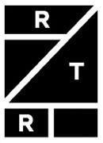

Rent the Runway, Inc.

Option Exchange

Rent the Runway has received your election via Rent the Runway's Option Exchange website by which you elected to accept or reject Rent the Runway’s offer to exchange your eligible outstanding options for replacement restricted stock units ("Replacement RSUs") with respect to some or all of your outstanding stock option grants, subject to the terms and conditions of the Offer to Exchange and Terms of Election (the "Option Exchange").

Your election has been recorded as follows:

Name: Demo User
Employee ID: DEMO1
Date and Time: 06/8/2023 8:37 AM Eastern Time

Grant Date | Grant ID | Award Type | Per Share | Total Outstanding | Vested Options | Hypothetical | Election
 |  |  | Exercise Price | Shares | as of | Replacement
 |  |  |  | Underlying Option | 7/10/2023** | RSU Range***
 |  |  |  | Grant*
9/15/2016 | DEMOGRANT1 | Options (ISO) | $7.02 | 10,000 | 6,875 | 2,631 - 5,000 | Exchange
12/6/2020 | DEMOGRANT2 | Options (ISO) | $7.01 | 25,000 | 17,187 | 6,578 - 12,500 | Exchange
10/28/2021 | DEMOGRANT3 | Options (ISO) | $21.00 | 19,044 | 7,814 | 5,011 - 9,522 | Exchange

*This column displays the number of shares of our Class A common stock or Class B common stock, as applicable, subject to the stock option grant as of July 10, 2023 (assuming no exercise or early termination occurs, through July 10, 2023).

**This column displays the number of vested shares of our Class A common stock or Class B common stock, as applicable, subject to the stock option grant as of July 10, 2023 (assuming vesting in accordance with the applicable vesting schedule, and no exercise or early termination occurs, through July 10, 2023).

***The specific final exchange ratio will be determined by the Compensation Committee of our Board of Directors at the close of trading on the last business day prior to the Expiration Time (currently scheduled for July 10, 2023). The exchange ratio cannot be calculated as of now because it will be based in part on the future value of our Class A common stock and our eligible options during and near the end of the Option Exchange. We currently expect that an exchange ratio between 2.0 and 3.8 to 1.0 (2.0-3.8 : 1.0) will be selected by the Compensation Committee using a Black-Scholes valuation model, meaning that for every 2.0 to 3.8 eligible options surrendered, a participant will receive one replacement RSU (with any fractional replacement RSUs rounded down to the nearest whole share on a grant-by-grant basis). However, because the exchange ratio will be based in part on the future value of our Class A common stock, which is inherently difficult to predict, the final exchange ratio selected by the Compensation Committee could fall outside of this range. For example, if the trailing 20-Day volume weighted average price (the "20-Day VWAP") is between $1.00 - $2.00, the exchange ratio could potentially fall within a range as high as 2.5-4.1 to 1.0 and, conversely, if the 20-Day VWAP is between $4.00 - $5.00, the exchange ratio could potentially fall within a range as low as 1.7-2.1 to 1.0. Furthermore, the exchange ratio will represent an amount that would result, as of the determination time, in the issuance of a number of replacement RSUs that would have an aggregate fair value equal to a specific amount between 90% to 100% of the aggregate fair value of all eligible options, and not on a grant-by-grant basis (assuming all eligible options are exchanged). As such, on an individual grant basis, the number of replacement RSUs that you receive may not have a fair value equal to 90% to 100% of the fair value of the eligible options that you exchanged.

Please refer to the Option Exchange documents, including Section 8 of the Offer to Exchange, for additional terms. If you have any questions, please contact legal@renttherunway.com.

If you change your mind regarding your election, you may change your election to accept or reject the Option Exchange with respect to some or all of your eligible stock option grants by submitting a new election. However, any election must be made on a grant-by-grant basis and no partial exchanges of separate option grants will be permitted. The new election must be delivered via Rent the Runway’s Option Exchange website at www.myoptionexchange.com, no later than the completion date, currently expected to be 11:59 PM Eastern Time, on July 10, 2023 (unless the offer is extended).

Only elections that are properly completed, electronically signed, dated and actually received by Rent the Runway via the Option Exchange website at www.myoptionexchange.com on or before the completion date of the Option Exchange will be accepted. Elections submitted by any other means, including hand delivery, interoffice, email, U.S. mail or Federal Express (or similar delivery service), are not permitted.

Please note that our receipt of your election is not by itself an acceptance of your stock options for exchange. For purposes of the Option Exchange, we will be deemed to have accepted stock options for exchange that are validly elected to be exchanged and are not properly withdrawn as of the time when we give written notice to the eligible participants generally of our acceptance of stock options for exchange. We may issue this notice of acceptance by press release, email or other form of communication. Stock options accepted for exchange will be cancelled, and the Replacement RSUs will be granted on the Replacement RSUs grant date, which is expected to occur on the first business day following the day of the expiration time (unless the offer is extended).

This notice does not constitute the Option Exchange. The full terms of the Option Exchange are described in (1) the Offer to Exchange Certain Eligible Outstanding Options for a Number of Replacement Restricted Stock Units; (2) the email to all eligible service providers with additional information about the Option Exchange from Rent the Runway; and (3) the Terms of Election. You may access these documents free of charge through the U.S. Securities and Exchange Commission’s website at www.sec.gov, on Rent the Runway’s Option Exchange website at www.myoptionexchange.com, or by contacting Rent the Runway by email at legal@renttherunway.com.

Please do NOT reply to this email. This mailbox is not monitored and you will not receive a response. If you have any questions, please email legal@renttherunway.com.

Exhibit (a)(1)(vii)

FINAL EXCHANGE RATIO

We are sending this e-mail to you to notify you of the final exchange ratio to be used in the Offer to Exchange Certain Eligible Outstanding Options for a Number of Replacement Restricted Stock Units, dated June 9, 2023 (the “Offer to Exchange”).

Final Exchange Ratio: Based on a per share stock price of $[ ● ], which was the closing price of our Class A common stock on July 7, 2023 and a 20-Day VWAP of $[ ● ] ending as of July 7, 2023, the final exchange ratio is [ ● ] to 1.0. The same exchange ratio will be applied to all eligible options. In the event that application of the exchange ratio results in a replacement RSU for a fractional share, the number of replacement RSUs will be rounded down to the nearest whole share.

Illustrative Example: To determine the number of replacement RSUs you will receive for each Eligible Option (as defined in the Offer to Exchange), divide the number of shares subject to the Eligible Option by the exchange ratio, and round down to the nearest whole share. For example, if you tender for exchange an Eligible Option to purchase 1,000 shares, the exchange ratio is [ ● ] to 1.0 ( = 1,000 ÷ [ ● ]) and accordingly you would receive [ ● ] replacement RSUs.

You have until July 10, 2023 at 11:59 PM Eastern Time to make or change your elections on the Option Exchange website. The Option Exchange deadline will be strictly enforced, so we encourage you to give yourself adequate time to make your election if you wish to participate. You can access the Option Exchange website at www.myoptionexchange.com and follow the directions to make a timely decision. If you have already established your account, login with your password and check your email for the authentication code. If you have not already established your account, please click on “Register as New User”, set your password, and check your email for the authentication code. Simply follow the instructions on the website to access personalized information about your eligible options and how to make, change or withdraw your election before the end of the offering period.

Your participation in the Option Exchange is completely voluntary. You are not obligated to participate in the Option Exchange.

Any options you do not elect to surrender for exchange will not be canceled and will remain subject to their present terms.

If you have any questions about the program, please contact legal@renttherunway.com.

The Option Exchange is being made pursuant to the terms and conditions set forth in Rent the Runway’s Tender Offer Statement on Schedule TO and the exhibits attached thereto, including the Offer to Exchange Certain Eligible Outstanding Options for a Number of Replacement Restricted Stock Units, filed with the Securities and Exchange Commission, which are available free of charge at http://www.sec.gov or on the Option Exchange website located at: www.myoptionexchange.com. You should read these written materials carefully because they contain important information about the Option Exchange, including related risks.

Exhibit (a)(1)(viii)
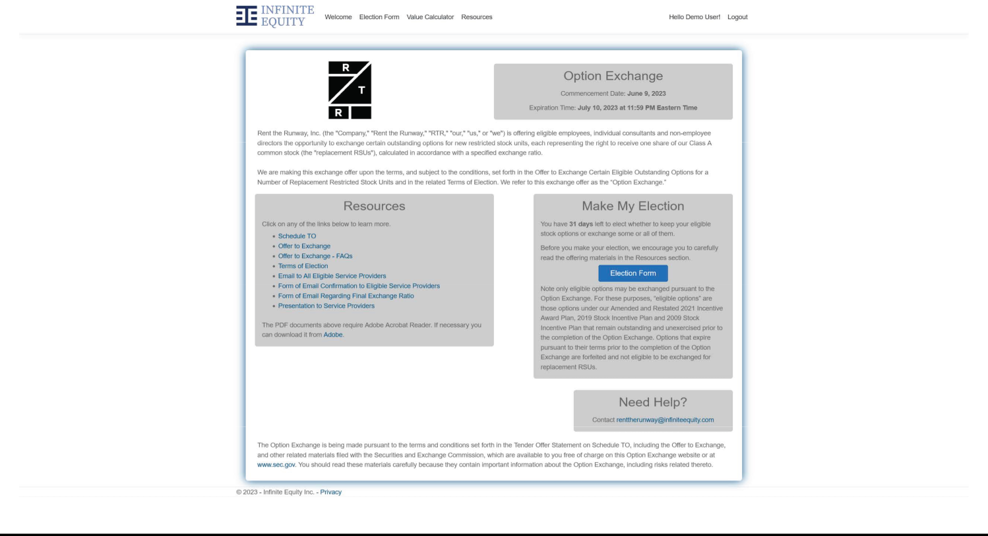

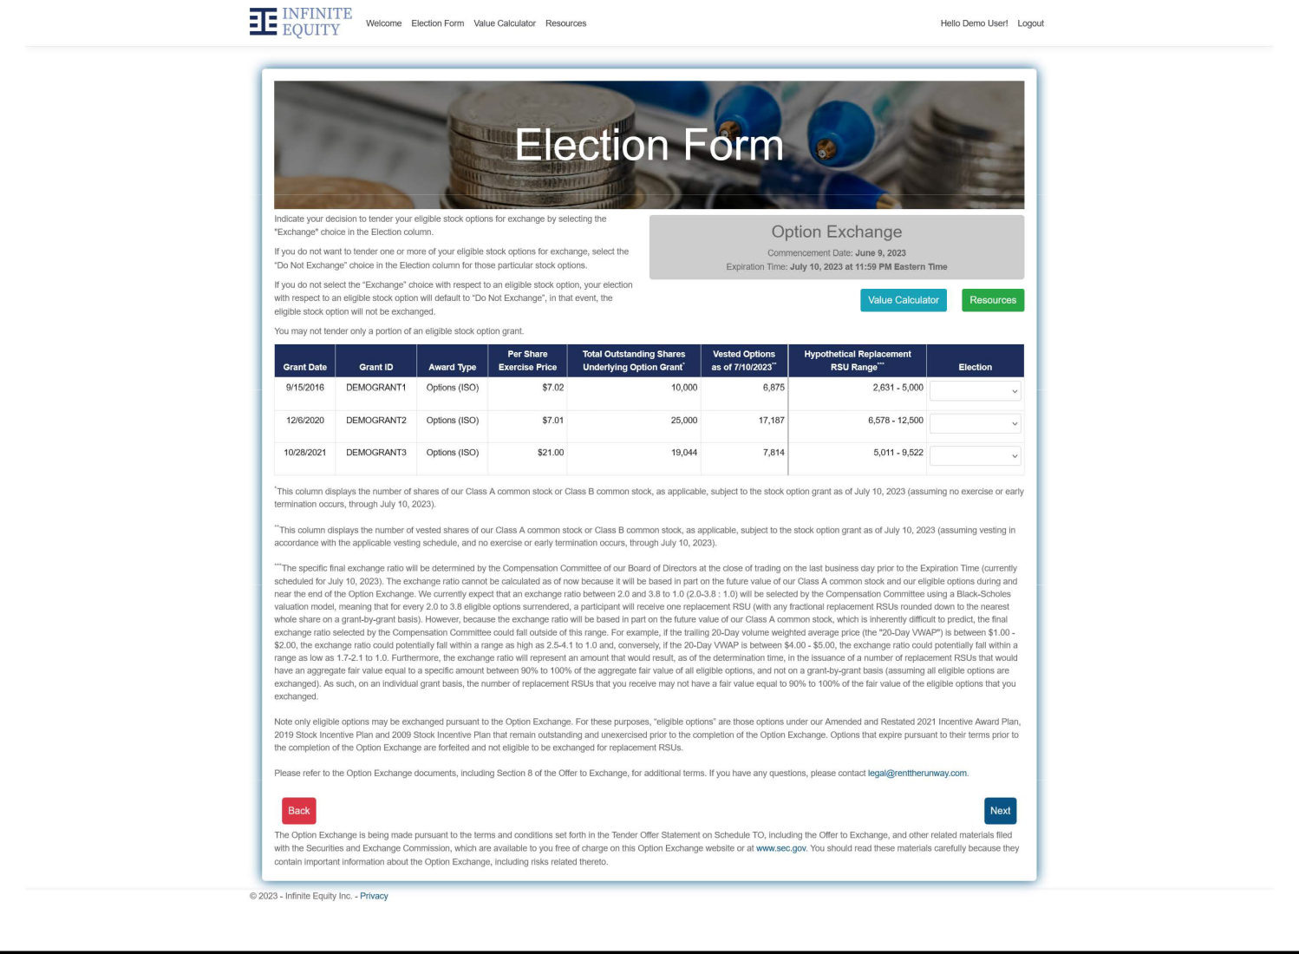

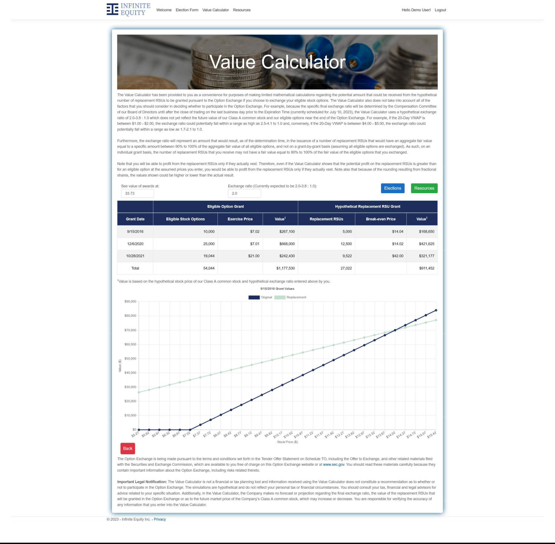

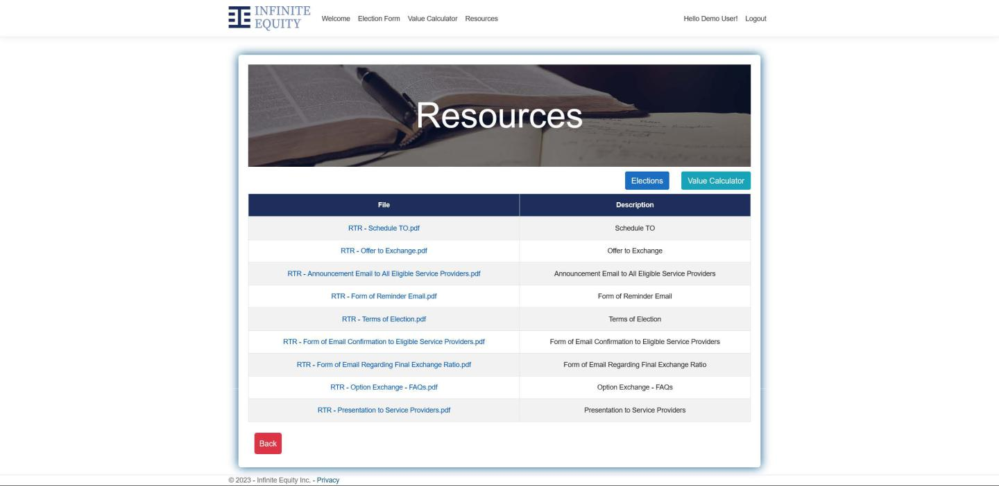

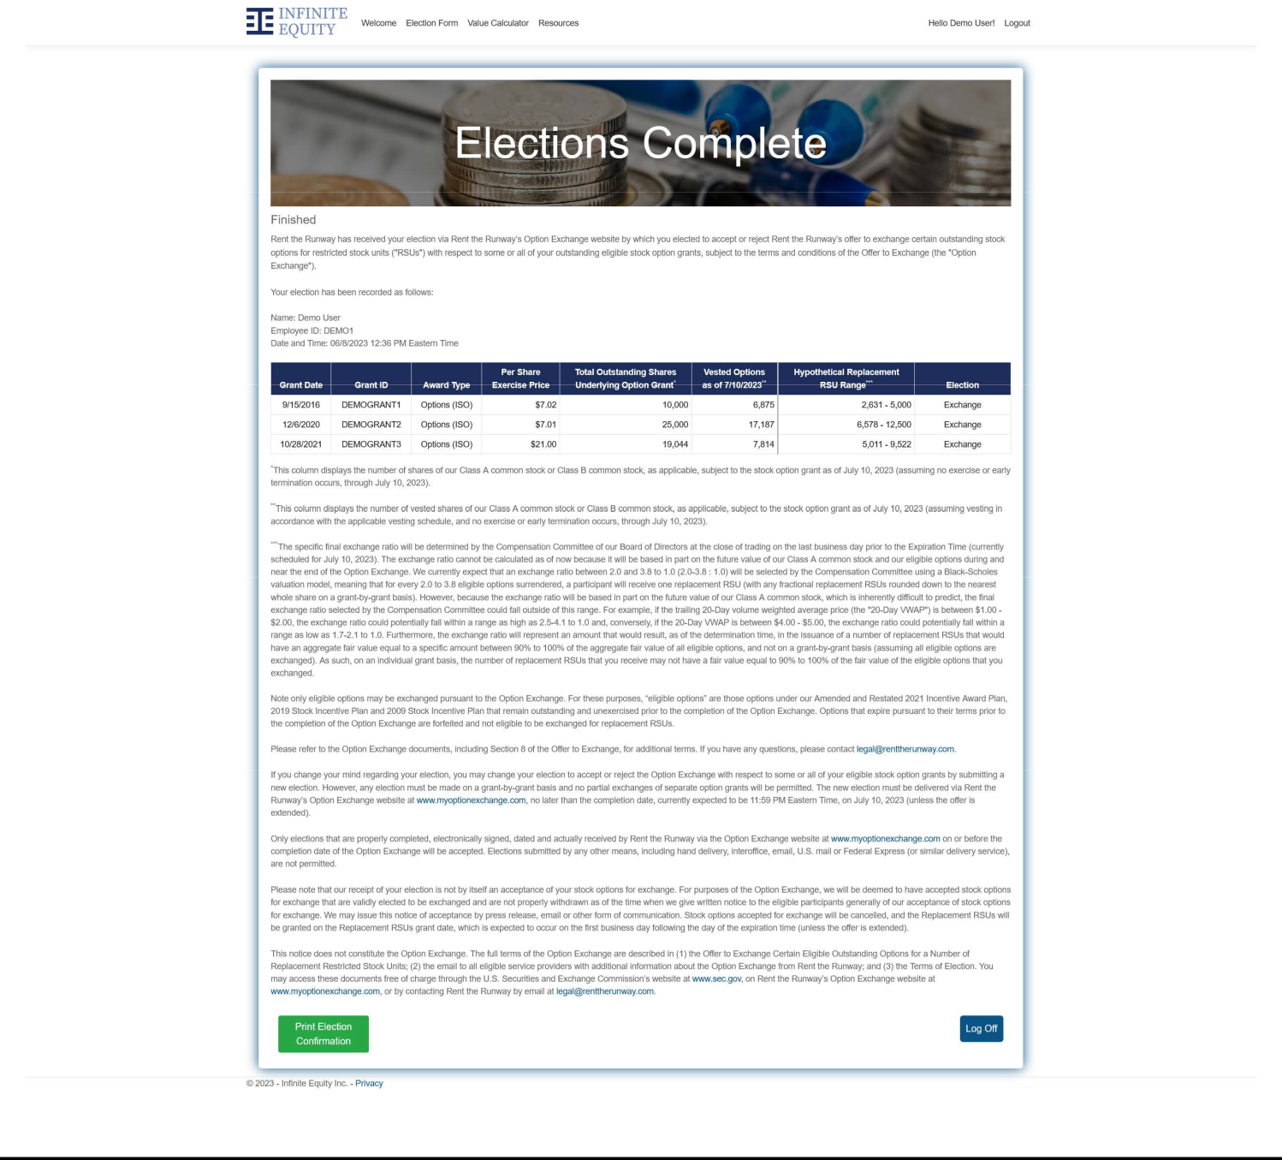

Exhibit (a)(1)(ix)

FREQUENTLY ASKED QUESTIONS AND ANSWERS

The following are answers to some of the questions that you may have about the Option Exchange. We urge you to read them carefully, as well as the remainder of this Offer to Exchange. Where applicable, we have included section references to the remainder of this Offer to Exchange where you can find a more complete description of the topics in this question and answer summary. We suggest that you consult with your personal financial, legal and tax advisors before deciding whether to participate in the Option Exchange. Please review this summary term sheet and questions and answers, and the remainder of this Offer to Exchange and the Terms of Election to ensure that you are making an informed decision regarding your participation in the Option Exchange. This summary is not intended to reflect any specific terms that relate to options held by our former Chief Financial Officer, that were agreed to pursuant to the terms of her Transition Agreement.

The questions have been separated into three sections:

- Exchange Design.

- Administrative/Timing.

- Other Important Questions.

Exchange Design

- What is the Option Exchange?

The Option Exchange is being offered by Rent the Runway to allow eligible active service providers of Rent the Runway to exchange their outstanding options that remain outstanding and unexercised prior to the completion of the Option Exchange for new restricted stock units, each representing the right to receive one share of our Class A common stock, which we refer to as replacement RSUs.

The number of eligible options to be surrendered in exchange for each replacement RSU will be determined by the exchange ratio described below under question 3. The replacement RSUs will be granted under the 2021 Plan on the replacement RSUs grant date, which will be the date on which we cancel the eligible options accepted for exchange, which we expect will be the first business day following the expiration date of the Option Exchange. The replacement RSUs will have the terms and be subject to the conditions as provided for in the 2021 Plan and RSU Agreement entered into between you and RTR.

- Why are we offering the Option Exchange?

An objective of our equity incentive programs has been, and continues to be, to provide us with a competitive advantage, particularly in our efforts to hire and retain top talent, and we believe that the Option Exchange is an important component in our efforts to achieve that goal. We are implementing the Option Exchange using an exchange ratio designed to result in potential grants of replacement RSUs with an aggregate fair value that will be between 90% to 100% of the aggregate fair value of the eligible options that are surrendered in the Option Exchange.

A significant majority of our service providers’ options have exercise prices that exceed, in some cases significantly, the trading prices of our Class A common stock over the past year. We believe these underwater options are no longer effective as incentives to motivate and retain our service providers. In the face of a competitive market for exceptional service providers, the need for adequate and appropriate incentives and retention tools remains strong. The Option Exchange will also allow our eligible non-employee directors to be fairly compensated for their service on our Board of Directors.

1

As of June 2, 2023, we had an aggregate of 11,092,146 shares of Class A common stock and Class B common stock available for issuance subject to outstanding options and restricted stock units under our equity incentive plans or available for issuance under the 2021 Plan, which we collectively refer to as our “overhang.” As of June 2, 2023, eligible options outstanding under our existing equity incentive plans were exercisable for approximately 3,888,155 shares of Class A common stock and approximately 3,057,017 shares of Class B common stock.

Eligible options remain outstanding and contribute to overhang until such time as they expire or are otherwise cancelled. Although eligible options are not likely to be exercised as long as our share price is lower than the applicable exercise price, they will remain on our financial statements with the potential to dilute shareholders’ interests for up to the full term of the options, while delivering relatively little retentive or incentive value, unless they are surrendered or cancelled. For illustrative purposes, if all of these eligible stock options are exchanged and replaced by replacement RSUs at an exchange ratio of 2.9 to 1, which is the midpoint of the range of our expected exchange ratio, there would be a net reduction in the overhang of our equity awards by approximately 4,550,285 shares subject to outstanding options. We believe that the replacement RSUs will drive service provider retention as they have inherent value and are more motivational than current underwater options. The Option Exchange gives eligible service providers an opportunity to exchange certain options that are significantly “underwater” as of the commencement date for replacement RSUs that may provide value to eligible service providers, even if our stock price does not increase. Further, surrendered eligible options will be cancelled and returned to the pool of shares reserved for future grant under the 2021 Plan.

The Option Exchange is voluntary and will allow eligible service providers to choose whether to keep their existing options at existing exercise prices and vesting schedules or to exchange those options for replacement RSUs. We intend the Option Exchange to enable eligible service providers to restore equity value so they are further motivated to deliver the important strategic and operational initiatives of our Company.

Subject to the limitations set forth in Section 6 of this Offer to Exchange (“Conditions of the Option Exchange”) and Section 14 of this Offer to Exchange (“Extension of the Option Exchange; Termination; Amendment”), respectively, we reserve the right before the Expiration Time, to terminate or amend the Option Exchange and to postpone our acceptance and cancellation of any options elected for exchange, if at any time on or after the date of commencement of the Option Exchange and prior to the Expiration Time certain events have occurred, including any increase or decrease of greater than 33% of the market price of our Class A common stock that occurs during the tender offer as measured from $2.45, which was the closing price of our Class A common stock on Nasdaq on June 8, 2023.

- How do RSUs differ from stock options?

The table below outlines some key differences between stock options and RSUs:

Stock Options

What they are The right to purchase a fixed number of shares of

Rent the Runway Class A common stock or Class B common stock, as applicable, at a fixed exercise price for a fixed period of time.

How they work Once a stock option grant vests, you can exercise the

vested portion at any time until the expiration date

of that option. Exercising means you buy the stock

at the exercise price set on the date of grant.

If the price of our Class A common stock or Class B common stock is greater than the exercise price when you exercise and sell the shares, you receive the gain (after payment of applicable taxes).

However, when our stock price is less than the exercise price, the stock option has no intrinsic value and is considered to be underwater.

RSUs

The right to receive shares of Rent the Runway Class A common stock in the future at no exercise or purchase price.

Once an RSU vests, a share of Rent the Runway Class A common stock is issued to you and at no cost to you, other than any applicable withholding taxes associated with the RSU. The value you receive for an RSU upon issuance of the Class A common stock will be based on the then-current Rent the Runway stock price. Once our stock is issued to you following the vesting of the RSU, you can either keep it as an investment or sell it.

2

- Will my replacement RSUs have an exercise or purchase price? What will their terms and conditions be?

Your replacement RSUs will not have an exercise or purchase price. Each replacement RSU will represent your right to receive one share of our Class A common stock upon vesting for each replacement RSU that vests in the future. See Section 1 of this Offer to Exchange (“Eligibility; Number of Options; Expiration Time”) below for additional information. You do not have to make a cash payment to RTR to receive a grant of replacement RSUs in exchange for your exchanged eligible options or pay RTR to receive the shares of Class A common stock that become issuable to you if your replacement RSUs vest though you may have taxes due on the vesting or settlement of the RSUs. Generally, replacement RSUs that do not vest will be forfeited to RTR, as determined in accordance with the 2021 Plan and applicable RSU Agreement.

See Section 7 of this Offer to Exchange (“Price Range of Class A Common Stock Underlying the Options”) for information concerning our historical Class A common stock prices.

Replacement RSUs will have the terms and be subject to the conditions as provided for in the 2021 Plan and the RSU Agreement. In addition, the number of shares subject to the replacement RSUs and the replacement RSUs’ vesting dates will be different from the terms that are applicable to eligible options.

You are encouraged to consult the 2021 Plan and RSU Agreement for complete information about the terms of the replacement RSUs, which are available through the option exchange website.

- How does the Option Exchange work?

We are offering eligible service providers the opportunity to exchange eligible options that remain outstanding and unexercised prior to the completion of the Option Exchange for a number of replacement RSUs, based on the exchange ratio described below. The outstanding options that you hold give you the right to purchase a fixed number of Rent the Runway Class A common stock or Class B common stock, as applicable, once you exercise those options by paying the applicable exercise price of those options (and satisfying any applicable tax withholding obligations). Thus, when we use the term “options” in this Option Exchange, we refer to the actual options you hold to purchase our Class A common stock or Class B common stock, as applicable, and not the shares of Class A common stock or Class B common stock underlying those options.

Participating in the Option Exchange requires an eligible service provider to make a voluntary election to tender eligible options on or before 11:59 P.M. U.S. Eastern Time on Monday, July 10, 2023, unless the Option Exchange is extended, after which time such election will be irrevocable.

Unless prevented by law or applicable regulations, eligible options accepted for exchange will be cancelled, and replacement RSUs will be granted under our 2021 Plan.

3

Examples

To illustrate how the exchange ratio works, assume that:

- You are an active service provider.

- You have an eligible option to purchase 1,000 shares.

- The exchange ratio is determined to be 2.9 to 1.

- The replacement RSUs grant date is July 11, 2023.

If you elect to participate in the Option Exchange, you would receive 344 replacement RSUs for the eligible option to purchase 1,000 shares (i.e., 1,000 ÷ 2.9) (with any fractional RSUs rounded down to the nearest whole share).

Replacement RSUs will vest in eight equal quarterly installments over two years on November 1, 2023, February 1, 2024, May 1, 2024, August 1, 2024, November 1, 2024, February 1, 2025, May 1, 2025, and August 1, 2025 (which vesting dates may change if the Expiration Time is extended), subject to your continued employment or service through the applicable vesting dates, regardless of whether any of the surrendered eligible options are vested as of July 10, 2023. This means that each replacement RSU will generally be completely unvested on July 11, 2023 (the replacement RSUs grant date in this example), regardless of whether the surrendered option was wholly or partially vested on such date.

- What does the exchange ratio mean and what will it be?

The exchange ratio in the Option Exchange represents the number of Class A common stock or Class B common stock, as applicable, underlying an eligible option that a service provider must surrender in order to receive one Class A common stock underlying a replacement RSU. The exchange ratio for the Option Exchange cannot be calculated as of the date of the Option Exchange because the ratio will be based in part on the 20-Day VWAP. The same exchange ratio will be applied to all eligible options and will represent an amount that would result, as of the determination time, in the issuance of a number of replacement RSUs that would have an aggregate fair value equal to a specific amount between 90% to 100% of the aggregate fair value of all eligible options, and not on a grant-by-grant basis (assuming all eligible options are exchanged and calculated using a Black-Scholes valuation model), which we refer to as a “value-for-value” exchange. As such, on an individual grant basis, the number of replacement RSUs that you receive may not have a fair value equal to 90% to 100% of the fair value of the eligible options that you exchanged.

The exchange ratio will be determined using the Black-Scholes valuation model and will be based on, among other things, the price of our Class A common stock, the volatility of the stock price of our peers and us, and the strike price and remaining term of the eligible stock options in order to balance the compensatory goals of the Option Exchange and the interests of our shareholders, including reducing our total number of common stock underlying outstanding options, avoiding further dilution to our shareholders and minimizing the share compensation expense of the grants of replacement RSUs. For the purposes of determining the fair value of eligible options, the fair market value of a share of our Class A common stock will be determined based on the trailing 20-Day volume weighted average price, or “20-Day VWAP”. The 20-Day VWAP means the simple arithmetic average of the Daily VWAPs (as defined below) over the 20 consecutive trading days up to and including July 7, 2023. The “Daily VWAP” means, for any trading day, the per share volume-weighted average price of our Class A common stock on Nasdaq, as displayed under the heading “Bloomberg VWAP” on Bloomberg page “RENT <equity> AQR” (or its equivalent successor if such page is not available), in respect of the period from the scheduled open of trading until the scheduled close of trading of the primary trading session of Nasdaq on such trading day (or if such volume-weighted average price is unavailable, the market value of one share of our Class A common stock on such trading day determined, using a volume-weighted average method, by a nationally recognized independent investment banking firm retained for this purpose by us). The Daily VWAP will be determined without regard to pre-market hours or after-hours trading or any other trading outside of the regular trading session trading hours.

4

Because the methodology used to calculate the final exchange ratio will include the Black-Scholes value of the eligible options and the replacement RSUs, the exact exchange ratio will not be known until shortly after the close of trading, U.S. Eastern Time, on July 7, 2023. After the close of trading, U.S. Eastern Time, on July 7, 2023, we will distribute by email to all holders the exact exchange ratio to be used in the Option Exchange with respect to all eligible options.

For illustrative purposes only, below is a table setting forth the number of replacement RSUs you could receive in exchange for an eligible option to purchase 1,000 shares, at various exchange ratios within the currently expected range. However, because the exchange ratio will be based in part on the future value of our Class A common stock, which is inherently difficult to predict, the final exchange ratio selected by the Compensation Committee could fall outside of this range. For example, if the 20-Day VWAP is between $1.00 - $2.00, the exchange ratio could potentially fall within a range as high as 2.5-4.1 to 1.0 and, conversely, if the 20-Day VWAP is between $4.00 - $5.00, the exchange ratio could potentially fall within a range as low as 1.7-2.1 to 1.0.

Hypothetical Exchange Ratios for Eligible

Options
Number of |  |  |  | Number of
Eligible |  | Exchange |  | Replacement
Options |  | Ratio |  | RSUs
1,000 |  | 2.0 : 1.0 |  | 500
1,000 |  | 2.3 : 1.0 | 434
1,000 |  | 2.6 : 1.0 | 384
1,000 |  | 2.9 : 1.0 | 344
1,000 |  | 3.2 : 1.0 | 312
1,000 |  | 3.5 : 1.0 | 285
1,000 |  | 3.8 : 1.0 | 263

7. Which options are eligible for the Option Exchange?

Options eligible for exchange are those held by active service providers that remain outstanding and unexercised prior to the completion of the Option Exchange.

Additionally, options that expire pursuant to their terms prior to the completion of the Option Exchange will be forfeited and will not eligible to be exchanged for replacement RSUs.

- Who is eligible to participate in the Option Exchange?

You are eligible to participate in the Option Exchange only if (i) you are an active U.S.-based employee, individual consultant or non-employee director (each, a “service provider”) of Rent the Runway as of the date this Option Exchange commences and remain an active service provider through the completion of the Option Exchange and (ii) you hold at least one eligible option as of the commencement of the Option Exchange.

If you are no longer employed by or engaged as a service provider to Rent the Runway, whether your termination is voluntary, involuntary, or for any other reason as of the completion of the Option Exchange, you will not be able to participate in the Option Exchange.

ACCORDINGLY, IF YOU ARE NOT AN ELIGIBLE SERVICE PROVIDER OF RENT THE RUNWAY AT THE EXPIRATION TIME, EVEN IF YOU HAD ELECTED TO PARTICIPATE IN THE OPTION EXCHANGE AND HAD TENDERED SOME OR ALL OF YOUR OPTIONS FOR EXCHANGE, YOUR TENDER WILL AUTOMATICALLY BE DEEMED WITHDRAWN AND YOU WILL NOT PARTICIPATE IN THE OPTION EXCHANGE, AND YOU WILL RETAIN YOUR OUTSTANDING OPTION(S) IN ACCORDANCE WITH THEIR CURRENT TERMS AND CONDITIONS. IN THE CASE OF A TERMINATION OF YOUR EMPLOYMENT OR SERVICE, YOU MAY BE ENTITLED TO EXERCISE YOUR OUTSTANDING OPTION(S) DURING A LIMITED PERIOD OF TIME FOLLOWING THE TERMINATION OF EMPLOYMENT OR SERVICE IN ACCORDANCE WITH THEIR TERMS TO THE EXTENT THAT THEY ARE VESTED AS OF SUCH TERMINATION OF EMPLOYMENT OR SERVICE. See Section 1 of this Offer to Exchange (“Eligibility; Number of Options; Expiration Time”) and Section 5 of this Offer to Exchange (“Acceptance of Options for Exchange; Grant of Replacement RSUs”) below for additional information.

5

- Why isn’t the exchange ratio set at one-for-one?

The exchange ratio will be calculated to result in an aggregate fair value, for accounting purposes, of the replacement RSUs that will be between 90% to 100% of the aggregate fair value of the eligible options they replace, and not on a grant-by-grant basis (assuming all eligible options are exchanged and calculated using a Black-Scholes valuation model), calculated as of July 7, 2023, in order to balance the compensatory goals of the option exchange and the interests of our shareholders, including reducing our total number of common stock underlying outstanding options, avoiding further dilution to our shareholders and minimizing the share-based compensation expense of the grants of replacement RSUs.

10. If I participate, what will happen to my exchanged options?

Eligible options that you elect to exchange will be cancelled on the first business day following the expiration date of the Option Exchange, which is currently scheduled for 11:59 P.M. U.S. Eastern Time on Monday, July 10, 2023, unless the Option Exchange is extended.

- Can I select which of my eligible options to exchange? If I elect to exchange some of my eligible options, do I have to elect to exchange all of my eligible options?

If you hold more than one eligible separate option grant, you may choose to elect to exchange your eligible options on a grant-by-grant basis (determined based on options having the same grant date and exercise price), without having to exchange all of your eligible separate option grants. If you elect to exchange any portion of an eligible separate option grant in the Option Exchange, you must elect to exchange that entire eligible separate option grant. No partial exchanges of separate option grants will be permitted.

12. What happens to eligible options that I choose not to exchange or that you do not accept for exchange?

Eligible options that you choose not to exchange or that we do not accept for exchange will remain outstanding and will retain their existing terms, exercise prices and vesting schedules.

- What happens if I have an eligible option grant that is subject to a domestic relations order or comparable legal document as the result of the end of a marriage?

If you have an eligible separate option grant that is subject to a domestic relations order (or comparable legal document as the result of the end of a marriage) and a person who is not an eligible service provider beneficially owns a portion of that eligible separate option grant, then in order to participate in the Option Exchange with respect to such eligible separate option grant, you may accept this Option Exchange with respect to the entire remaining outstanding portion of the eligible separate option grant, including the portion beneficially owned by the other person, as long as you are the legal owner of the eligible separate option grant. We are not accepting partial tenders of an eligible separate option grant, so you may not accept this Option Exchange with respect to a portion of an eligible separate option grant that is beneficially owned by you while rejecting it with respect to the portion beneficially owned by someone else. As you are the legal owner of the eligible separate option grant, we will respect an election properly made by you, but will not be responsible to you or the beneficial owner of the eligible separate option grant for any errors made by you with respect to such eligible separate option grant.

14. What are the conditions to the Option Exchange?

The Option Exchange is subject to the conditions described in Section 6 of this Offer to Exchange (“Conditions of the Option Exchange”). The Option Exchange is not conditioned upon a minimum aggregate number of options being elected for exchange. See Section 6 of this Offer to Exchange (“Conditions of the Option Exchange”) below for additional information.

6

Administrative/Timing

15. How do I participate in the Option Exchange?

If you choose to participate in the Option Exchange, you must take the following action on or before 11:59 P.M., U.S. Eastern Time, on Monday, July 10, 2023:

- Use your user log-in ID and password (which you will set up using instructions that will be emailed to you) to access the option exchange website at www.myoptionexchange.com; and

- Properly complete and submit your election via the option exchange website by (a) navigating to the Election Form page, (b) indicating which eligible options you wish to exchange by selecting “Exchange” or “Do Not Exchange” in the Election column and “Next” at the bottom of the page, and (c) after reading all of the offering documents, checking the appropriate boxes, typing your electronic signature, and selecting “Submit.” By selecting the “Submit” button you are acknowledging and agreeing to the Terms of Election.

Rent the Runway must receive your properly completed submission on or before 11:59 P.M. U.S. Eastern Time on Monday, July 10, 2023, unless extended by us.

You can change your election any time on or after the commencement of the Option Exchange and prior to the Expiration Time; however, the last election that you make, if any, on or prior to 11:59 P.M. U.S. Eastern Time on Monday, July 10, 2023 will be final and irrevocable.

If you elect to exchange an eligible separate option grant, you must elect to exchange that entire eligible option grant. If you hold more than one eligible separate option grant, however, you may choose to exchange separate eligible option grants, on a grant-by-grant basis, without having to exchange all of your eligible option grants. No partial exchanges of separate option grants will be permitted. If you are eligible to participate in the Option Exchange, the option exchange website will list all of your eligible separate option grants.

Confirmation statements for submissions through the option exchange website will be emailed directly to you, and you may also obtain a confirmation from the option exchange website after submitting your election or withdrawal. You should print and save a copy of the confirmation for your records.

Elections submitted by any other means, including email, facsimile, hand delivery, interoffice, United States mail (or other post) and Federal Express (or similar delivery service), are not permitted, and will not be accepted.

16. How do I find out the details about my existing options?

Information on your eligible options will be provided to you with the Option Exchange on the option exchange website located at www.myoptionexchange.com.

17. What will happen if I do not submit my election by the deadline?

If you do not submit your election by the deadline, then you will not participate in the Option Exchange, and all options currently held by you will remain intact at their original exercise price and subject to their original terms and conditions. (See “Risk Factors” below for additional information).

18. How will we determine whether an eligible option has been properly tendered?

We will determine, in our sole discretion, all questions as to the validity, form, eligibility (including time of receipt) and acceptance of any eligible option grants. We reserve the right to reject any election or any eligible option elected to be exchanged that we determine are not in appropriate form or that we determine are unlawful to accept or not timely made. Neither we nor any other person is obligated to give notice of any defects or irregularities in any election, nor will anyone incur any liability for failure to give any notice. No surrender of eligible options will be deemed to have been properly made until all defects or irregularities have been cured by the tendering holder of the eligible options or waived by us. Subject to any order or decision by a court or arbitrator of competent jurisdiction, our determination of these matters will be final and binding on all parties. Subject to Rule 13e-4 under the Exchange Act we also reserve the right to waive any of the conditions of the Option Exchange or any defect or irregularity in any surrender with respect to any particular eligible options or any particular eligible service provider.

7

See also Section 3 of this Offer to Exchange (“Procedures for Electing to Exchange Options”) below for additional information.

IF YOU FAIL TO PROPERLY SUBMIT YOUR ELECTION BY THE DEADLINE, YOU WILL NOT BE PERMITTED TO PARTICIPATE IN THE OPTION EXCHANGE.

19. During what period of time can I withdraw or change my previous elections?

You can withdraw or change your previously submitted election to exchange or not exchange eligible options at any time on or before 11:59 P.M. U.S. Eastern Time on Monday, July 10, 2023, unless extended by us. If the Option Exchange is extended beyond July 10, 2023, you can withdraw or change your election at any time until the extended expiration of the Option Exchange. To change your previously submitted election, you must submit a new election in the same manner described in Question 13 before the election deadline. To withdraw your previously submitted election, submit a new election before the election deadline, and select “No” in the election column for the particular option(s) you wish to withdraw. It is your responsibility to confirm that we have received your correct election before the deadline. In all cases, the last election submitted and received prior to the deadline will be final and irrevocable. See Section 4 of this Offer to Exchange (“Withdrawal Rights”) below for additional information.

AFTER THE DEADLINE TO WITHDRAW OR CHANGE YOUR ELECTION HAS OCCURRED, YOU WILL NOT BE PERMITTED TO WITHDRAW OR CHANGE YOUR ELECTION.

20. Can I exchange the remaining portion of an eligible separate option grant that I have already partially exercised?

Yes, any unexercised portion of an eligible separate option grant can be exchanged. If you have previously exercised a portion of an eligible separate option grant, only the portion of that separate option grant that has not yet been exercised will be eligible to be exchanged. Any portion of a separate option grant that has been exercised is not eligible to participate in the Option Exchange. The replacement RSUs will only replace the portion of eligible separate option grant that is cancelled upon the expiration of the Option Exchange.

21. Can I exchange both vested and unvested eligible options?

Yes. You can exchange eligible options regardless of whether they are vested or unvested. However, you will not be able to choose to only exchange the vested or unvested portion of a particular option grant. If you choose to exchange a particular option grant, you must exchange all of the unexercised portion of such grant.

As a reminder, each replacement RSU will generally be completely unvested on the replacement RSUs grant date, regardless of whether the surrendered eligible option was wholly or partially vested.

22. Will I be required to give up all of my rights under the exchanged options?

Yes. Once RTR has accepted your exchanged options, your exchanged options will be cancelled and you will no longer have any rights under those exchanged options. RTR will cancel all exchanged options on the first business day following the Expiration Time. We expect to grant the replacement RSUs on the first business day following the Expiration Time. See Section 8 of this Offer to Exchange (“Source and Amount of Consideration; Terms of Replacement RSUs”) below for additional information. Once your exchanged options have been cancelled, you do not need to take additional action in order to receive your replacement RSUs.

23. When will the replacement RSUs vest?

Replacement RSUs will generally be unvested on the replacement RSUs grant date and will vest in eight equal quarterly installments over two years on November 1, 2023, February 1, 2024, May 1, 2024, August 1, 2024, November 1, 2024, February 1, 2025, May 1, 2025, and August 1, 2025 (which vesting dates may change if the Expiration Time is extended), subject to your continued employment or service through the applicable vesting dates.

8

Like all of our outstanding options and restricted stock units, the vesting of the replacement RSUs is dependent upon continued employment with Rent the Runway (if you are an employee) or continued service with Rent the Runway (if you are an individual consultant or non-employee director) through the applicable vesting date. Replacement RSUs are subject to the terms and conditions as provided for in the 2021 Plan and the RSU Agreement and may be forfeited if not vested at the time of a termination of service. See Section 8 of this Offer to Exchange (“Source and Amount of Consideration; Terms of Replacement RSUs”) below for additional information.

24. What if my employment or service with Rent the Runway is terminated after the replacement RSUs are granted?

If your employment or service is terminated for any reason after the replacement RSUs has been granted, replacement RSUs will generally be forfeited if not vested at the time of a termination of employment or service. See Section 8 of this Offer to Exchange (“Source and Amount of Consideration; Terms of Replacement RSUs”) below for additional information.

25. What happens if Rent the Runway is subject to a change in control BEFORE the replacement RSUs are granted?

Although we are not currently contemplating a merger or similar transaction that could result in a change in control of our Company, we reserve the right, in the event of a merger or similar transaction, to take any actions that we deem necessary or appropriate to complete a transaction that our Board of Directors believes is in the best interest of our Company and our shareholders. This could include terminating the Option Exchange and/or your right to receive replacement RSUs under the Option Exchange.

Any change in control transaction, or announcement of such transaction, could have a substantial effect on our share price.

26. Are there other circumstances where I would not be granted replacement RSUs?

Yes. Even if we accept your tendered options, we will not grant replacement RSUs to you if we are prohibited by applicable law or regulations from doing so, or until all necessary government approvals have been obtained. We will use reasonable efforts to avoid a prohibition, but if prohibited by applicable law or regulation on the date of Expiration Time, you will not be granted replacement RSUs, if at all, until all necessary government approvals have been obtained. In addition, we will not grant replacement RSUs to you if you are not an eligible service provider on the replacement RSUs grant date. See Section 12 of this Offer to Exchange (“Agreements; Legal Matters; Regulatory Approvals”) below for additional information.

27. Will my decision to participate in the Option Exchange have an impact on my ability to receive options or other equity awards in the future?

No. Your election to participate or abstain from participating in the Option Exchange will have no effect on our making future grants of options, other equity awards, or any other rights to you or anyone else.

Other Important Questions

28. What are the U.S. Federal tax consequences of my participation in the Option Exchange?

If you accept the Option Exchange and reside and work in the United States, under current U.S. law, you generally will not recognize income for federal income tax purposes either at the time your exchanged options are cancelled or when the replacement RSUs are granted. You generally will recognize income for income tax and other tax purposes when the replacement RSUs vest and the shares underlying the replacement RSUs are issued to you. If you are subject to the tax laws of a country other than the United States, even if you are a resident of the United States, you should be aware that there may be other tax consequences that may apply to you. Tax consequences may vary depending on each individual’s circumstances. Included as part of this Option Exchange are disclosures regarding the expected material federal tax consequences of the Option Exchange in the United States. You should review these disclosures carefully before deciding whether or not to participate in the Option Exchange.

9

29. How should I decide whether or not to participate?

The decision to participate must be each individual’s personal decision and will depend largely on each individual’s assumptions about the future of our business, our share price, the overall economic environment, and the performance of publicly traded stocks generally. Please review all of the materials provided to you in connection with the Option Exchange, including this Offer to Exchange, Summary Term Sheet and Questions and Answers. These materials can all be found on the Option Exchange website and in, or filed as exhibits to, a document filed by RTR with the SEC called a “Schedule TO,” which is available on the SEC website at http://www.sec.gov.

In addition to reviewing the materials provided, please note the following:

- The number of shares issuable under your replacement RSUs will be determined based on an exchange ratio that will not be known until July 7, 2023, the last business day prior to the Expiration Time. You will likely receive fewer shares subject to your replacement RSUs than underlying your eligible options that you surrender for exchange.

- Options generally provide value upon exercise only if our common stock price increases after its grant date. RSUs provide value upon vesting even if our Class A common stock price does not increase after its grant date. However, because the exchange ratio for the Option Exchange is value-based upon the aggregate fair value of all eligible options, and not on a grant-by-grant basis (assuming all eligible options are exchanged), and will likely be less than one-for-one replacement RSUs to options, it is possible that, at some point in the future, eligible options you choose to exchange could be economically more valuable than the replacement RSUs received by you pursuant to the Option Exchange.

- Replacement RSUs granted in the Option Exchange are subject to new vesting schedules, even if the eligible options you exchange were fully vested.

- You should carefully consider the tax consequences of the replacement RSUs. In general, the replacement RSUs will be taxed when they vest and shares are issued to you. If you are a resident of or subject to the tax laws in more than one country, you should be aware that there may be additional or different tax consequences that may apply to you. You are strongly encouraged to consult with your personal legal counsel, accountant, financial and/or tax advisor(s) for advice on these matters.

Please also note that no one from RTR is, or will be, authorized to provide you with advice or recommendations or to provide you additional information not included in this Offer to Exchange or the documents referenced in this Offer to Exchange. You must make your own personal decision as to whether or not to participate in the Option Exchange. You are strongly encouraged to consult with your personal legal counsel, accountant, financial, and/or tax advisor(s) for further advice.

Please also review the “Risk Factors” that appear following this Summary Term Sheet and Questions and Answers.

We understand that this will be a challenging decision for all eligible individuals. THE OPTION EXCHANGE CARRIES CONSIDERABLE RISK, AND THERE ARE NO GUARANTEES OF OUR FUTURE SHARE PERFORMANCE OR THE PRICE OF OUR CLASS A COMMON STOCK AT THE EXPIRATION TIME. See Section 17 of this Offer to Exchange (“Miscellaneous”) below for additional information.

30. What do we think of the Option Exchange? Who can I contact to help me decide whether or not I should exchange my eligible options?

Although our Board of Directors and stockholders have approved the Option Exchange, neither RTR nor our executive officers or members of our Board of Directors make any recommendation as to whether you should elect to exchange or refrain from exchanging your eligible options. No one from RTR is, or will be, authorized to provide you with advice or recommendations or to provide you additional information not included in this Offer to Exchange or the documents referenced in this Offer to Exchange. You must make your own personal decision as to whether or not to participate in the Option Exchange. Please contact your personal financial, legal and tax advisors to assist you in determining if you should exchange your eligible options and for further advice.

31. To whom should I ask questions regarding the Option Exchange?

If you have questions regarding the Option Exchange or have requests for assistance (including requests for additional copies of this Offer to Exchange document or other documents relating to the Option Exchange), please email legal@renttherunway.com.

10

Exhibit (a)(1)(x)
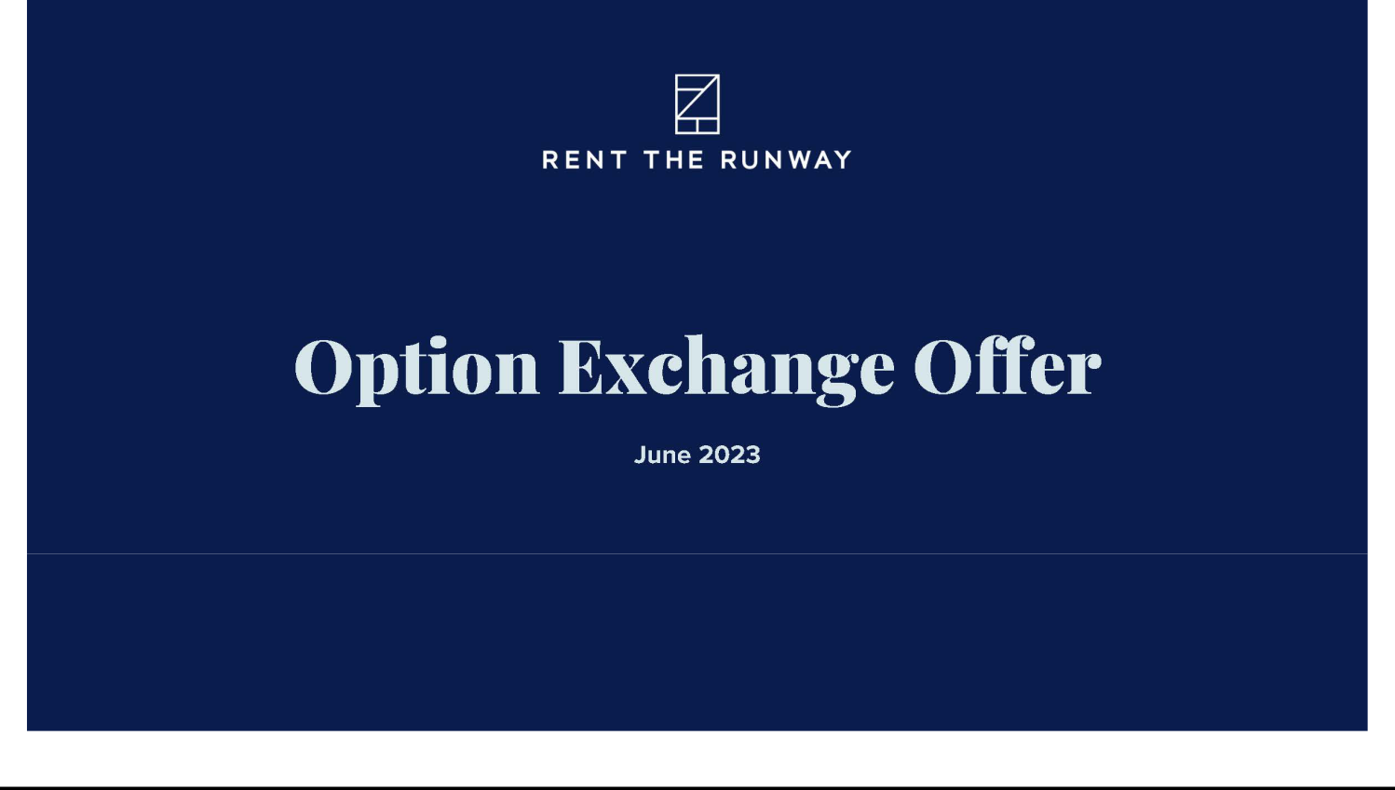

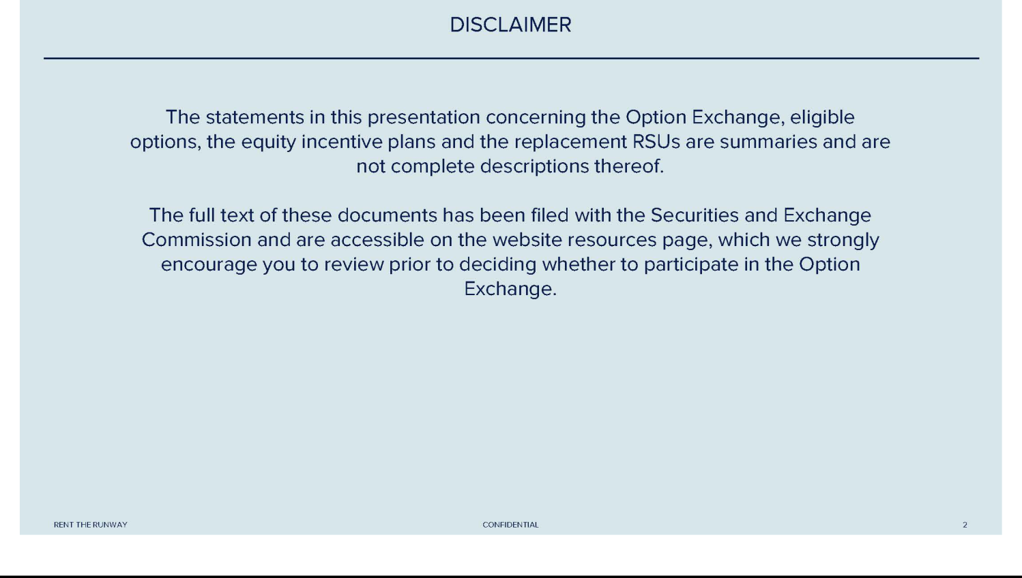

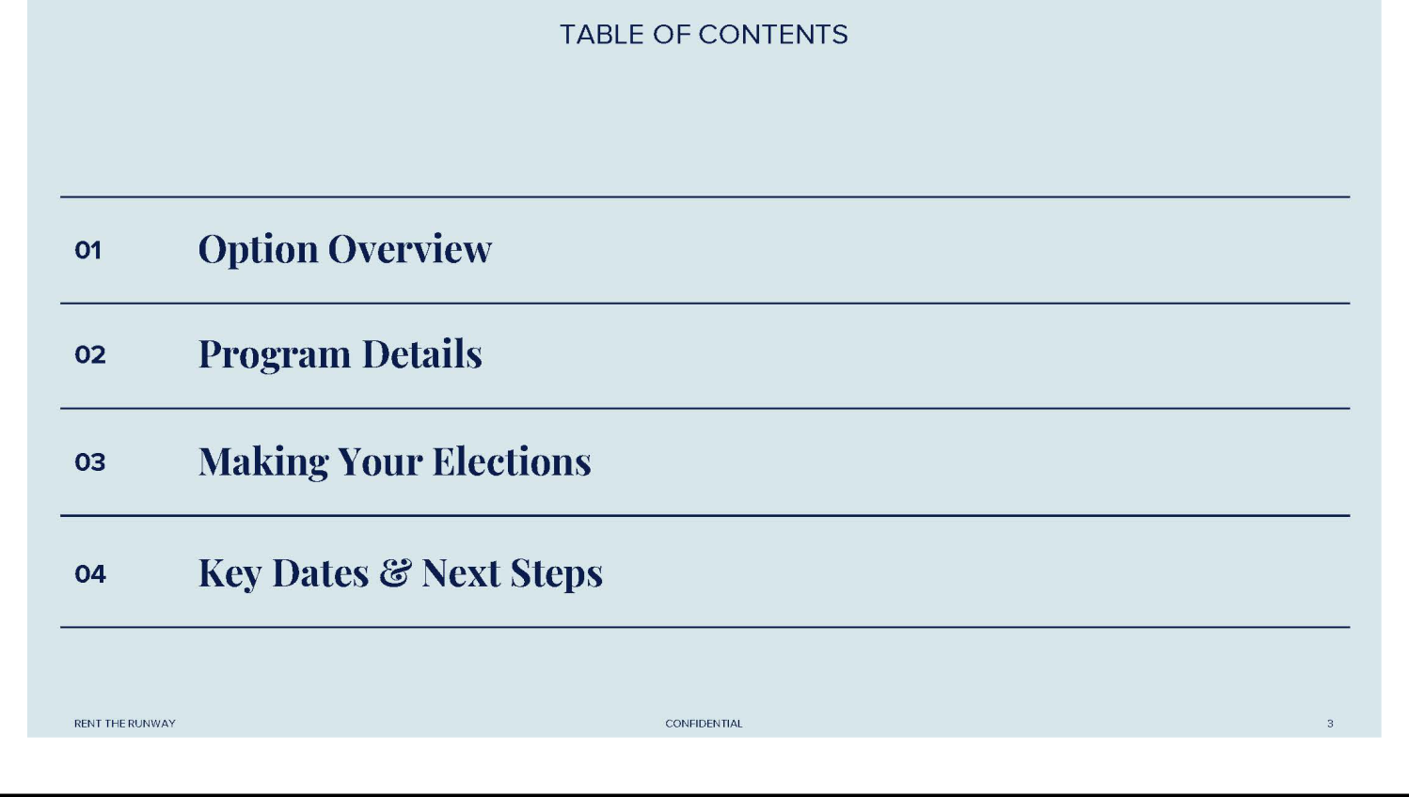



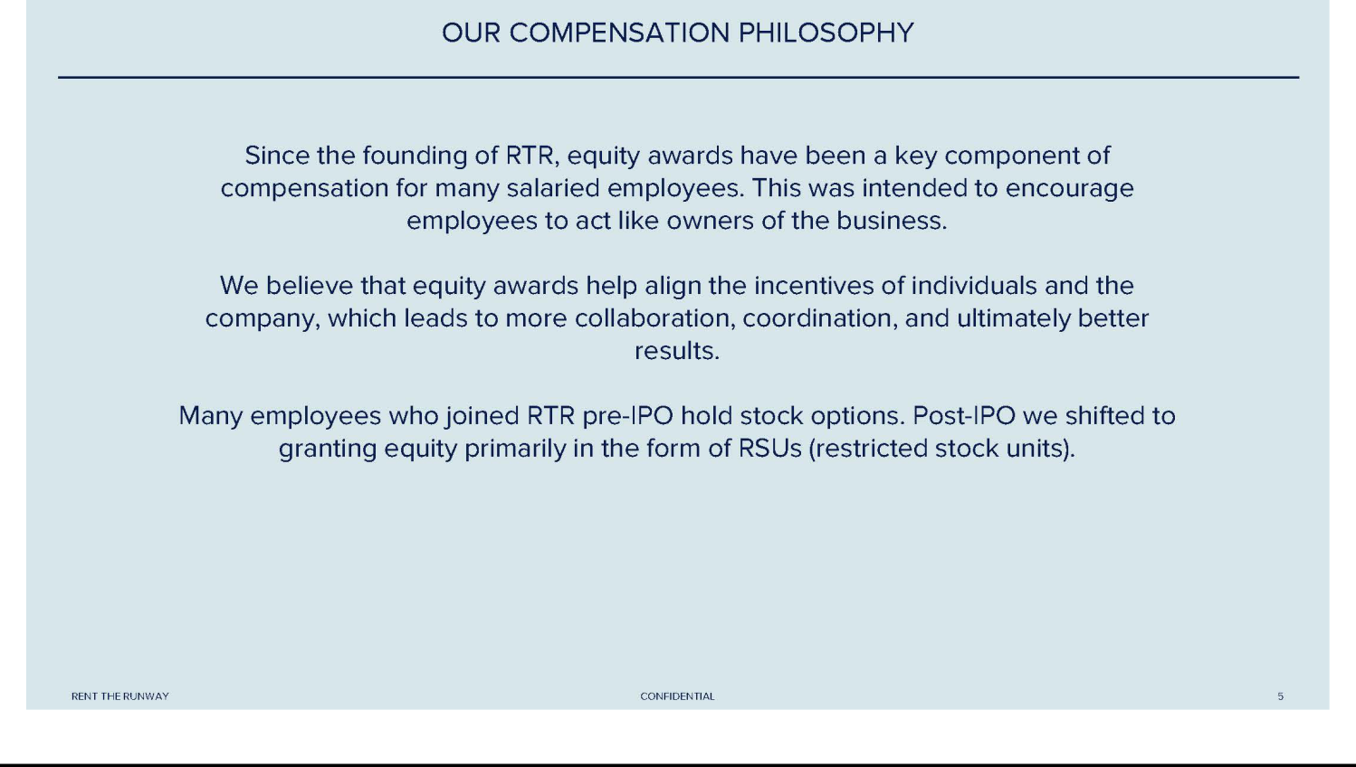

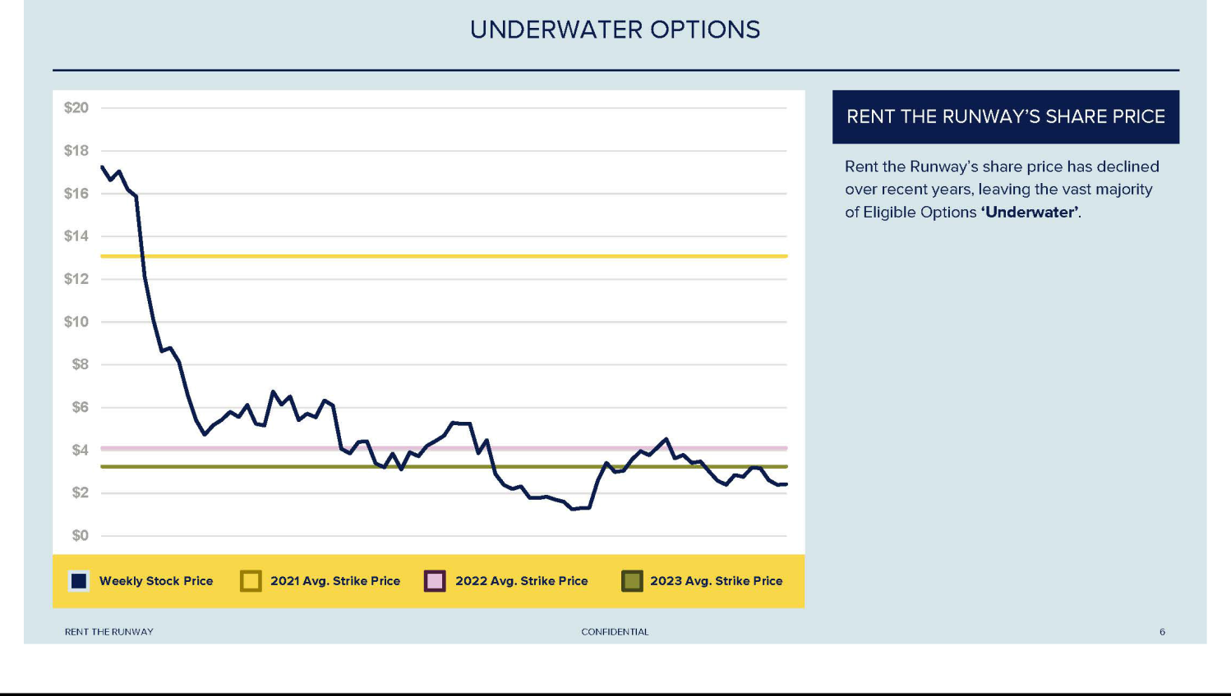

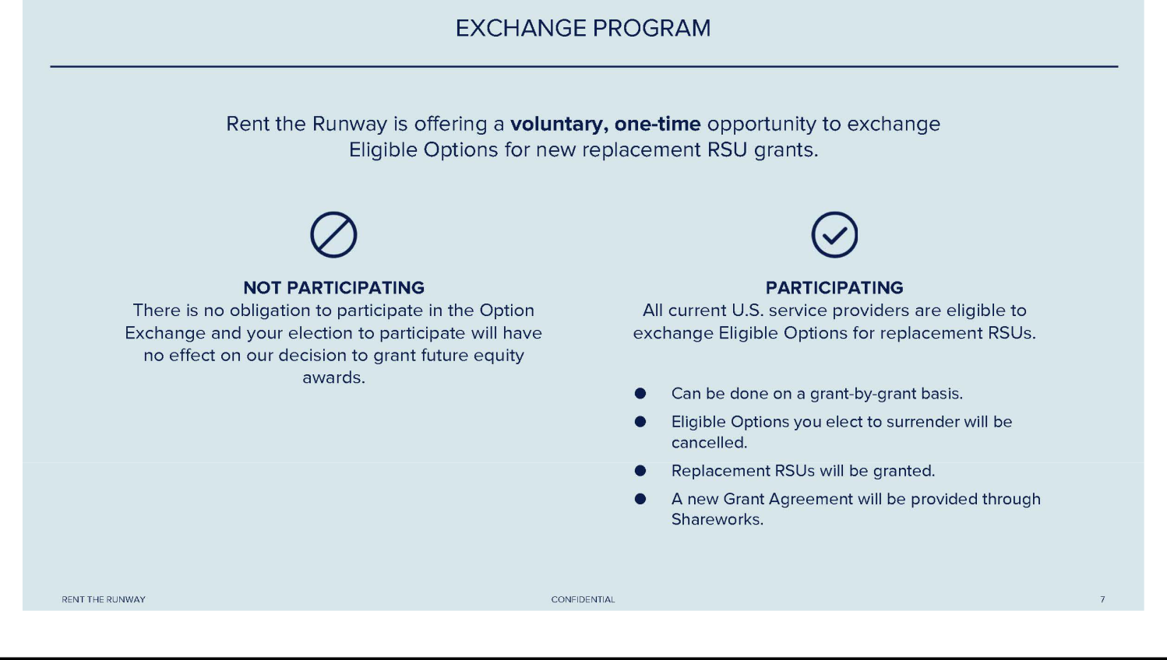



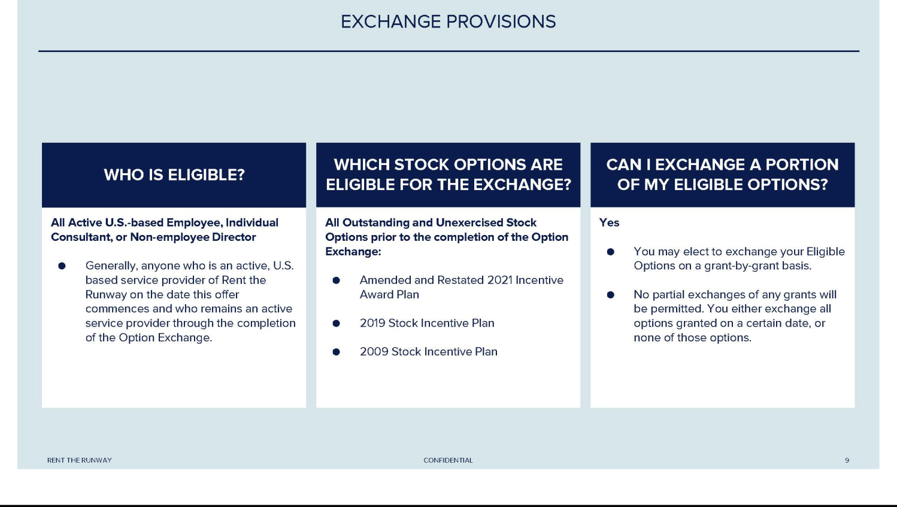

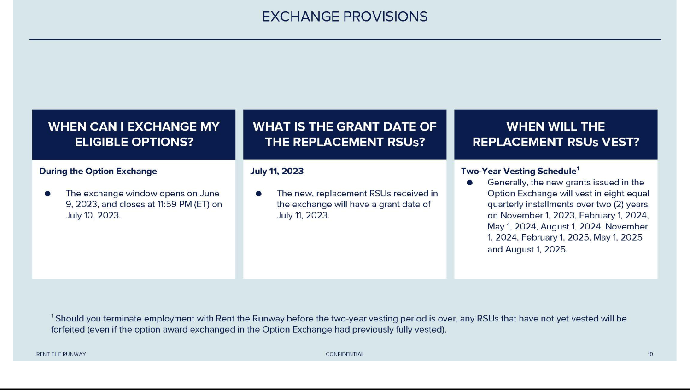

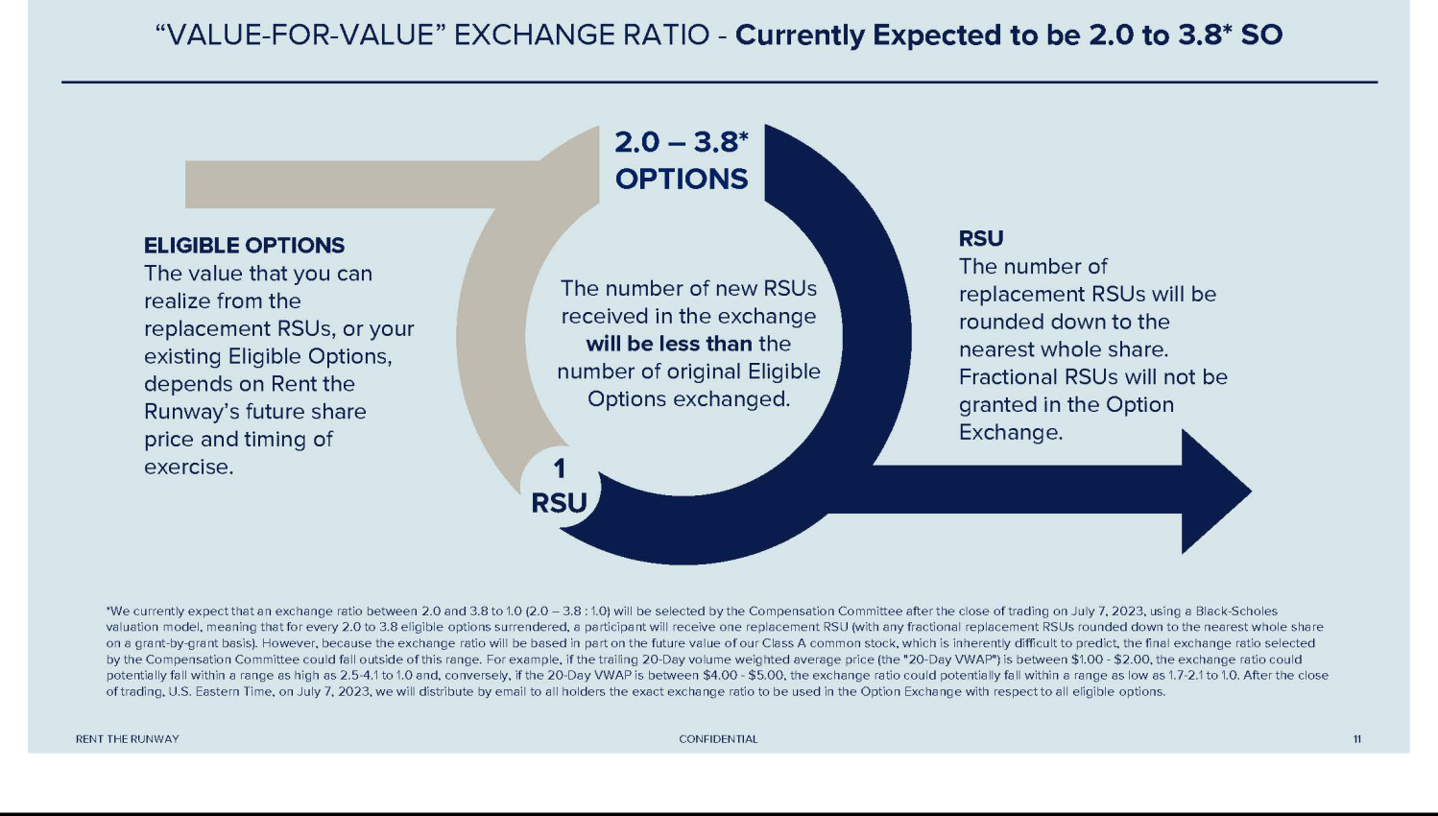

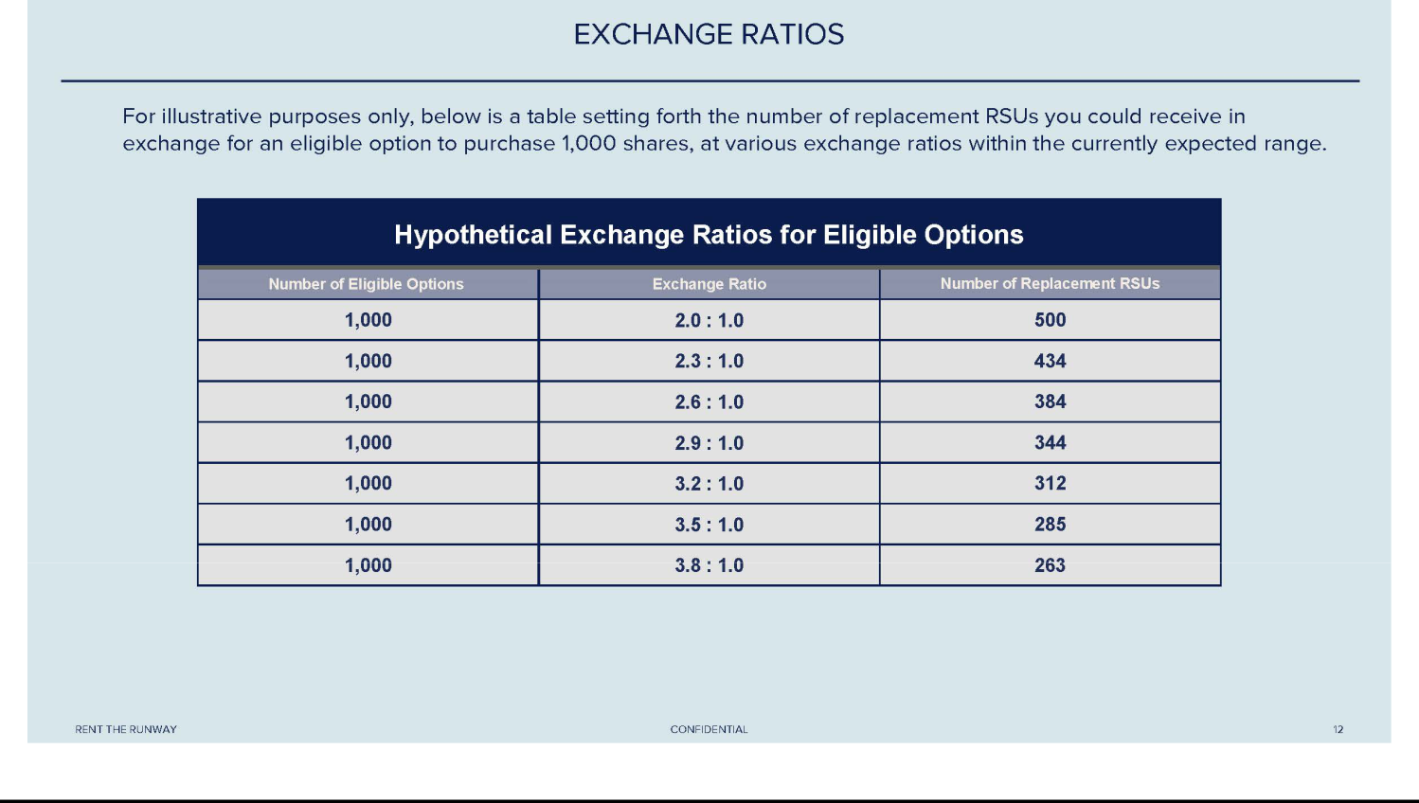

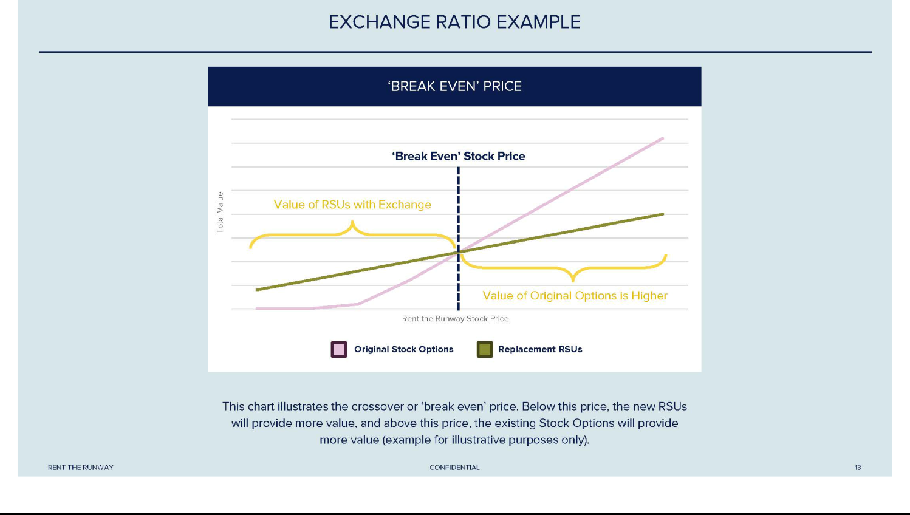

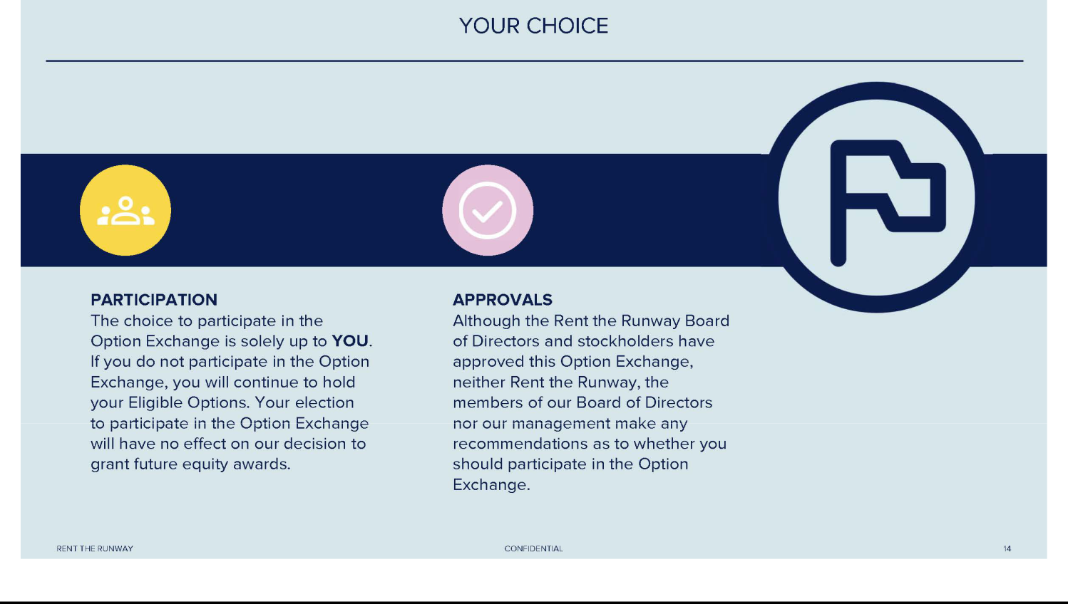

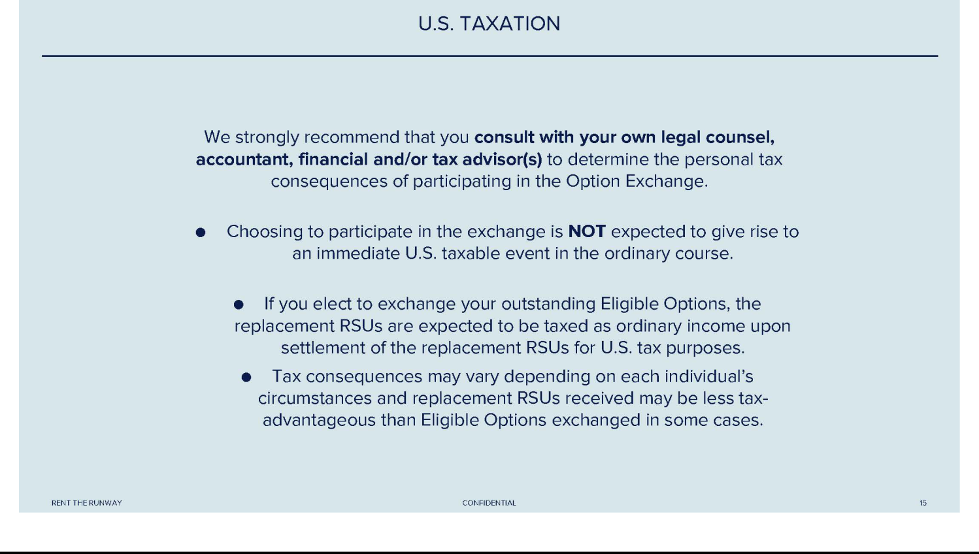

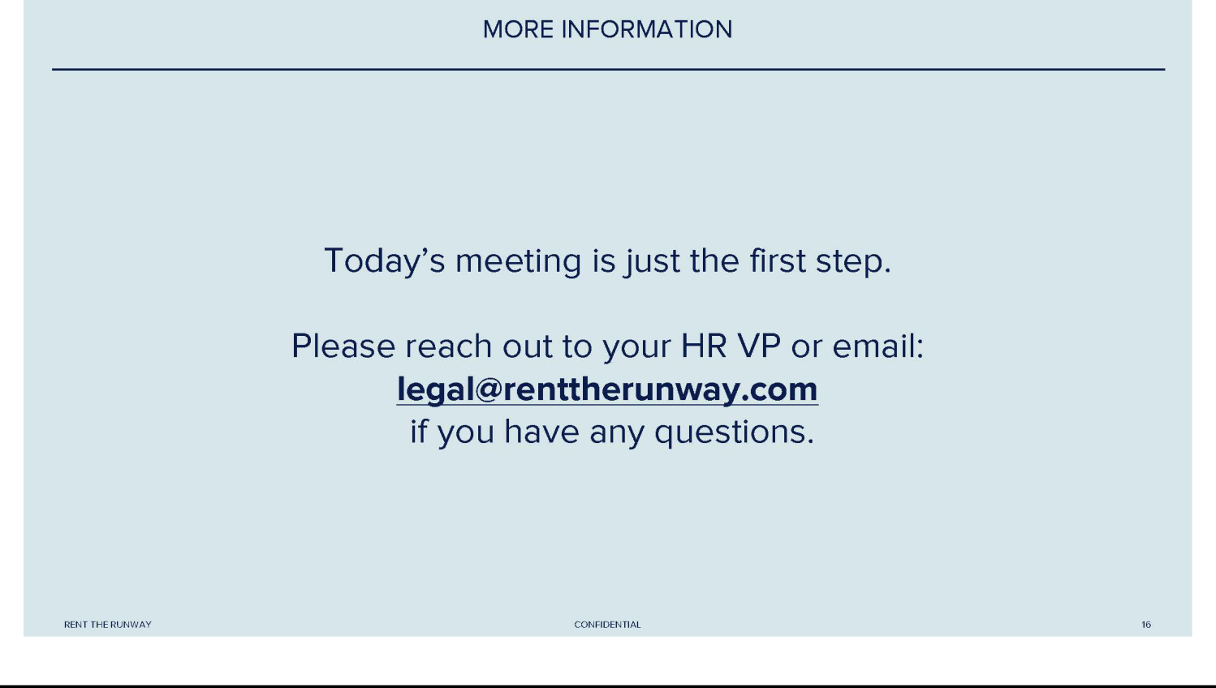



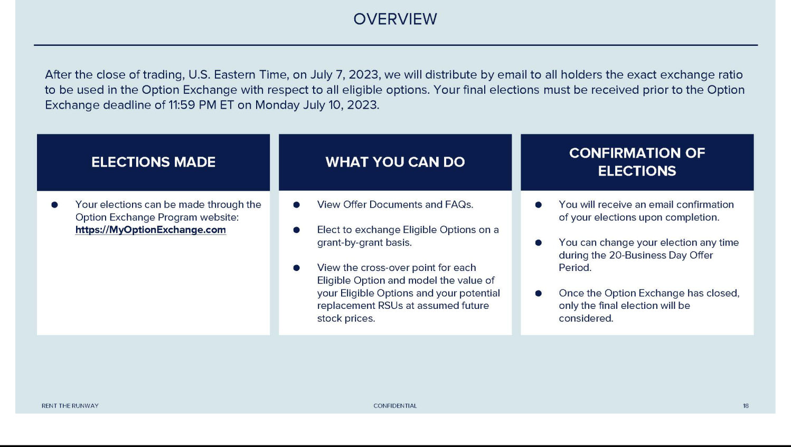

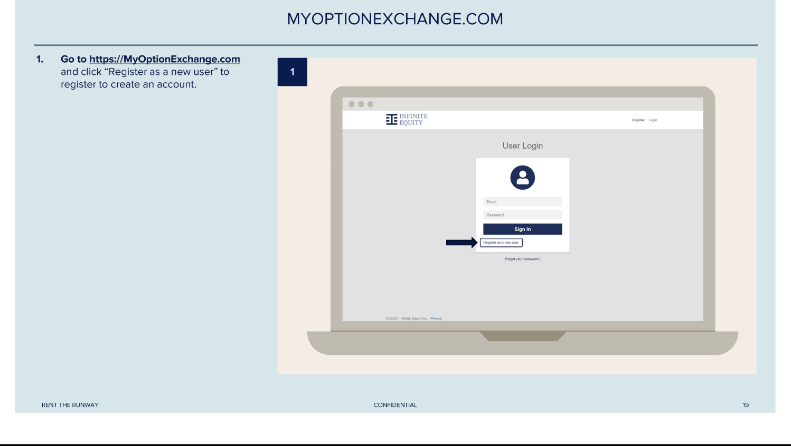

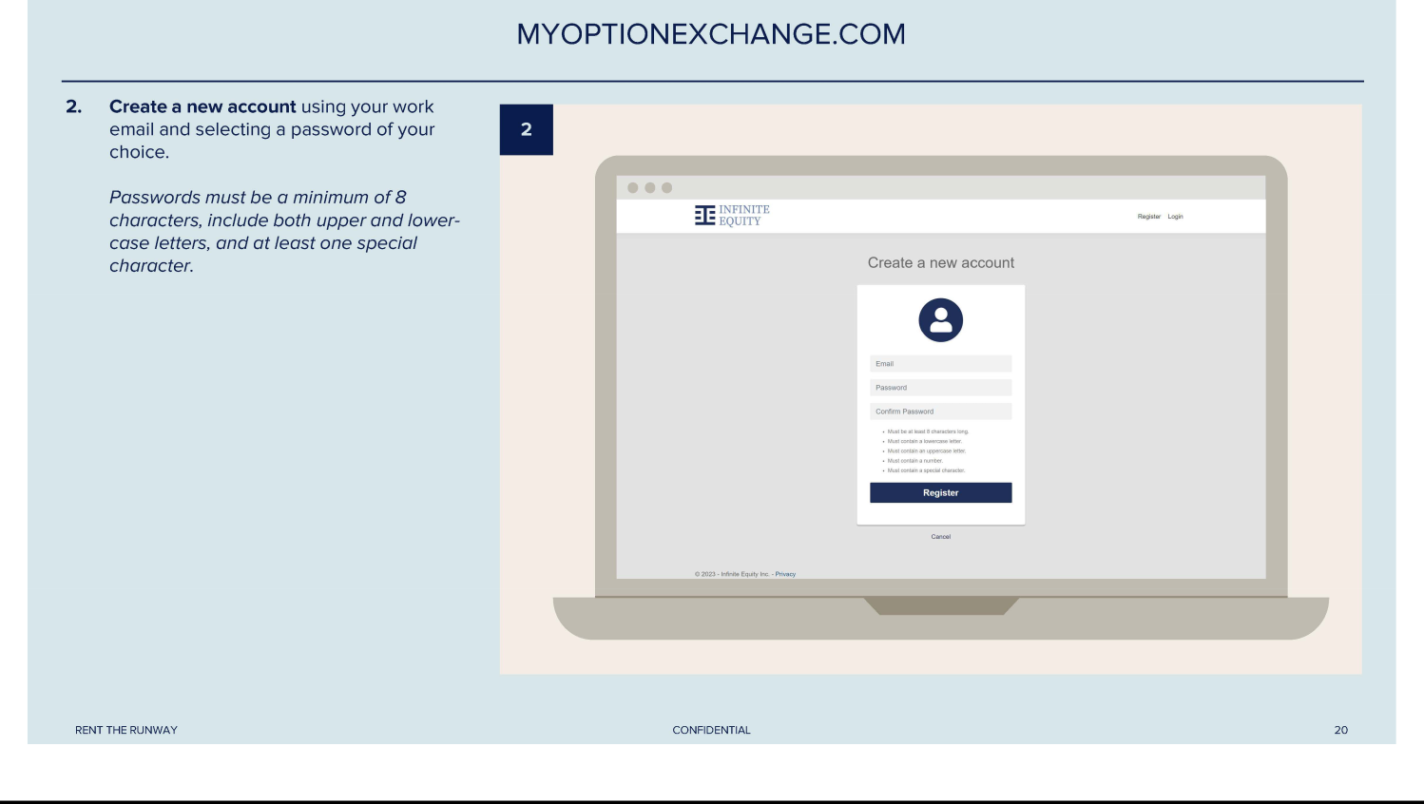

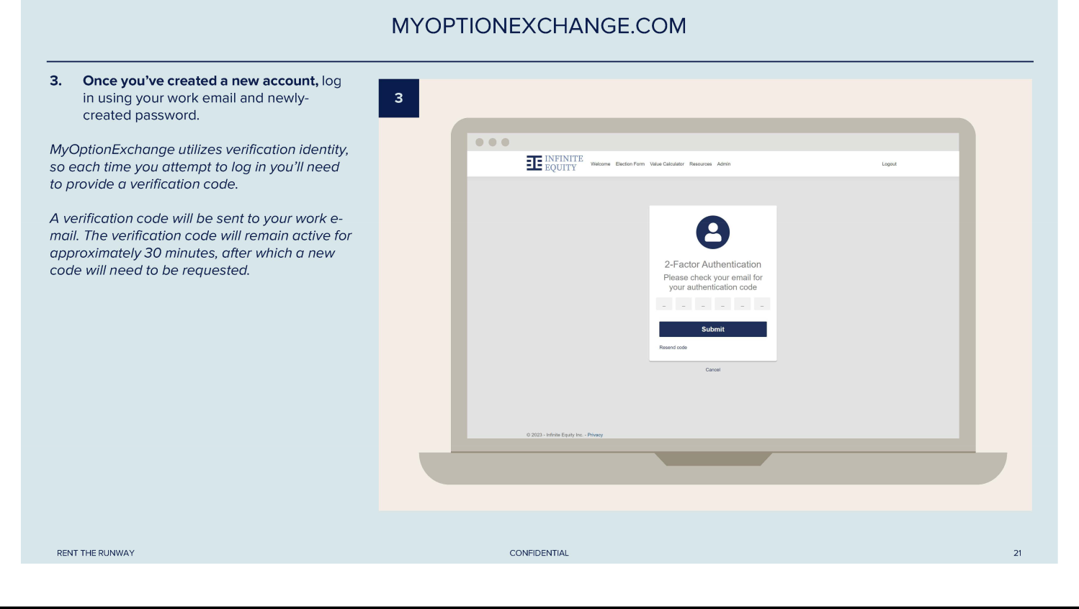

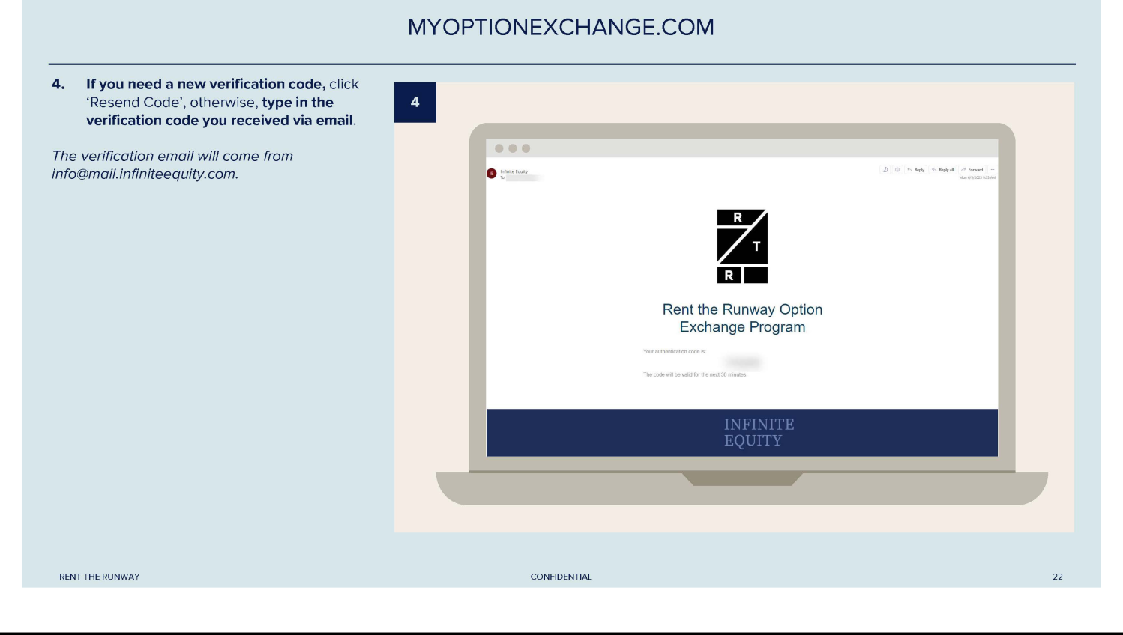

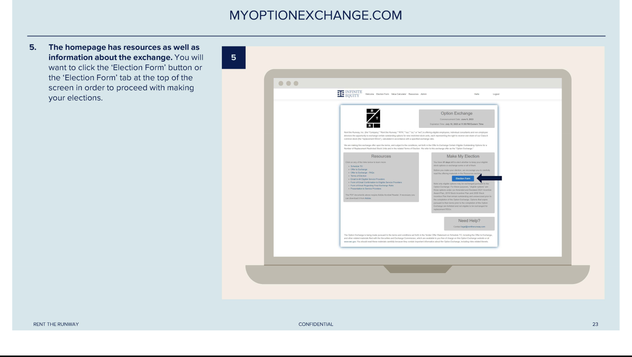

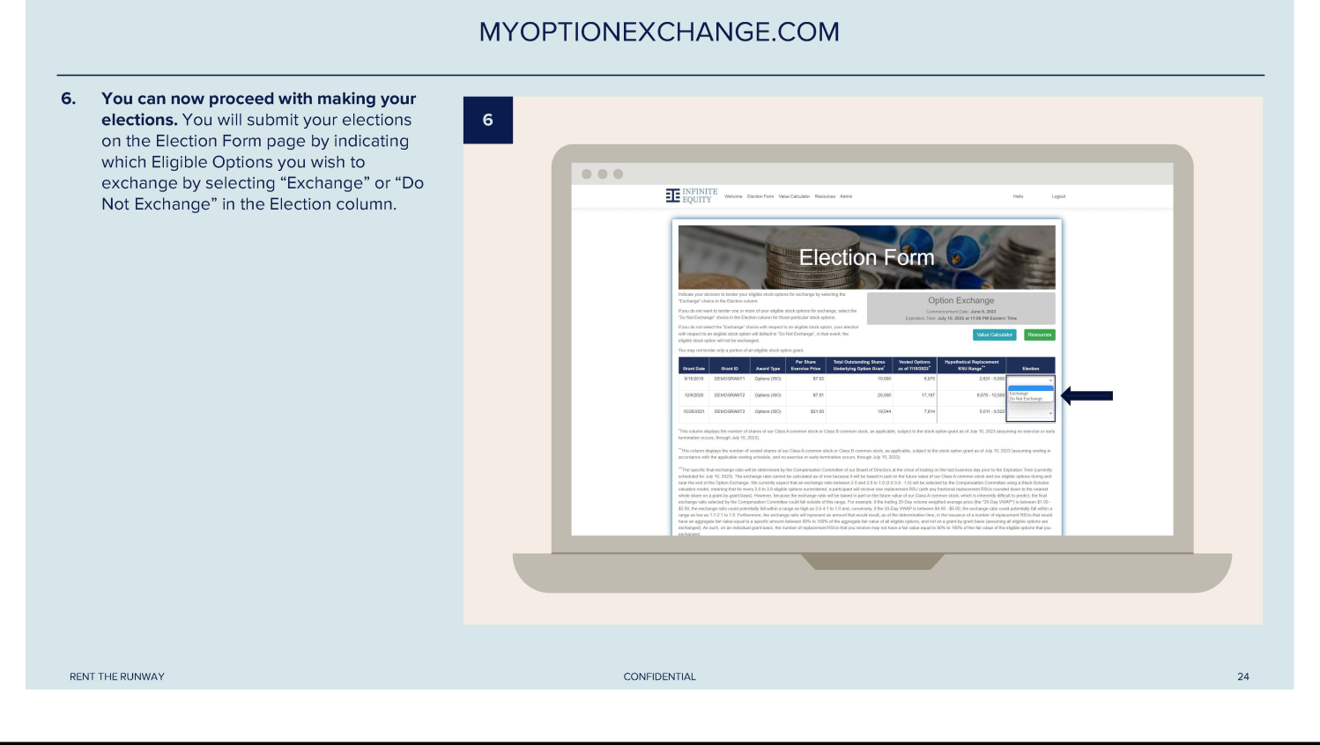

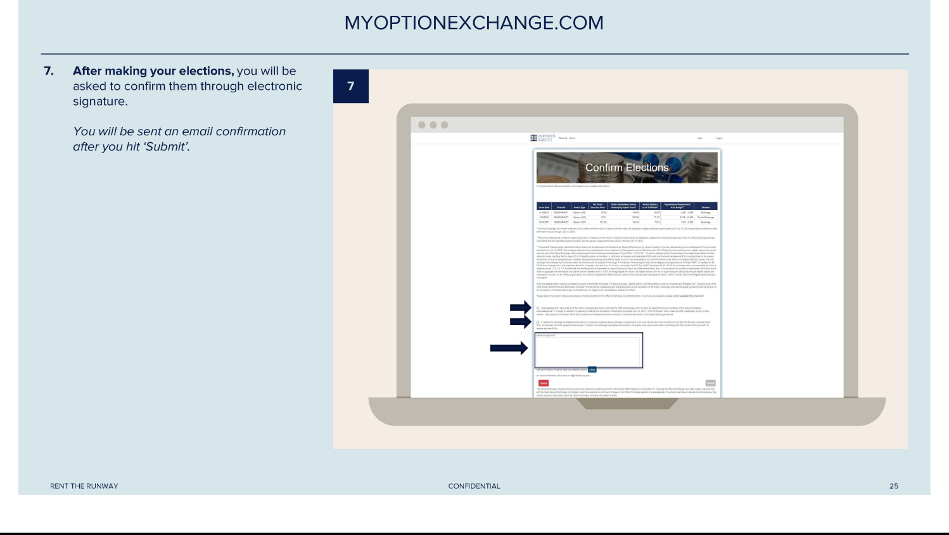

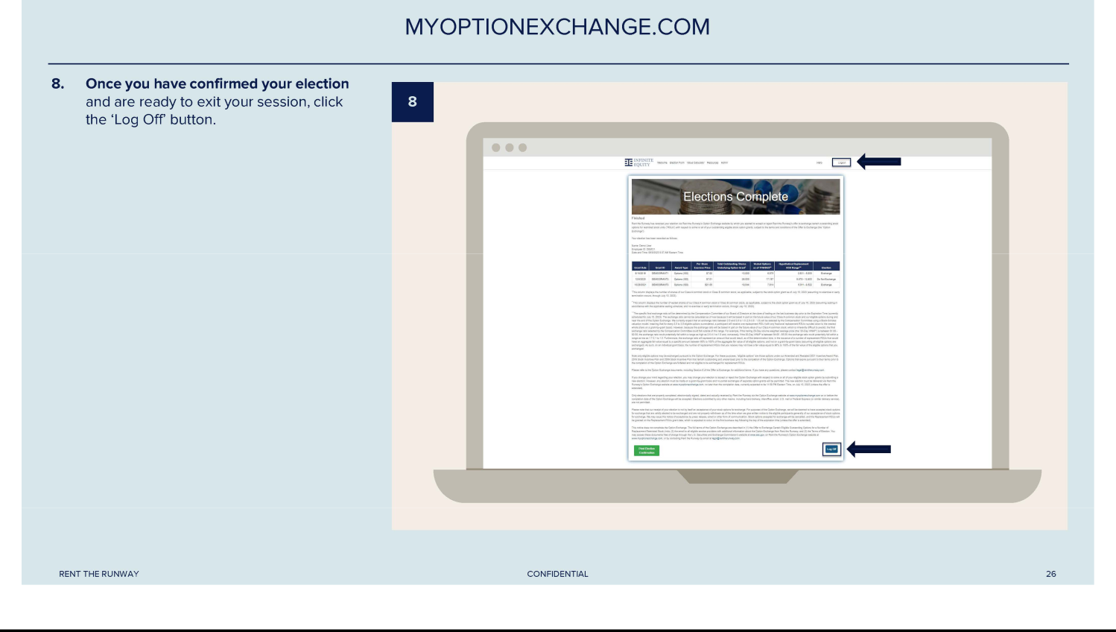

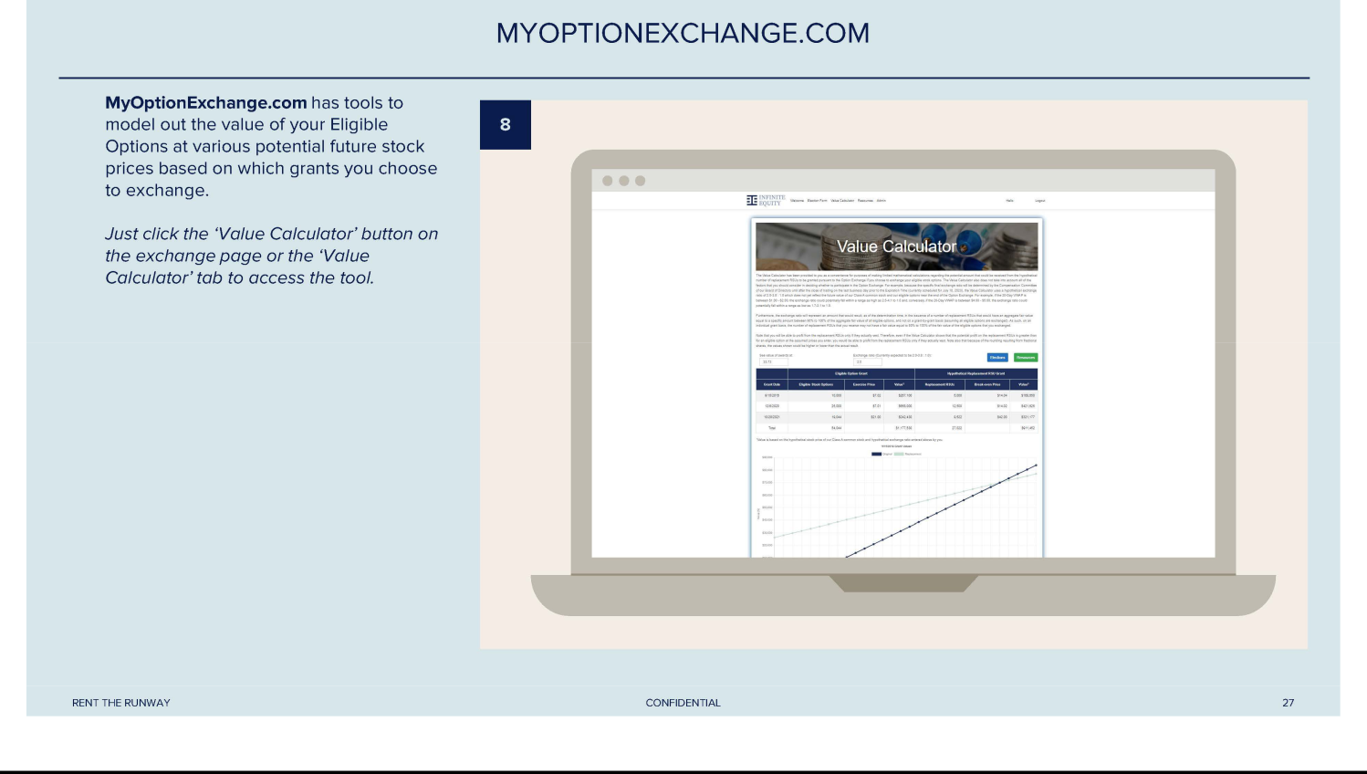



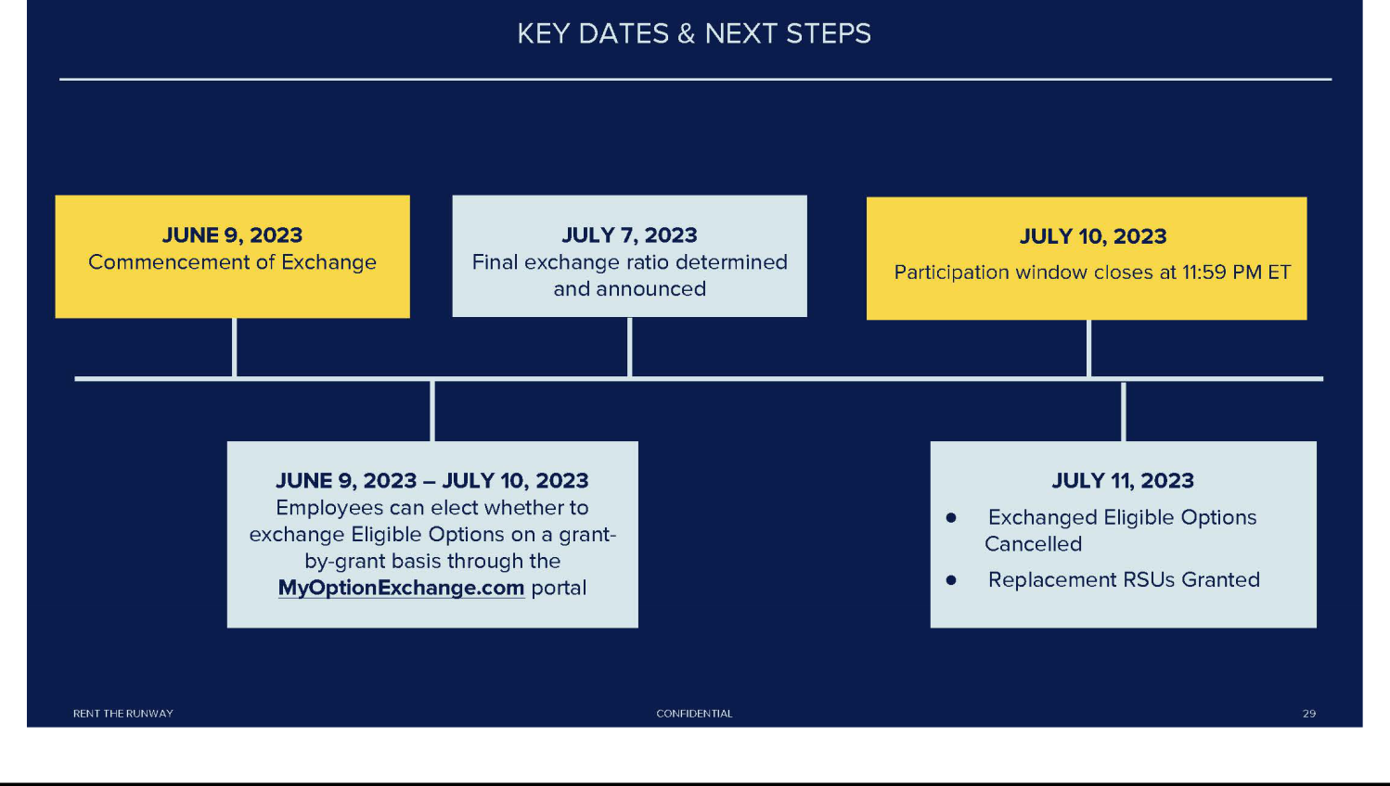

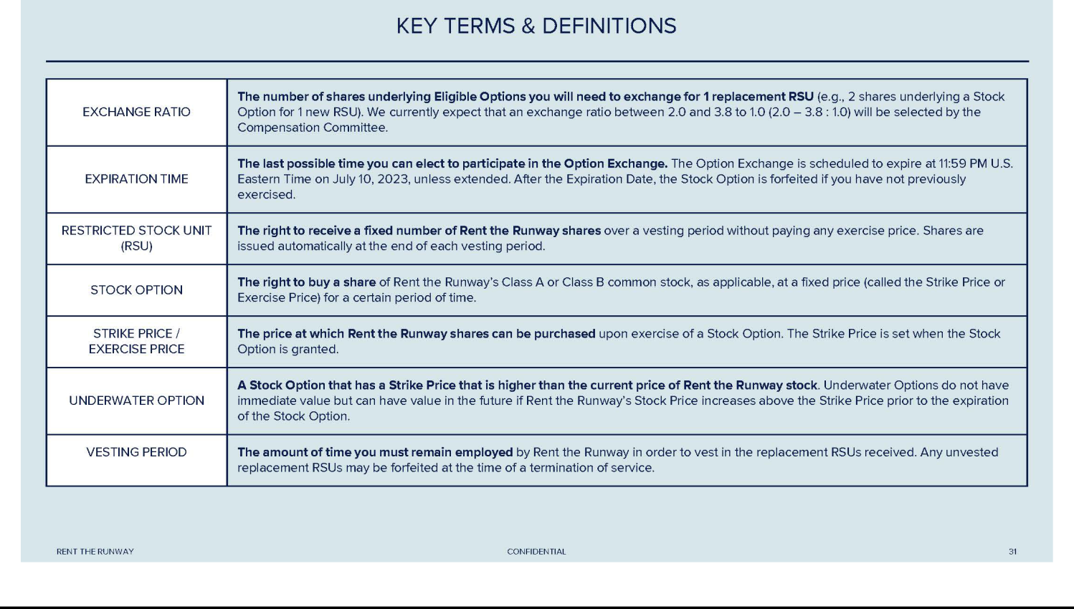

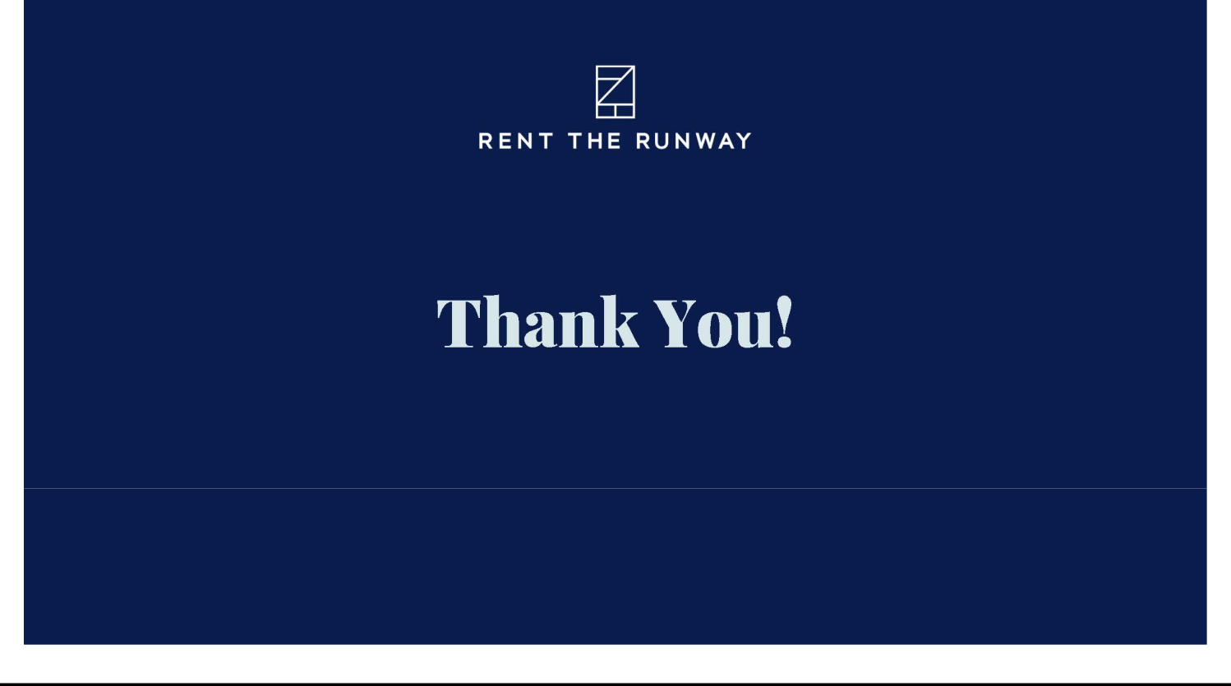

Exhibit (d)(4)

RENT THE RUNWAY, INC.

NOTICE OF RESTRICTED STOCK UNIT AWARD
2021 INCENTIVE AWARD PLAN

You have been granted restricted stock units representing shares of common stock of Rent the Runway, Inc. (the “Company”) on the following terms:

Name of Participant:

Total Number of Restricted Stock

###PARTICIPANT_NAME###

###TOTAL_AWARDS###

Units Granted:

Date of Grant:

Vesting Commencement Date:

Vesting Schedule:

###GRANT_DATE###

###ALTERNATIVE_VEST_BASE_DATE###

###VEST_SCHEDULE_DESCRIPTION###

These restricted stock units are granted under and governed by the terms and conditions of the Company’s 2021 Incentive Award Plan (the “Plan”) and the Restricted Stock Unit Agreement, both of which are incorporated into this document. You agree that you have reviewed the Plan, this Notice of Restricted Stock Unit Award and the Restricted Stock Unit Agreement, you have had an opportunity to obtain the advice of counsel prior to executing this Notice of Restricted Stock Unit Grant and that you understand the terms of the Plan, this Notice of Restricted Stock Unit Grant and the Restricted Stock Unit Agreement.

You agree to accept electronically all documents relating to the Plan or this restricted stock unit award.

You further agree to comply with the Company’s insider trading policy when selling shares of the Company’s common stock.

Withholding Taxes – Sell To Cover : By accepting this award electronically, you understand and agree that the grant of the restricted stock units pursuant to this Notice of Restricted Stock Unit Grant and the Restricted Stock Unit Agreement, explicitly includes the following (the “Sell to Cover ”): Upon the issuance of the resulting Shares from the vesting of the restricted stock units, the Company, on your behalf, will instruct the Agent (as defined in the Agreement) to (1) sell that number of Shares determined in accordance with the “Withholding Taxes” section of the Restricted Stock Unit Agreement as may be necessary to satisfy any applicable withholding obligations with respect to any taxable event arising in connection with the restricted stock units, and (2) to pay the cash proceeds of such sale(s) to the Company. The Company shall then make a cash payment equal to the required tax withholding from the cash proceeds of such sale(s) directly to the appropriate taxing authorities.

BY ACKNOWLEDGING AND ACCEPTING THIS NOTICE, THE RESTRICTED STOCK UNIT AGREEMENT AND THE PLAN, YOU AGREE TO THE TERMS AND CONDITIONS DESCRIBED IN THESE DOCUMENTS

 |  | RENT THE RUNWAY, INC.
 |  | 2021 INCENTIVE AWARD PLAN
 | RESTRICTED STOCK UNIT AGREEMENT
Grant of Units | Subject to all of the terms and conditions set forth in the Notice of Restricted Stock Unit Award, this Restricted Stock Unit
 | Agreement (the “Agreement”) and the Plan, the Company has granted to you the number of restricted stock units set forth in
 | the Notice of Restricted Stock Unit Award.
 | All capitalized terms used in this Agreement shall have the meanings assigned to them in this Agreement, the Notice of
 | Restricted Stock Unit Award or the Plan.
Payment for Units | No payment is required for the restricted stock units that you are receiving.
Vesting | The restricted stock units are eligible to vest in accordance with the vesting schedule set forth in the Notice of Restricted
 | Stock Unit Award.
 | No additional restricted stock units will vest after your Termination of Service for any reason, unless the Administrator
 | determines otherwise.
Forfeiture | In the event of your Termination of Service for any reason, your restricted stock units will be forfeited to the extent that they
 | have not vested before the date of your Termination of Service and do not vest as a result of your Termination of Service.
 | This means that any restricted stock units that have not vested under this Agreement will be cancelled immediately. You
 | receive no payment for restricted stock units that are forfeited. The Company determines when your Termination of Service
 | occurs for all purposes of your restricted stock units.
Settlement of Units | Each restricted stock unit will be settled in Shares as soon as administratively practicable after the vesting of the applicable
 | restricted stock unit, but no later than more than 60 days after the restricted stock unit’s vesting date. However, the
 | Company may delay any payment if it determines that such payment would violate applicable laws and, in such case,
 | payment will be delayed until the earliest date on which the Company determines that the payment would not cause a
 | violation of laws, provided that the Company reasonably believes that the delay will not result in an imposition of taxes
 | under Section 409A of the Internal Revenue Code (“Section 409A”).
 | At the time of settlement, you will receive one Share for each vested restricted stock unit.
 | No fractional Shares will be issued upon settlement.

Section 409A

Nature of Units / Limitation on Your Rights

Stockholder Rights

Transfer of Restricted Stock Units

The restricted stock units are not intended to constitute “nonqualified deferred compensation” within the meaning of Section 409A.

Further, if the Company determines that you are a “specified employee,” as defined in the regulations under Section 409A at the time of your “separation from service,” as defined in Treasury Regulation Section 1.409A-1(h) and it is determined that settlement of these restricted stock units is not exempt from Section 409A, then any restricted stock units that otherwise would have been settled during the first six months following your “separation from service” will instead be settled on the first business day following the earlier of (i) the six-month anniversary of your separation from service or (ii) your death. Each installment of restricted stock units is hereby designated as a separate payment for purposes of Section 409A.

Your restricted stock units are mere bookkeeping entries. They represent only the Company’s unfunded and unsecured promise to issue Shares with respect to your restricted stock units on a future date, and this Agreement may not be construed as creating a trust. As a holder of restricted stock units, you have no rights other than the rights of a general unsecured creditor of the Company. Neither the Plan nor any underlying program, in and of itself, has any assets.

You, or your estate heirs, have no rights as a stockholder of the Company unless and until your restricted stock units are settled in accordance with the terms of this Agreement by issuing you Shares.

You cannot transfer or assign the restricted stock units. For instance, you may not sell the restricted stock units or use it as security for a loan. If you attempt to do any of these things, the restricted stock units will immediately become invalid. You may, however, dispose of the restricted stock units in your will or by means of a written beneficiary designation; provided, however, that your beneficiary or a representative of your estate acknowledges and agrees in writing in a form reasonably acceptable to the Company, to be bound by the provisions of this Agreement and the Plan as if the beneficiary of the estate were you.

Withholding Taxes

As set forth in Section 9.5 of the Plan, the Company will have the authority and the right to deduct or withhold, or to require you to pay to the Company, an amount sufficient to satisfy all applicable federal, state and local taxes required by law to be withheld with respect to any taxable event arising in connection with the restricted stock units. Such applicable taxes shall be satisfied using a Sell to Cover pursuant to the Grant Notice. The Company will not be obligated to deliver any new certificate representing Shares to you or your legal representative or enter such Shares in book entry form unless you or your legal representative have paid or otherwise satisfied in full the amount of all federal, state and local taxes applicable to your the taxable income resulting from the grant or vesting of the restricted stock units or the issuance of Shares upon the settlement of the restricted stock units. By accepting this award of restricted stock units, you have agreed to a Sell to Cover to satisfy any applicable withholding taxes, as determined by the Company, and you hereby acknowledge and agree:

- You appoint the Company’s broker, transfer agent or stock plan administrator (together with any other party the Company determines necessary to execute the Sell to Cover, the “Agent”) as your agent and authorize the Agent to
  - sell on the open market at the then prevailing market price(s), on your behalf, as soon as practicable on or after the Shares are issued upon the vesting of the restricted stock units, that number (rounded up to the next whole number) of the Shares so issued necessary to generate proceeds to cover (x) any tax withholding obligations incurred with respect to such vesting or issuance and (y) all applicable fees and commissions due to, or required to be collected by, the Agent and (2) apply any remaining funds to your federal tax withholding or remit such remaining funds to you.

- You authorize the Company and the Agent to cooperate and communicate with one another to determine the number of Shares that must be sold pursuant to subsection (i) above.

- You understand that the Agent may conduct the sales as provided in subsection (i) above in one or more sales and that the average price for executions resulting from bunched orders will be assigned to your account. In addition, you acknowledge that it may not be possible to sell Shares as provided by subsection (i) above due to (1) a legal or contractual restriction applicable to the you or the Agent, (2) a market disruption, or (3) rules governing order execution priority on the national exchange where the Shares may be traded. You further agree and acknowledge that in the event the sale of Shares would result in material adverse harm to the Company, as determined by the Company in its sole discretion, the Company may instruct the Agent not to sell Shares as provided by subsection (i) above. In the event of the Agent’s inability to sell Shares, you will continue to be responsible for the timely payment to the Company and/or its affiliates of all federal, state, local and foreign taxes that are required by applicable laws and regulations to be withheld, including but not limited to those amounts specified in subsection (i) above.

- You acknowledge that regardless of any other term or condition of this section, the Agent will not be liable to you for (1) special, indirect, punitive, exemplary, or consequential damages, or incidental losses or damages of any kind, or (2) any failure to perform or for any delay in performance that results from a cause or circumstance that is beyond its reasonable control.

- You hereby agree to execute and deliver to the Agent any other agreements or documents as the Agent reasonably deems necessary or appropriate to carry out the purposes and intent of this section. The Agent is a third-party beneficiary of this section.

- This section will terminate not later than the date on which all tax withholding obligations arising in connection with the vesting or settlement of the restricted stock units have been satisfied.

 | No stock certificates (or their electronic equivalent) will be distributed to you unless you have paid any withholding taxes
 | that are due as a result of the vesting or settlement of the restricted stock units.
 | If you fail to make timely payment of withholding taxes in connection with the settlement of the restricted stock units, the
 | Company has the right to satisfy all or any portion of the withholding taxes by withholding Shares otherwise issuable upon
 | settlement of the restricted stock units.
Restrictions on Resale | You agree not to sell any Shares issued upon settlement of the restricted stock units at a time when applicable laws,
 | Company policies or an agreement between the Company and its underwriters prohibit a sale. This restriction will apply as
 | long as your service with the Company or a Subsidiary continues and for a period of time after your Termination of Service
 | as may be specified by the Company.
Retention Rights | Your award of restricted stock units or this Agreement does not give you the right to be retained by the Company, or any
 | parent or Subsidiary of the Company, in any capacity. The Company and its parents and Subsidiaries reserve the right to
 | terminate your service at any time, with or without cause.
Adjustments | Upon the occurrence of certain events as provided in Article VIII of the Plan, the number of restricted stock units covered by
 | this award will be adjusted, modified or terminated pursuant to the Plan.
Effect of Significant | If the Company is a party to a merger, consolidation, or certain change in control transactions, then your restricted stock
Corporate Transactions | units will be subject to the applicable provisions of Article VIII of the Plan.
Recoupment Policy | This award, and the Shares acquired upon settlement of this award, shall be subject to any Company recoupment or
 | clawback policy in effect from time to time, as further provided in Section 10.13 of the Plan.
Applicable Law | This Agreement will be interpreted and enforced under the laws of the State of Delaware (without regard to its choice-of-
 | law provisions).

The Plan and Other | The text of the Plan is incorporated in this Agreement by reference.
Agreements | This Plan, this Agreement and the Notice of Restricted Stock Unit Award constitute the entire understanding between you
 | and the Company regarding these restricted stock units. Any prior agreements, commitments or negotiations concerning
 | these restricted stock units are superseded. To the extent permitted by the Plan, this Agreement may be amended or
 | otherwise suspended or terminated at any time by the Administrator or the Board; provided, that no amendment, suspension
 | or modification may adversely affect the restricted stock units in any material respect without the prior written consent of
 | the Participant. In the event that any provision of the Notice of Restricted Stock Unit Award or this Agreement is held
 | invalid or unenforceable, then the applicable provision will be severable from, and any invalidity or unenforceability will
 | not be construed to have any effect on, the remaining provisions of the Notice of Restricted Stock Unit Award or this
 | Agreement.
 | By Acknowledging and Accepting this Agreement, you agree to all of the
 | terms and conditions described above and in the Plan.

Exhibit 107

Calculation of Filing Fee Tables

FORM SC TO

(Form Type)

RENT THE RUNWAY, INC.

(Exact Name of Registrant as Specified in its Charter)

Table 1 – Transaction Valuation

 |  | Transaction |  |  |  |  | Amount of
 |  | Valuation |  | Fee Rate |  |  | Filing Fee
Fees to Be Paid | $ | 16,644,412.80⁽¹⁾ |  | 0.01102%⁽²⁾ |  | $ | 1,834.21⁽²⁾
Fees Previously Paid |  | — |  |  |  |  | —
Total Transaction Valuation | $ | 16,644,412.80 | (1)
Total Fees Due for Filing |  |  |  |  |  | $ | 1,834.21⁽²⁾
Total Fees Previously Paid |  |  |  |  |  |  | —
Total Fee Offsets |  |  |  |  |  |  | —
Net Fee Due |  |  |  |  |  | $ | 1,834.21⁽²⁾

- Calculated solely for purposes of determining the filing fee. The calculation of the Transaction Valuation assumes that all outstanding options to purchase shares of the Issuer’s Class A common stock and Class B common stock, as applicable, that may be eligible for exchange in the offer will be exchanged pursuant to the offer. This calculation assumes options to purchase an aggregate of 3,878,155 shares of the Issuer's Class A common stock and 3,057,017 shares of the Issuer’s Class B common stock, having an aggregate value of $16,644,412.80 based on the average high and low prices of our Class A common stock on June 8, 2023.

- The amount of the filing fee, calculated in accordance with Rule 0-11(b) of the Securities Exchange Act of 1934, as amended, equals $110.20 per $1,000,000 of the aggregate amount of the Transaction Valuation. The Transaction Valuation set forth above was calculated for the sole purpose of determining the filing fee and should not be used for any other purpose.

