SEC Form 3
FORM 3 | UNITED STATES SECURITIES AND EXCHANGE COMMISSION
 | Washington, D.C. 20549
 | Washington, D.C. 20549 |  | OMB APPROVAL
 | INITIAL STATEMENT OF BENEFICIAL OWNERSHIP OF SECURITIES
 | INITIAL STATEMENT OF BENEFICIAL OWNERSHIP OF SECURITIES |  | OMB Number: | 3235-0104
 |  |  | Estimated average burden
 | Filed pursuant to Section 16(a) of the Securities Exchange Act of 1934 |  | hours per response: | 0.5
or Section 30(h) of the Investment Company Act of 1940
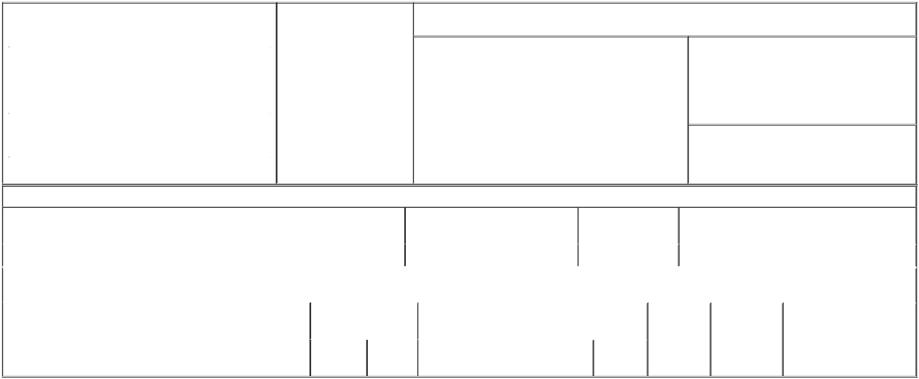

1. Name and Address of Reporting Person* |  |  |  |  |  | 2. Date of Event Requiring
 |  | Thacker Siddharth |  |  |  | Statement (Month/Day/Year)
 |  |  |  |  | 05/25/2023
 |  | (Last) | (First) |  | (Middle)
 |  | C/O RENT THE RUNWAY, INC.
 |  | 10 JAY STREET
(Street)
 |  | BROOKLYN | NY |  | 11201
 |  | (City) | (State) |  | (Zip)

3. Issuer Name and Ticker or Trading Symbol

Rent the Runway, Inc. [ RENT ]

4. Relationship of Reporting Person(s) to Issuer |  |  | 5. If Amendment, Date of Original Filed (Month/Day/Year)
(Check all applicable)
 | Director | 10% Owner
X | Officer (give title | Other (specify below)
below)

Chief Financial Officer

6. Individual or Joint/Group Filing (Check Applicable Line)

X Form filed by One Reporting Person

Form filed by More than One Reporting Person

Table I - Non-Derivative Securities Beneficially Owned

1. Title of Security (Instr. 4) | 2. Amount of Securities Beneficially | 3. Ownership Form: | 4. Nature of Indirect Beneficial Ownership (Instr. 5)
 | Owned (Instr. 4) | Direct (D) or Indirect
 |  | (I) (Instr. 5)

 | Class A Common Stock |  |  |  | 768,750⁽¹⁾ | D
 |  |  | Table II - Derivative Securities Beneficially Owned
 |  | (e.g., puts, calls, warrants, options, convertible securities)
 | 1. Title of Derivative Security (Instr. 4) |  | 2. Date Exercisable and |  | 3. Title and Amount of Securities Underlying |  | 4. | 5. Ownership | 6. Nature of Indirect Beneficial
 |  |  | Expiration Date |  | Derivative Security (Instr. 4) |  | Conversion | Form: Direct | Ownership (Instr. 5)
 |  |  | (Month/Day/Year) |  |  |  | or Exercise | (D) or Indirect
 |  |  |  |  |  |  | Price of | (I) (Instr. 5)
 |  |  |  |  |  | Amount or | Price of | (I) (Instr. 5)
 |  |  | Date | Expiration |  | Amount or | Derivative
 |  |  | Date | Expiration | Title | Number of | Security
 |  |  | Exercisable | Date | Title | Shares

Explanation of Responses:

- Includes 768,750 restricted stock units ("RSUs"). Consists of an award of 300,000 RSUs that vests as to 75,000 RSUs on August 1, 2023 and the remainder in 12 approximately equal installments on each quarterly anniversary of August 1, 2023, 43,750 RSUs that vest in 7 approximately equal installments on each quarterly anniversary of May 1, 2023, and an award of 425,000 RSUs that will vest in 12 approximately equal installments on each quarterly anniversary of March 15, 2023, in each case subject to the Reporting Person's continued employment with the Issuer. Each RSU represents a contingent right to receive one share of the Issuer's Class A Common Stock.

Remarks:

Exhibit 24.1 - Power of Attorney

/s/ Cara Schembri as Attorney in-fact

for Siddharth Thacker

** Signature of Reporting Person

Reminder: Report on a separate line for each class of securities beneficially owned directly or indirectly.

* If the form is filed by more than one reporting person, see Instruction 5 (b)(v).

- Intentional misstatements or omissions of facts constitute Federal Criminal Violations See 18 U.S.C. 1001 and 15 U.S.C. 78ff(a). Note: File three copies of this Form, one of which must be manually signed. If space is insufficient, see Instruction 6 for procedure.
Persons who respond to the collection of information contained in this form are not required to respond unless the form displays a currently valid OMB Number.

05/03/2023

Date



