UNITED STATES

SECURITIES AND EXCHANGE COMMISSION
Washington, D.C. 20549

FORM 8-K

CURRENT REPORT

Pursuant to Section 13 or 15(d) of the
Securities Exchange Act of 1934

Date of Report (Date of earliest event reported): April 11, 2023

Rent the Runway, Inc.

(Exact name of registrant as specified in its charter)

Delaware | 001-40958 |  |  | 80-0376379
(State or other jurisdiction |  | (Commission |  | (IRS Employer
of incorporation) |  | File Number) |  | Identification Number)
 |  | Rent the Runway, Inc.
 |  | 10 Jay Street
 |  | Brooklyn, New York 11201
 |  | (Address of principal executive offices, including Zip Code)
 | Registrant’s telephone number, including area code: (212) 524-6860

Check the appropriate box below if the Form 8-K filing is intended to simultaneously satisfy the filing obligation of the registrant under any of the following provisions:

- Written communications pursuant to Rule 425 under the Securities Act (17 CFR 230.425)

- Soliciting material pursuant to Rule 14a-12 under the Exchange Act (17 CFR 240.14a-12)

- Pre-commencement communications pursuant to Rule 14d-2(b) under the Exchange Act (17 CFR 240.14d-2(b))

- Pre-commencement communications pursuant to Rule 13e-4(c) under the Exchange Act (17 CFR 240.13e-4(c))

Securities registered pursuant to Section 12(b) of the Act:

 |  | Trading
Title of each class |  | Symbol(s) |  | Name of each exchange on which registered
Class A common stock, $0.001 par value per share |  | RENT |  | The Nasdaq Global Select Market

Indicate by check mark whether the registrant is an emerging growth company as defined in Rule 405 of the Securities Act of 1933 (§230.405 of this chapter) or Rule 12b-2 of the Securities Exchange Act of 1934 (§240.12b-2 of this chapter).

Emerging growth company ☒

If an emerging growth company, indicate by check mark if the registrant has elected not to use the extended transition period for complying with any new or revised financial accounting standards provided pursuant to Section 13(a) of the Exchange Act. ☐

Item 2.02 Results of Operations and Financial Condition.

On April 12, 2023, Rent the Runway, Inc. (the “Company”) issued a press release announcing its financial results for the quarter and year ended January 31, 2023. A copy of the press release is furnished as Exhibit 99.1 to this Form 8-K and is incorporated by reference.

Information in Exhibit 99.1 of this Form 8-K shall not be deemed “filed” for the purposes of Section 18 of the Securities Exchange Act of 1934, as amended (the “Exchange Act”), or otherwise incorporated by reference into any filing pursuant to the Securities Act of 1933, as amended, or the Exchange Act, except as otherwise expressly stated in such filing.

Item 5.02 Departure of Directors or Certain Officers; Election of Directors; Appointment of Certain Officers; Compensatory Arrangements of Certain Officers.

On April 11, 2023, Scarlett O’Sullivan resigned as the Company’s Chief Financial Officer, effective May 25, 2023 (the “Transition Date”). On April 11, 2023, in connection with Ms. O’Sullivan’s resignation, the Company’s Board of Directors appointed Siddharth Thacker as the Company’s new Chief Financial Officer, effective on the Transition Date. Mr. Thacker will succeed Ms. O’Sullivan as the principal financial officer and principal accounting officer as of the Transition Date.

Mr. Thacker, age 46, previously served as the Company’s Senior Vice President, FP&A since July 2022. From January 2020 to March 2022, Mr. Thacker served as an Investment Partner at Coalition Investment Partners, an alternative asset manager. From June 2018 to January 2020, Mr. Thacker served as CEO of SAR Capital Advisors, LP, an investment advisory firm, and from August 2011 to December 2017, he served as Founder, CEO and CIO of Signpost Capital Advisors, LP, an investment advisory firm. Mr. Thacker holds a BA from Oberlin College and an MBA from Harvard Business School.

In connection with his appointment, the Company has entered into an offer letter amendment with Mr. Thacker, dated April 11, 2023 (the “Thacker Agreement”). The Thacker Agreement provides that, effective as of April 15, 2023, Mr. Thacker’s annual base salary will be increased from $350,000 to $475,000; he shall be eligible to participate in the fiscal year 2023 executive bonus program with a target bonus opportunity of 38% of his base salary; and notwithstanding anything to the contrary in the Company’s Amended and Restated Executive Severance Plan (the “Severance Plan”) or his previous participation letter, Mr. Thacker shall be eligible to participate in the Severance Plan at the level of “Executive Officer Group” for purposes of any severance benefits payable thereunder.

In addition, the Company’s Compensation Committee determined to grant Mr. Thacker an award of 425,000 restricted stock units (“RSUs”) in connection with his promotion, which will be effective immediately following the effectiveness of the Company’s next Form S-8 Registration Statement. The RSUs will vest as to 1/12 of the underlying shares on each quarterly anniversary of March 15, 2023 such that the RSUs will be fully vested on March 15, 2026, subject to his continued service through the applicable vesting dates.

In addition, in connection with Ms. O’Sullivan’s transition, the Company has entered into a Transition Agreement with Ms. O’Sullivan, dated April 11, 2023 (the “Transition Agreement”). The Transition Agreement provides that, following her resignation as Chief Financial Officer on the Transition Date, Ms. O’Sullivan will serve as a consultant advisor to the Company through August 25, 2023 (or such later date as may be mutually agreed to by the Company and Ms. O’Sullivan) (such period, the “Advisory Period”). As consideration for her provision of advisory services through the end of the Advisory Period, her execution and non-revocation of a release of claims and continued compliance with any applicable restrictive covenant obligations, Ms. O’Sullivan will be entitled to:

- continued base salary payments for twelve months following the Transition Date, payable in accordance with the Company’s regular payroll practices, (ii) her annual bonus for fiscal year 2023, determined based on actual performance achievement and prorated for the portion of the fiscal year Ms. O’Sullivan served through the Transition Date, payable when fiscal year 2023 bonuses are payable to other executives of the Company, and (iii) payment of the costs of COBRA premiums for her and her covered dependents through May 31, 2024 (or, if earlier, the date upon which Ms. O’Sullivan is no longer eligible for COBRA continuation coverage).

In addition, the Transition Agreement provides that (i) the post-termination exercise period of all outstanding vested options held by Ms. O’Sullivan as of the last day of the Advisory Period will extend through the last day of the original term of such options, (ii) any outstanding time-based equity awards that would have become vested on or prior to May 25, 2024 had Ms. O’Sullivan remained a service provider through such date will accelerate and vest as of the earlier of (x) the last day of the Advisory Period and (y) immediately prior to any stock option exchange program implemented by the Company (such date, the “Accelerated Vesting Date”), and (iii) Ms. O’Sullivan will be permitted to participate in any stock option exchange program implemented by the Company, subject to approval of such exchange program by the Company’s Board and stockholders, on the same terms as other eligible participants except that only Ms. O’Sullivan’s outstanding vested stock options held as of the Accelerated Vesting Date may be exchanged and all restricted stock units received by Ms. O’Sullivan in connection with such an exchange will be fully vested as of the grant date.

The foregoing summary of the terms of the Thacker Agreement and the Transition Agreement are qualified in their entirety by reference to the complete text of the Thacker Agreement and the Transition Agreement, respectively, copies of which are filed as Exhibit 10.1 and 10.2, respectively, to this Current Report on Form 8-K and incorporated by reference herein.

Item 7.01 Regulation FD Disclosure.

The slides for the Company’s earnings presentation on April 12, 2023 for the quarter and year ended January 31, 2023 is available through the “Events & Presentations” page of the Company’s investor relations website at investors.renttherunway.com.

In addition, the Company will be participating in various upcoming meetings with investors and analysts. A copy of the Company’s presentation materials that may be used at these meetings is labeled “Company Overview” and is available through the “Events & Presentations” page of the Company’s investor relations website at investors.renttherunway.com.

The information in Item 7.01 of this Current Report on Form 8-K shall not be deemed “filed” for purposes of Section 18 of the Securities Exchange Act of 1934, as amended (the “Exchange Act”), or otherwise subject to the liabilities of that Section, nor shall it be deemed to be incorporated by reference into any filing of the Company under the Securities Act of 1933, as amended, or the Exchange Act, except as expressly set forth by specific reference in such filing.

Item 9.01

(d) Exhibits.

Exhibit No.

10.1

10.2

99.1

104

Financial Statements and Exhibits.

Description

Offer Letter Amendment, between the Company and Siddharth Thacker, dated April 11, 2023.

Transition Agreement, between the Company and Scarlett O’Sullivan, dated April 11, 2023.

Press Release issued by Rent the Runway, Inc. on April 12, 2023

Cover Page Interactive Data File - the cover page XBRL tags are embedded within the Inline XBRL document

SIGNATURES

Pursuant to the requirements of the Securities Exchange Act of 1934, as amended, the registrant has duly caused this report to be signed on its behalf by the undersigned hereunto duly authorized.

RENT THE RUNWAY, INC.

Date: April 12, 2023 By: /s/ Cara Schembri

Cara Schembri

General Counsel and Corporate Secretary

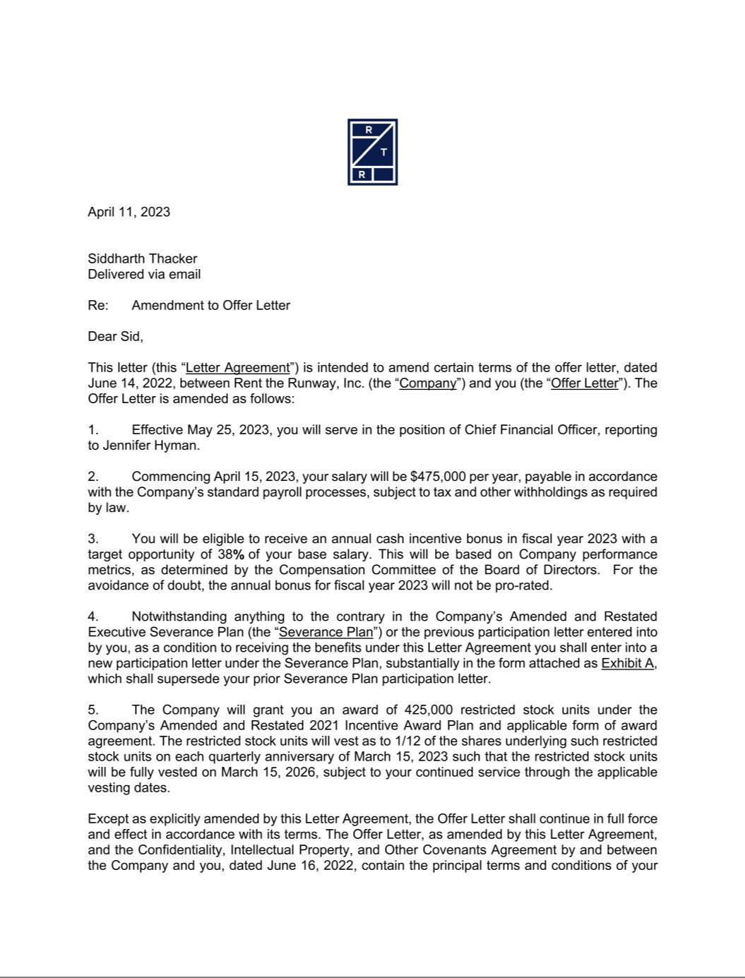

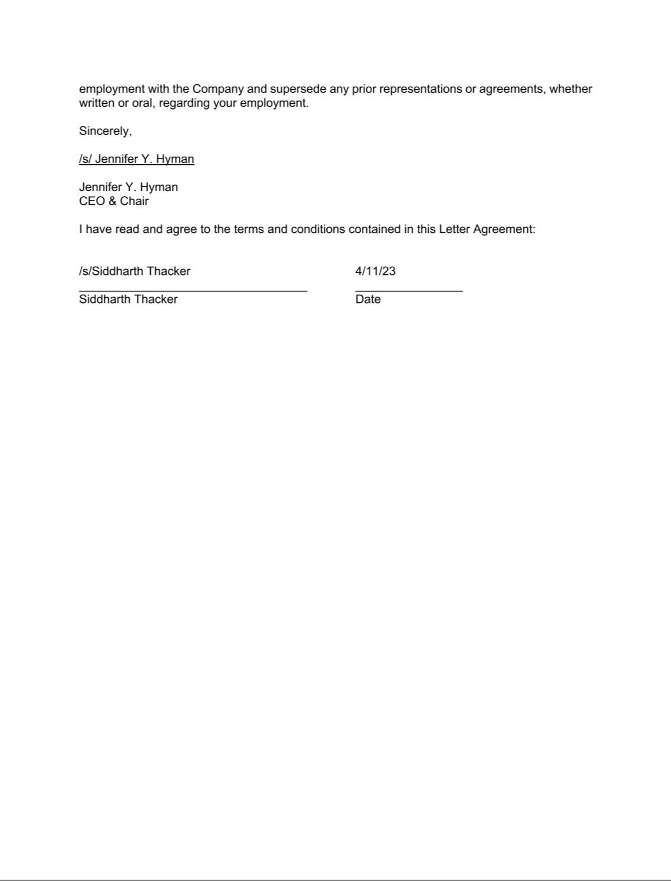

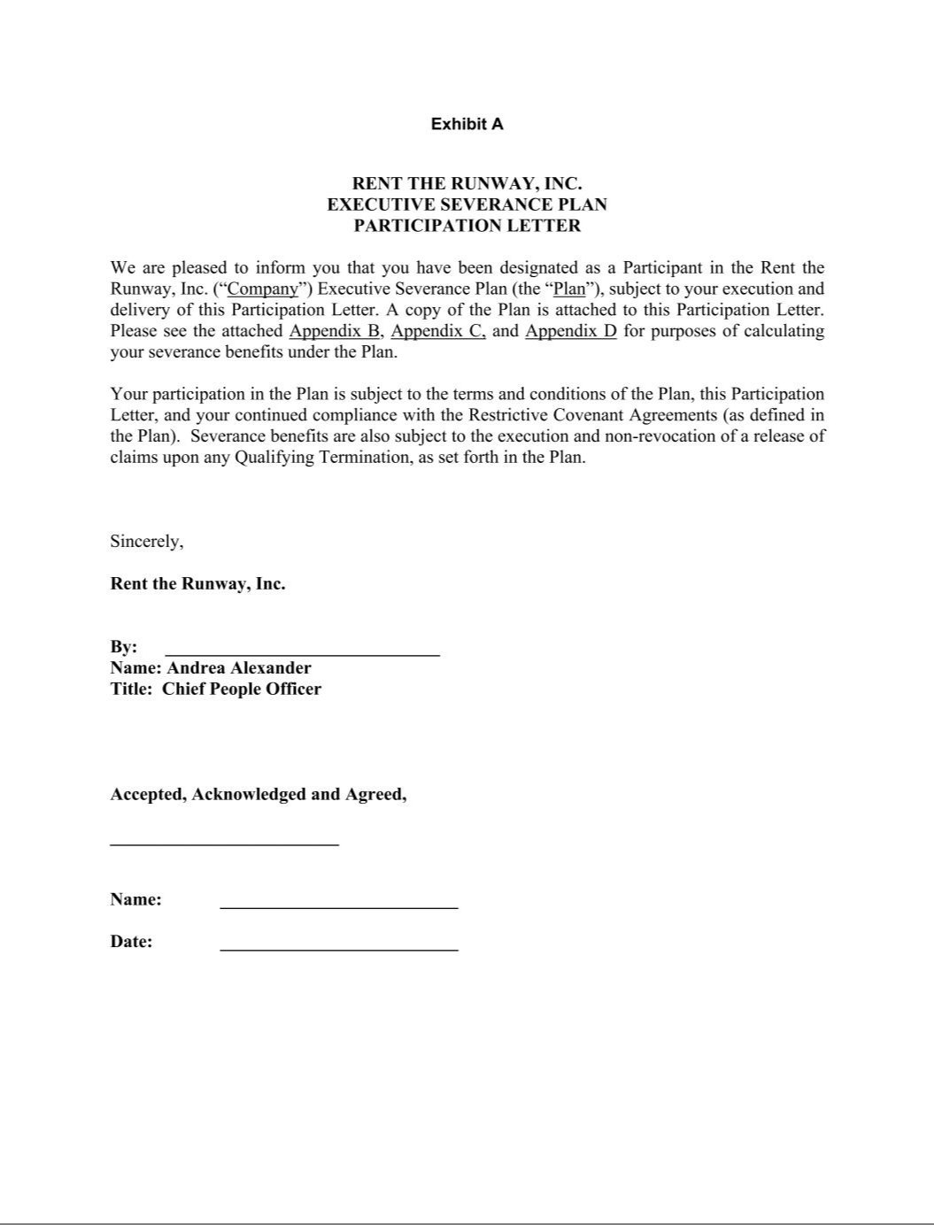

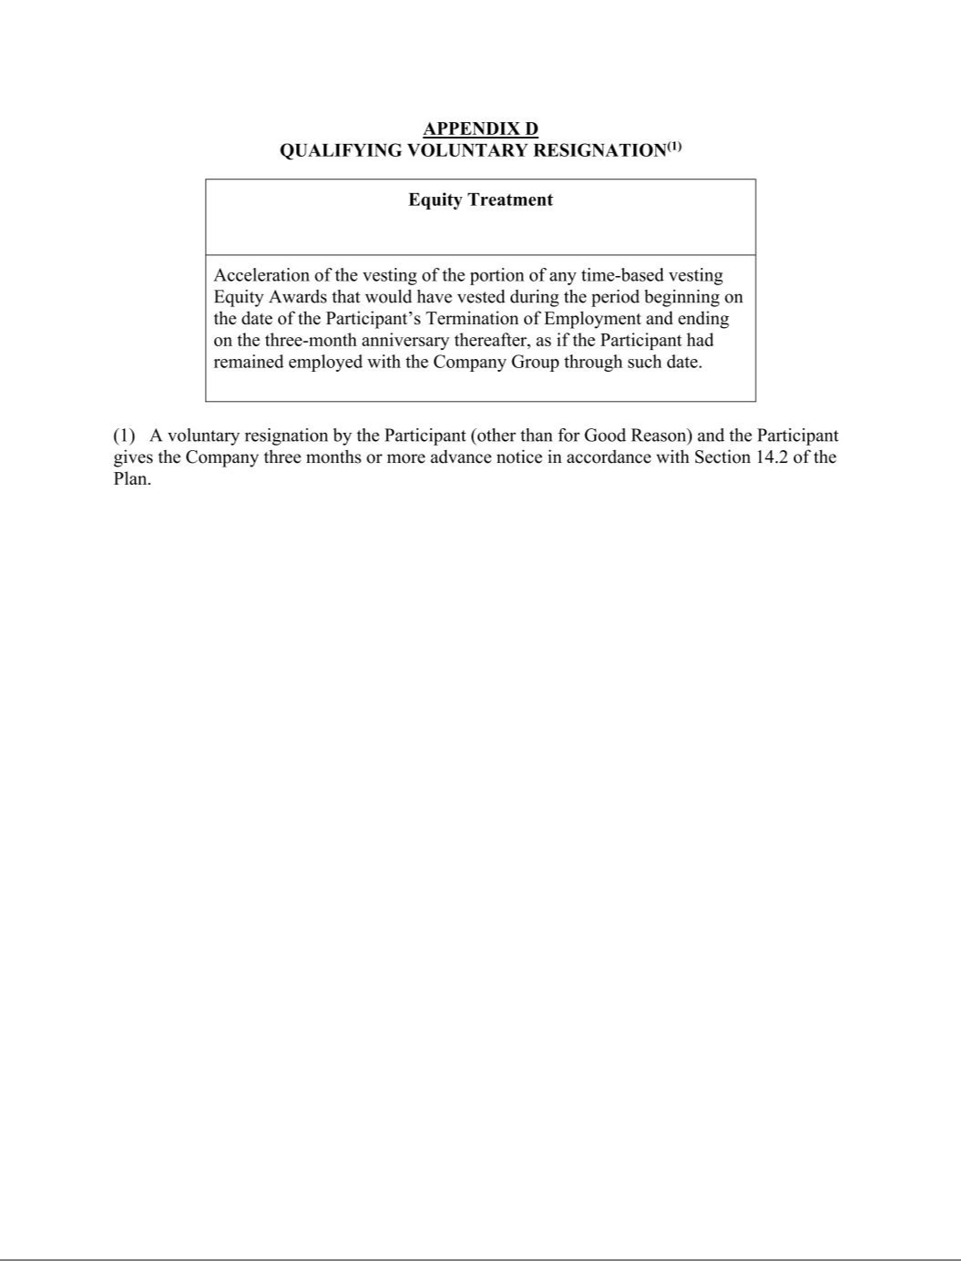

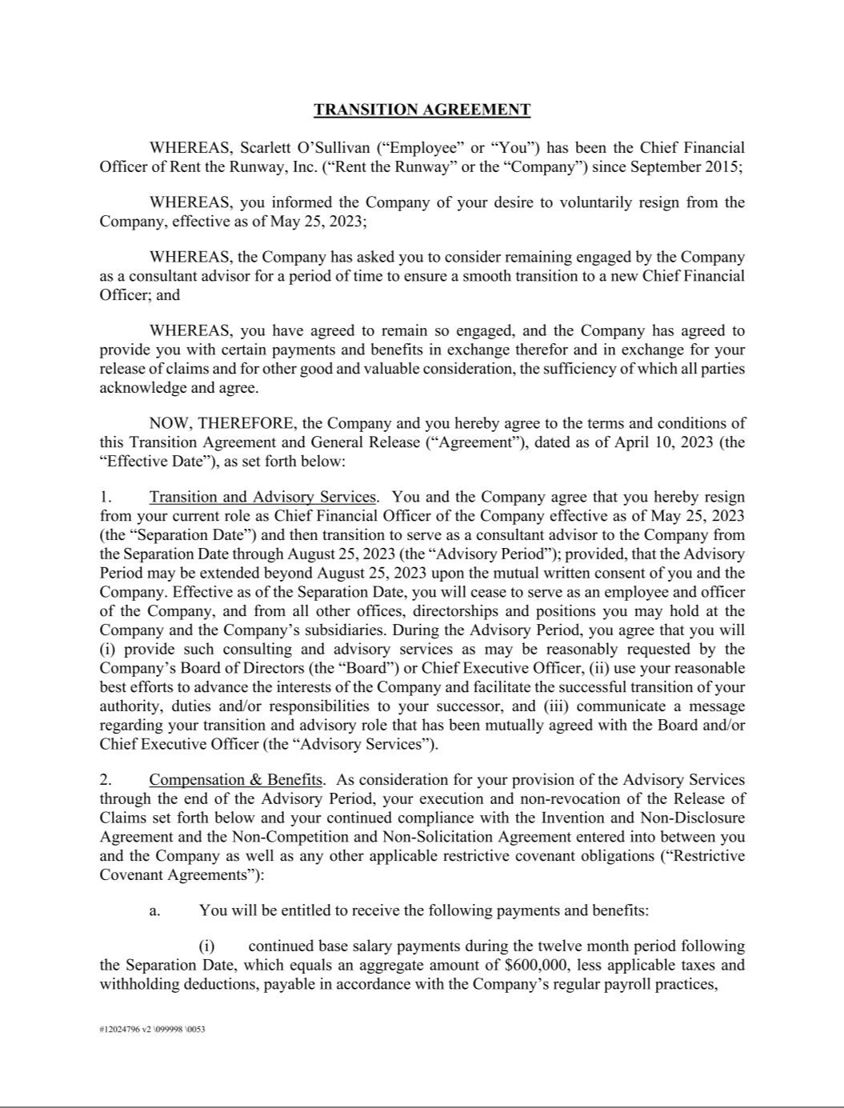

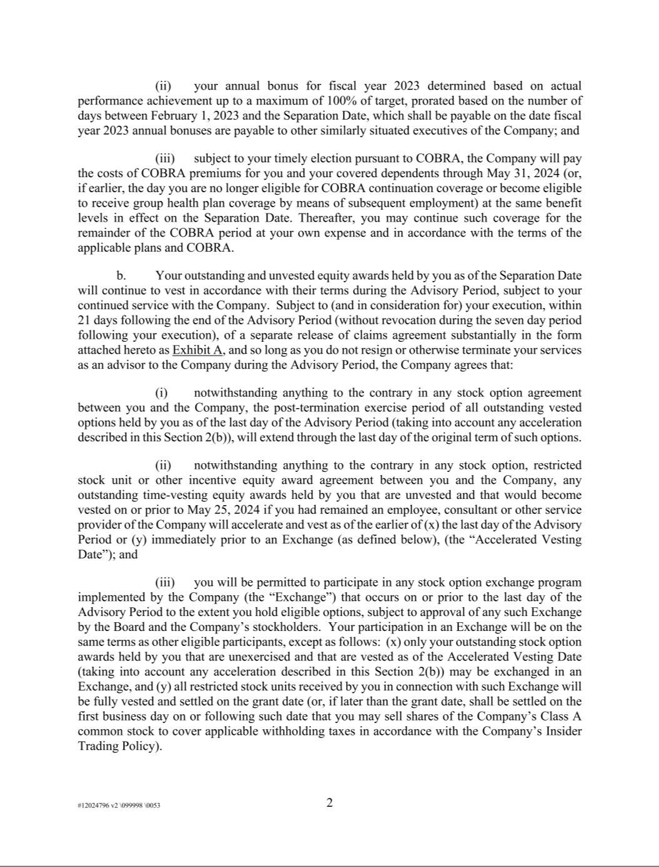

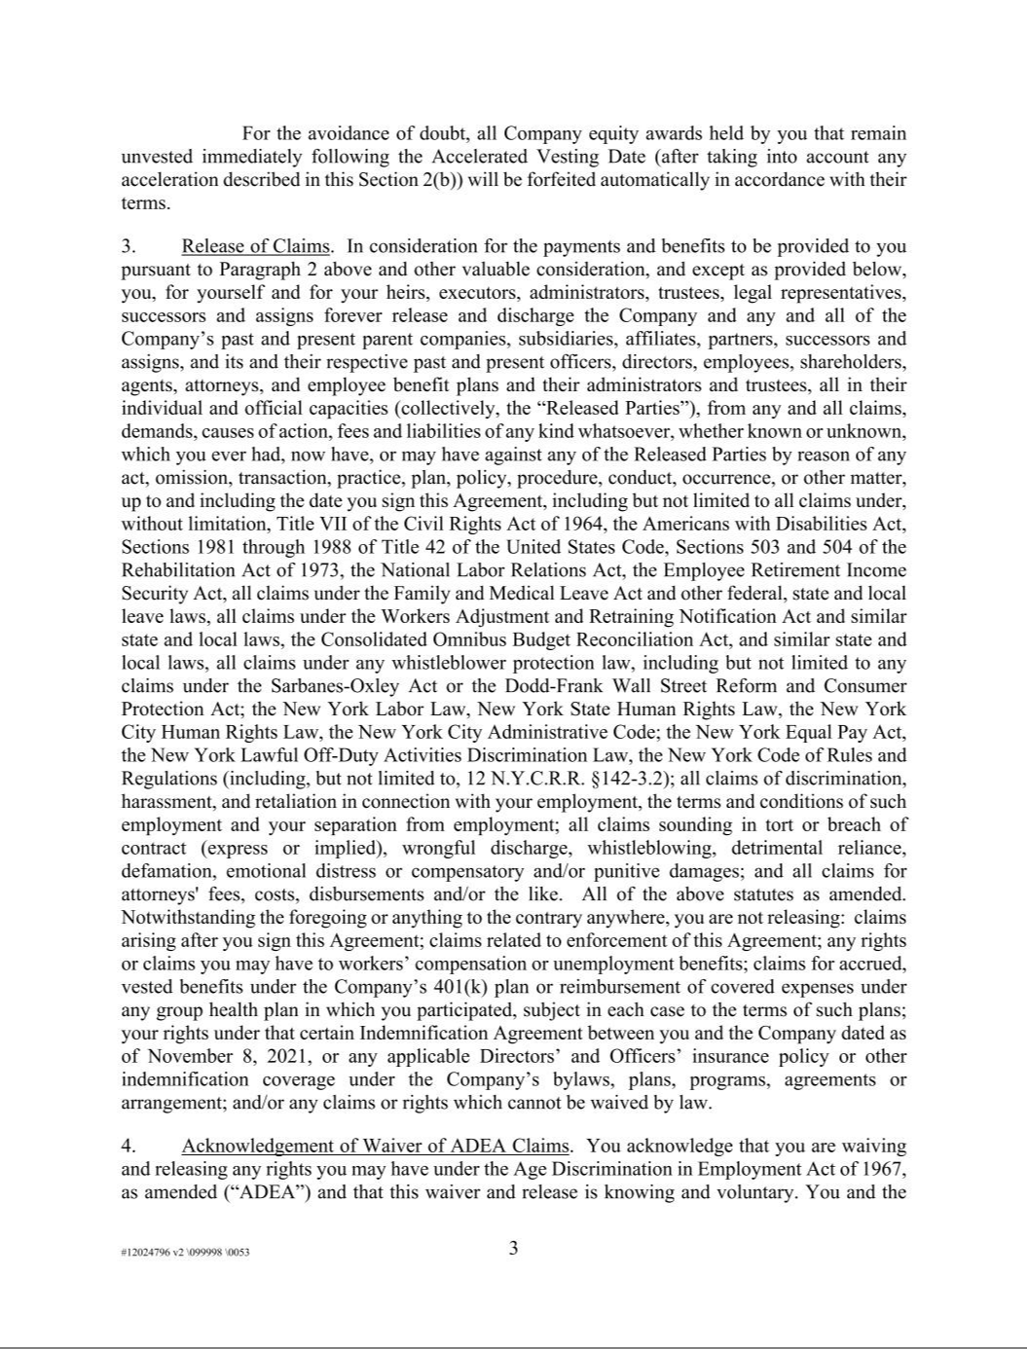

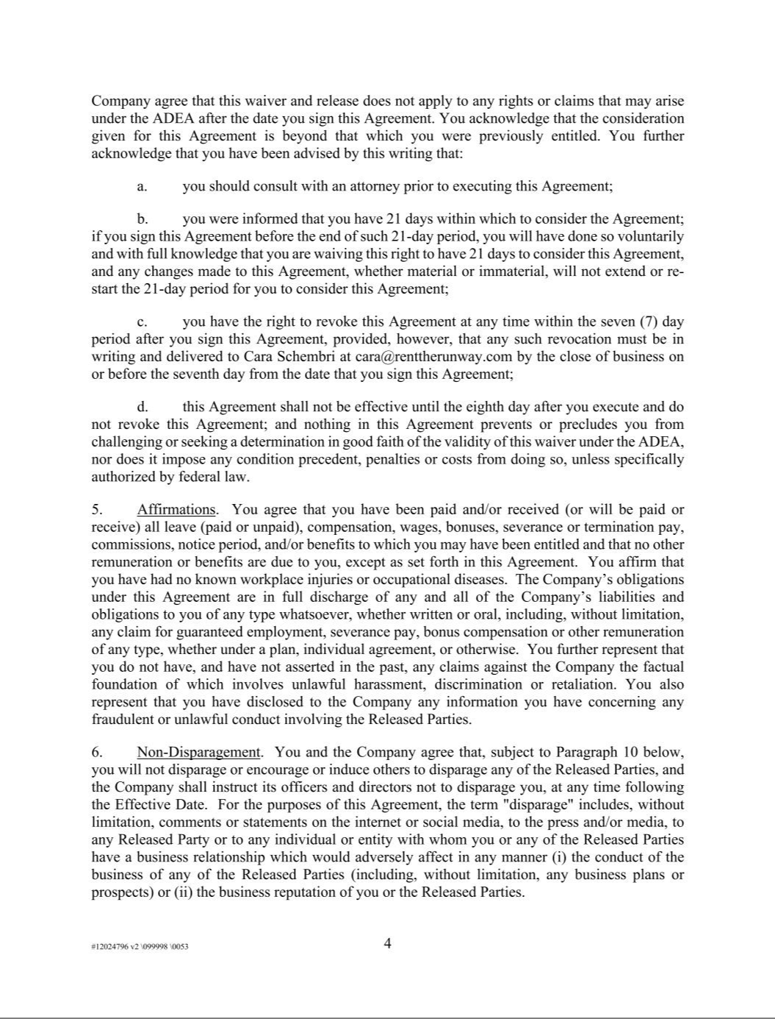

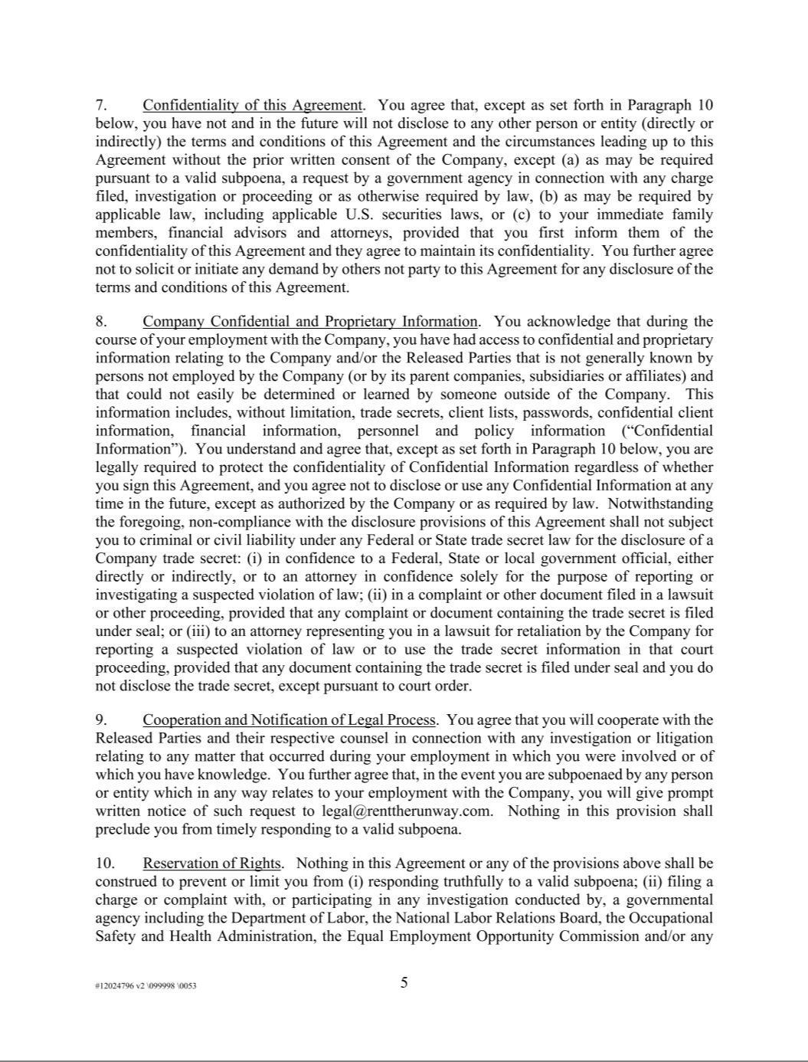

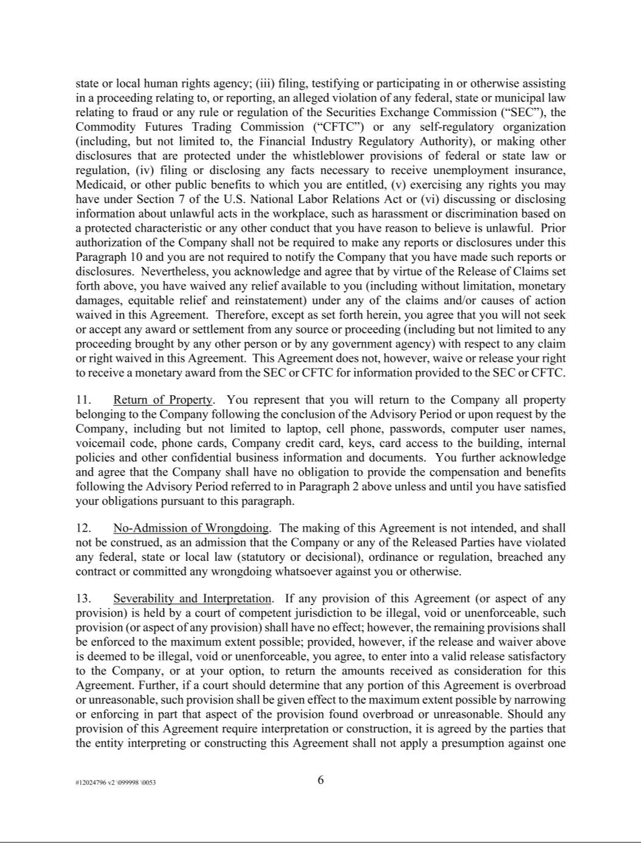

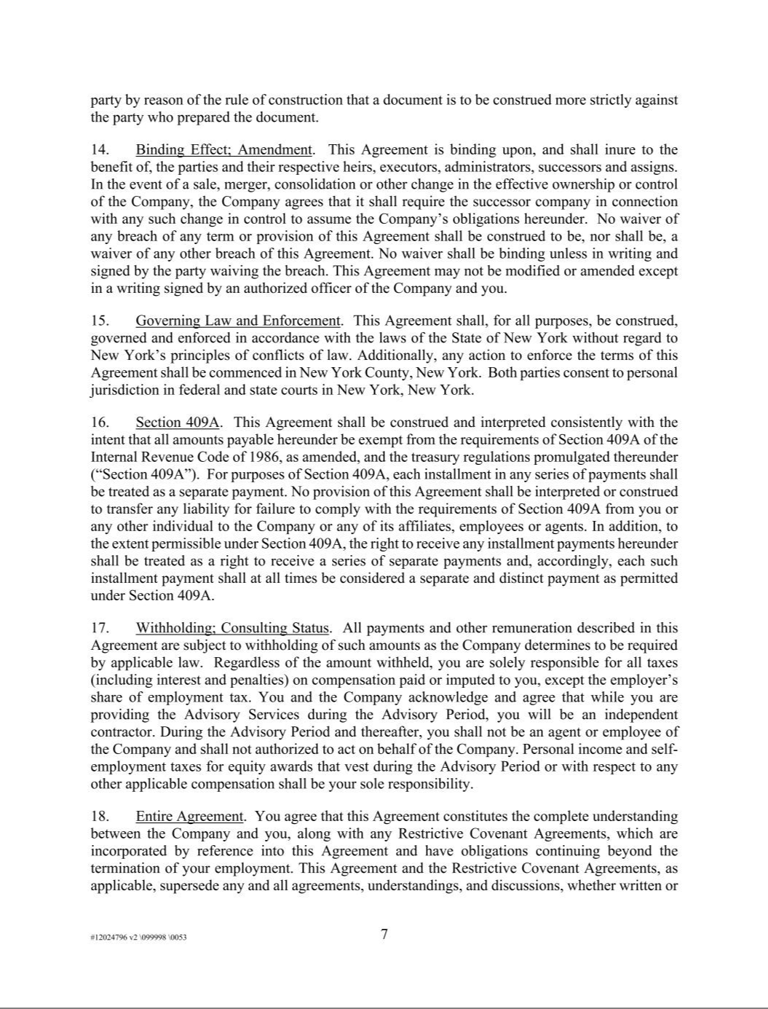

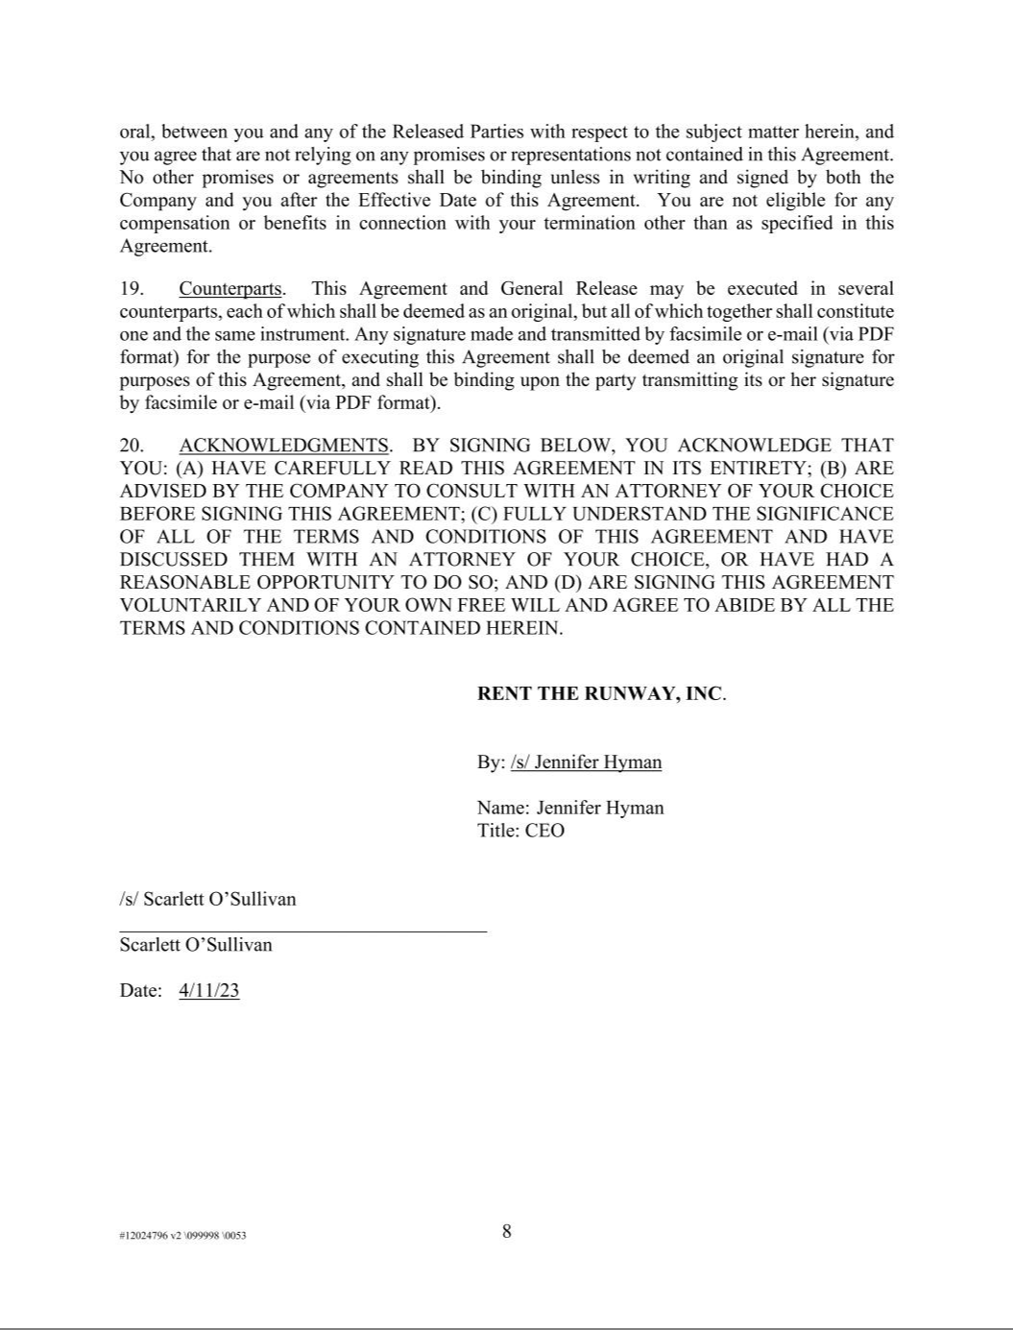

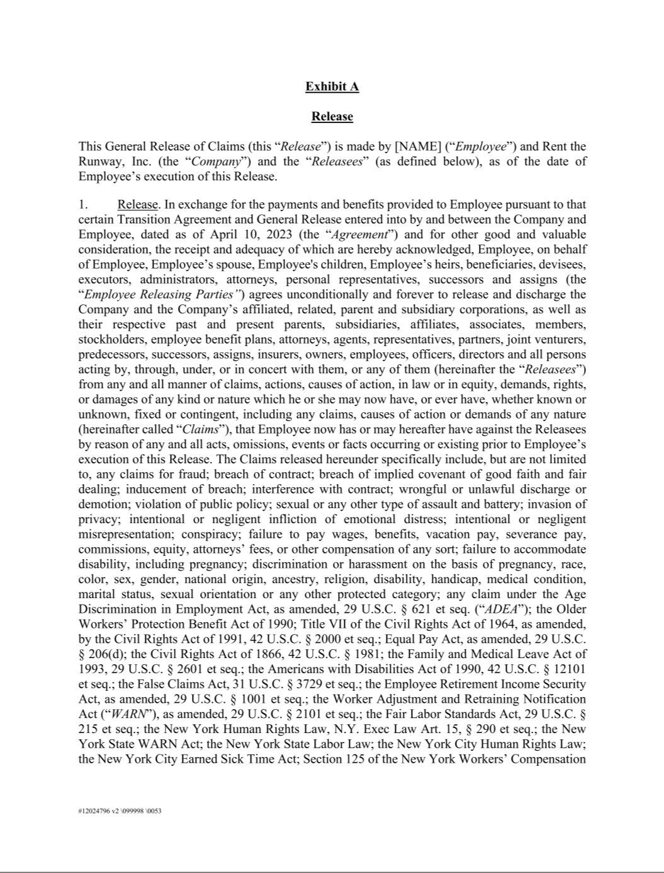

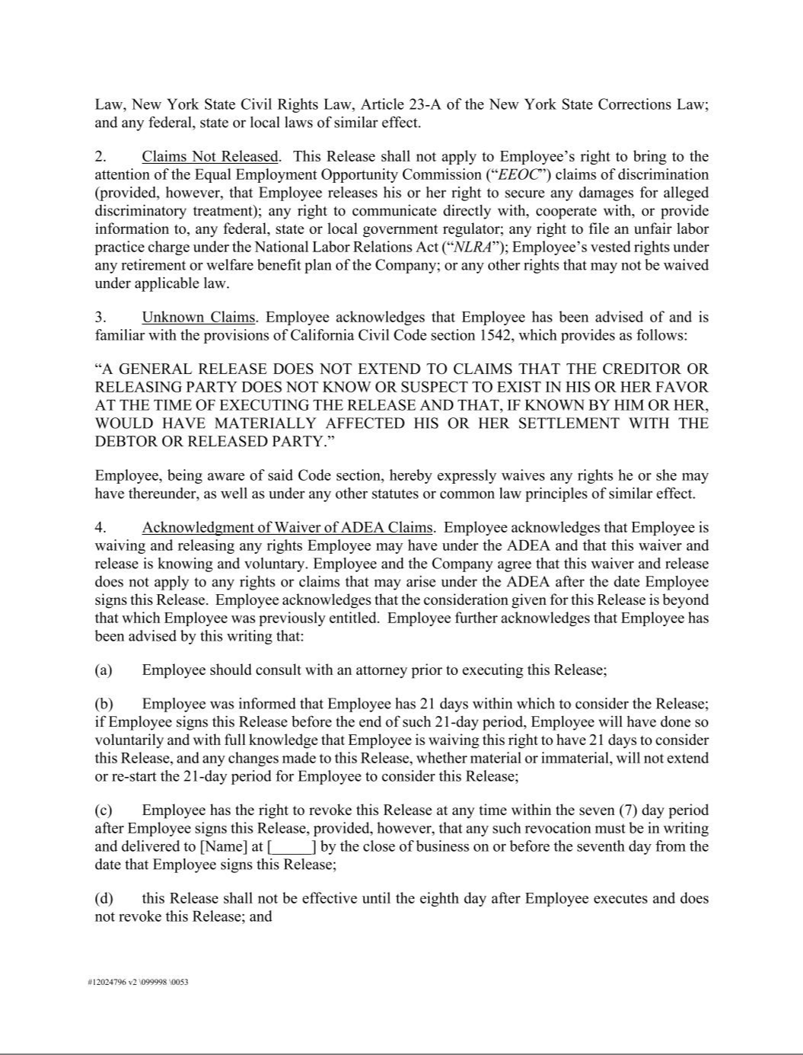

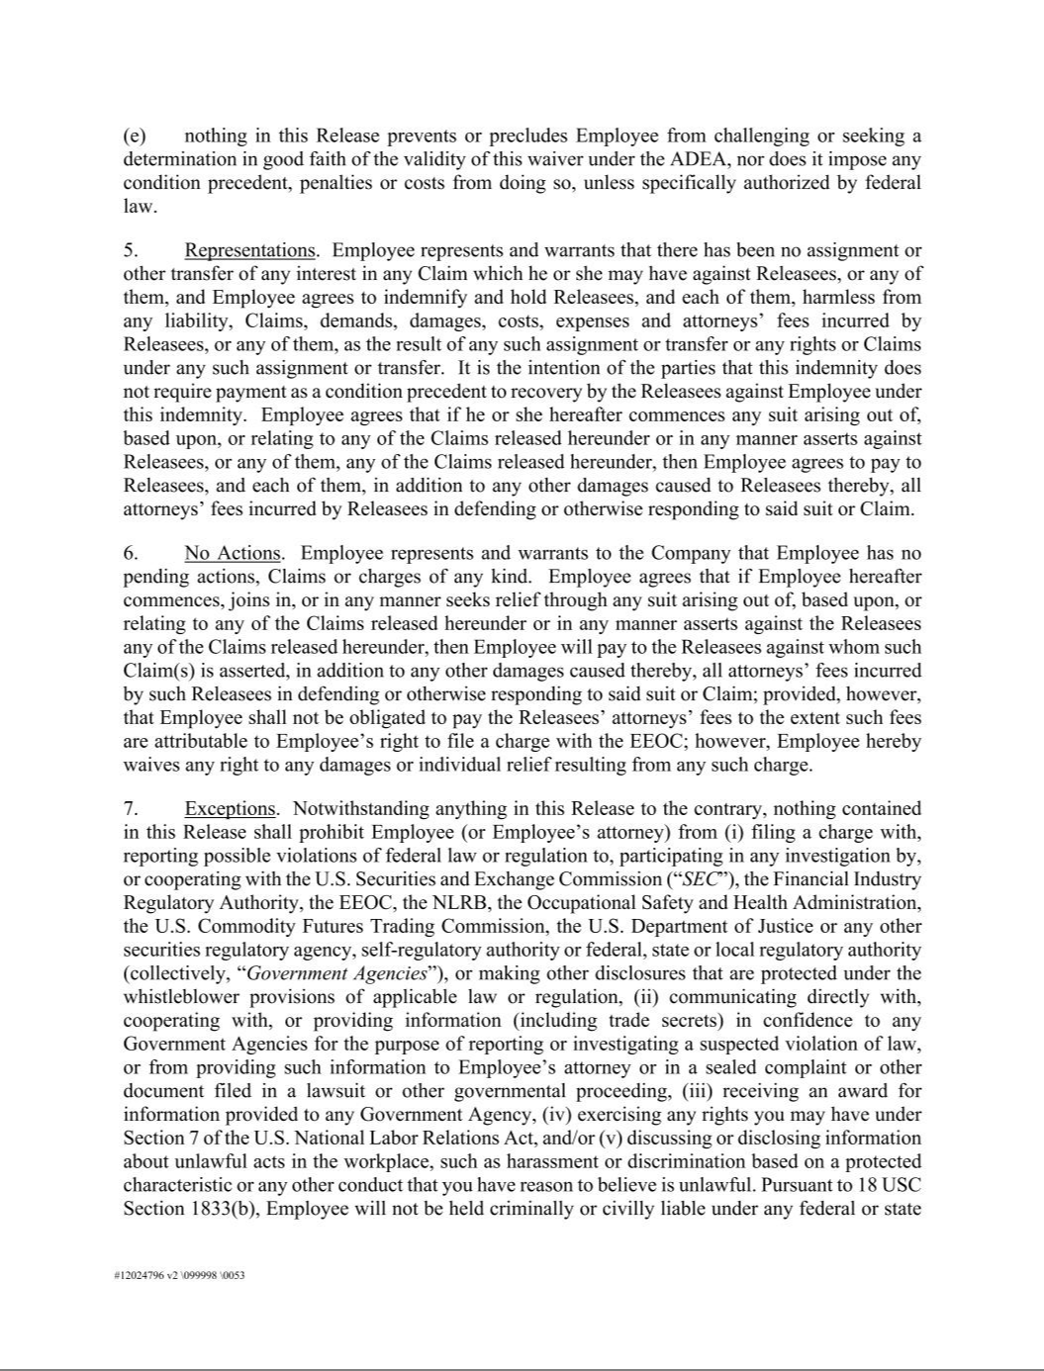

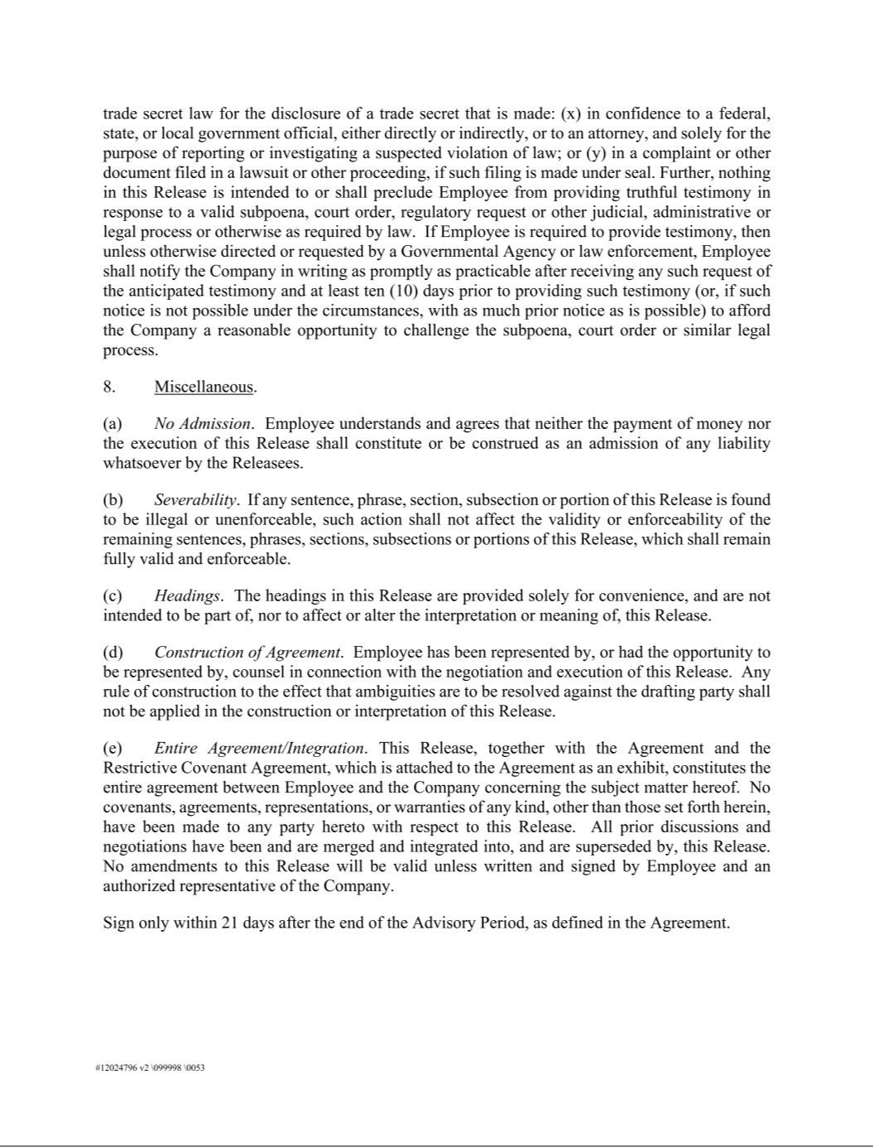



Exhibit 99.1

Rent the Runway, Inc. Announces Fourth Quarter and Full Year 2022 Results

Accelerating Subscriber Growth:

Record High 141,205 Active Subscribers as of April 8, 2023 Guiding to More than 25% Active Subscriber Growth for Year-End 2023 FY 2023 Growth Strategy Focuses on Continuously Delivering More Value to the Customer

Record Annual Revenue of $296.4M in FY 2022, up 46% YoY

Q4 2022 and FY 2022 Net Losses Narrowed Significantly YoY

Positive Adjusted EBITDA for First Full Year & Third Consecutive Quarter

Anticipates YoY Reduction in Cash Consumption by Almost 50% in FY 2023

Scarlett O’Sullivan to Transition Out of CFO Role;

SVP, FP&A Sid Thacker Appointed as Successor

New York (April 12, 2023) - Rent the Runway, Inc. (“Rent the Runway” or "RTR") (NASDAQ: RENT), the world’s first and largest shared designer closet platform, today reported financial results for the fiscal quarter and fiscal year 2022 ended January 31, 2023.

"I'm proud that in fiscal 2022, we achieved 46% Revenue growth and completed a significant financial transformation, doubling our gross margins compared to 2019, right-sizing our fixed cost base, improving the capital efficiency of our product acquisition and restructuring our debt. These efforts drove progress on our path to FCF profitability, as we posted our first full year and third consecutive quarter of positive Adjusted EBITDA ahead of the timeline we outlined at IPO," said Jennifer Hyman, CEO and Co-Founder of Rent the Runway. "We believe we’ve built the financial foundation and infrastructure to capture the vast opportunity ahead and have conviction that we’ll continue to grow and become a profitable business by delivering meaningful value and innovation to the customer. We kicked off our customer-centric strategy in 2023 by changing all of our subscription programs to include an additional item in every shipment, which has already improved retention and rejoin rates, and contributed to our record high active subscriber count of 141,205 as of April 8, 2023."

CFO Scarlett O’Sullivan stated, “The fulfillment and product spend efficiencies we have driven in fiscal year 2022 have enabled us to provide an additional item in our subscription programs with minimal anticipated impact to our gross margins. Combined with the $25 million in annualized fixed cost savings we expect from our Q2 2022 restructuring, we believe we are set up for strong Adjusted EBITDA and significantly lower cash consumption in fiscal 2023, on our path to achieve free cash flow breakeven."

Fourth Quarter 2022 Key Metrics and Financial Highlights

- Revenue was $75.4 million, an 18% increase year-over-year from $64.1 million in the fourth quarter of fiscal year 2021.

- 126,712 ending Active Subscribers, representing an increase of 10% year-over-year from 115,240 at the end of the fiscal year 2021.

- 141,205 Active Subscribers as of April 8, 2023, reaching record high.

- 130,476 Average Active Subscribers, representing an increase of 12% year-over-year from 116,037 at the end of the fourth quarter of 2021.

- 171,998 ending Total Subscribers, representing an increase of 8% year-over-year from 159,544 at the end of the fiscal year 2021.

- Gross Profit was $33.3 million, representing an increase of 42% from $23.5 million in the fourth quarter of 2021. Gross Margin was 44.2%, as compared to 36.7% in the fourth quarter of 2021.

- Net Loss was $(26.2) million, as compared to $(39.3) million in the fourth quarter of 2021. Net Loss as a percentage of revenue was (34.7)%, as compared to (61.3)% in the fourth quarter of 2021.

- Adjusted EBITDA was $7.1 million, as compared to $(5.5) million in the fourth quarter of 2021. Adjusted EBITDA margin was 9.4%, as compared to (8.6)% in the fourth quarter of 2021.

Fiscal Year 2022 Key Metrics and Financial Highlights

- Revenue was $296.4 million, a 46% increase year-over-year from $203.3 million in fiscal year 2021.

- 128,586 Average Active Subscribers, representing an increase of 38% year-over-year from 93,371 at the end of fiscal year 2021.

- Gross Profit was $120.0 million, representing an increase of 72% from $69.7 million in fiscal year 2021. Gross Margin was 40.5%, as compared to 34.3% in fiscal year 2021.

- Net Loss was $(138.7) million, as compared to $(211.8) million in fiscal year 2021. Net Loss as a percentage of revenue was (46.8)%, as compared to (104.2)% in fiscal year 2021.

- Adjusted EBITDA was $6.7 million, as compared to $(19.2) million in fiscal year 2021. Adjusted EBITDA margin was 2.3%, as compared to (9.4)% in fiscal year 2021.

- Net cash used in operating activities plus net cash used in investing activities was $(92.0) million for fiscal year 2022, as compared to $(64.8) million for fiscal year 2021.

- Net cash used in operating activities plus net cash used in investing activities as a percentage of revenue was (31.0)% for fiscal year 2022, as compared to (31.9)% for fiscal year 2021.

- As of January 31, 2023, cash and cash equivalents were $154.5 million.

Fiscal Fourth Quarter, Fiscal Year 2022 and Recent Business Highlights

- In March 2023, permanently added an extra item to every shipment of our rental subscription programs to deliver greater value to subscribers. Early launch results already show improved retention and rejoin rates, with minimal expected impact on gross margin in fiscal year 2023.

- In March 2023, rolled out “Rent the Look”, a highly requested feature that showcases how to rent full outfits styled on-model and presents similar items if a particular item is not available to rent right now.

- In February 2023, executed this year’s first major technology launch to deliver best-in-class product discovery, completing the integration of our new product catalog, EPIC, into our new search service. As a result, we believe richer and fresher product attributes are yielding better search results.

- In fiscal 2022, completed migration to the cloud to unlock better resiliency, site performance and reliability, increased developer velocity, and the ability to scale more efficiently with subscriber growth.

- Q4 2022 saw continued strong subscriber engagement, with 28% of subscribers adding one or more paid additional items into their subscription program.

- Expanded at-home pickup to 34 markets covering 60% of our subscriber base. In addition, 29% of at-home pickups in Q4 2022 were “live-swap” (where the delivery and return happen simultaneously), leading to consolidation-based transportation cost savings. Subscriber adoption of at-home pickup within eligible zip codes was 37% at the end of Q4 2022 up from 34%¹ at the end of Q3 2022.

- Achieved our product acquisition goal of 60% non-wholesale in fiscal 2022, excluding the opportunistic pull-forward of product spend from fiscal 2023 into fiscal 2022. Inclusive of all product spend for the year, non-wholesale represented 58% in fiscal 2022.

- In March 2023, launched 360, full-funnel “Era of Extra” marketing campaign to announce the launch of RTR's new subscription plans, which included

collaboration with social media creators, video content to members from our CEO, full site and app takeover, a multi-touch email campaign, full coverage on paid social and search, plus activation with the RTR ambassador community.
- In March 2023, executed continued integration of Rent the Runway’s brand into pop culture with notable inclusion in Netflix’s Next in Fashion hosted by Gigi Hadid and Tan France. Winner Nigel Xavier’s collection -- which appears exclusively on RTR -- features upcycled garments, including pre-loved items from RTR.

Outlook

For fiscal year 2023, Rent the Runway expects:

- Ending Active Subscriber growth of more than 25%

- Revenue in the range of $320 million to $330 million

- Adjusted EBITDA Margin of 7% to 8%

- YoY reduction in cash consumption by almost 50%

For the fiscal first quarter of 2023, Rent the Runway expects:

- Revenue in the range of $72 million to $74 million

- Adjusted EBITDA Margin of 2% to 3%

Please see our fourth quarter 2022 earnings presentation at https://investors.renttherunway.com/ under the “Presentations” section for supplemental guidance.

- Q3 2022 previously reported erroneously as 39%. Home pickup adoption is calculated using adoption levels and total eligible shipments during the final week of the applicable fiscal period.

CFO Transition

RTR also announced today that Scarlett O’Sullivan, its Chief Financial Officer has made the decision to transition out of her role effective May 25, 2023 (the “Effective Date”) and that Sid Thacker, currently the SVP, FP&A, has been appointed as Chief Financial Officer as of the Effective Date. Ms. O’Sullivan will continue to serve as an advisor to RTR until August 25, 2023 (or such other date as may be mutually agreed to by RTR and Ms. O’Sullivan).

“On behalf of the entire company and Board of Directors, I would like to thank Scarlett for her extensive contributions to Rent the Runway over the past seven-plus years,” said Hyman. “Scarlett has been a consistent and strong strategic partner to me, helping to guide Rent the Runway through critical financial and business transformations: from an a la carte business to a subscription business, through COVID-19, and from private company to public company. Scarlett’s leadership post-IPO enabled us to double our gross margins, restructure our debt and position the company for future free cash flow profitability. I’m personally grateful for Scarlett embodying a true founder mentality along every exciting stop of her journey at RTR, and appreciate her commitment to a smooth transition."

“Having completed a significant financial transformation of the business over the past several years, I believe that now is the right time to transition out of the role and elevate Sid Thacker, who has already proven himself an invaluable partner to me, Jenn and the company,” said O’Sullivan. “As a public investor for 20+ years, he brings a new perspective to our already strong team and we believe is the right finance leader to shepherd RTR through its next chapter. I am grateful to Jenn, the Executive Team and Board of Directors for their support. I have confidence in the 2023 plan, believe Rent the Runway has a great journey ahead and look forward to following the company’s success for years to come.”

“I'm honored to assume the role of CFO of Rent the Runway. I appreciate the confidence that Jenn, Scarlett, and the Board of Directors have in me. I'm grateful to be joining the leadership team of the company at an important inflection point,” said Thacker. “Over my investment career, I've seen companies succeed when they focus on their customers. I believe the ‘Era of Extra’ additional item subscription initiative, the exciting product improvements we are making this year and beyond, and the financial transformation over the past few years are a winning combination. I think our opportunity is considerable, and I look forward to working with the Board and Executive team to achieve our goals and help build a growing and free cash flow positive company.”

Earnings Presentation, Conference Call and Webcast

The fourth quarter and fiscal year 2022 Earnings Presentation is now accessible through the Investor Relations section of Rent the Runway’s website at https://investors.renttherunway.com/ under the “Presentations” section.

Rent the Runway will host a conference call and webcast to discuss its fourth quarter and fiscal year 2022 financial results and provide a business update today, April 12, 2023, at 4:30 pm EDT.

The financial results and live webcast will be accessible through the Investor Relations section of Rent the Runway’s website at https://investors.renttherunway.com/ under the “Events” section. To access the call through a conference line, dial 1-877-407-3982 (in the U.S.) or 1-201-493-6780 (international callers).

A replay of the conference call will be posted shortly after the call and will be available for at least fourteen days. To access the replay, dial 1-844-512-2921 (in the U.S.) or 1-412-317-6671 (international callers). The access code for the replay is 13737124.

About Rent the Runway, Inc.

Founded in 2009, Rent the Runway is disrupting the trillion-dollar fashion industry and changing the way women get dressed through the Closet in the Cloud, the world’s first and largest shared designer closet. RTR’s mission has remained the same since its founding: powering women to feel their best every day. Through RTR, customers can subscribe, rent items a-la-carte and shop resale from hundreds of designer brands. The Closet in the Cloud offers a wide assortment of millions of items for every occasion, from evening wear and accessories to ready-to-wear, workwear, denim, casual, maternity, outerwear, blouses, knitwear, loungewear, jewelry, handbags, activewear and ski wear. RTR has built a two-sided discovery engine, which connects deeply engaged customers and differentiated brand partners on a powerful platform built around its brand, data, logistics and technology. Under CEO and Co-Founder Jennifer Hyman’s leadership, RTR has been named to CNBC’s “Disruptor 50” five times in ten years, and has been placed on Fast Company’s Most Innovative Companies list four times, while Hyman herself has been named to the “TIME 100: Most Influential People in the World" and as one of People Magazine’s “Women Changing the World."

Forward-Looking Statements

This press release contains forward-looking statements within the meaning of the Private Securities Litigation Reform Act of 1995. All statements contained in this press release that do not relate to matters of historical fact should be considered forward-looking statements. These statements include, but are not limited to, statements regarding our future results of operations, financial position, and revenue, future product launches, strategic initiatives, business objectives, anticipated macroeconomic environment, anticipated impacts of our restructuring plan, benefits of our customer-focused strategy and other strategic initiatives, expectations regarding customer loyalty and other subscriber trends, and the transition of the Chief Financial Officer role, the anticipated timing of Ms. O’Sullivan’s service as an advisor and Mr. Thacker’s expected contributions as Chief Financial Officer. Forward-looking statements are inherently subject to risks and uncertainties, some of which cannot be predicted or quantified. In some cases, you can identify forward-looking statements because they contain words such as “aim,” “anticipate,” “believe,” “contemplate,” “continue,” “could,” “estimate,” “expect,” “intend,” “may,” “plan,” “potential,” “predict,” “project,” “should,” “target,” “toward,” “will,” or “would,” or the negative of these words or other similar terms or expressions. You should not put undue reliance on any forward-looking statements. Forward-looking statements should not be read as a guarantee of future performance or results and will not necessarily be accurate indications of the times at, or by, which such performance or results will be achieved, if at all.

Forward-looking statements are based on information available at the time those statements are made and were based on current expectations, estimates, forecasts, and projections as well as the beliefs and assumptions of management as of that time with respect to future events. These statements are subject to risks and uncertainties, many of which involve factors or circumstances that are beyond our control, that could cause actual performance or results to differ materially from those expressed in or suggested by the forward-looking statements. In light of these risks and uncertainties, the forward-looking events and circumstances discussed in this press release may not occur and actual results could differ materially from those anticipated or implied in the forward-looking statements. These risks and uncertainties include our ability to manage our growth effectively; risks related to the macroeconomic environment; the highly competitive and rapidly changing nature of the global fashion industry; our ability to cost-effectively grow our customer base; any failure to retain customers; risk related to the COVID-19 pandemic and other future pandemics or public health crises; risks related to shipping, logistics and our supply chain; our ability to accurately forecast customer demand, manage our offerings effectively and plan for future expenses; risks arising from the restructuring of our operations; our reliance on the effective operation of proprietary technology systems and software as well as those of third-party vendors and service providers; our ability to remediate our material weaknesses in our internal control over financial reporting; laws and regulations applicable to our business; failure by us to adequately obtain, maintain, protect and enforce our intellectual property and proprietary rights; compliance with data privacy, data security, data protection and consumer protection laws and industry standards; risks associated with our brand and manufacturing partners; our reliance on third parties for elements of the payment processing infrastructure underlying our business; our dependence on online sources to attract consumers and promote our business which may be affected by third-party interference or cause our customer acquisition costs to rise; failure by us, our brand partners, or third party manufacturers to comply with our vendor code of conduct or other laws; and risks related to our Class A capital stock and ownership structure. Additional information regarding these and other risks and uncertainties that could cause actual results to differ materially from the Company’s expectations is included in our Quarterly Report on Form 10-Q for the quarter ended October 31, 2022, as will be updated in our Annual Report on Form 10-K for the year ended January 31, 2023. Except as required by law, we do not undertake any obligation to publicly update or revise any forward-looking statement, whether as a result of new information, future developments, or otherwise.

Key Business and Financial Metrics

Active Subscribers is defined as the number of subscribers with an active membership as of the last day of any given period and excludes paused subscribers.

Average Active Subscribers is defined as the mean of the beginning of quarter and end of quarter Active Subscribers for a quarterly period; and for other periods, represents the mean of the Average Active Subscribers of every quarter within that period.

Gross Profit is defined as total revenue less fulfillment expense, revenue share and rental product depreciation. We depreciate owned apparel assets over three years and owned accessory assets over two years net of 20% and 30% salvage values, respectively, and recognize the depreciation and remaining cost of items when sold or retired on our statement of operations. Rental product depreciation expense is time-based and reflects all items we own. We use Gross Profit and Gross Profit as a percentage of revenue, or Gross Margin to measure the continued efficiency of our business after the cost of our products and fulfillment costs are included.

Non-GAAP Financial Measures

This press release and the accompanying tables contain the non-GAAP financial measures of Adjusted EBITDA and Adjusted EBITDA margin. In addition to our results determined in accordance with GAAP, we believe that Adjusted EBITDA and Adjusted EBITDA margin are useful in evaluating our performance. Adjusted EBITDA is a key performance measure used by management to assess our operating performance and the operating leverage of our business prior to capital expenditures. These non-GAAP financial metrics are not meant to be considered as indicators of our financial performance in isolation from or as a substitute for our financial information prepared in accordance with GAAP and should be read only in conjunction with financial information presented on a GAAP basis. There are limitations to the use of the non-GAAP financial metrics presented in this press release. For example, our non-GAAP financial metrics may not be comparable to similarly titled measures of other companies. Other companies, including companies in our industry, may calculate non-GAAP financial metrics differently than we do, limiting the usefulness of those measures for comparative purposes.

We define Adjusted EBITDA as net loss, adjusted to exclude interest expense, rental product depreciation, other depreciation and amortization, share-based compensation expense, write-off of liquidated assets, non-recurring adjustments, and non-ordinary course legal fees (see below footnotes to reconciliation table), restructuring charges, loss on asset impairment related to restructuring, income taxes, other income and expense, gain / loss on warrant liability revaluation, net, gain / loss on debt extinguishment, net, and other gains / losses. Adjusted EBITDA margin is defined as Adjusted EBITDA calculated as a percentage of revenue.

The reconciliation of the non-GAAP financial metrics to the most directly comparable GAAP financial measure is presented below. We encourage reviewing the reconciliation in conjunction with the presentation of the non-GAAP financial metrics for each of the periods presented. In future periods, we may exclude similar items, may incur income and expenses similar to these excluded items, and may include other expenses, costs and non-recurring items. Reconciliation of Adjusted EBITDA and Adjusted EBITDA margin guidance to the closest corresponding GAAP measure is not available without unreasonable efforts on a forward-looking basis due to the high variability, complexity, and low visibility with respect to the charges excluded from these non-GAAP measures, in particular, share-based compensation expense and non-recurring expenses which can have unpredictable fluctuations based on unforeseen activity that is out of our control and/or cannot reasonably be predicted.

Investor Contact

Jackie Blatt

investors@renttherunway.com

Media Contact

Alison Rappaport

press@renttherunway.com

Rent the Runway, Inc.
Consolidated Balance Sheets

(in millions)

 |  | January 31,
 | 2023 |  |  |  | 2022
Assets
Current assets:
Cash and cash equivalents | $ | 154.5 |  | $ | 247.6
Restricted cash, current |  | 3.1 |  |  | 5.4
Prepaid expenses and other current assets |  | 14.5 |  |  | 11.7
Total current assets |  | 172.1 |  |  | 264.7
Restricted cash |  | 6.0 |  |  | 6.6
Rental product, net |  | 78.7 |  |  | 76.3
Fixed assets, net |  | 44.7 |  |  | 57.2
Intangible assets, net |  | 4.1 |  |  | 6.4
Operating lease right-of-use assets |  | 26.7 |  |  | 31.5
Other assets |  | 3.9 |  |  | 4.8
Total assets | $ | 336.2 |  | $ | 447.5
Liabilities and Stockholders’ Equity (Deficit)
Current liabilities:
Accounts payable | $ | 12.4 |  | $ | 15.9
Accrued expenses and other current liabilities |  | 24.4 |  |  | 30.0
Deferred revenue |  | 12.0 |  |  | 10.4
Customer credit liabilities |  | 6.8 |  |  | 6.9
Operating lease liabilities |  | 4.4 |  |  | 5.6
Total current liabilities |  | 60.0 |  |  | 68.8
Long-term debt, net |  | 272.5 |  |  | 260.8
Operating lease liabilities |  | 38.3 |  |  | 46.4
Other liabilities |  | 0.7 |  |  | 0.4
Total liabilities |  | 371.5 |  |  | 376.4
Stockholders’ equity (deficit)
Class A common stock |  | 0.1 |  |  | 0.1
Class B common stock |  | — |  |  | —
Preferred stock |  | — |  |  | —
Additional paid-in capital |  | 904.5 |  |  | 872.2
Accumulated deficit |  | (939.9) |  |  | (801.2)
Total stockholders’ equity (deficit) |  | (35.3) |  |  | 71.1
Total liabilities and stockholders’ equity (deficit) | $ | 336.2 |  | $ | 447.5

Rent the Runway, Inc.
Consolidated Statements of Operations
(in millions, except share and per share amounts)

 |  | Three Months Ended |  |  |  |  |  | Year Ended
 |  | January 31, |  |  |  |  |  | January 31,
 |  | 2023 |  |  | 2022 |  |  | 2023 |  |  | 2022
Revenue:
Subscription and Reserve rental revenue | $ | 68.4 |  | $ | 58.8 |  | $ | 268.6 |  | $ | 185.8
Other revenue |  | 7.0 |  |  | 5.3 |  |  | 27.8 |  |  | 17.5
Total revenue, net |  | 75.4 |  |  | 64.1 |  |  | 296.4 |  |  | 203.3
Costs and expenses:
Fulfillment |  | 22.7 |  |  | 20.4 |  |  | 92.2 |  |  | 61.9
Technology |  | 12.8 |  |  | 12.3 |  |  | 55.4 |  |  | 45.3
Marketing |  | 7.7 |  |  | 8.3 |  |  | 35.1 |  |  | 26.5
General and administrative |  | 24.9 |  |  | 28.0 |  |  | 109.0 |  |  | 104.4
Rental product depreciation and revenue share |  | 19.4 |  |  | 20.2 |  |  | 84.2 |  |  | 71.7
Other depreciation and amortization |  | 3.8 |  |  | 4.8 |  |  | 16.4 |  |  | 19.4
Restructuring charges |  | 0.4 |  |  | — |  |  | 2.4 |  |  | —
Loss on asset impairment related to restructuring |  | 1.5 |  |  | — |  |  | 5.3 |  |  | —
Total costs and expenses |  | 93.2 |  |  | 94.0 |  |  | 400.0 |  |  | 329.2
Operating loss |  | (17.8) |  |  | (29.9) |  |  | (103.6) |  |  | (125.9)
Interest income / (expense), net |  | (8.6) |  |  | (9.3) |  |  | (36.8) |  |  | (53.0)
Gain / (loss) on warrant liability revaluation, net |  | — |  |  | — |  |  | — |  |  | (24.9)
Gain / (loss) on debt extinguishment, net |  | — |  |  | — |  |  | — |  |  | (12.2)
Other income / (expense), net |  | 0.1 |  |  | — |  |  | 1.5 |  |  | 3.9
Net loss before income tax benefit / (expense) |  | (26.3) |  |  | (39.2) |  |  | (138.9) |  |  | (212.1)
Income tax benefit / (expense) |  | 0.1 |  |  | (0.1) |  |  | 0.2 |  |  | 0.3
Net loss | $ | (26.2) |  | $ | (39.3) |  | $ | (138.7) |  | $ | (211.8)
Net loss per share attributable to common stockholders, basic and diluted | $ | (0.40) |  | $ | (0.62) |  | $ | (2.16) |  | $ | (8.51)
Weighted-average shares used in computing net loss per share
Weighted-average shares used in computing net loss per share |  | 64,965,578 |  |  | 63,012,950 |  |  | 64,254,930 |  |  | 24,874,061
attributable to common stockholders, basic and diluted |  | 64,965,578 |  |  | 63,012,950 |  |  | 64,254,930 |  |  | 24,874,061

Rent the Runway, Inc.
Consolidated Statements of Cash Flow
(in millions)

Year Ended

January 31,

 | 2023 |  |  |  | 2022
OPERATING ACTIVITIES
Net loss | $ | (138.7) |  | $ | (211.8)
Adjustments to reconcile net loss to net cash (used in) provided by operating activities:
Rental product depreciation and write-offs |  | 46.2 |  |  | 45.6
Write-off of rental product sold |  | 6.7 |  |  | 4.7
Other depreciation and amortization |  | 16.4 |  |  | 19.5
(Gain) / loss from lease termination and write-off of fixed and intangible assets |  | 0.6 |  |  | —
Loss on asset impairment related to restructuring |  | 4.9 |  |  | —
Proceeds from rental product sold |  | (17.9) |  |  | (12.9)
(Gain) / loss from liquidation of rental product |  | (2.7) |  |  | (0.6)
Accrual of paid-in-kind interest |  | 14.3 |  |  | 38.8
Settlement of paid-in-kind interest |  | — |  |  | (6.3)
Amortization of debt discount |  | 4.3 |  |  | 5.9
Loss on debt extinguishment |  | — |  |  | 12.2
Share-based compensation expense |  | 25.4 |  |  | 26.6
Remeasurement of warrant liability |  | — |  |  | 24.9
Changes in operating assets and liabilities:
Prepaid expenses and other current assets |  | (2.8) |  |  | (7.0)
Operating lease right-of-use assets |  | 2.0 |  |  | 3.4
Other assets |  | 0.9 |  |  | (3.0)
Accounts payable, accrued expenses and other current liabilities |  | (3.9) |  |  | 18.4
Deferred revenue and customer credit liabilities |  | 1.5 |  |  | 4.7
Operating lease liabilities |  | (4.6) |  |  | (6.2)
Other liabilities |  | (0.3) |  |  | 0.8
Net cash (used in) provided by operating activities |  | (47.7) |  |  | (42.3)
INVESTING ACTIVITIES
Purchases of rental product |  | (62.1) |  |  | (30.8)
Proceeds from liquidation of rental product |  | 8.8 |  |  | 5.7
Proceeds from sale of rental product |  | 17.9 |  |  | 12.9
Purchases of fixed and intangible assets |  | (8.9) |  |  | (10.3)
Net cash (used in) provided by investing activities |  | (44.3) |  |  | (22.5)
FINANCING ACTIVITIES
Proceeds from issuance of common stock upon IPO, net of offering costs |  | — |  |  | 327.3
Proceeds from issuance of redeemable preferred stock |  | — |  |  | 21.2
Proceeds from exercise of stock options under stock incentive plan |  | — |  |  | 3.3

Principal repayments on long-term debt

Debt extinguishment costs

Proceeds from short-term financing agreements

Other financing payments

Net cash (used in) provided by financing activities

Net (decrease) increase in cash and cash equivalents and restricted cash

Cash and cash equivalents and restricted cash at beginning of period

Cash and cash equivalents and restricted cash at end of period

—(135.0)

—(4.7)

—5.0

(4.0) (1.9)

(4.0) 215.2

(96.0) 150.4

259.6 109.2

$ 163.6 $ 259.6

Rent the Runway, Inc.
Consolidated Statements of Cash Flow
(in millions)

RECONCILIATION OF CASH AND CASH EQUIVALENTS AND RESTRICTED CASH TO THE CONSOLIDATED BALANCE SHEETS

Cash and cash equivalents

Restricted cash, current

Restricted cash, noncurrent

Total cash and cash equivalents and restricted cash

Supplemental Cash Flow Information:

Cash payments (receipts) for:

Interest paid on loans

Interest paid on financing leases

Fixed operating leases payments (reimbursements), net

Fixed and intangible assets received in the prior period

Rental product received in the prior period

Non-cash financing and investing activities:

Financing leases right-of-use asset amortization

ROU assets obtained in exchange for lease liabilities

Purchases of fixed and intangible assets not yet settled

Purchases of rental product not yet settled

Reconciliation of loss on asset impairment:

Accrued expense related to the loss on asset impairment

Year Ended

January 31,

 | 2023 |  |  | 2022
$ | 154.5 |  | $ | 247.6
 | 3.1 |  |  | 5.4
 | 6.0 |  |  | 6.6
$ | 163.6 |  | $ | 259.6
$ | 19.8 |  | $ | 10.2
 | 0.1 |  |  | 0.1
 | 13.5 |  |  | 15.8
 | 0.8 |  |  | 0.5
 | 6.5 |  |  | 3.6
$ | 0.5 |  | $ | 0.3
 | 1.2 |  |  | 0.9
 | 0.1 |  |  | 0.8
 | 5.4 |  |  | 6.5
$ | 0.4 |  | $ | —

Rent the Runway, Inc.
Reconciliation of GAAP to Non-GAAP Financial Measures
(in millions)

The following table presents a reconciliation of net loss, the most comparable GAAP financial measure, to Adjusted EBITDA for the periods presented:
 |  | Three Months Ended |  |  |  |  |  | Year Ended
 |  | January 31, |  |  |  |  |  | January 31,
 |  | 2023 |  |  | 2022 |  |  | 2023 |  |  | 2022
 |  |  |  |  | (in millions)
Net loss | $ | (26.2) |  | $ | (39.3) |  | $ | (138.7) |  | $ | (211.8)
Interest (income) / expense, net ⁽¹⁾ |  | 8.6 |  |  | 9.3 |  |  | 36.8 |  |  | 53.0
Rental product depreciation |  | 11.9 |  |  | 12.7 |  |  | 52.9 |  |  | 50.3
Other depreciation and amortization ⁽²⁾ |  | 3.8 |  |  | 4.8 |  |  | 16.4 |  |  | 19.4
Share-based compensation ⁽³⁾ |  | 6.4 |  |  | 5.2 |  |  | 25.4 |  |  | 26.6
Write-off of liquidated assets ⁽⁴⁾ |  | 0.9 |  |  | 0.8 |  |  | 5.8 |  |  | 4.8
Non-recurring adjustments ⁽⁵⁾ |  | — |  |  | 0.7 |  |  | 1.3 |  |  | 5.3
Non-ordinary course legal fees ⁽⁶⁾ |  | 0.1 |  |  | — |  |  | 0.1 |  |  | —
Restructuring charges ⁽⁷⁾ |  | 0.4 |  |  | — |  |  | 2.4 |  |  | —
Loss on asset impairment related to restructuring ⁽⁸⁾ |  | 1.5 |  |  | — |  |  | 5.3 |  |  | —
Income tax (benefit) / expense |  | (0.1) |  |  | 0.1 |  |  | (0.2) |  |  | (0.3)
(Gain) / loss on warrant liability revaluation, net ⁽⁹⁾ |  | — |  |  | — |  |  | — |  |  | 24.9
(Gain) / loss on debt extinguishment, net ⁽¹⁰⁾ |  | — |  |  | — |  |  | — |  |  | 12.2
Other (income) / expense, net ⁽¹¹⁾ |  | (0.1) |  |  | — |  |  | (1.5) |  |  | (3.9)
Other (gains) / losses ⁽¹²⁾ |  | (0.1) |  |  | 0.2 |  |  | 0.7 |  |  | 0.3
Adjusted EBITDA | $ | 7.1 |  | $ | (5.5) |  | $ | 6.7 |  | $ | (19.2)
Adjusted EBITDA Margin ⁽¹³⁾
Adjusted EBITDA Margin ⁽¹³⁾ |  | 9.4 % |  |  | (8.6)% |  |  | 2.3 % |  |  | (9.4)%

- Includes debt discount amortization of $1.1 million in the three months ended January 31, 2023, $1.0 million in the three months ended January 31, 2022, $4.3 million in the year ended January 31, 2023 and $5.9 million in the year ended January 31, 2022.

- Reflects non-rental product depreciation and capitalized software amortization.

- Reflects the non-cash expense for share-based compensation. The three months and the year ended January 31, 2022 include $14.4 million of costs incurred for one-time IPO-related RSU vesting events.

- Reflects the write-off of the remaining book value of liquidated rental product that had previously been held for sale.

- Non-recurring adjustments for the three months ended January 31, 2022 includes $0.7 million of costs related to public company SOX readiness preparation. Non-recurring adjustments for the year ended January 31, 2023 includes $1.3 million of costs related to public company SOX readiness and for the year ended January 31, 2022 includes $5.2 million of costs primarily associated with public readiness preparation.

- Non-ordinary course legal fees for the three months and the year ended January 31, 2023 includes $0.1 million of costs related to a class action lawsuit.

- Reflects restructuring charges for severance and related costs in connection with the September 2022 restructuring plan.

- Reflects the asset impairment charges related to discontinuing warehouse operations projects in connection with the September 2022 restructuring plan.

- Reflects the expense associated with revaluing prior liability classified lender warrants to the respective fair value at period end, or prior to conversion. As of January 31, 2023, all outstanding warrants are equity classified and therefore do not require remeasurement going forward.

- Includes debt extinguishment costs related to debt paydown in the periods presented.

- Primarily includes $1.4 million of monetized tax credits for the year ended January 31, 2023 and $4.0 million of insurance claim proceeds for the year ended January 31, 2022.

- Includes costs associated with the write-off of non-rental product asset disposals, operating lease termination and foreign exchange (see “Note 5 - Leases – Lessee Accounting” in the Notes to the Consolidated Financial Statements).

- Adjusted EBITDA Margin calculated as Adjusted EBITDA as a percentage of revenue.

