UNITED STATES
SECURITIES AND EXCHANGE COMMISSION
Washington, D.C. 20549
____________________________
FORM 10-Q
____________________________
(Mark One)
☒ |  |  | QUARTERLY REPORT PURSUANT TO SECTION 13 OR 15(d) OF THE SECURITIES EXCHANGE ACT OF 1934
For the quarterly period ended July 31, 2026
OR
☐ |  |  | TRANSITION REPORT PURSUANT TO SECTION 13 OR 15(d) OF THE SECURITIES EXCHANGE ACT OF 1934
For the transition period from _______ to ________
Commission file number 001-40958
____________________________
RENT THE RUNWAY, INC.
____________________________
(Exact name of registrant as specified in its charter)
Delaware |  |  |  |  |  | 80-0376379
(State or other jurisdiction of  incorporation or organization) |  |  |  |  |  | (I.R.S. Employer  Identification No.)
10 Jay Street  Brooklyn, New York |  |  |  |  |  | 11201
(Address of Principal Executive Offices) |  |  |  |  |  | (Zip Code)
(212) 524-6860
(Registrant's telephone number, including area code)
N/A
(Former name, former address and former fiscal year, if changed since last report)
____________________________
Securities registered pursuant to Section 12(b) of the Act:
Title of each class |  |  | Trading Symbol(s) |  |  | Name of each exchange on which registered
Class A common stock, par value $0.001 per share |  |  | RENT |  |  | The Nasdaq Global Market
Indicate by check mark whether the registrant: (1) has filed all reports required to be filed by Section 13 or 15(d) of the Securities Exchange Act of 1934 during the preceding 12 months (or for such shorter period that the registrant was required to file such reports); and (2) has been subject to such filing requirements for the past 90 days. Yes ☒ No ☐
1

Indicate by check mark whether the registrant has submitted electronically every Interactive Data File required to be submitted pursuant to Rule 405 of Regulation S-T (§232.405 of this chapter) during the preceding 12 months (or for such shorter period that the registrant was required to submit such files). Yes ☒ No ☐
Indicate by check mark whether the registrant is a large accelerated filer, an accelerated filer, a non-accelerated filer, a smaller reporting company, or an emerging growth company. See the definitions of “large accelerated filer,” “accelerated filer,” “smaller reporting company,” and “emerging growth company” in Rule 12b-2 of the Exchange Act.
Large accelerated filer |  |  | ☐ |  |  |  |  |  | Accelerated filer |  |  | ☐
Non-accelerated filer |  |  | ☒ |  |  |  |  |  | Smaller reporting company |  |  | ☒
 |  |  |  |  |  |  |  |  | Emerging growth company |  |  | ☒
If an emerging growth company, indicate by check mark if the registrant has elected not to use the extended transition period for complying with any new or revised financial accounting standards provided pursuant to Section 13(a) of the Exchange Act. ☐
Indicate by check mark whether the registrant is a shell company (as defined in Rule 12b-2 of the Exchange Act). Yes ☐ No ☒
The registrant had outstanding 33,774,121 shares of Class A common stock as of September 4, 2026.

2

Table of Contents
 |  |  |  |  |  | Page
Part I
Item 1. |  |  | Financial Statements (Unaudited) |  |  | 4
Item 2. |  |  | Management's Discussion and Analysis of Financial Condition and Results of Operations |  |  | 33
Item 3. |  |  | Quantitative and Qualitative Disclosures About Market Risk |  |  | 51
Item 4. |  |  | Controls and Procedures |  |  | 51
Part II
Item 1. |  |  | Legal Proceedings |  |  | 53
Item 1A. |  |  | Risk Factors |  |  | 53
Item 2. |  |  | Unregistered Sales of Equity Securities and Use of Proceeds |  |  | 104
Item 3. |  |  | Defaults Upon Senior Securities |  |  | 104
Item 4. |  |  | Mine Safety Disclosures |  |  | 105
Item 5. |  |  | Other Information |  |  | 105
Item 6. |  |  | Exhibits |  |  | 106
 |  |  | Signatures |  |  | 107
Unless the context otherwise requires, we use the terms the “Company,” “RTR,” “Rent the Runway,” “we,” “us” and “our” in this Quarterly Report on Form 10-Q, or Quarterly Report, to refer to Rent the Runway, Inc. and, where appropriate, our consolidated subsidiaries.

1

Risk Factor Summary
Investing in our Class A common stock involves numerous risks, including the risks described in Part II, Item 1A. “Risk Factors” in this Quarterly Report on Form 10-Q. You should carefully consider these risks before making an investment. Below are some of these risks, any one of which could materially adversely affect our business, financial condition, results of operations, and prospects.
•If we are unable to drive future growth or manage our growth effectively, our brand, Company culture, and financial performance may suffer.
•The global fashion industry is highly competitive and rapidly changing, and we may not be able to compete effectively.
•We rely on consumer discretionary spending and have been, and may in the future be, adversely affected by economic downturns and other macroeconomic conditions or trends and developments, including global trade policies and tariffs.
•Our continued growth depends on our ability to attract new, and retain existing, customers, which may fluctuate based on our level of investment and success in our marketing initiatives. If we are unable to cost-effectively grow our customer base, our business, financial condition and results of operations would be harmed.
•If we fail to retain customers, our business, financial condition, and results of operations would be harmed.
•If we are unable to acquire and manage our products effectively and plan for future expenses, our operating results could be adversely affected.
•Our use of AI may subject us to new or heightened legal, regulatory, ethical, operational or other challenges.
•Failure to successfully integrate our new CEO, recruit a permanent CFO, and effectively manage these leadership transitions could materially adversely affect our business.
•We face risks associated with our indebtedness and with any future need to raise additional capital, including the risk that new financing or the restructuring or refinancing of our existing indebtedness may not be available on acceptable terms or at all and that our operations may be adversely impacted by the covenants in our current debt agreement or future financing agreements.
•We face risks arising from cost-cutting and restructuring of our operations, which could adversely affect our financial condition, results of operations, cash flows, or business reputation.
•We rely heavily on the effective operation of our proprietary technology systems and software, as well as those of our third-party vendors and service providers, for our business to effectively operate and to safeguard confidential information.
•Shipping and logistics are a critical part of our business and our supply chain and any changes or interruptions in shipping or logistics operations could adversely affect our operating results.
•We may fail to realize all of the anticipated benefits of the Recapitalization Transactions, or those benefits may be short-lived or insufficient for our future needs.
•We may be unable to successfully implement our business strategy, and changes in market, economic, competitive or other conditions may require us to modify or adapt our strategy.
•Failure to manage our Board-related changes could materially adversely affect our business.
•In connection with the Recapitalization Transactions, we entered into a new credit agreement, which includes covenants that could restrict our operations or our ability to pursue growth strategies and initiatives, and failure to comply with these covenants could have a material adverse effect on our business, financial condition and results of operations.
•We have identified material weaknesses in our internal control over financial reporting. If we are unable to remediate the material weaknesses in a timely manner, identify additional material weaknesses in the future or otherwise fail to maintain effective internal control over financial reporting, which may result in material misstatements of our consolidated financial statements or cause us to fail to meet our periodic reporting obligations, our ability to comply with applicable laws and regulations and our access to the capital markets could be impaired.
1

•Our business is subject to a large number of U.S. and non-U.S. laws and regulations, many of which are evolving.
•We are subject to U.S. and certain foreign export and import controls, sanctions, embargoes, anti-corruption laws, and anti-money laundering laws and regulations. Compliance with these legal standards could impair our ability to compete in domestic and international markets, and we could face criminal liability and other serious consequences for violations, which could harm our business.
•We rely on the experience and expertise of our senior management team, key technical and strategic employees and hourly personnel.
•Failure to adequately obtain, maintain, protect and enforce our intellectual property and proprietary rights could harm our brand, devalue our proprietary content, and adversely affect our ability to compete effectively.
•We are subject to rapidly changing and increasingly stringent laws and industry standards relating to data privacy, data security, data protection, and consumer protection.
•A significant technology disruption or failure, cyberattack or data security incident could adversely affect our business, financial condition and operations.
•We face risks associated with brand and manufacturing partners from whom our products are sourced or co-manufactured.
•We rely on third parties to provide payment processing infrastructure underlying our business. If these third-party providers become unavailable or unavailable on favorable terms, our business could be adversely affected.
•We depend on search engines, social media platforms, mobile application stores, content-based online advertising and other online sources, which may be affected by third-party interference beyond our control and, as we grow, our marketing and/or customer acquisition costs may rise.
•Any failure by us, our brand partners, or our third-party manufacturers to comply with our vendor code of conduct, product safety, labor, or other laws, or to provide safe factory conditions for their workers, may damage our reputation and brand, and harm our business.
•We are a “controlled company” within the meaning of the rules and listing standards of The Nasdaq Stock Market LLC (Nasdaq) and rely on exemptions from certain corporate governance requirements, which means that our stockholders do not have the same protections as those afforded to stockholders of companies that are not “controlled.” This could make our Class A common stock less attractive to investors or otherwise harm our stock price.
•Our share price may be volatile, and investors may be unable to sell their shares at or above the price they purchased them.
If we are unable to adequately address these and other risks we face, our business may be harmed.

2

FORWARD-LOOKING STATEMENTS

This Quarterly Report on Form 10-Q contains forward-looking statements. We intend such forward-looking statements to be covered by the safe harbor provisions for forward-looking statements contained in Section 27A of the Securities Act of 1933, as amended (the “Securities Act”), and Section 21E of the Securities Exchange Act of 1934, as amended (the “Exchange Act”). All statements other than statements of historical fact contained in this Quarterly Report may be forward-looking statements. In some cases, you can identify forward-looking statements by terms such as “aims,” “may,” “will,” “should,” “expects,” “plans,” “anticipates,” “could,” “intends,” “targets,” “projects,” “contemplates,” “believes,” “estimates,” “forecasts,” “predicts,” “potential” or “continue” or the negative of these terms or other similar expressions. Forward-looking statements contained in this Quarterly Report include, but are not limited to, statements regarding our future results of operations and financial position, industry and business trends, share-based compensation, business strategy and initiatives, including rental product acquisition plans, initiatives, leadership transitions, AI initiatives, business plans, promotional and marketing strategy, anticipated future expenditures, compliance with our debt covenants, liquidity position, market growth and our objectives for future operations.
The forward-looking statements in this Quarterly Report on Form 10-Q are only predictions. We have based these forward-looking statements largely on our current expectations and projections about future events and financial trends that we believe may affect our business, financial condition and results of operations. Forward-looking statements involve known and unknown risks, uncertainties and other important factors that may cause our actual results, performance or achievements to be materially different from any future results, performance or achievements expressed or implied by the forward-looking statements, including, but not limited to, the important factors discussed in Part II, Item 1A, “Risk Factors” in this Quarterly Report for the quarter ended July 31, 2026. The forward-looking statements in this Quarterly Report are based upon information available to us as of the date of this Quarterly Report, and while we believe such information forms a reasonable basis for such statements, such information may be limited or incomplete, and our statements should not be read to indicate that we have conducted an exhaustive inquiry into, or review of, all potentially available relevant information. These statements are inherently uncertain and investors are cautioned not to unduly rely upon these statements.
You should read this Quarterly Report on Form 10-Q and the documents that we reference in this Quarterly Report and have filed as exhibits to this Quarterly Report with the understanding that our actual future results, levels of activity, performance and achievements may be materially different from what we expect. We qualify all of our forward-looking statements by these cautionary statements. These forward-looking statements speak only as of the date of this Quarterly Report. Except as required by applicable law, we do not plan to publicly update or revise any forward-looking statements contained in this Quarterly Report, whether as a result of any new information, future events or otherwise.

3

Part I - Financial Information

Item 1. Financial Statements
 |  |  | Page
Condensed Consolidated Balance Sheets - Unaudited as of July 31, 2026 and Audited as of January 31, 2026 |  |  | 5
Condensed Consolidated Statements of Operations - Unaudited for the three and six months ended July 31, 2026 and 2025 |  |  | 6
Condensed Consolidated Statements of Changes in Stockholders’ Equity (Deficit) - Unaudited for the three and six months ended July 31, 2026 and 2025 |  |  | 7
Condensed Consolidated Statements of Cash Flows - Unaudited for the six months ended July 31, 2026 and 2025 |  |  | 9
Notes to Condensed Consolidated Financial Statements
1. Business |  |  | 11
2. Summary of Significant Accounting Policies |  |  | 11
3. Liquidity |  |  | 18
4. Leases - Lessee Accounting |  |  | 19
5. Rental Product, Net |  |  | 19
6. Long-Term Debt |  |  | 20
7. Income Taxes |  |  | 22
8. Accrued Expenses and Other Current Liabilities |  |  | 22
9. Fair Value Measurements |  |  | 23
10. Stockholders’ Equity |  |  | 23
11. Share-based Compensation Plans |  |  | 24
12. Net Loss per Share Attributable to Common Stockholders |  |  | 28
13. Related Party Transactions |  |  | 29
14. Commitments and Contingencies |  |  | 29
15. Subsequent Events |  |  | 32

4
Table of Contents
RENT THE RUNWAY, INC.
Condensed Consolidated Balance Sheets
(In millions, except share and per share amounts, unaudited)
 |  |  | July 31, |  |  |  |  |  | January 31,
 |  |  | 2026 |  |  |  |  |  | 2026
Assets
Current assets:
Cash and cash equivalents |  |  | $ | 29.0 |  |  |  |  | $ | 50.4
Restricted cash, current |  |  | 4.0 |  |  |  |  |  | 4.5
Prepaid expenses and other current assets |  |  | 11.5 |  |  |  |  |  | 11.8
Total current assets |  |  | 44.5 |  |  |  |  |  | 66.7
Restricted cash |  |  | 4.2 |  |  |  |  |  | 4.2
Rental product, net |  |  | 84.1 |  |  |  |  |  | 86.0
Fixed assets, net |  |  | 22.9 |  |  |  |  |  | 24.0
Intangible assets, net |  |  | 1.9 |  |  |  |  |  | 2.0
Operating lease right-of-use assets |  |  | 27.5 |  |  |  |  |  | 29.3
Other assets |  |  | 7.3 |  |  |  |  |  | 8.8
Total assets |  |  | $ | 192.4 |  |  |  |  | $ | 221.0
Liabilities and Stockholders’ Equity (Deficit)
Current liabilities:
Accounts payable |  |  | $ | 4.4 |  |  |  |  | $ | 9.9
Accrued expenses and other current liabilities |  |  | 36.5 |  |  |  |  |  | 29.1
Deferred revenue |  |  | 13.0 |  |  |  |  |  | 12.0
Customer credit and gift card liabilities |  |  | 6.5 |  |  |  |  |  | 6.6
Operating lease liabilities |  |  | 5.7 |  |  |  |  |  | 5.6
Total current liabilities |  |  | 66.1 |  |  |  |  |  | 63.2
Long-term debt, net |  |  | 157.5 |  |  |  |  |  | 156.6
Operating lease liabilities |  |  | 32.8 |  |  |  |  |  | 35.7
Other liabilities |  |  | 1.5 |  |  |  |  |  | 1.6
Total liabilities |  |  | 257.9 |  |  |  |  |  | 257.1
Commitments and Contingencies (Note 14)
Stockholders’ equity (deficit)
Class A common stock, $0.001 par value; 300,000,000 shares authorized as of July 31, 2026 and January 31, 2026; 33,757,416 and 33,390,904 shares issued and outstanding as of July 31, 2026 and January 31, 2026, respectively |  |  | — |  |  |  |  |  | —
Class B common stock, $0.001 par value; no shares authorized as of July 31, 2026 and 50,000,000 shares authorized as of January 31, 2026; 0 shares issued and outstanding as of July 31, 2026 and January 31, 2026 (1) |  |  | — |  |  |  |  |  | —
Preferred stock, $0.001 par value; no shares authorized as of July 31, 2026 and 10,000,000 shares authorized as of January 31, 2026; 0 shares issued and outstanding as of July 31, 2026 and January 31, 2026 (1) |  |  | — |  |  |  |  |  | —
Additional paid-in capital |  |  | 1,066.7 |  |  |  |  |  | 1,064.3
Accumulated deficit |  |  | (1,132.2) |  |  |  |  |  | (1,100.4)
Total stockholders’ equity (deficit) |  |  | (65.5) |  |  |  |  |  | (36.1)
Total liabilities and stockholders’ equity (deficit) |  |  | $ | 192.4 |  |  |  |  | $ | 221.0
(1) In July 2026, the Company’s stockholders approved the elimination of the Company’s authorized shares of Class B common stock and preferred stock. See Note 2, “Summary of Significant Accounting Policies” and Note 10, “Stockholders’ Equity” for additional details.

The accompanying notes are an integral part of these unaudited condensed consolidated financial statements.

5
Table of Contents
RENT THE RUNWAY, INC.
Condensed Consolidated Statements of Operations
(In millions, except share and per share amounts, unaudited)
 |  |  | Three Months Ended July 31, |  |  |  |  |  |  |  |  |  |  |  | Six Months Ended July 31,
 |  |  | 2026 |  |  |  |  |  | 2025 |  |  |  |  |  | 2026 |  |  |  |  |  | 2025
Revenue:
Subscription and Reserve rental revenue |  |  | $ | 83.8 |  |  |  |  | $ | 69.2 |  |  |  |  | $ | 161.5 |  |  |  |  | $ | 131.2
Other revenue |  |  | 13.9 |  |  |  |  |  | 11.7 |  |  |  |  |  | 26.1 |  |  |  |  |  | 19.3
Total revenue, net |  |  | 97.7 |  |  |  |  |  | 80.9 |  |  |  |  |  | 187.6 |  |  |  |  |  | 150.5
Costs and expenses:
Fulfillment |  |  | 23.5 |  |  |  |  |  | 22.5 |  |  |  |  |  | 47.1 |  |  |  |  |  | 42.9
Technology |  |  | 9.8 |  |  |  |  |  | 9.8 |  |  |  |  |  | 19.2 |  |  |  |  |  | 19.4
Marketing |  |  | 7.4 |  |  |  |  |  | 7.4 |  |  |  |  |  | 15.4 |  |  |  |  |  | 16.0
General and administrative |  |  | 23.8 |  |  |  |  |  | 24.6 |  |  |  |  |  | 47.2 |  |  |  |  |  | 45.3
Rental product depreciation and revenue share |  |  | 38.9 |  |  |  |  |  | 34.1 |  |  |  |  |  | 81.9 |  |  |  |  |  | 61.4
Other depreciation and amortization |  |  | 2.1 |  |  |  |  |  | 2.6 |  |  |  |  |  | 4.3 |  |  |  |  |  | 5.3
Total costs and expenses |  |  | 105.5 |  |  |  |  |  | 101.0 |  |  |  |  |  | 215.1 |  |  |  |  |  | 190.3
Operating loss |  |  | (7.8) |  |  |  |  |  | (20.1) |  |  |  |  |  | (27.5) |  |  |  |  |  | (39.8)
Interest income / (expense), net |  |  | (0.2) |  |  |  |  |  | (6.9) |  |  |  |  |  | (0.5) |  |  |  |  |  | (13.2)
Other income / (expense), net |  |  | 1.3 |  |  |  |  |  | 0.6 |  |  |  |  |  | 2.4 |  |  |  |  |  | 0.7
Securities litigation expense |  |  | (6.1) |  |  |  |  |  | — |  |  |  |  |  | (6.1) |  |  |  |  |  | —
Net loss before income tax benefit / (expense) |  |  | (12.8) |  |  |  |  |  | (26.4) |  |  |  |  |  | (31.7) |  |  |  |  |  | (52.3)
Income tax benefit / (expense) |  |  | (0.1) |  |  |  |  |  | — |  |  |  |  |  | (0.1) |  |  |  |  |  | (0.2)
Net loss |  |  | $ | (12.9) |  |  |  |  | $ | (26.4) |  |  |  |  | $ | (31.8) |  |  |  |  | $ | (52.5)
Net loss per share attributable to common stockholders, basic and diluted |  |  | $ | (0.38) |  |  |  |  | $ | (6.23) |  |  |  |  | $ | (0.95) |  |  |  |  | $ | (12.49)
Weighted-average shares used in computing net loss per share attributable to common stockholders, basic and diluted |  |  | 33,576,091 |  |  |  |  |  | 4,237,890 |  |  |  |  |  | 33,501,272 |  |  |  |  |  | 4,203,550
The accompanying notes are an integral part of these unaudited condensed consolidated financial statements.

6
Table of Contents
RENT THE RUNWAY, INC.
Condensed Consolidated Statements of Changes in Stockholders’ Equity (Deficit)
(In millions, except share amounts, unaudited)
 |  |  |  |  |  | Common Stock |  |  |  |  |  |  |  |  |  |  |  | Additional  Paid-in  Capital |  |  |  |  |  | Accumulated  Deficit |  |  |  |  |  | Total  Stockholders’  Equity (Deficit)
 |  |  |  |  |  | Shares |  |  |  |  |  | Amount
Balances as of April 30, 2026 |  |  |  |  |  | 33,464,771 |  |  |  |  |  | $ | — |  |  |  |  | $ | 1,066.0 |  |  |  |  | $ | (1,119.3) |  |  |  |  | $ | (53.3)
Stock issued under stock incentive plan |  |  |  |  |  | 292,645 |  |  |  |  |  | — |  |  |  |  |  | — |  |  |  |  |  | — |  |  |  |  |  | —
Share-based compensation expense |  |  |  |  |  | — |  |  |  |  |  | — |  |  |  |  |  | 0.7 |  |  |  |  |  | — |  |  |  |  |  | 0.7
Net loss |  |  |  |  |  | — |  |  |  |  |  | — |  |  |  |  |  | — |  |  |  |  |  | (12.9) |  |  |  |  |  | (12.9)
Balances as of July 31, 2026 |  |  |  |  |  | 33,757,416 |  |  |  |  |  | $ | — |  |  |  |  | $ | 1,066.7 |  |  |  |  | $ | (1,132.2) |  |  |  |  | $ | (65.5)
Balances as of April 30, 2025 |  |  |  |  |  | 3,981,495 |  |  |  |  |  | $ | — |  |  |  |  | $ | 942.0 |  |  |  |  | $ | (1,149.1) |  |  |  |  | $ | (207.1)
Stock issued under stock incentive plan |  |  |  |  |  | 73,263 |  |  |  |  |  | — |  |  |  |  |  | — |  |  |  |  |  | — |  |  |  |  |  | —
Share-based compensation expense |  |  |  |  |  | — |  |  |  |  |  | — |  |  |  |  |  | 1.4 |  |  |  |  |  | — |  |  |  |  |  | 1.4
Net loss |  |  |  |  |  | — |  |  |  |  |  | — |  |  |  |  |  | — |  |  |  |  |  | (26.4) |  |  |  |  |  | (26.4)
Balances as of July 31, 2025 |  |  |  |  |  | 4,054,758 |  |  |  |  |  | $ | — |  |  |  |  | $ | 943.4 |  |  |  |  | $ | (1,175.5) |  |  |  |  | $ | (232.1)
The accompanying notes are an integral part of these unaudited condensed consolidated financial statements.

7
Table of Contents
RENT THE RUNWAY, INC.
Condensed Consolidated Statements of Changes in Stockholders’ Equity (Deficit)
(In millions, except share amounts, unaudited)
 |  |  |  |  |  | Common Stock |  |  |  |  |  |  |  |  |  |  |  | Additional  Paid-in  Capital |  |  |  |  |  | Accumulated  Deficit |  |  |  |  |  | Total  Stockholders’  Equity (Deficit)
 |  |  |  |  |  | Shares |  |  |  |  |  | Amount
Balances as of January 31, 2026 |  |  |  |  |  | 33,390,904 |  |  |  |  |  | $ | — |  |  |  |  | $ | 1,064.3 |  |  |  |  | $ | (1,100.4) |  |  |  |  | $ | (36.1)
Stock issued under stock incentive plan |  |  |  |  |  | 321,154 |  |  |  |  |  | — |  |  |  |  |  | — |  |  |  |  |  | — |  |  |  |  |  | —
Stock issued related to the ATM offering, net of issuance costs |  |  |  |  |  | 45,358 |  |  |  |  |  | — |  |  |  |  |  | 0.2 |  |  |  |  |  | — |  |  |  |  |  | 0.2
Share-based compensation expense |  |  |  |  |  | — |  |  |  |  |  | — |  |  |  |  |  | 2.2 |  |  |  |  |  | — |  |  |  |  |  | 2.2
Net loss |  |  |  |  |  | — |  |  |  |  |  | — |  |  |  |  |  | — |  |  |  |  |  | (31.8) |  |  |  |  |  | (31.8)
Balances as of July 31, 2026 |  |  |  |  |  | 33,757,416 |  |  |  |  |  | $ | — |  |  |  |  | $ | 1,066.7 |  |  |  |  | $ | (1,132.2) |  |  |  |  | $ | (65.5)
Balances as of January 31, 2025 |  |  |  |  |  | 3,916,932 |  |  |  |  |  | $ | — |  |  |  |  | $ | 940.5 |  |  |  |  | $ | (1,123.0) |  |  |  |  | $ | (182.5)
Stock issued under stock incentive plan |  |  |  |  |  | 137,826 |  |  |  |  |  | — |  |  |  |  |  | — |  |  |  |  |  | — |  |  |  |  |  | —
Share-based compensation expense |  |  |  |  |  | — |  |  |  |  |  | — |  |  |  |  |  | 2.9 |  |  |  |  |  | — |  |  |  |  |  | 2.9
Net loss |  |  |  |  |  | — |  |  |  |  |  | — |  |  |  |  |  | — |  |  |  |  |  | (52.5) |  |  |  |  |  | (52.5)
Balances as of July 31, 2025 |  |  |  |  |  | 4,054,758 |  |  |  |  |  | $ | — |  |  |  |  | $ | 943.4 |  |  |  |  | $ | (1,175.5) |  |  |  |  | $ | (232.1)
The accompanying notes are an integral part of these unaudited condensed consolidated financial statements.

8
Table of Contents

RENT THE RUNWAY, INC.
Condensed Consolidated Statements of Cash Flows
(In millions, unaudited)
Six Months Ended
July 31,
 |  |  | 2026 |  |  |  |  |  | 2025
OPERATING ACTIVITIES
Net loss |  |  | $ | (31.8) |  |  |  |  | $ | (52.5)
Adjustments to reconcile net loss to net cash (used in) provided by operating activities:
Rental product depreciation and write-offs |  |  | 20.8 |  |  |  |  |  | 21.6
Write-off of rental product sold |  |  | 7.7 |  |  |  |  |  | 7.5
Other depreciation and amortization |  |  | 4.3 |  |  |  |  |  | 5.3
Proceeds from rental product sold |  |  | (13.3) |  |  |  |  |  | (11.8)
(Gain) / loss from liquidation of rental product |  |  | 0.1 |  |  |  |  |  | (0.4)
Accrual of paid-in-kind interest |  |  | 5.4 |  |  |  |  |  | 7.2
Amortization of debt (premium) discount |  |  | (4.5) |  |  |  |  |  | 3.0
Share-based compensation expense |  |  | 2.2 |  |  |  |  |  | 2.9
Changes in operating assets and liabilities:
Prepaid expenses and other current assets |  |  | 0.3 |  |  |  |  |  | (3.2)
Operating lease right-of-use assets |  |  | 1.8 |  |  |  |  |  | 1.4
Other assets |  |  | 1.5 |  |  |  |  |  | (1.2)
Accounts payable, accrued expenses and other current liabilities |  |  | 2.5 |  |  |  |  |  | 18.7
Deferred revenue and customer credit liabilities |  |  | 0.9 |  |  |  |  |  | 1.3
Operating lease liabilities |  |  | (2.8) |  |  |  |  |  | (2.2)
Other liabilities |  |  | (0.1) |  |  |  |  |  | 0.2
Net cash (used in) provided by operating activities |  |  | (5.0) |  |  |  |  |  | (2.2)
INVESTING ACTIVITIES
Purchases of rental product |  |  | (27.7) |  |  |  |  |  | (42.0)
Proceeds from liquidation of rental product |  |  | 0.8 |  |  |  |  |  | 1.6
Proceeds from sale of rental product |  |  | 13.3 |  |  |  |  |  | 11.8
Purchases of fixed and intangible assets |  |  | (3.0) |  |  |  |  |  | (2.1)
Net cash (used in) provided by investing activities |  |  | (16.6) |  |  |  |  |  | (30.7)
FINANCING ACTIVITIES
Proceeds from issuance of common stock |  |  | 0.2 |  |  |  |  |  | —
Other financing payments |  |  | (0.5) |  |  |  |  |  | (1.4)
Net cash (used in) provided by financing activities |  |  | (0.3) |  |  |  |  |  | (1.4)
Net (decrease) increase in cash and cash equivalents and restricted cash |  |  | (21.9) |  |  |  |  |  | (34.3)
Cash and cash equivalents and restricted cash at beginning of period |  |  | 59.1 |  |  |  |  |  | 86.5
Cash and cash equivalents and restricted cash at end of period |  |  | $ | 37.2 |  |  |  |  | $ | 52.2
The accompanying notes are an integral part of these unaudited condensed consolidated financial statements.

9
Table of Contents

RENT THE RUNWAY, INC.
Condensed Consolidated Statements of Cash Flows
(In millions, unaudited)
Six Months Ended
July 31,
 |  |  | 2026 |  |  |  |  |  | 2025
Supplemental Cash Flow Information:
Cash payments (receipts) for:
Interest paid on loans |  |  | $ | 2.8 |  |  |  |  | $ | —
Fixed operating lease payments, net |  |  | 5.9 |  |  |  |  |  | 5.7
Fixed assets and intangibles received in the prior period |  |  | 0.2 |  |  |  |  |  | —
Rental product received in the prior period |  |  | 1.6 |  |  |  |  |  | 2.7
Non-cash financing and investing activities:
Purchases of fixed assets and intangibles not yet settled |  |  | $ | 0.3 |  |  |  |  | $ | 0.1
Purchases of rental product not yet settled |  |  | 1.4 |  |  |  |  |  | 4.4
The accompanying notes are an integral part of these unaudited condensed consolidated financial statements.

10
Table of Contents
RENT THE RUNWAY, INC.
Notes to Condensed Consolidated Financial Statements

1.Business
Description of Business
Rent the Runway, Inc.’s (the “Company”) mission is to power women to feel their best every day. Launched in November 2009, the Company has built the world’s first shared designer closet with thousands of styles by hundreds of brand partners. The Company gives customers access to its “unlimited closet” through its subscription offering (“Subscription”) or the ability to rent a-la-carte through its reserve offering (“Reserve”). The Company’s corporate headquarters is located in Brooklyn, New York and its operational facilities are located in Secaucus, New Jersey, and Arlington, Texas. Its wholly-owned subsidiary, Rent the Runway Limited, is located in Galway, Ireland, and is focused on software development and support activities.
All revenue is currently generated in the United States. Substantially all revenue is derived from rental subscription fees and a-la-carte rental fees, with a portion derived from the sale of apparel and accessories and other fees.

2.Summary of Significant Accounting Policies
Basis of Presentation
The accompanying unaudited condensed consolidated financial statements include the accounts of the Company and its subsidiary. All intercompany accounts and transactions have been eliminated in consolidation. The Company’s condensed consolidated financial statements were prepared in accordance with accounting principles generally accepted in the United States of America (“U.S. GAAP”). The Company adjusted the weighted-average shares used in computing net loss per share for all periods presented in the Condensed Consolidated Statements of Operations to reflect the bonus element from the rights offering completed in October 2025. See “Note 12 - Net Loss per Share Attributable to Common Stockholders” for additional information.
The unaudited interim condensed consolidated financial statements and related disclosures have been prepared by management on a basis consistent with the annual consolidated financial statements and, in the opinion of management, include all adjustments necessary for a fair statement of the results for the interim periods presented.
The results for the three and six months ended July 31, 2026 are not necessarily indicative of the operating results expected for the year ending January 31, 2027 or any future period. The condensed consolidated balance sheet as of January 31, 2026 is derived from the audited consolidated financial statements. Certain information and notes normally included in financial statements prepared in accordance with U.S. GAAP have been condensed or omitted under the Securities and Exchange Commission’s (the “SEC”) rules and regulations. Accordingly, the unaudited condensed consolidated financial statements and notes included herein should be read in conjunction with the Company’s audited consolidated financial statements and notes for the year ended January 31, 2026 which can be found in the Company’s Annual Report on Form 10-K filed with the SEC on April 14, 2026.

Common and Preferred Stock

In July 2026, the Company’s stockholders approved the elimination of the Company’s authorized shares of Class B common stock and preferred stock. Prior to the elimination, the Company had 50,000,000 authorized shares of Class B common stock and 10,000,000 authorized shares of preferred stock. There were no shares of Class B common stock and no shares of preferred stock issued or outstanding. The Company filed the Thirteenth Amended and Restated Certificate of Incorporation with the Secretary of State of the State of Delaware on July 15, 2026 to implement the elimination of authorized Class B common stock and preferred stock.

11
Table of Contents
RENT THE RUNWAY, INC.
Notes to Condensed Consolidated Financial Statements

Fiscal Year
The Company’s fiscal year ends on January 31 of the next calendar year. For example, references to “fiscal year 2026” refer to the fiscal year ending January 31, 2027, references to “fiscal year 2025” refer to the fiscal year ended January 31, 2026, and references to “fiscal year 2024” refer to the fiscal year ended January 31, 2025.
Segment Information
Operating segments are defined as components of an entity for which discrete financial information is available that is regularly reviewed by the chief operating decision maker (“CODM”) in deciding how to allocate resources and in assessing performance. The Company’s Chief Executive Officer is the Company’s CODM. The Company has one operating and reportable segment as the CODM reviews financial information on a consolidated basis for purposes of making operating decisions, allocating resources, and evaluating financial performance.

The key measure of segment profit or loss that the CODM uses to make operating decisions, allocate resources, and evaluate financial performance is the Company’s net loss as reported in the Company’s condensed consolidated statements of operations.

Significant expenses within net loss include fulfillment, technology, marketing, and general and administrative expenses, rental product depreciation and revenue share, and other depreciation and amortization. These operating expenses are each separately presented in the condensed consolidated statements of operations. Other segment items within net loss include interest income (expense), net, other income (expense), net and income tax benefit (expense). The CODM evaluates financial performance by comparing consolidated expenses against the budget and forecasted expenses to inform decision-making.

All revenue is attributed to customers based in the United States and substantially all the Company’s long-lived assets are located in the United States.

Use of Estimates
The preparation of financial statements in conformity with U.S. GAAP requires management to make estimates and assumptions that affect the reported amounts of assets and liabilities at the date of the financial statements and the reported amounts of revenue and expenses during the reporting period. The Company bases its estimates on historical experience, market conditions, and on various other assumptions that are believed to be reasonable. Actual results could differ from those estimates. Significant items subject to such estimates and assumptions include the useful life and salvage value of rental product, incremental borrowing rate to determine lease liabilities, valuation of share-based compensation, and recoverability of long-lived assets.
As of July 31, 2026, the effects of the macroeconomic environment on the Company’s business, results of operations, and financial condition continue to evolve. As a result, many of the Company’s estimates and assumptions required increased judgment and carry a higher degree of variability and volatility. As additional information becomes available, the Company’s estimates may change materially in future periods.
Concentrations of Credit Risks
Financial instruments that potentially subject the Company to concentrations of credit risk consist primarily of cash and cash equivalents. The Company places its cash investments with high credit quality financial institutions. The Company believes no significant credit risk exists with respect to these financial instruments.
No single customer accounted for more than 5% of the Company’s revenue during the three or six months ended July 31, 2026 and 2025.
12
Table of Contents
RENT THE RUNWAY, INC.
Notes to Condensed Consolidated Financial Statements

Fair Value Measurements and Financial Instruments
Fair value accounting is applied for all financial assets and liabilities and non-financial assets and liabilities that are recognized or disclosed at fair value in the condensed consolidated financial statements. These measurements are conducted on an ongoing basis, at least annually. Fair value is defined as the price that would be received to sell an asset or paid to transfer a liability in an orderly transaction between market participants at the measurement date.
Assets and liabilities recorded at fair value in the condensed consolidated financial statements are categorized based upon the level of judgment associated with the inputs used to measure their fair value. Hierarchical levels, which are directly related to the amount of subjectivity, associated with the inputs to the valuation of these assets or liabilities, are as follows:
Level 1: Observable inputs, such as quoted prices in active markets for identical assets and liabilities.
Level 2: Inputs other than the quoted prices in active markets that are observable either directly or indirectly.
Level 3: Unobservable inputs, in which there is little or no market data which require the Company to develop its own assumptions.
Observable inputs are based on market data obtained from independent sources. Unobservable inputs reflect the Company’s assessment of the assumptions market participants would use to value certain financial instruments. This hierarchy requires the Company to use observable market data, when available, and to minimize the use of unobservable inputs when determining fair value. The categorization of financial instruments within the valuation hierarchy is based upon the lowest level of input that is significant to the fair value measurement.

Cash, Cash Equivalents and Restricted Cash

The Company had restricted cash balances for cash collateralized standby letters of credit as of July 31, 2026 and January 31, 2026 of $8.2 million and $8.7 million, respectively, primarily to satisfy security deposit requirements on its leases, as well as for rental product purchases and credit card transactions.

The following table provides a reconciliation of cash, cash equivalents and restricted cash reported within the Company’s Condensed Consolidated Balance Sheets, which sum to the total of the same amounts shown in the Company’s Condensed Consolidated Statements of Cash Flows (in millions):
 |  |  | July 31, |  |  |  |  |  | January 31,
 |  |  | 2026 |  |  |  |  |  | 2026
Cash, Cash Equivalents, and Restricted Cash
Cash and cash equivalents |  |  | $ | 29.0 |  |  |  |  | $ | 50.4
Restricted cash, current |  |  | 4.0 |  |  |  |  |  | 4.5
Restricted cash, noncurrent |  |  | 4.2 |  |  |  |  |  | 4.2
Total cash and cash equivalents and restricted cash |  |  | $ | 37.2 |  |  |  |  | $ | 59.1

Prepaid Expenses and Other Current Assets
Prepaid expenses and other current assets consist primarily of insurance receivable, shipping rebates, accounts receivable, net, prepaid insurance, and other prepaid expenses incurred in the normal course of business. Insurance receivable was $2.9 million as of July 31, 2026.
13
Table of Contents
RENT THE RUNWAY, INC.
Notes to Condensed Consolidated Financial Statements

Rental Product, Net
The Company considers rental product to be a long-term productive asset and, as such, classifies it as a noncurrent asset on the Condensed Consolidated Balance Sheets.
Rental product is stated at cost, less accumulated depreciation. The Company depreciates rental product, less an estimated salvage value, over the estimated useful lives of the assets using the straight-line method. The useful life is determined based on historical trends and an assessment of any future changes. The salvage value considers the historical trends and projected liquidation proceeds for the assets. The estimated useful lives and salvage values are described below:
 |  |  | Useful Life |  |  |  |  |  | Salvage Value
Apparel |  |  | 3 years |  |  |  |  |  | 20 |  | %
Accessories |  |  | 2 years |  |  |  |  |  | 30 |  | %
In accordance with its policy, the Company reviews the estimated useful lives and salvage values of rental product on an ongoing basis.
The Company offers its customers an opportunity to purchase items in rentable condition prior to the end of their useful life. In such instances, the Company considers the disposal of rental product to be a sale and, as such, records the proceeds as other revenue and the net book value of the items at the time of sale as rental product depreciation in the condensed consolidated statements of operations within Rental product depreciation and revenue share. Write-offs for losses on lost, damaged, and unreturned apparel and accessories are also recorded within Rental product depreciation and revenue share.
Once it is no longer considered rentable, rental product in a sellable condition is classified as held for sale and written down to salvage value. The value of rental product held for sale as of July 31, 2026 and January 31, 2026 was $1.6 million and $1.8 million, respectively. The accelerated depreciation related to rental product held for sale was $0.7 million and $1.5 million for the three months ended July 31, 2026 and 2025, respectively, and $1.4 million and $3.0 million for the six months ended July 31, 2026 and 2025, respectively. The accelerated depreciation is presented on the condensed consolidated statements of operations within Rental product depreciation and revenue share.
When rental product is liquidated, the Company records the gain or loss calculated as proceeds, net of the remaining salvage value and costs to sell, within general and administrative expenses on the condensed consolidated statement of operations. The gain or loss from the liquidation of rental product is included as an adjustment to reconcile net loss to net cash used by operating activities in the condensed consolidated statements of cash flows.
The purchases of rental product as well as the proceeds from the sale and liquidation of rental product are classified as cash flows from investing activities on the condensed consolidated statements of cash flows because the predominant activity of the rental product purchased is to generate rental revenue and such classification is consistent with the classification of long-term asset activity. Proceeds from the sale of rental product were $13.3 million and $11.8 million for the six months ended July 31, 2026 and 2025, respectively. Proceeds from the liquidation of rental product, net of costs to sell, were $0.8 million and $1.6 million for the six months ended July 31, 2026 and 2025, respectively.
14
Table of Contents
RENT THE RUNWAY, INC.
Notes to Condensed Consolidated Financial Statements

Revenue Recognition
Subscription and a-la-carte rental fees (“Subscription and Reserve rental revenue”) are recognized in accordance with Leases, Topic 842 (“ASC 842”). Other revenue, primarily related to the sale of rental product, is recognized under Revenue from Contracts with Customers, Topic 606 (“ASC 606”) at the date of delivery of the product to the customer. Other revenue represented 14% and 14% of total revenue for the three months ended July 31, 2026 and 2025, respectively, and 14% and 13% of total revenue for the six months ended July 31, 2026 and 2025, respectively. Sales of rental product to customers within Other revenue represented 14% and 13% of total revenue for the three and six months ended July 31, 2026, respectively. Sales of rental product to customers within Other revenue represented 13% and 11% of total revenue for the three and six months ended July 31, 2025, respectively.
Revenue is presented net of promotional discounts, customer credit issuances and refunds and recognized in accordance with either ASC 842 or ASC 606. The Company recognizes discounts on Subscription and Reserve fees ratably over the subscription or rental period. Discounts on sales of rental product to customers are recognized upon delivery. Refunds and customer credit issuances are recognized over the subscription or rental period or when returned items are received. Revenue is presented net of taxes that are collected from customers and remitted to governmental authorities.
The Company issued gift cards and customer credits during the six months ended July 31, 2026 and the years ended January 31, 2026 and 2025. In the year ended January 31, 2026, the Company modified its arrangement with its third-party gift card partner. Under the current model, the partner maintains the legal obligation to the holder and holds the associated cash until the customer applies the gift card to their Rent the Runway account. Upon application, the gift card is converted into a customer credit, at which point the Company recognizes a liability and corresponding receivable from the partner. In the year ended January 31, 2025, the Company operated under a different model with the same third-party gift card partner where the Company received cash and recognized a liability at the time of gift card issuance. The gift cards issued during the six months ended July 31, 2026 and the years ended January 31, 2026 and 2025 were immaterial to the Company’s condensed consolidated financial statements. Upon redemption of the gift card or credit, revenue is recognized in line with the customer’s rental or item purchase. The Company’s gift card liability and customer credit liability are presented within Customer credit and gift card liabilities on the Condensed Consolidated Balance Sheets. During the three months ended July 31, 2026 and 2025, $0.4 million and $0.3 million of credits included in the customer credit liability as of April 30, 2026 and 2025, respectively, were redeemed. During the six months ended July 31, 2026 and 2025, $0.7 million and $0.6 million of credits included in the customer credit liability as of January 31, 2026 and 2025, respectively, were redeemed. Gift cards and customer credits do not have expiration dates. Over time, a portion of these instruments is not redeemed. The Company recognizes breakage income related to these instruments based on the redemption pattern method. The Company continues to maintain the full liability for the unredeemed portion of the gift cards and credits when the Company has any legal obligation to remit such credits to government authorities in relevant jurisdictions.
Subscription and Reserve Rental Revenue
Subscription fees are recognized ratably over the subscription period, commencing on the date the subscriber enrolls in the rental program. The fees are collected upon enrollment. The subscription automatically renews on a monthly basis until cancelled or paused by the customer. Subscribers can pause or cancel their subscriptions at any time.
The Company recognizes fees for a-la-carte rentals ratably over the rental period, which starts with the date of delivery of rental product to the customer. A-la-carte rental orders can be placed up to four months prior to the rental start date and the customer’s payment form is charged upon order confirmation. The Company defers recognizing the fees and any related promotions for a-la-carte rentals until the date of delivery, and then recognizes those fees ratably over the four- or eight-day rental period. Additionally, the Company receives consideration from late fees associated with its Subscription and Reserve rental programs, which are considered variable lease payments.
15
Table of Contents
RENT THE RUNWAY, INC.
Notes to Condensed Consolidated Financial Statements

The Company accrues for credits and refunds issued subsequent to the balance sheet date that relate to rentals prior to the balance sheet date. These amounts were not material as of July 31, 2026 and January 31, 2026.
Other Revenue
Other revenue consists primarily of revenue from the sale of rental product. The Company recognizes revenue from the sale of rental product in accordance with ASC 606. Sale of rental product occurs when a customer purchases rental product at a discounted price, calculated as a percentage of retail value. Payment is due upon order confirmation and there is no financing component. The single performance obligation associated with rental product sales is generally satisfied upon delivery of the rental product to the customer. The Company does not have any material contractual receivables, assets or liabilities with respect to other revenue as of July 31, 2026 and January 31, 2026.
From time to time, other revenue may include revenue generated from pilots and other growth initiatives which may cause quarterly fluctuations in the Other revenue line.
Share-Based Compensation
The Company recognizes all employee share-based compensation as an expense in the condensed consolidated financial statements. Equity classified awards are measured at the grant date fair value of the award. The Company estimates grant date fair value of stock options using the Black-Scholes option pricing model. The fair value of stock options is recognized as compensation expense on a straight-line basis over the requisite service period of the award. Determining the fair value of options at the grant date requires judgment, including the expected term that stock options will be outstanding prior to exercise, the associated volatility, and the expected dividend yield. The fair value of common stock is based on the closing price of the common stock on the date of grant as reported on Nasdaq. Upon grant of awards, the Company also estimates an amount of forfeitures that will occur prior to vesting. There were no stock options granted during the three and six months ended July 31, 2026 and 2025.

The Company has granted two types of restricted stock units denominated in shares of Class A common stock: RSUs which vest upon satisfaction of time-based service conditions and performance-based RSUs (“PSUs”) which will vest upon satisfaction of time-based service and performance-based conditions. We also grant certain PSUs to certain executives which also include market-based conditions. The Company records share-based compensation expense for these RSUs on a straight-line basis over the requisite service period. Stock-based compensation expense for PSUs with performance-based conditions will be recognized based on estimated performance against established performance targets and revisions will be recorded as a cumulative adjustment to earnings in the period of the revision. For PSUs with market-based conditions, the grant date fair value is determined using a valuation model that incorporates the probability of achieving the market condition, and expense is recognized over the requisite service period. The Company also estimates an amount of forfeitures that will occur prior to vesting. See “Note 11—Share-based Compensation Plans” for a description of the accounting for share-based awards.

Interest Income and Expense
Interest income and expense consist primarily of interest on the Company’s debt facility, debt discount (premium) amortization, and financing lease interest expense offset by interest income earned. The Company recognized interest and debt discount (premium) amortization expense of $0.4 million and $7.2 million during the three months ended July 31, 2026 and 2025, respectively, and $0.9 million and $14.2 million during the six months ended July 31, 2026 and 2025, respectively.

16
Table of Contents
RENT THE RUNWAY, INC.
Notes to Condensed Consolidated Financial Statements

Interim Impairment Evaluation
During the six months ended July 31, 2026 and year ended January 31, 2026, the Company concluded a triggering event had occurred during the first and second quarters of fiscal year 2026 and fiscal year 2025 due to a decline in the Company’s stock price. For the six months ended July 31, 2026 and year ended January 31, 2026, the Company performed a quantitative assessment and concluded the undiscounted cash flows expected to be generated by the use and/or eventual disposition of the Company’s long-lived assets exceeded their carrying values. Therefore, no impairment was recognized for the six months ended July 31, 2026 and year ended January 31, 2026.
Recently Issued and Adopted Accounting Pronouncements
Recently Issued Accounting Pronouncements
Interim Reporting (Topic 270): Narrow Scope Improvements

In December 2025, the FASB issued ASU 2025-11, Interim Reporting (Topic 270): Narrow Scope Improvements, to improve the navigability of required interim disclosures and clarify when the guidance is applicable. The amendments provide additional guidance on what disclosures should be provided in interim reporting periods and adds a principle that requires entities to disclose events since the end of the last annual reporting period that have a material impact on the entity. This standard is effective for interim reporting periods within annual reporting periods beginning after December 15, 2028, and early adoption is permitted. The Company is currently evaluating the impact that the adoption of this standard will have on its financial statement disclosures.

Intangibles—Goodwill and Other—Internal-Use Software
In September 2025, the FASB issued ASU 2025-06, Intangibles—Goodwill and Other—Internal-Use Software (Subtopic 350-40): Targeted Improvements to the Accounting for Internal-Use Software. The amendments modernize the accounting for software costs accounted for under ASC 350-40. The amendments remove all references to software development stages and require entities to start capitalizing software costs when management has authorized and committed to funding the software project and it is probable that the project will be completed and the software will be used to perform the intended function. This standard is effective for annual reporting periods beginning after December 15, 2027, including interim periods within those annual periods. Early adoption is permitted. The amendments are to be applied retrospectively, prospectively, or a modified transition approach may be used based on the status of the project and whether software costs were capitalized before the date of adoption. The Company is currently evaluating the impact that the adoption of this standard will have on the consolidated financial statements.

Income Statement - Reporting Comprehensive Income - Expense Disaggregation Disclosures
In November 2024, the FASB issued ASU 2024-03, Income Statement - Reporting Comprehensive Income - Expense Disaggregation Disclosures (Subtopic 220-40). In January 2025, the FASB issued ASU 2025-01, Income Statement—Reporting Comprehensive Income—Expense Disaggregation Disclosures (Subtopic 220-40): Clarifying the Effective Date to clarify the effective date of ASU 2024-03. The amendments require disclosure of additional information about specific expense categories in the notes to the financial statements. This standard is effective for annual reporting periods beginning after December 15, 2026, and interim reporting periods within annual reporting periods beginning after December 15, 2027. Early adoption is permitted. The amendments are to be applied either prospectively to financial statements issued for reporting periods after the effective date of this Update or retrospectively to any or all prior periods presented in the financial statements. The Company is currently evaluating the impact that the adoption of this standard will have on the consolidated financial statements.

17
Table of Contents
RENT THE RUNWAY, INC.
Notes to Condensed Consolidated Financial Statements

3.Liquidity
The Company has incurred net losses of $(12.9) million and $(31.8) million for the three and six months ended July 31, 2026, respectively. The Company has incurred significant recurring net operating losses since inception and has an accumulated deficit of $(1,132.2) million as of July 31, 2026. The Company has historically relied on debt and equity financing to fund its operations. The Company’s principal sources of liquidity are existing cash and cash equivalents and cash flows from operating activities. There is no remaining borrowing availability under the Company’s New Credit Agreement, as defined below. The Company’s cash flows (used in) provided by operations for the six months ended July 31, 2026 were $(5.0) million compared to $(2.2) million for the six months ended July 31, 2025. Cash out flows from investing activities for the six months ended July 31, 2026 were $(16.6) million compared to $(30.7) million for the six months ended July 31, 2025. The decrease in cash flows (used) in investing activities during the six months ended July 31, 2026 as compared to the six months ended July 31, 2025 was due to a strategic, intentional increase in rental product purchases during fiscal year 2025. As of July 31, 2026, the Company held cash and cash equivalents of $29.0 million and long-term debt of $157.5 million with a maturity date in October 2029.
The Company experienced net operating losses for the last three years and an increase in such losses during the year ended January 31, 2026 as compared to the year ended January 31, 2025. The Company also experienced positive cash flows from operations in fiscal years 2025 and 2024, though it continued to have cash outflows related to its investing activities. To the extent the Company is impacted by macroeconomic trends, or other factors, including, but not limited to, lower demand for our business, increased rental product costs, or tariffs, the Company plans to preserve liquidity by reducing fixed and variable costs, which may include additional reductions to labor, operating expenses, and/or capital expenditures. However, these actions may not provide sufficient incremental liquidity to fund the Company’s long-term obligations.

See “Note 6 - Long-Term Debt” for a description of the Company’s Recapitalization Transactions completed in October 2025. On January 28, 2026, the Company entered into the First Amendment to the New Credit Agreement (the “First Amendment”), which permanently removed the minimum liquidity maintenance covenant. The Second Amendment to the New Credit Agreement (the “Second Amendment”) was executed on April 1, 2026 and provides the Company with the ability to capitalize interest in lieu of cash payments until May 3, 2027. On September 1, 2026, the Company entered into the Third Amendment to the New Credit Agreement (the “Third Amendment”). The Third Amendment provides an additional $10.0 million of new term loans from the Investor Group (as defined below) to support the Company’s working capital needs and other general corporate purposes and improve its overall liquidity. The Company expects that its existing resources and future cash flows from operations and cash and cash equivalents, will provide it with sufficient liquidity to meet its obligations for at least the next twelve months from the issuance date of these financial statements. The Company plans to explore additional funding sources to increase liquidity and strengthen its balance sheet. However, there can be no assurance plans will be completed.

18
Table of Contents
RENT THE RUNWAY, INC.
Notes to Condensed Consolidated Financial Statements

4.Leases - Lessee Accounting

During the year ended January 31, 2025, the Company entered into a sublease agreement for the ninth floor of its corporate headquarters in Brooklyn, NY for the remainder of the lease term through November 2032. The sublease commenced in December 2024 and does not relieve the Company of its primary lease obligations. The Company recorded immaterial additional assets for the sublease and the net amount received from the sublease is recorded in general and administrative expenses on the Condensed Consolidated Statements of Operations.
The following table summarizes the Company’s minimum fixed lease obligations under existing agreements as a lessee, excluding variable payments and short-term lease payments, as of July 31, 2026:

 |  |  | Operating |  |  |  |  |  | Financing
Fiscal year:
2026 |  |  | $ | 5.7 |  |  |  |  | $ | 0.1
2027 |  |  | 11.3 |  |  |  |  |  | 0.2
2028 |  |  | 11.4 |  |  |  |  |  | 0.2
2029 |  |  | 10.0 |  |  |  |  |  | 0.1
2030 |  |  | 6.9 |  |  |  |  |  | 0.1
Thereafter |  |  | 11.9 |  |  |  |  |  | 0.2
Total minimum lease payments |  |  | 57.2 |  |  |  |  |  | 0.9
Imputed interest |  |  | (18.7) |  |  |  |  |  | (0.2)
Lease liabilities as of July 31, 2026 |  |  | $ | 38.5 |  |  |  |  | $ | 0.7

Amortization of financing lease right-of-use assets were $0.1 million and $0.2 million for the six months ended July 31, 2026 and 2025, respectively.

5.Rental Product, Net
Rental product, net consisted of the following:
 |  |  | July 31, |  |  |  |  |  | January 31,
 |  |  | 2026 |  |  |  |  |  | 2026
Apparel |  |  | $ | 156.0 |  |  |  |  | $ | 155.5
Accessories |  |  | 4.4 |  |  |  |  |  | 4.7
 |  |  | 160.4 |  |  |  |  |  | 160.2
Less: accumulated depreciation |  |  | (76.3) |  |  |  |  |  | (74.2)
Rental product, net |  |  | $ | 84.1 |  |  |  |  | $ | 86.0
Depreciation and write-offs related to rental product, including write-offs of rental products sold, was $14.7 million and $15.9 million for the three months ended July 31, 2026 and 2025, respectively, and $28.5 million and $29.1 million for the six months ended July 31, 2026 and 2025, respectively.

19
Table of Contents
RENT THE RUNWAY, INC.
Notes to Condensed Consolidated Financial Statements

6.Long-Term Debt
Summary
The following table summarizes the Company’s long-term debt outstanding as of July 31, 2026 and January 31, 2026:
 |  |  | July 31, |  |  |  |  |  | January 31,
 |  |  | 2026 |  |  |  |  |  | 2026
Debt Facility principal outstanding |  |  | $ | 120.0 |  |  |  |  | $ | 120.0
Add: payment-in-kind interest |  |  | 5.4 |  |  |  |  |  | —
Add: unamortized debt premium |  |  | 32.1 |  |  |  |  |  | 36.6
Debt Facility, net |  |  | 157.5 |  |  |  |  |  | 156.6
Less: current portion of long-term debt |  |  | — |  |  |  |  |  | —
Total noncurrent long-term debt |  |  | $ | 157.5 |  |  |  |  | $ | 156.6
Debt Facility

In December 2023, the Company entered into an amendment to the 2022 Amended Temasek Facility (the “2023 Amended Temasek Facility”). This transaction was accounted for as a troubled debt restructuring. The terms of the amendment provided for (i) elimination of all interest (both payment-in-kind and cash interest) for a period of six full fiscal quarters beginning with the fourth quarter of fiscal year 2023; (ii) reduction of the minimum liquidity maintenance covenant from $50 million to $30 million; and (iii) additional covenants requiring the Company to comply with mutually agreed upon quarterly and annual spend levels. The Company did not record a gain in connection with the restructuring as the total undiscounted future cash payments specified in the 2023 Temasek Facility Amendment exceeded the carrying value of debt.

In July 2025, the Company entered into a Thirteenth Amendment to the 2023 Amended Temasek Facility to extend the due date of the cash interest payment due on August 1, 2025 to August 29, 2025. In August 2025, concurrently with the Exchange Agreement, the Company entered into a Fourteenth Amendment to the Credit Agreement. The Fourteenth Amendment provided that, among other things, (i) interest that would otherwise be payable in cash will be capitalized; and (ii) the liquidity financial covenant level will be reduced from $30 million to $15 million until the closing of the Recapitalization Transactions. The Fourteenth Amendment also eliminated the spend levels for fiscal year 2025.

On October 28, 2025, the Company completed recapitalization transactions to enhance the Company’s financial position and financial flexibility by significantly reducing its existing indebtedness, improving its borrowing rate and extending the maturity of its remaining indebtedness (the “Recapitalization Transactions”).
20
Table of Contents
RENT THE RUNWAY, INC.
Notes to Condensed Consolidated Financial Statements

Under the terms of the Recapitalization Transactions, the Company entered into an amended and restated credit agreement, dated as of October 28, 2025 (the “New Credit Agreement”), by and among the Company, as borrower, CHS (US) Management LLC, as administrative agent (the “Agent”), and CHS US Investments LLC (“Lender”), Gateway Runway, LLC (“Nexus”) and S3 RR Aggregator, LLC, as lenders (“STORY3” and, collectively with Lender and Nexus, the “Investor Group”).
On October 28, 2025, Lender exchanged $100 million of existing outstanding indebtedness on a dollar-for-dollar cashless basis for new term loans under the New Credit Agreement and exchanged the remaining indebtedness for 26,175,193 newly issued shares of the Company’s Class A Common Stock, par value $0.001 per share. The Investor Group also provided an additional $20 million of new term loans, resulting in a total aggregate principal amount of $120 million as of the closing of the Recapitalization Transactions.
The New Credit Agreement requires the Company to comply with specified non-financial covenants including, but not limited to, restrictions on the incurrence of debt, payment of dividends, making of investments, sale of assets, mergers and acquisitions, modifications of certain agreements and its fiscal year, and granting of liens. Term loans under the New Credit Agreement will mature on October 28, 2029, and will bear interest, at the Company’s option, at either (i) a bank reference rate, plus 4.00% or (ii) term SOFR plus 5.00%, in each case per annum. The New Credit Agreement contains various events of default, the occurrence of which could result in the acceleration of obligations under the facility. The New Credit Agreement also modified the prior credit agreement in certain respects, including by temporarily reducing the minimum liquidity maintenance covenant from $30 million to $15 million during the period from October 28, 2025 until February 20, 2027, which would revert thereafter to $30 million.
In October 2025, the Company also completed a rights offering and issued an aggregate of 3,063,725 shares of the Company’s Class A Common Stock at a price of $4.08 per share, totaling proceeds of $12.5 million.
For a full description of the Recapitalization Transactions and the Company’s debt facility, see the Company's Annual Report on Form 10-K for the fiscal year ended January 31, 2026.

The exchange transaction with the existing lender was accounted for as a troubled debt restructuring of $334.2 million of existing outstanding debt, excluding the remaining unamortized debt premium and $10.0 million of additional cash from the Lender, in exchange for $110.0 million of new term loans. The Company exchanged $234.2 million of existing indebtedness for 26,175,193 newly issued shares of the Company’s Class A Common Stock to the lender. As the carrying value of debt reduced by the fair value of the equity issued exceeded the total undiscounted future cash payments, the Company recognized a gain on troubled debt restructuring, net of allocated transaction costs of $11.8 million incurred, of $96.3 million during the year ended January 31, 2026. The gain was reflected in Gain on Debt Restructuring on the Company’s Consolidated Statements of Operations.

Upon completion of the exchange transaction, the carrying value of the new term loans with the Lender was $149.5 million, comprised of the total future undiscounted cash payments to the Lender. The Company recorded a debt premium as a result of the troubled debt restructuring of $39.5 million which will be amortized over the term of the loan.

The Company accounted for the $10.0 million of new term loans issued to Nexus and STORY3 as a new issuance of debt and recorded a debt discount of $0.4 million related to allocated issuance costs. The debt discount will be accreted to the principal amount of the debt through the recognition of noncash interest expense using the effective interest method. The effective interest rate of the debt facility as of January 31, 2026 was 9.83%.

21
Table of Contents
RENT THE RUNWAY, INC.
Notes to Condensed Consolidated Financial Statements

On January 28, 2026, the Company entered into the First Amendment to the New Credit Agreement. The First Amendment removed the minimum liquidity maintenance covenant. On April 1, 2026, the Company entered into the Second Amendment to the New Credit Agreement. The Second Amendment provides the Company with the ability to capitalize interest in lieu of cash payments until May 3, 2027. Pursuant to the Second Amendment, from April 1, 2026 to May 3, 2027, interest payable on the term loans under the New Credit Agreement will be capitalized and added to the principal amount of the term loan outstanding at the end of each fiscal quarter. This transaction was accounted for as a debt modification. The effective interest rate of the new term loans issued to the Lender as of July 31, 2026 was 0.48%. The effective interest rate of the new term loans issued to Nexus and STORY3 as of July 31, 2026 was 9.63%. On September 1, 2026, the Company entered into the Third Amendment to the New Credit Agreement. The Third Amendment provides an additional $10.0 million of new term loans from the Investor Group.
The Company determined that all of the embedded features of the New Credit Agreement were clearly and closely related to the debt host and did not require bifurcation as a derivative liability, or the fair value of the feature was immaterial to the Company’s condensed consolidated financial statements.

7.Income Taxes

The Company’s provision or benefit from income taxes in interim periods is determined using an estimate of the annual effective tax rate, adjusted for discrete items, if any, that are taken into account in the relevant period. Each quarter the Company updates its estimate of the annual effective tax rate, and if its estimated tax rate changes, the Company makes a cumulative adjustment. The estimate of the annual effective income tax rate for the full year is applied to the respective interim period, taking into account year-to-date amounts and projected results for the full year.
The Company continues to maintain a full valuation allowance on all United States net deferred tax assets for all periods presented.
The amount of unrecognized tax benefits as of July 31, 2026 and January 31, 2026 was $1.1 million and $1.1 million, respectively. The Company recognizes interest and penalties related to unrecognized tax benefits in income tax expense. The total amount of unrecognized benefits relating to the Company’s tax position is subject to change based on future events including, but not limited to, the settlements of ongoing audits and/or the expiration of applicable statutes of limitations.

8.Accrued Expenses and Other Current Liabilities
Accrued expenses and other current liabilities consisted of the following:
 |  |  | July 31, |  |  |  |  |  | January 31,
 |  |  | 2026 |  |  |  |  |  | 2026
Revenue share payable |  |  | $ | 13.7 |  |  |  |  | $ | 11.5
Accrued securities litigation expense |  |  | 9.0 |  |  |  |  |  | —
Accrued operating and general expenses |  |  | 8.8 |  |  |  |  |  | 8.6
Accrued payroll related expenses |  |  | 2.6 |  |  |  |  |  | 3.5
Accrued interest |  |  | — |  |  |  |  |  | 2.8
Sales and other taxes |  |  | 2.4 |  |  |  |  |  | 2.3
Short-term financing |  |  | — |  |  |  |  |  | 0.4
Accrued expenses and other current liabilities |  |  | $ | 36.5 |  |  |  |  | $ | 29.1
The borrowing rate for the short-term financing obligation was 8.00% as of January 31, 2026.

22
Table of Contents
RENT THE RUNWAY, INC.
Notes to Condensed Consolidated Financial Statements

9.Fair Value Measurements
As of July 31, 2026 and January 31, 2026, the carrying amounts of the Company’s cash and cash equivalents, current and noncurrent restricted cash, prepaid expenses and other current assets, accounts payable and accrued expenses and other current liabilities approximated their estimated fair value due to their relatively short maturities.
The Company’s long-term debt is reported at carrying value on the Condensed Consolidated Balance Sheets. See “Note 6 — Long-Term Debt”. The Company estimates the fair value of its long-term debt using a Black-Derman-Toy (BDT) model based on the Company’s implied credit spread using the lower end of option adjusted spreads for similar financial instruments with similar credit ratings, and, as such, long-term debt is classified as Level 3 within the fair value hierarchy. As of July 31, 2026, the estimated fair value of the Company’s long-term debt was $115.9 million.

10.Stockholders’ Equity

ATM Offering

On April 15, 2026, the Company entered into an at-the-market sales agreement for the sale of shares of the Company’s Class A common stock (the “ATM offering”). During the six months ended July 31, 2026, the Company sold 45,358 shares of Class A common stock at a weighted average price of $5.52 per share for proceeds of $0.2 million, net of commissions of 3% and allocated equity issuance costs. The Company sold no shares during the three months ended July 31, 2026. The Company may sell shares up to an aggregate offering price of $40 million. As of the date of this Form 10-Q, the Company’s public float was less than $75 million. As a result, the Company is subject to the limitations of General Instruction I.B.6 to Form S-3 until such time as the Company’s public float exceeds $75 million, which means the Company only has the capacity to sell shares up to one-third of its public float under its registration statement on Form S-3, including the ATM offering, in any 12-month period.

Rights Offering

See “Note 6 - Long-Term Debt” and “Note 12 - Net Loss per Share Attributable to Common Stockholders” for information regarding the rights offering.

Common Stock
Holders of Class A common stock are entitled to one vote per share, as well as dividends if and when declared by the Board and, upon liquidation, dissolution, winding up or other liquidation event of the Company, all assets available for distribution to common stockholders. There are no redemption provisions with respect to common stock.

In connection with the closing of the Recapitalization Transactions, all outstanding shares of the Company’s Class B common stock were converted into shares of Class A common stock on a one-for-one basis, such that no shares of Class B common stock remain outstanding. See “Note 6 - Long-Term Debt” and “Note 11 — Share-based Compensation Plans” in the Notes to the Condensed Consolidated Financial Statements for more information.

In July 2026, the Company’s stockholders approved the elimination of the Company’s authorized shares of Class B common stock. Prior to the elimination, the Company had 50,000,000 authorized shares of Class B common stock and no shares were issued or outstanding. See “Note 2 - Summary of Significant Accounting Policies” for more information.

23
Table of Contents
RENT THE RUNWAY, INC.
Notes to Condensed Consolidated Financial Statements

Preferred Stock
In July 2026, the Company’s stockholders approved the elimination of the Company’s authorized shares of preferred stock. Prior to the elimination, the Company had 10,000,000 authorized shares of preferred stock and no shares were issued or outstanding. See “Note 2 - Summary of Significant Accounting Policies” for more information.

Warrants
As of July 31, 2026 and January 31, 2026, the Company had the following outstanding warrants:
Outstanding Warrants |  |  | Date  Issued |  |  |  |  |  | Number of  Shares |  |  |  |  |  | Class of  Shares |  |  |  |  |  | Exercise  Price (Per Warrant) |  |  |  |  |  | Fair Value  at Issuance |  |  | Expiration Date
Equity classified:
TriplePoint |  |  | Nov-16 |  |  |  |  |  | 4,144 |  |  |  |  |  | Common |  |  |  |  |  | $ | 150.80 |  |  |  |  | $ | 0.3 |  | Oct-26
TriplePoint |  |  | Jun-17 |  |  |  |  |  | 911 |  |  |  |  |  | Common |  |  |  |  |  | 150.80 |  |  |  |  |  | 0.1 |  |  | Oct-26
TriplePoint |  |  | Sep-17 |  |  |  |  |  | 746 |  |  |  |  |  | Common |  |  |  |  |  | 150.80 |  |  |  |  |  | 0.1 |  |  | Oct-26
TriplePoint |  |  | Jan-18 |  |  |  |  |  | 828 |  |  |  |  |  | Common |  |  |  |  |  | 150.80 |  |  |  |  |  | 0.1 |  |  | Oct-26
TriplePoint |  |  | Apr-18 |  |  |  |  |  | 828 |  |  |  |  |  | Common |  |  |  |  |  | 150.80 |  |  |  |  |  | 0.1 |  |  | Oct-26
TriplePoint |  |  | Nov-15 |  |  |  |  |  | 1,760 |  |  |  |  |  | Common |  |  |  |  |  | 340.77 |  |  |  |  |  | 0.2 |  |  | Oct-26
TriplePoint |  |  | Jun-16 |  |  |  |  |  | 1,408 |  |  |  |  |  | Common |  |  |  |  |  | 340.77 |  |  |  |  |  | 0.2 |  |  | Oct-26
TriplePoint |  |  | Sep-16 |  |  |  |  |  | 1,232 |  |  |  |  |  | Common |  |  |  |  |  | 340.77 |  |  |  |  |  | 0.1 |  |  | Oct-26
CHS (US) Management LLC |  |  | Oct-21 |  |  |  |  |  | 19,717 |  |  |  |  |  | Common |  |  |  |  |  | 420.00 |  |  |  |  |  | 5.3 |  |  | Oct-28
CHS (US) Management LLC |  |  | Jan-23 |  |  |  |  |  | 100,000 |  |  |  |  |  | Common |  |  |  |  |  | 100.00 |  |  |  |  |  | 6.9 |  |  | Jan-30
 |  |  |  |  |  |  |  |  | 131,574 |  |  |  |  |  |  |  |  |  |  |  |  |  |  |  |  |  | $ | 13.4
As of July 31, 2026 and January 31, 2026, all outstanding warrants were equity-classified and recorded as additional paid-in capital. Equity-classified contracts are not subsequently remeasured unless reclassification is required from equity to liability classification.
The fair value was estimated using the Black-Scholes option pricing model. The fair value is subjective and is affected by changes in inputs to the valuation model including the fair value per share of the underlying stock, the expected term of each warrant, volatility of the Company’s stock and peer company stock, and risk-free rates based on the U.S. Treasury yield curves.

11.Share-based Compensation Plans

2009 Stock Incentive Plan and 2019 Stock Incentive Plan
In 2009, the Company adopted its stock incentive plan (the “2009 Plan”) to grant equity to employees and service providers. In 2019, the Company adopted a new stock incentive plan (the “2019 Plan”) which replaced the 2009 Plan. The Company has granted RSUs and stock options, each of which is settleable in shares. Options are generally granted for a 10-year term, and generally vest and become fully exercisable over four years of service. While no shares are available for future issuance under the 2009 Plan or the 2019 Plan, they continue to govern outstanding equity awards granted thereunder. Outstanding awards granted under the 2009 Plan and 2019 Plan are exercisable for or settled in shares of Class A common stock. There are no outstanding RSUs under the 2009 Plan and 2019 Plan as of July 31, 2026. There will not be any further equity grants under the 2009 and 2019 Plans.

24
Table of Contents
RENT THE RUNWAY, INC.
Notes to Condensed Consolidated Financial Statements

Amended and Restated 2021 Incentive Award Plan
The Company's Amended and Restated 2021 Incentive Award Plan (the "2021 Plan") was adopted by the Board and approved by stockholders in October 2021 and became effective upon the effective date of the IPO. The 2021 Plan replaced the 2019 Plan and no further grants will be made under the 2019 Plan. The terms of equity awards granted under the 2021 Plan in the year ended January 31, 2022 were generally consistent with those granted under the 2019 Plan, as described above. RSUs granted under the 2021 Plan in the year ended January 31, 2022 generally vest over four years and do not have liquidity-based vesting conditions. RSUs granted under the 2021 Plan during the years ended January 31, 2026 and 2025 have a shorter vesting period of one to two years. There will not be any further equity grants under the 2021 Plan. See below for details of the Second Amended and Restated 2021 Incentive Award Plan.
Second Amended and Restated 2021 Incentive Award Plan

In October 2025, the Company’s stockholders approved the Second Amended and Restated 2021 Incentive Award Plan (the “Amended 2021 Plan”), which the Board approved in September 2025, to increase the number of shares of Class A common stock reserved for issuance thereunder by 6,130,499 shares of Class A common stock and to extend the expiration date to the tenth anniversary of the closing date, October 28, 2035. Further, on July 14, 2026, the Company’s stockholders approved an amendment to increase the number of shares of Class A common stock reserved for issuance thereunder by 3,899,439 shares of Class A common stock, which the Board approved on December 15, 2025. As of July 31, 2026, there were 6,365,246 shares of Class A common stock available for issuance under the Amended 2021 Plan. RSUs granted under the Amended 2021 Plan generally vest over a four-year period and PSUs vest based on the satisfaction of time-vesting requirements, achievement of performance targets, and market-based conditions where applicable. The PSU awards have been included assuming payout at target level. There will not be any further equity grants of Class B common stock. Shares of Class B common stock are not available for issuance under the Amended 2021 Plan.
In addition, we have granted RSUs outside of the Amended 2021 Plan in reliance on the employment inducement award exemption set forth in Nasdaq Listing Rule 5635(c)(4). These RSUs are generally subject to the terms of the Amended 2021 Plan and vest over a four-year period.
The grant date fair value of each option award is estimated on the date of grant using the Black-Scholes option pricing model. The option pricing model considers several variables and assumptions in estimating the fair value of share-based awards. The risk-free rate for the expected term of the option is based on the U.S. Treasury yield curve at the date of grant. There were no stock options granted during the six months ended July 31, 2026 or year ended January 31, 2026.
25
Table of Contents
RENT THE RUNWAY, INC.
Notes to Condensed Consolidated Financial Statements

Stock Options
Stock option activity during the period indicated is as follows:
 |  |  | Number of  Shares |  |  |  |  |  | Weighted  Average  Exercise  Price |  |  |  |  |  | Weighted  Average  Remaining  Contract  Term  (in years) |  |  |  |  |  | Aggregate  Intrinsic  Value
Balances as of January 31, 2026 |  |  | 12,089 |  |  |  |  |  | $ | 175.64 |  |  |  |  | 2.55 |  |  |  |  |  | $ | —
Granted |  |  | — |  |  |  |  |  | —
Exercised |  |  | — |  |  |  |  |  | —
Forfeited |  |  | (3,482) |  |  |  |  |  | 144.31
Balances as of July 31, 2026 |  |  | 8,607 |  |  |  |  |  | $ | 188.32 |  |  |  |  | 2.66 |  |  |  |  |  | $ | —
Exercisable as of July 31, 2026 |  |  | 8,607 |  |  |  |  |  | $ | 188.32 |  |  |  |  | 2.66 |  |  |  |  |  | $ | —

During the year ended January 31, 2024, the Company completed an option exchange designed to incentivize and retain employees, directors and other service providers by providing the ability to exchange outstanding stock options for RSUs representing the right to receive Class A common stock. Stock options relating to 331,370 shares of Class A and Class B common stock were forfeited in exchange for 132,546 RSUs which generally vest over two years. The Company recognized $0.8 million of incremental stock compensation expense from the RSUs granted as a result of the option exchange over the two year vesting period.

The Company currently uses authorized and unissued shares to satisfy the exercise of stock option awards.
RSUs
RSUs activity during the period indicated is as follows:
 |  |  | Number of  Shares |  |  |  |  |  | Weighted  Average  Grant-Date  Fair Value  per Share
Unvested and outstanding as of January 31, 2026 |  |  | 2,343,505 |  |  |  |  |  | $ | 8.38
Granted |  |  | 1,338,995 |  |  |  |  |  | 5.05
Vested/Released |  |  | (321,154) |  |  |  |  |  | 7.34
Forfeited |  |  | (961,527) |  |  |  |  |  | 6.65
Unvested and outstanding as of July 31, 2026 |  |  | 2,399,819 |  |  |  |  |  | $ | 7.35
As of July 31, 2026, there was $5.8 million of unrecognized compensation cost related to RSUs granted that is expected to be recognized over a weighted average period of 3 years. Of the total unrecognized compensation cost, an immaterial amount related to RSUs granted as a result of the option exchange.

26
Table of Contents
RENT THE RUNWAY, INC.
Notes to Condensed Consolidated Financial Statements

Performance RSUs
Fiscal Year 2026
During the three and six months ended July 31, 2026, the Company granted 100,000 and 2,105,988 PSU awards, respectively. The awards were granted to employees and non-employees and vest upon the satisfaction of performance-based and market conditions, subject to continued service through such date. The performance-based condition requires the occurrence of a liquidity event, which is not considered probable as of July 31, 2026. The awards also include a market condition based on achieving a target equity value of the Company. The performance condition is applicable through October 28, 2029, after which time the awards vest solely on the market condition, which is assessed as of October 28, 2029 and as of each subsequent fiscal quarter. Share-based compensation expense related to these awards was nominal for the three and six months ended July 31, 2026. During the three and six months ended July 31, 2026, 2,005,988 PSU awards were forfeited. The PSU awards have been excluded from the calculation of weighted-average shares used in computing net loss per share attributable to common stockholders, basic and diluted, as the performance-based and market conditions have not been met.
During the three and six months ended July 31, 2026, the Company’s Board of Directors approved 316,100 PSU awards for employees, which vest based upon the attainment of performance targets and metrics to be set by the Board. These awards were not deemed granted during the three and six months ended July 31, 2026 as the performance metrics and targets have not been established. The Company recognized no share-based compensation expense for such PSU awards during the three and six months ended July 31, 2026 as the performance metrics and targets had not yet been established. During the three and six months ended July 31, 2026, 10,000 PSU awards were cancelled. The PSU awards have been excluded from the calculation of weighted-average shares used in computing net loss per share attributable to common stockholders, basic and diluted, as the performance-based condition has not been met. The PSU awards may vest up to 200% of the number of awards granted based on the achievement of performance targets.
Fiscal Year 2025
PSU awards require the achievement of certain performance targets established by the Company’s Board of Directors during a three-year performance period. PSU awards vest following the last day of the performance period, subject to continued employment through such date. Share-based compensation expense is recognized based on the Company’s best estimate of expected performance.

During the year ended January 31, 2026, the Company’s Board of Directors approved 2,206,540 PSU awards for employees. These awards were not deemed granted during the three and six months ended July 31, 2026 and year ended January 31, 2026 as the performance metrics and targets have not been established. There were no PSU awards granted prior to fiscal year 2025. The Company recognized no share-based compensation expense for the PSU awards during the three and six months ended July 31, 2026 and year ended January 31, 2026 as the performance metrics and targets have not been established or met. During the three and six months ended July 31, 2026, 1,243,365 and 1,275,458 PSU awards were forfeited, respectively. The PSU awards have been excluded from the calculation of weighted-average shares used in computing net loss per share attributable to common stockholders, basic and diluted, as the performance-based condition has not been met. The PSU awards may vest up to 200% of the number of awards granted based on the achievement of performance targets.
27
Table of Contents
RENT THE RUNWAY, INC.
Notes to Condensed Consolidated Financial Statements

Share-Based Compensation Summary
The classification of share-based compensation for the three and six months ended July 31, 2026 and 2025, respectively, presented within each line item of the Condensed Consolidated Statements of Operations is as follows:
 |  |  | Three Months Ended July 31, |  |  |  |  |  |  |  |  |  |  |  | Six Months Ended July 31,
 |  |  | 2026 |  |  |  |  |  | 2025 |  |  |  |  |  | 2026 |  |  |  |  |  | 2025
Technology |  |  | $ | 0.1 |  |  |  |  | $ | 0.2 |  |  |  |  | $ | 0.3 |  |  |  |  | $ | 0.5
Marketing |  |  | — |  |  |  |  |  | — |  |  |  |  |  | — |  |  |  |  |  | —
General and administrative |  |  | 0.6 |  |  |  |  |  | 1.2 |  |  |  |  |  | 1.9 |  |  |  |  |  | 2.4
Total share-based compensation |  |  | $ | 0.7 |  |  |  |  | $ | 1.4 |  |  |  |  | $ | 2.2 |  |  |  |  | $ | 2.9

The Company recognized an immaterial amount of share-based compensation expense during the three and six months ended July 31, 2026, respectively, on the RSUs granted as a result of the option exchange discussed above. The Company recognized $0.3 million and $0.7 million of share-based compensation expense during the three and six months ended July 31, 2025, respectively, on the RSUs granted as a result of the option exchange discussed above.

12.Net Loss per Share Attributable to Common Stockholders
The Company computed net loss per share attributable to common stockholders under the two-class method required for multiple classes of common stock and participating securities for the three and six months ended July 31, 2025. The rights of the Class A common stock and Class B common stock were substantially identical, other than voting rights. Accordingly, the net loss per share attributable to common stockholders was the same for Class A and Class B common stock on an individual or combined basis. In July 2026, the Company’s stockholders approved the elimination of the Company’s authorized shares of Class B common stock. See “Note 2 - Summary of Significant Accounting Policies” for more information. The Company completed a rights offering in October 2025. As the exercise price for the rights offering was lower than the Company’s stock price, the rights offering contained a bonus element similar to a stock dividend. The Company adjusted the weighted-average shares used in computing net loss per share to reflect the bonus element for the second quarter of fiscal year 2025.
The following table sets forth the computation of basic and diluted net loss per share attributable to common stockholders:
 |  |  | Three Months Ended July 31, |  |  |  |  |  |  |  |  |  |  |  | Six Months Ended July 31,
 |  |  | 2026 |  |  |  |  |  | 2025 |  |  |  |  |  | 2026 |  |  |  |  |  | 2025
Numerator:
Net loss attributable to common stockholders |  |  | $ | (12.9) |  |  |  |  | $ | (26.4) |  |  |  |  | $ | (31.8) |  |  |  |  | $ | (52.5)
Denominator:
Weighted-average shares used in computing net loss per share attributable to common stockholders, basic and diluted |  |  | 33,576,091 |  |  |  |  |  | 4,237,890 |  |  |  |  |  | 33,501,272 |  |  |  |  |  | 4,203,550
Net loss per share attributable to common stockholders, basic and diluted |  |  | $ | (0.38) |  |  |  |  | $ | (6.23) |  |  |  |  | $ | (0.95) |  |  |  |  | $ | (12.49)
As the Company incurred net losses for the three and six months ended July 31, 2026 and 2025, weighted-average basic shares and weighted-average diluted shares outstanding are equal for these periods.

28
Table of Contents
RENT THE RUNWAY, INC.
Notes to Condensed Consolidated Financial Statements

13.Related Party Transactions
As of July 31, 2026, the Company had outstanding long-term debt, net of $157.5 million with the Investor Group. The debt is presented as Long-term debt, net on the Condensed Consolidated Balance Sheets. The Investor Group held 84% of the voting power of the Company’s outstanding Class A Common Stock as of July 31, 2026. The Company recognized a nominal amount of interest expense related to the $10.0 million of new term loans held by other members of the Investor Group during the three and six months ended July 31, 2026. The Company recognized $2.7 million and $5.4 million of paid-in-kind interest during the three and six months ended July 31, 2026, respectively. On January 28, 2026, the Company entered into the First Amendment to the New Credit Agreement. The First Amendment removed the minimum liquidity maintenance covenant. On April 1, 2026, the Company entered into the Second Amendment to the New Credit Agreement. The Second Amendment provides the Company with the ability to capitalize interest in lieu of cash payments until May 3, 2027. On September 1, 2026, the Company entered into the Third Amendment to the New Credit Agreement. The Third Amendment provides an additional $10.0 million of new term loans from the Investor Group. See “Note 6 - Long-Term Debt” for additional information.

14.Commitments and Contingencies
See “Note 2 - Summary of Significant Accounting Policies” for information regarding the Company’s restricted cash balances.

The Company had the following non-cancelable minimum purchase commitments related to technology services as of July 31, 2026:

 |  |  | Commitment
Fiscal year:
2026 |  |  | $ | 4.3
2027 |  |  | 4.2
Commitments as of July 31, 2026 |  |  | $ | 8.5

29
Table of Contents
RENT THE RUNWAY, INC.
Notes to Condensed Consolidated Financial Statements

Legal Proceedings
From time to time in the normal course of business, various claims and litigation have been asserted or commenced against the Company. Due to uncertainties inherent in litigation and other claims, the Company can give no assurance that it will prevail in any such matters, which could subject the Company to significant liability for damages. Any claims or litigation could have an adverse effect on the Company’s results of operations, cash flows, or business and financial condition in the period the claims or litigation are resolved. Accruals for loss contingencies are recorded when a loss is probable, and the amount of such loss can be reasonably estimated.
On November 14, 2022, a purported stockholder of the Company filed a putative class action lawsuit in the Eastern District of New York against the Company, certain of its officers and directors, and the underwriters of its IPO, entitled Rajat Sharma v. Rent the Runway, Inc., et al. 22-cv-6935 (the “Securities Action”). The complaint alleges that the defendants violated Sections 11 and 15 of the Securities Act of 1933, as amended (the “Securities Act”), by making allegedly materially misleading statements, and by omitting material facts necessary to make the statements made therein not misleading concerning, inter alia, the Company’s growth at the time of the IPO. The lawsuit seeks, among other things, compensatory damages, an award of attorneys’ fees and costs and such other relief as deemed just and proper by the Court. On June 8, 2023, the Court appointed Delaware Public Employees’ Retirement System and Denver Employees Retirement Plan as lead plaintiffs. On August 21, 2023, lead plaintiffs filed an amended complaint against the Company, certain of its officers and directors, and the underwriters of its IPO. The amended complaint alleges that defendants violated Sections 11, 12(a)(2) and 15 of the Securities Act by allegedly making certain false and misleading statements, and by omitting material facts necessary to make the statements made therein not misleading, concerning, among other things, the Company’s growth prospects and fulfillment costs at the time of the IPO. The lawsuit seeks an award of damages, attorney’s fees and costs, and such other relief as the Court deems just and proper. All defendants moved to dismiss the amended complaint, with the motion fully briefed as of February 23, 2024. On September 25, 2024, the Court issued an order granting in part and denying in part defendants’ motion to dismiss, dismissing the claims based on the Company’s growth prospects statements but allowing certain other claims to proceed. On October 9, 2024, defendants moved for reconsideration of the September 25, 2024 order and/or for certification under 28 U.S.C. § 1292(b), which motion was fully submitted as of October 30, 2024. In response to an application filed by defendants on November 19, 2024, on November 20, 2024, the Court issued an order adjourning defendants’ deadline to file an answer to the amended complaint sine die. On May 16, 2025, the Court issued an order granting Defendants’ motion to extend the time to answer the amended complaint until after the motion for reconsideration is resolved. The Court also determined that a phased approach to discovery was appropriate so as to permit the exchange of “key documents” and to promote the preservation of documents and evidence and directed the parties to submit a proposed initial discovery plan, which they did. The Court approved the initial discovery plan on June 3, 2025.
30
Table of Contents
RENT THE RUNWAY, INC.
Notes to Condensed Consolidated Financial Statements

On September 12, 2025, the Court issued an order granting in part and denying in part defendants’ motion for reconsideration, dismissing all remaining claims except those based on fulfillment costs. Following the order, defendants filed their answers to the amended complaint on October 6, 2025. On October 16, 2025, defendants requested, per the Court’s rules, a pre-motion conference in connection with their anticipated motion for judgment on the pleadings, which plaintiffs opposed. On October 24, 2025, the Court ordered briefing on defendants’ motion for judgment on the pleadings. On November 12, 2025, plaintiffs filed a letter motion seeking an order allowing discovery to proceed during the pendency of defendants’ motion for judgment on the pleadings, which defendants opposed on November 21, 2025. On December 3, 2025, the Court issued an order directing a limited “second phase” of discovery to proceed pending the outcome of defendants’ motion for judgment on the pleadings, focusing on a limited category of information appropriately cabined by the scope of plaintiffs’ remaining claims. On February 17, 2026, the parties submitted a joint letter to the court concerning plaintiffs’ request for further discovery. On March 3, 2026, the court issued an order requiring that, by March 31, 2026, the Company produce those documents it proposed to produce as part of the “second phase” discovery and rejected plaintiffs’ request for additional documents. The Company completed production of “second phase” documents on March 31, 2026. On May 19, 2026, the parties submitted a joint request to the court to stay all proceedings in the matter pending conclusion of the parties’ mediation process. On May 20, 2026, the court temporarily stayed the case until July 13, 2026 and directed the parties to file a status letter or stipulation of dismissal if settlement is reached by July 14, 2026. Thereafter, the parties kept the Court informed of the progress of their discussions and requested that all proceedings be stayed pending the Court’s consideration of a proposed settlement. On August 7, 2026, the Court administratively terminated Defendants’ pending motion for judgment on the pleadings without prejudice to its renewal should settlement not be consummated and directed lead plaintiffs to file their motion for preliminary approval of the proposed settlement by August 28, 2026, which date was later extended until September 3, 2026.
On September 3, 2026, the Company entered into a Stipulation and Agreement of Settlement (the “Stipulation of Settlement”) to settle the Securities Action. The Stipulation of Settlement has been attached as an exhibit to the motion for preliminary approval of the proposed settlement, filed by the lead plaintiffs with the Court on September 3, 2026. On September 10, 2026, the Court granted preliminary approval of the settlement. The preliminary approval order set a hearing on December 15, 2026 to consider final approval of the settlement.
Pursuant to the Stipulation of Settlement, the parties have agreed to resolve all claims brought against the defendants, subject to certain conditions including the approval of the Court. The Stipulation of Settlement provides that the Company shall pay, or shall cause to be paid, total settlement consideration with an aggregate value of $9.0 million (the “Settlement Amount”), consisting of (i) $6.0 million in cash (the “Cash Settlement Amount”), and (ii) shares of the Company’s Class A common stock, with an aggregate value of $3.0 million (the “Stock Component Amount”) (of which the Company may, in its sole discretion, pay all or a portion in cash instead). The Cash Settlement Amount will include a contribution of approximately $3.1 million from the Company and a contribution of approximately $2.9 million from the Company’s insurers. The Stipulation of Settlement contemplates that the resolution of the matter would be without any admission of liability, wrongdoing, damages, negligence, or fault by the Company.
The proposed settlement is subject to, among other things, final approval by the Court. There can be no assurance that the Court will approve the proposed settlement on its current or any other terms. If the Court provides final approval of the settlement, the settlement would resolve all claims asserted against the Company in the lawsuit.
31
Table of Contents
RENT THE RUNWAY, INC.
Notes to Condensed Consolidated Financial Statements

On October 18, 2024, a purported stockholder of the Company filed a putative stockholder derivative lawsuit on behalf of the Company in the Eastern District of New York against certain of the Company’s officers and directors (“Defendants”), and nominally against the Company, entitled Bandyopadhyay v. Hyman, et al., 24-cv-7321. The complaint, which is largely predicated on the same alleged facts and violations alleged in the Securities Action, asserts claims for breach of fiduciary duty, aiding and abetting breach of fiduciary duty, unjust enrichment, waste, and contribution and indemnification and seeks an award of damages, certain equitable relief, and attorneys’ fees and costs. The lawsuit is in its preliminary stages. On December 31, 2024, the Court issued an order staying the derivative action until the resolution of any motions for summary judgment in the Securities Action or notification of a settlement in-principle in the Securities Action, whichever occurs earlier. Defendants intend to vigorously defend themselves against these claims and believe that they have meritorious defenses to the claims asserted in the complaint.

15.Subsequent Events

On September 1, 2026, the Company entered into the Third Amendment to the New Credit Agreement. The Third Amendment provides an additional $10.0 million of new term loans from the Investor Group, the proceeds of which will be used for working capital and other general corporate purposes.

On September 3, 2026, the Company entered into a Stipulation and Agreement of Settlement (the “Stipulation of Settlement”) to settle the previously-disclosed putative class action lawsuit filed by a purported stockholder of the Company on November 14, 2022 in the Eastern District of New York against the Company, certain of its officers and directors, and the underwriters of its IPO, entitled Rajat Sharma v. Rent the Runway, Inc., et al., 22-cv-6935. See “Note 14 - Commitments and Contingencies” in the Notes to the Condensed Consolidated Financial Statements for a summary of the settlement. In accordance with ASC 855, Subsequent Events, the Settlement Amount and expected insurance proceeds have been recognized in the Company’s financial statements for the three months ended July 31, 2026.

On September 11, 2026 (the “Appointment Date”), the Company’s Board of Directors (the “Board”) appointed Paige Thomas as the Company’s Chief Executive Officer, principal executive officer,President and member of the Board, effective as of September 14, 2026 (the “Effective Date”). Pursuant to the Employment Agreement between Paige Thomas and the Company dated September 11, 2026, she will receive an annual base salary of $650,000, a target annual bonus equal to 100% of her annual base salary, and a grant of restricted stock units and performance stock units pursuant to the Company’s Amended 2021 Plan.

In connection with Ms. Thomas’ appointment, on the Appointment Date, Ms. Bariquit stepped down as the Company’s Interim Chief Executive Officer and President and was appointed by the Board to serve as non-executive Chair of the Board, effective as of the Effective Date. In connection with Ms. Bariquit’s appointment, Dhiren Fonseca stepped down as Executive Chairman and will continue to serve as a Class III director of the Board.

32
Table of Contents
Item 2. Management’s Discussion and Analysis of Financial Condition and Results of Operations
The following discussion of our financial condition and results of operations should be read in conjunction with our unaudited condensed consolidated financial statements and the related notes included elsewhere in this Quarterly Report on Form 10-Q and the audited financial statements and notes thereto as of and for the year ended January 31, 2026 and the related Management’s Discussion and Analysis of Financial Condition and Results of Operations in our Annual Report on Form 10-K for the fiscal year ended January 31, 2026 (the “2025 Annual Report on Form 10-K”).

In addition to historical financial information, the following discussion contains forward-looking statements that reflect our plans, estimates and beliefs. Our actual results may differ materially from those described in or implied by any forward-looking statements. Factors that could cause or contribute to these differences include those discussed below and elsewhere in this Quarterly Report on Form 10-Q, particularly in Part II, Item 1A, “Risk Factors”.

Overview
We give customers ongoing access to our “unlimited closet” — with thousands of styles by hundreds of designer brands — through our Subscription offering or the ability to rent a-la-carte through our Reserve offering. We also give our subscribers and customers the ability to buy our products through our Resale offering, which offers customers pre-loved styles from our closet at a discount to retail price, up to 90% off of designer retail value. These offerings allow us to engage and serve our subscribers and customers across diverse use cases from everyday life to special occasions. We have served approximately 3.5 million lifetime customers across all of our offerings and we had 186,019 ending Total Subscribers1 (active and paused) as of July 31, 2026. We had 140,826 Active Subscribers as of July 31, 2026. The majority of our revenue is highly recurring and is generated by our subscribers. For the six months ended July 31, 2026 and 2025, respectively, 90% and 89% of our total revenue (including Reserve and Resale revenue) was generated by subscribers while they were active or paused.
The variety, breadth and quantity of products we carry is important to our business, and we strategically manage the capital efficient acquisition of a high volume of items every year. The fashion apparel items and accessories we offer often last beyond one season as we are able to rent or “turn” our products multiple times over multiple years. We price our rental items at a fraction of their retail or comparable value, aiming to create an attractive price and value proposition for our subscribers and customers.
We source virtually all of our products, which includes apparel and accessories, directly from, or in partnership with, designer brands. Prior to 2018, we purchased nearly all of our products from our brand partners typically at a discount to wholesale cost, which we refer to as “Wholesale” items. In late 2018, we began to procure products through Share by RTR and Exclusive Designs. See “—Our Product Acquisition Strategy” below for a description of the three ways in which we procure products.

Key Fiscal Second Quarter and Recent Business Highlights:
•AI-Powered Outfits Generation Now Live to All Customers: In May 2026, we piloted outfits generation, and by the end of June the experience was live to all customers. Customers can now discover complete looks rather than individual items, making it easier to imagine what to wear together. Engagement with the feature in our app is running approximately 35% and during the pilot, customers with the experience added items to their bag approximately 12% more often than those without it.
•Using AI to Help Customers See Themselves in the Product: In August 2026, we rolled out avatars within the outfits experience to all customers, so they can see recommended looks on a variety of figures. We also began piloting virtual try-on tools, designed to show a customer how a specific item will look on them before renting or buying.
1 Ending Total Subscribers represents the number of subscribers with an active or paused membership as of the last day of the period and excludes subscribers who had an active or paused subscription during the period, but ended their subscription prior to the last day of the fiscal period.
33
Table of Contents
•Sharpened Focus on the Core Business: We concentrated our resources on our rental and selling offerings this quarter. We paused the online marketplace pilot until it can be fully integrated with the core rental experience, we paused on-site advertising and monetization to prioritize a premium experience, and we are no longer pursuing new B2B dry cleaning business opportunities while continuing to serve our existing partner. Those resources are moving to the parts of the business our customer values most, including Reserve, which carries our strongest satisfaction scores.

Key Operating and Financial Results. We have achieved the following operating and financial results for the three months ended July 31, 2026 and 2025, respectively:

•Revenue was $97.7 million and $80.9 million, respectively, representing 20.8% growth year-over-year;
•140,826 and 146,373 ending Active Subscribers2, respectively, representing a change of (3.8)% year-over-year;
•148,259 and 146,765 Average Active Subscribers3, respectively, representing an increase of 1.0% year-over-year;
•186,019 and 185,102 ending Total Subscribers (including paused subscribers), respectively, representing an increase of 0.5% year-over-year;
•Gross Profit was $35.3 million and $24.3 million, respectively, representing a gross margin of 36.1% and 30.0%, respectively;
•Net Loss was $(12.9) million and $(26.4) million, respectively. Net Loss as a percentage of revenue was (13.2)% and (32.6)%, respectively; and
•Adjusted EBITDA was $12.6 million and $3.6 million, respectively, representing an Adjusted EBITDA Margin of 12.9% and 4.4%, respectively.

We have achieved the following operating and financial results for the six months ended July 31, 2026 and 2025, respectively:

•Revenue was $187.6 million and $150.5 million, respectively, representing 24.7% growth year-over-year;
•Gross Profit was $58.6 million and $46.2 million, respectively, representing a gross margin of 31.2% and 30.7%, respectively;
•Net Loss was $(31.8) million and $(52.5) million, respectively. Net Loss as a percentage of revenue was (17.0)% and (34.9)%, respectively;
•Adjusted EBITDA was $11.8 million and $2.3 million, respectively, representing an Adjusted EBITDA margin of 6.3% and 1.5%, respectively;
•Net cash (used in) provided by operating activities was $(5.0) million and $(2.2) million, and net cash used in investing activities was $(16.6) million and $(30.7) million, respectively;
•Net cash (used in) provided by financing activities was $(0.3) million and $(1.4) million, respectively;
•Net cash (used in) provided by operating activities as a percentage of revenue was (2.7)% and (1.5)% and net cash used in investing activities as a percentage of revenue was (8.8)% and (20.4)%, respectively; and
•Cash and Cash Equivalents was $29.0 million and $43.6 million, respectively.
2 Active Subscribers is defined as ending Total Subscribers as of period end, excluding paused subscribers.
3 Average Active Subscribers represents the mean of the beginning of quarter and end of quarter Active Subscribers for a quarterly period; and for other periods, represents the mean of the Average Active Subscribers of every quarter within that period.

34
Table of Contents

Our Product Acquisition Strategy
We acquire and monetize products in three primary ways: Wholesale, Share by RTR and Exclusive Designs. Wholesale items are acquired directly from brand partners, typically at a discount to Wholesale price. Share by RTR items are acquired directly from brand partners on consignment, at zero or a fraction of the Wholesale cost with performance-based revenue share payments to our brand partners over time. Exclusive Designs items are designed using our data in collaboration with our brand partners. These units are manufactured through third-party partners with an upfront fee and, in most cases, minimal revenue share payments to our brand partners over time.
Our three product acquisition methods are strategic levers to manage our capital efficiency, profitability and product risk. Our Exclusive Designs channel partners with brands to acquire RTR-exclusive items at a lower cost, which are designed to generate higher profitability over time. Share by RTR meaningfully reduces our upfront purchases of rental product and de-risks our investment since we pay brands primarily based on item performance. Our Share by RTR arrangements with brands target delivering 75% to 100% of comparable Wholesale cost to the brand in the first twelve to eighteen months; however there is no minimum commitment other than the upfront payment, if applicable. Nearly all Share by RTR deals consummated after September 2020 include a cap on total potential payments to the brand partner.
In fiscal year 2025, 31% of new items were acquired through Wholesale, 57% through Share by RTR and 12% through Exclusive Designs, compared to 30% Wholesale, 48% Share by RTR and 22% Exclusive Designs in fiscal year 2024. In total, approximately 69% of new items were acquired through Share by RTR and Exclusive Designs, our more capital-efficient channels in fiscal year 2025 and approximately 70% in fiscal year 2024. Both our purchasing power and the diversification into Share by RTR and Exclusive Designs have led to a decrease in rental product capital expenditures (or Purchases of Rental Product as presented in the Condensed Consolidated Statement of Cash Flows) as a percentage of revenue over time. We plan to acquire fewer rental product units year-over-year in fiscal year 2026 and we expect the total percentage of units acquired through our more capital-efficient channels to increase in fiscal year 2026 versus fiscal year 2025, with an increase in the percentage of units acquired through our Share by RTR and Exclusive Designs programs versus fiscal year 2025. We expect to incur lower capital expenditures for purchases of rental product in fiscal year 2026 relative to fiscal year 2025 primarily due to a lower proportion of rental product acquired through Wholesale in fiscal year 2026.

Key Factors Affecting Our Performance
We believe that our performance and future success depend on a variety of factors that present significant opportunities for our business, but also present risks and challenges that could adversely impact our growth and profitability.
Subscribers and Customers
Ability to Attract and Retain Subscribers and Customers. We believe that we have a significant market opportunity to increase our base of subscribers and customers, and that our long-term growth depends in large part on our continued ability to acquire and retain subscribers and customers.
We provide a flexible offering that allows our subscribers to customize their subscription as their everyday life changes, choosing to pause and reactivate their membership as needed. We have also historically seen that many subscribers who cancel their subscription will return and resubscribe when membership again makes sense for their everyday life. Customer acquisition is dependent on organic growth, the effectiveness of our paid marketing strategy and the availability of and satisfaction with our product. In the second half of fiscal year 2026, we are focused on prioritizing paid marketing optimization and efficiency. Our acquisitions are also reliant on new customer promotions. Our promotional strategy is subject to change depending on business and market conditions.

35
Table of Contents
We believe customer retention plays an important role in driving business growth. Customer retention is influenced by a number of factors, including rental product in-stock levels and satisfaction, product experience, and customer service levels. In fiscal year 2025, we approximately doubled the quantity of our rental product acquisitions year-over-year and enhanced the desirability of rental product acquisitions, which we believe increased customer satisfaction and improved retention versus fiscal year 2024. We also focused on new product features as well as a more personalized customer experience. In fiscal year 2026, we expect to continue to make efforts to increase customer retention through improved customer experience with our rental product as well as new product features.

Brands and Products
Ability to Acquire, Manage and Monetize Products Efficiently. Our ability to deliver an elevated experience for our subscribers and customers that keeps them loyal to RTR depends on us having the right assortment. Due to our deep partnerships with brands, flexibility in our buying timelines and ability to react to advantageous retail purchasing environments, we can acquire products directly from brands in multiple cost effective ways. Our expertise in reverse logistics and garment restoration also provides us with the ability to monetize our products effectively over their useful life. Diversifying our product acquisition away from 100% Wholesale has driven higher overall product return on investment and reduced the capital needs of the business. In fiscal year 2025, approximately 69% of new items were acquired through our more capital efficient non-Wholesale channels, compared to 70% in fiscal year 2024 and 61% in fiscal year 2023. We plan to further increase the percentage of units acquired through Exclusive Designs and Share by RTR on a combined basis in fiscal year 2026. We continuously evaluate our product acquisition mix to maximize our strategic priorities.
Purchases of rental product includes the cost of Wholesale products acquired in the period and other ancillary costs such as freight, where applicable. Many factors impact the purchases of rental product including our depth and acquisition mix strategy, the proportion of subscribers to total customers, timing of when those subscribers are acquired, the formality of styles, brand assortment, opportunities in the market and timing of when the rental product is received and paid for. Purchases of rental product as a percentage of revenue in fiscal year 2025 increased to 23% from 16% in fiscal year 2024, despite higher Share by RTR units as a percentage of total receipts, as a result of our strategy to approximately double the quantity of rental product purchases versus fiscal year 2024. Purchases of rental product as a percentage of revenue was 16% and 26% in fiscal year 2024 and 2023, respectively. We anticipate this percentage to decrease in fiscal year 2026 compared with fiscal year 2025 primarily due to a decrease in the proportion of units acquired through our Wholesale channel. Due to seasonality factors, we track our progress on purchases of rental product as a percentage of revenue on a full year basis, as quarterly expenditures are not necessarily reflective of full year trends.
Ability to Achieve Leverage in our Cost Structure. Improving operational efficiency of our platform is imperative to improving profitability. We expect certain of our operating costs to increase as order volume increases and as we make investments to grow subscribers and revenue and to enhance the customer experience. Though we anticipate quarterly fluctuations in operating leverage, over time we anticipate that our operating costs will grow more slowly than our total revenue on an annual basis.
We use technology and customer data to drive efficiency across products, fulfillment expenses and operating costs. Our data has allowed us to build a differentiated and proprietary rental reverse logistics platform with a vertically integrated cleaning and restoration process. We have invested in technology and automation in order to drive operating leverage and higher margins as we focus on growing and scaling our business.
Over time, we expect to improve our margins, profitability and cash flow, and we believe we will continue to benefit from economies of scale. We are focused on driving additional efficiencies in our operating expenses and improving profitability to also cover rental product depreciation, in addition to fulfillment, revenue share and operating expenses.
We use Adjusted EBITDA to assess our operating performance and the operating leverage of our business prior to capital expenditures. We also measure the cash consumption of the business including capital expenditures by assessing net cash used in operating activities and net cash used in investing activities on a combined basis. See also “Note 3 - Liquidity” and “Note 6 - Long-Term Debt” in the Notes to the Condensed Consolidated Financial Statements for more details regarding our New Credit Agreement and Recapitalization Transactions, which we expect to improve our overall liquidity.
36
Table of Contents
Seasonality
For our Subscription rentals, we typically acquire the highest number of subscribers in March through May and September through November, as these are the times customers naturally think about changing over their wardrobes. We generally see a higher rate of subscribers pause in the summer, and in December and January. From time to time, our seasonality patterns have been impacted due to the effects of COVID-19, the macro environment, and business decisions and may in the future continue to evolve and not reflect historical trends. Examples of business decisions that have impacted seasonality in prior periods include, but are not limited to, changes in prices for our Subscription programs, changes in timing and amounts of promotional spending, changes in timing and amounts of paid marketing spending, and changes in timing and quantity of rental product availability. It is difficult to predict all of relevant reasons and ways that seasonality trends could change in the future.
We also experience seasonality in the timing of expenses and capital outlays. Transportation expense, and therefore fulfillment cost, is typically highest in the fourth fiscal quarter, given typical timing of carrier rate increases, higher service levels, such as more costly and expedited shipping, and competition during holidays. Our most significant receipt of rental product typically occurs in the first fiscal quarter and the third fiscal quarter, when we acquire product for the upcoming fall and spring seasons.

Impact of Macro and Consumer Environment on Our Business
There remains significant uncertainty in the current macroeconomic and consumer environment, driven by several factors, including inflationary pressures, global trade policies and tariffs, higher interest rates, potential risk of recession, ongoing industry-wide supply chain issues, instability in the financial system, and the wars in Ukraine and the Middle East. These factors have impacted, and are expected to continue to impact, consumer discretionary spending and purchasing behavior, price sensitivity, wage rates, transportation costs, rental product costs, and other costs associated with our business.
We continue to review and learn how changes in customer behavior post the COVID-19 pandemic may impact our business and demand, particularly in a challenging macro environment. We believe that Active Subscriber levels have been impacted by seasonal changes in consumer behavior and macro factors, such as higher levels of remote work and evolving demand for work wear, inflationary pressures and sensitivity to increased pricing, or other factors, and may continue to be impacted by these factors in the future.
We continue to take actions to adjust to the changing business environment and related inflationary pressure. For example, we increased wage rates during the first quarter of fiscal years 2025 and 2026 to attract and retain talent at our fulfillment centers. We expect to continue to be impacted by rising labor costs in the future. In addition, we implemented a price increase for our subscription plans in August 2025 and implemented a new shipping charge for Subscription plans in June 2026 in response to increasing shipping costs from carriers. We expect the shipping charge to be temporary; however, we expect to implement pricing increases and/or new or additional fees in the future if costs continue to rise. We aim to continue to mitigate longer-term rising costs through a variety of methods, including by seeking to optimize shipping methods and improve contractual and pricing terms. However, the global trade environment is unpredictable and evolving and macroeconomic or geopolitical developments have in the past and, may in the future, negatively impact our ability to meet our current expectations and objectives, including due to unfavorable policies and tariffs, and rising shipping costs. In addition, steps we take may not fully mitigate rising costs. For example, the conflict in the Middle East has led to fuel surcharges that have increased our shipping costs, which are likely to continue to increase if the conflict continues. As a result, it is also difficult to predict what transportation costs as a percentage of Revenue will be in fiscal year 2026. Although we continue to face a challenging and unpredictable environment, we plan to invest in our customers, manage our staffing, and further leverage our transportation partners to help to drive growth and efficiencies in our business.
The full extent to which the macro environment will directly or indirectly impact our business, results of operations, growth rates, and financial condition will depend on future developments that are highly uncertain and cannot be accurately predicted. Given this uncertainty, we cannot estimate the financial impact of the macro environment on our future results of operations, cash flows, or financial condition.
For additional details about key factors affecting our performance, see our 2025 Annual Report on Form 10-K and Part II, Item 1A, “Risk Factors” of this Quarterly Report on Form 10-Q.

37

Key Business and Financial Metrics

In addition to the measures presented in our condensed consolidated financial statements, we use the following key business and financial metrics to help us evaluate our business, identify trends affecting our business, formulate business plans, and make strategic decisions. The calculation of the key business and financial metrics discussed below may differ from similarly titled metrics used by other companies, securities analysts or investors, limiting the usefulness of those measures for comparative purposes. These key business and financial metrics are not meant to be considered as indicators of our financial performance in isolation from or as a substitute for our financial information prepared in accordance with generally accepted accounting principles in the United States (“U.S. GAAP”) and should be considered in conjunction with other metrics and components of our results of operations, such as each of the other key business and financial metrics, and our revenue and net loss.
 |  |  | Three Months Ended July 31, |  |  |  |  |  |  |  |  |  |  |  | Six Months Ended July 31,
 |  |  | 2026 |  |  |  |  |  | 2025 |  |  |  |  |  | 2026 |  |  |  |  |  | 2025
 |  |  | ($ in millions) |  |  |  |  |  |  |  |  |  |  |  | ($ in millions)
Active Subscribers |  |  | 140,826 |  |  |  |  |  | 146,373 |  |  |  |  |  | 140,826 |  |  |  |  |  | 146,373
Average Active Subscribers |  |  | 148,259 |  |  |  |  |  | 146,765 |  |  |  |  |  | 149,002 |  |  |  |  |  | 140,116
Gross Profit |  |  | $ | 35.3 |  |  |  |  | $ | 24.3 |  |  |  |  | $ | 58.6 |  |  |  |  | $ | 46.2
Net Loss |  |  | $ | (12.9) |  |  |  |  | $ | (26.4) |  |  |  |  | $ | (31.8) |  |  |  |  | $ | (52.5)
Adjusted EBITDA (1) |  |  | $ | 12.6 |  |  |  |  | $ | 3.6 |  |  |  |  | $ | 11.8 |  |  |  |  | $ | 2.3
__________
(1)Adjusted EBITDA is a non-GAAP financial measure; for a reconciliation to the most directly comparable U.S. GAAP financial measure, net loss, and why we consider Adjusted EBITDA to be a useful metric, see “—Non-GAAP Financial Metrics” below.
Active Subscribers: Active Subscribers represents the number of subscribers with an active membership as of the last day of any given period and excludes paused subscribers. As of July 31, 2026, we had 140,826 Active Subscribers, a decrease from 146,373 as of July 31, 2025. The decrease in Active Subscribers was driven primarily by a year-over-year increase in the rate of pause and a year-over-year decrease in the number of subscribers acquired, partially offset by a higher base of active subscribers at the end of the first quarter of fiscal year 2026 compared to the first quarter of fiscal year 2025, in addition to a year-over-year increase in retention.

Average Active Subscribers: Average Active Subscribers represents the mean of the beginning of quarter and end of quarter Active Subscribers for a quarterly period; and for other periods, represents the mean of the Average Active Subscribers of every quarter within that period. As of July 31, 2026, we had 148,259 Average Active Subscribers, an increase from 146,765 as of July 31, 2025. The year-over-year increase in Average Active Subscribers was primarily due to a higher base of active subscribers at the end of the first quarter of fiscal year 2026 compared to the first quarter of fiscal year 2025, partially offset by a lower base of active subscribers at the end of the second quarter of fiscal year 2026 compared to the second quarter of fiscal year 2026.

Gross Profit and Gross Margin: We define Gross Profit as total revenue less costs related to activities to fulfill customer orders and rental product acquisition costs, presented as fulfillment and rental product depreciation and revenue share, respectively, on the condensed consolidated statement of operations. We depreciate owned apparel assets over three years and owned accessory assets over two years net of 20% and 30% salvage values, respectively, and recognize the depreciation on a straight-line basis and remaining cost of items when sold or retired on our condensed consolidated statement of operations. Rental product depreciation expense is time-based and reflects all rental product items we own. We use Gross Profit and Gross Profit as a percentage of revenue, or Gross Margin, to measure the continued efficiency of our business after the cost of our products and fulfillment costs are included.

38

Gross Profit was $35.3 million for the three months ended July 31, 2026 compared to $24.3 million for the three months ended July 31, 2025, representing Gross Margins of 36.1% and 30.0%, respectively. Gross Profit was $58.6 million for the six months ended July 31, 2026 compared to $46.2 million for the six months ended July 31, 2025, representing Gross Margins of 31.2% and 30.7%, respectively. Gross Profit for the three and six months ended July 31, 2026 increased primarily due to higher Revenue partially offset by higher Rental Product Depreciation and Revenue Share costs, as well as higher Fulfillment expenses. Gross Margin for the three months ended July 31, 2026 increased because of lower Fulfillment costs and lower Rental Product Deprecation and Revenue Share costs as a percentage of Revenue. Gross Margin for the six months ended July 31, 2026 increased primarily due to lower Fulfillment costs as a percentage of revenue partially offset by higher Rental Product Depreciation and Revenue Share costs as a percentage of Revenue.

Adjusted EBITDA and Adjusted EBITDA Margin: We define Adjusted EBITDA as net loss, adjusted to exclude interest expense, rental product depreciation, other depreciation and amortization, share-based compensation expense, write-off of liquidated assets, non-recurring adjustments, non-ordinary course legal expenses, non-ordinary course executive transition costs, income tax (benefit) expense, other income and expense, and other gains / losses. Adjusted EBITDA margin is defined as Adjusted EBITDA calculated as a percentage of total revenue, net for a period.

Net Loss was $(12.9) million for the three months ended July 31, 2026 compared to $(26.4) million for the three months ended July 31, 2025, representing margins of (13.2)% and (32.6)%, respectively. Net Loss decreased year-over-year primarily due to higher Gross Profit, lower reported Interest Expense, and lower General and Administrative expenses partially offset by higher Securities Litigation Expenses. Net Loss was $(31.8) million for the six months ended July 31, 2026 compared to $(52.5) million for the six months ended July 31, 2025, representing margins of (17.0)% and (34.9)%, respectively. Net Loss decreased year-over-year primarily due to lower reported Interest Expense and higher Gross Profit partially offset by higher General and Administrative expenses and higher Securities Litigation Expenses.

Adjusted EBITDA was $12.6 million for the three months ended July 31, 2026 compared to $3.6 million for the three months ended July 31, 2025, representing margins of 12.9% and 4.4%, respectively. Adjusted EBITDA increased year-over-year primarily due to higher Revenue partially offset by higher Revenue Share costs within Rental Product Depreciation and Revenue Share and higher Fulfillment costs. Adjusted EBITDA Margin increased year-over-year primarily due to lower General and Administrative, Fulfillment, Technology, and Marketing expenses as a percentage of Revenue partially offset by higher Revenue Share expenses as a percentage of Revenue. Adjusted EBITDA was $11.8 million for the six months ended July 31, 2026 compared to $2.3 million for the six months ended July 31, 2025, representing margins of 6.3% and 1.5%, respectively. Adjusted EBITDA increased year-over-year primarily due to higher Revenue partially offset by higher Revenue Share costs within Rental Product Depreciation and Revenue Share and higher General and Administrative Expenses. Adjusted EBITDA Margin increased year-over-year primarily due to lower General and Administrative, Fulfillment, Technology, and Marketing expenses as a percentage of Revenue partially offset by higher Revenue Share expenses as a percentage of Revenue.

We believe we have the opportunity to improve Adjusted EBITDA and offset cost increases as we increase Revenue and drive operating expense leverage.

39

Components of Results of Operations
Total Revenue, Net. Our total revenue, net consists of Subscription and Reserve rental revenue and Other revenue. Total revenue is presented net of promotional discounts, credits and refunds and taxes.
Subscription and Reserve Rental Revenue. We generate Subscription and Reserve rental revenue from Subscription and Reserve rental fees. The majority of our revenue is generated by our Subscription offering. We recognize Subscription fees ratably over the subscription period, commencing on the date the subscriber enrolls in a Subscription program. These fees are collected upon enrollment and any revenue from an unrecognized portion of the subscription period is deferred to the following fiscal period. We implemented a price increase for our Subscription plans in August 2025, which increased revenue per subscriber in the third quarter of fiscal year 2025 and subsequent quarters. We also implemented a shipping charge for Subscription plans in June 2026 which we expect to be temporary. This charge increased revenue per subscriber beginning in Q2 2026. We recognize Reserve fees over the rental period, which starts on the date of delivery of the product to the customer. Reserve orders can be placed up to four months prior to the rental start date and the customer’s payment form is charged upon order confirmation. We defer recognizing the rental fees and any related promotions for Reserve rentals until the date of delivery, and then recognize those fees evenly over the four- or eight-day rental period.
Other Revenue. We generate Other revenue primarily from our Resale offering, i.e., the sale of products while they are in rental condition. We offer the ability for subscribers and customers to purchase products at a discount to retail price. Payment for the sale of products occurs upon order confirmation while the associated revenue is recognized either at the time the sold product is delivered or when purchased, if the item is already at home with the customer. From time to time, Other revenue may include revenue generated from pilots and other growth and business development initiatives which may cause quarterly fluctuations in the Other revenue line.
Costs and Expenses

Fulfillment. Fulfillment expenses consist of all costs to receive, process and fulfill customer orders. This primarily includes shipping costs to/from customers and personnel and related costs, which include salaries and bonuses, and employee benefit costs. Personnel and related costs are related to processing inbound and outbound customer orders, cleaning, restoring and repairing items received from customers, tracking and managing items within our fulfillment center network and ingesting new items received from brands. Fulfillment expenses also include costs of packing materials, cleaning supplies, and other fulfillment-related expenses. Fulfillment expense may fluctuate due to various factors including commercial terms and market trends. See section “Impact of Macro and Consumer Environment on Our Business” for discussion of macroeconomic considerations. Fulfillment expense may also increase due to competitive pressures in the labor market which could lead to continued higher wage rates. We expect to continue to invest in automation and other process improvements to support and drive efficiencies in our operations. To the extent we are successful in becoming more efficient in fulfilling orders, and at a magnitude that is able to offset long-term increases in shipping costs, wage rates and cleaning/packing supply price increases, we would expect these expenses to decrease as a percentage of total revenue over the longer term.
Technology. Technology expenses consist of personnel and related costs for employees engaged in software development and engineering, quality assurance, product, customer experience, data science, analytics and information technology-related efforts, net of personnel costs associated with capitalized software. Technology expenses also include professional services, third-party hosting expenses, website monitoring costs, and software and license fees. Over the long term, these expenses may increase (in total dollars) as we continue to improve the customer and subscriber experience and invest in our technology stack and infrastructure to support overall growth in our business. While these expenses may vary from period to period as a percentage of total revenue, we expect them to decrease as a percentage of total revenue over the longer term.

Marketing. Marketing expenses include online and mobile marketing, search engine optimization and email costs, marketing personnel and related costs, agency fees, brand marketing, influencer marketing, printed collateral, consumer research, and other related costs. Marketing expenses unrelated to personnel costs may increase if we increase marketing spend to drive the growth of our business and increase our brand awareness.
40

General and Administrative. General and administrative (“G&A”) expenses consist of all other personnel and related costs for customer service, finance, tax, legal, human resources, fashion and photography and fixed operations costs. General and administrative expenses also include occupancy costs (including warehouse-related), professional services, credit card fees, general corporate and warehouse expenses, other administrative costs, and gains and losses associated with asset disposals and operating lease terminations. Over the longer term, these expenses may increase as we grow our infrastructure to support the overall growth of the business. Rent expense and other facilities-related costs may increase in the future due to inflation or to support overall business growth and fulfillment efficiencies. While these expenses may vary from period to period as a percentage of total revenue, we expect them to decrease as a percentage of total revenue over the longer term.
Rental Product Depreciation and Revenue Share. Rental product depreciation and revenue share expenses consist of depreciation and write-offs of rental products, and payments under revenue share arrangements with brand partners. We depreciate the cost, less an estimated salvage value, of our owned products (Wholesale and Exclusive Designs items), over the estimated useful lives of these items and, if applicable, accelerate depreciation of the items when they are no longer in rental condition. We recognize the cost of items acquired under Share by RTR, as incurred, through upfront payments and performance-based revenue share payments. We expect rental product depreciation and revenue share expenses to increase in absolute dollars as we continue to support subscriber and customer growth. The amount and proportion of rental product depreciation and revenue share will vary from period to period based on how and when we acquire items as well as the mix of our rental product base.
Other Depreciation and Amortization. Other depreciation and amortization expenses consist of depreciation and amortization amounts for fixed assets, intangible assets including capitalized software, and financing right-of-use assets.

Interest Income / (Expense). Interest income / (expense) consists primarily of accrued paid-in-kind interest, cash interest and debt (premium) discount amortization associated with our New Credit Agreement going forward. The 2023 Amended Temasek Facility eliminated all interest (both payment-in-kind and cash interest) for a period of six full fiscal quarters beginning with the fourth quarter of fiscal year 2023.

Other Income / (Expense). Other income / (expense) consists primarily of recoveries on lost shipments and tax credits.

Securities Litigation Expense. Securities litigation expense consists of the settlement of the class action lawsuit described in “Note 14 - Commitments and Contingencies” in the Notes to the Condensed Consolidated Financial Statements.
Income Tax Benefit / (Expense). Income taxes consist primarily of state minimum and foreign taxes. We have established a valuation allowance for our U.S. federal and state deferred tax assets, including net operating losses. We expect to maintain this valuation allowance until it becomes more likely than not that the benefit of our federal and state deferred tax assets will be realized by way of expected future taxable income in the United States.

41

Results of Operations
The results of operations presented below should be reviewed in conjunction with the condensed consolidated financial statements and notes included elsewhere in this Quarterly Report on Form 10-Q. The following tables set forth our results of operations for the periods presented:
 |  |  | Three Months Ended July 31, |  |  |  |  |  |  |  |  |  |  |  | Six Months Ended July 31,
 |  |  | 2026 |  |  |  |  |  | 2025 |  |  |  |  |  | 2026 |  |  |  |  |  | 2025
 |  |  | (in millions) |  |  |  |  |  |  |  |  |  |  |  | (in millions)
Revenue:
Subscription and Reserve rental revenue |  |  | $ | 83.8 |  |  |  |  | $ | 69.2 |  |  |  |  | $ | 161.5 |  |  |  |  | $ | 131.2
Other revenue |  |  | 13.9 |  |  |  |  |  | 11.7 |  |  |  |  |  | 26.1 |  |  |  |  |  | 19.3
Total revenue, net |  |  | 97.7 |  |  |  |  |  | 80.9 |  |  |  |  |  | 187.6 |  |  |  |  |  | 150.5
Costs and expenses:
Fulfillment |  |  | 23.5 |  |  |  |  |  | 22.5 |  |  |  |  |  | 47.1 |  |  |  |  |  | 42.9
Technology |  |  | 9.8 |  |  |  |  |  | 9.8 |  |  |  |  |  | 19.2 |  |  |  |  |  | 19.4
Marketing |  |  | 7.4 |  |  |  |  |  | 7.4 |  |  |  |  |  | 15.4 |  |  |  |  |  | 16.0
General and administrative |  |  | 23.8 |  |  |  |  |  | 24.6 |  |  |  |  |  | 47.2 |  |  |  |  |  | 45.3
Rental product depreciation and revenue share |  |  | 38.9 |  |  |  |  |  | 34.1 |  |  |  |  |  | 81.9 |  |  |  |  |  | 61.4
Other depreciation and amortization |  |  | 2.1 |  |  |  |  |  | 2.6 |  |  |  |  |  | 4.3 |  |  |  |  |  | 5.3
Total costs and expenses |  |  | 105.5 |  |  |  |  |  | 101.0 |  |  |  |  |  | 215.1 |  |  |  |  |  | 190.3
Operating loss |  |  | (7.8) |  |  |  |  |  | (20.1) |  |  |  |  |  | (27.5) |  |  |  |  |  | (39.8)
Interest income / (expense), net |  |  | (0.2) |  |  |  |  |  | (6.9) |  |  |  |  |  | (0.5) |  |  |  |  |  | (13.2)
Other income / (expense), net |  |  | 1.3 |  |  |  |  |  | 0.6 |  |  |  |  |  | 2.4 |  |  |  |  |  | 0.7
Securities litigation expense |  |  | (6.1) |  |  |  |  |  | — |  |  |  |  |  | (6.1) |  |  |  |  |  | —
Net loss before income tax benefit / (expense) |  |  | (12.8) |  |  |  |  |  | (26.4) |  |  |  |  |  | (31.7) |  |  |  |  |  | (52.3)
Income tax benefit / (expense) |  |  | (0.1) |  |  |  |  |  | — |  |  |  |  |  | (0.1) |  |  |  |  |  | (0.2)
Net loss |  |  | $ | (12.9) |  |  |  |  | $ | (26.4) |  |  |  |  | $ | (31.8) |  |  |  |  | $ | (52.5)
Comparison of the three months ended July 31, 2026 and 2025
Total Revenue, Net. Total revenue, net was $97.7 million for the three months ended July 31, 2026, an increase of $16.8 million, or 20.8%, compared to $80.9 million for the three months ended July 31, 2025. This increase was driven by higher Subscription and Reserve rental revenue and higher Other revenue. In fiscal year 2026, we expect revenue to increase due to higher Subscription prices and a larger Subscription customer base due to a particular focus on increasing our Active Subscribers year-over-year.
Subscription and Reserve Rental Revenue. Subscription and Reserve rental revenue was $83.8 million for the three months ended July 31, 2026, an increase of $14.6 million, or 21.1%, compared to $69.2 million for the three months ended July 31, 2025. This increase was primarily driven by higher revenue per subscriber and higher average Active Subscribers, partially offset by lower Reserve rental revenue.
Other Revenue. Other revenue was $13.9 million for the three months ended July 31, 2026, an increase of $2.2 million, or 18.8%, compared to $11.7 million for the three months ended July 31, 2025. This increase was primarily driven by an increase in items purchased per Average Active Subscriber, higher average selling price per item and higher Average Active Subscribers. Other revenue represented 14.2% of total revenue, compared to 14.5% in the same period last year.
Costs and Expenses. Total costs and expenses were $105.5 million for the three months ended July 31, 2026, an increase of $4.5 million, or 4.5%, compared to $101.0 million for the three months ended July 31, 2025. This increase was primarily driven by higher Rental Product Depreciation and Revenue Share costs and higher Fulfillment expenses, partially offset by lower G&A expenses and Other Depreciation and Amortization costs.
42

Fulfillment. Fulfillment expenses were $23.5 million for the three months ended July 31, 2026, an increase of $1.0 million, or 4.4%, representing 24.1% of revenue, compared to $22.5 million for the three months ended July 31, 2025, representing 27.8% of revenue. The increase in fulfillment dollars was primarily driven by higher transportation costs due to carrier rate increases and increases in warehouse processing costs. Fulfillment costs decreased as a percentage of revenue due primarily to higher revenue per order partially offset by higher transportation and processing costs per order.
Technology. Technology expenses were $9.8 million for the three months ended July 31, 2026, flat to the three months ended July 31, 2025. Technology expenses were 10.0% of revenue for the three months ended July 31, 2026 compared to 12.1% for the same period last year primarily due to operating leverage from higher Revenue. Technology related share-based compensation expense was $0.1 million for the three months ended July 31, 2026 and was $0.2 million for the same period last year.

In fiscal year 2026, we expect technology expenses to decrease as a percentage of total revenue compared to fiscal year 2025.
Marketing. Marketing expenses were $7.4 million for the three months ended July 31, 2026, flat to the three months ended July 31, 2025. Minimal increases in paid marketing expenses were offset by decreases in marketing employee expenses. Marketing expenses unrelated to personnel costs were $6.7 million in the three months ended July 31, 2026 and 6.9% of revenue, compared to $6.5 million and 8.0% of total revenue for the same period last year.

In fiscal year 2026, we expect marketing expenses to increase in dollars but decrease as a percentage of total revenue compared to fiscal year 2025. The timing of our marketing expenses during the year will depend in part on the timing of marketing campaigns.

General and Administrative. General and administrative (“G&A”) expenses were $23.8 million for the three months ended July 31, 2026, a decrease of $(0.8) million, or (3.3)%, compared to $24.6 million for the three months ended July 31, 2025. This decrease was driven primarily by expenses relating to the Recapitalization Transactions that occurred in July 2025. G&A expenses as a percentage of revenue were 24.4%, compared to 30.4% last year. G&A related share-based compensation expense was $0.6 million for the three months ended July 31, 2026 and was $1.2 million for the three months ended July 31, 2025.

In fiscal year 2026, we expect G&A expenses to decrease as a percentage of total revenue compared to fiscal year 2025.
Rental Product Depreciation and Revenue Share. Rental product depreciation and revenue share was $38.9 million for the three months ended July 31, 2026, an increase of $4.8 million, or 14.1%, compared to $34.1 million for the three months ended July 31, 2025. The increase was primarily driven by higher revenue share expenses due to higher Share by RTR units utilized during the period. Rental product depreciation and revenue share was 39.8% of revenue in the three months ended July 31, 2026, down from 42.2% in the same period last year.
Other Depreciation and Amortization. Other depreciation and amortization was $2.1 million for the three months ended July 31, 2026, a decrease of $(0.5) million, or (19.2)%, compared to $2.6 million for the three months ended July 31, 2025. This decrease was primarily driven by lower depreciation and amortization associated with machinery and equipment.
43

Interest Income / (Expense), Net. Interest expense, net was $(0.2) million for the three months ended July 31, 2026, a decrease in expense of $6.7 million, or (97.1)%, compared to $(6.9) million for the three months ended July 31, 2025. The decrease was driven by reduced interest expense following the New Credit Agreement, as the modification of the existing debt, which was part of the October 2025 recapitalization transactions, was accounted for as a troubled debt restructuring. This decrease was partially offset by interest expense recognized on the new term loans issued to Nexus and STORY3 as part of the recapitalization transactions, interest expense recognized as a result of the Second Amendment to the New Credit Agreement, and lower interest income. Of the $(0.2) million total interest expense in the three months ended July 31, 2026, $2.3 million related to debt premium amortization, $(2.7) million related to paid-in-kind interest, and $0.2 million was the net of interest earned, financing lease and other interest, compared to $(7.2) million related to paid-in-kind interest, $(3.6) million of the net of cash interest, interest earned, financing lease and other interest and $3.9 million of debt discount amortization in the three months ended July 31, 2025.

Other Income / (Expense), Net. Other income / (expense), net was $1.3 million for the three months ended July 31, 2026, an increase from $0.6 million for the three months ended July 31, 2025 primarily due to tariff refunds and recoveries on lost shipments.

Securities Litigation Expense. Securities litigation expense was $(6.1) million for the three months ended July 31, 2026 due to the settlement of the class action lawsuit described in “Note 14 - Commitments and Contingencies” in the Notes to the Condensed Consolidated Financial Statements.
Comparison of the six months ended July 31, 2026 and 2025
Total Revenue, Net. Total revenue, net was $187.6 million for the six months ended July 31, 2026, an increase of $37.1 million, or 24.7%, compared to $150.5 million for the six months ended July 31, 2025. This increase was driven by higher Subscription and Reserve rental revenue and higher Other revenue. In fiscal year 2026, we expect revenue to increase due to higher Subscription prices and a larger Subscription customer base due to a particular focus on increasing our Active Subscribers year-over-year.

Subscription and Reserve Rental Revenue. Subscription and Reserve rental revenue was $161.5 million for the six months ended July 31, 2026, an increase of $30.3 million, or 23.1%, compared to $131.2 million for the six months ended July 31, 2025. This increase was primarily driven by higher revenue per subscriber and higher average Active Subscribers, partially offset by lower Reserve rental revenue.
Other Revenue. Other revenue was $26.1 million for the six months ended July 31, 2026, an increase of $6.8 million, or 35.2%, compared to $19.3 million for the six months ended July 31, 2025. This increase was primarily driven by an increase in items purchased per Average Active Subscriber, higher average selling price per item and higher Average Active Subscribers. Other revenue represented 13.9% of total revenue, up from 12.8% in the same period last year.
Costs and Expenses. Total costs and expenses were $215.1 million for the six months ended July 31, 2026, an increase of $24.8 million, or 13.0%, compared to $190.3 million for the six months ended July 31, 2025. This increase was driven by higher Rental Product Depreciation and Revenue Share costs, higher Fulfillment expenses, and higher G&A expenses, partially offset by lower Other Depreciation and Amortization costs, Marketing expenses and Technology expenses.
Fulfillment. Fulfillment expenses were $47.1 million for the six months ended July 31, 2026, an increase of $4.2 million, or 9.8%, representing 25.1% of revenue, compared to $42.9 million for the six months ended July 31, 2025, representing 28.5% of revenue. The increase in fulfillment dollars was primarily driven by an increase in orders due to higher average active subscribers, higher transportation costs due to carrier rate increases, and increases in warehouse processing costs. Fulfillment costs decreased as a percentage of revenue due primarily to higher revenue per order partially offset by higher transportation and processing costs per order.
44

Technology. Technology expenses were $19.2 million for the six months ended July 31, 2026, a decrease of $(0.2) million, or (1.0)%, compared to $19.4 million for the six months ended July 31, 2025. Technology expenses were 10.2% of revenue for the six months ended July 31, 2026 compared to 12.9% for the same period last year primarily due to operating leverage from higher Revenue. Technology related share-based compensation expense was $0.3 million for the six months ended July 31, 2026 and was $0.5 million for the same period last year.

In fiscal year 2026, we expect technology expenses to decrease as a percentage of total revenue compared to fiscal year 2025.
Marketing. Marketing expenses were $15.4 million for the six months ended July 31, 2026, a decrease of $(0.6) million, or (3.8)%, compared to $16.0 million for the six months ended July 31, 2025. This decrease was driven primarily by lower paid marketing expenses and lower marketing employee expenses. Marketing expenses unrelated to personnel costs were $14.0 million in the six months ended July 31, 2026 and 7.5% of revenue, compared to $14.4 million and 9.6% of total revenue for the same period last year.

In fiscal year 2026, we expect marketing expenses to increase in dollars but decrease as a percentage of total revenue compared to fiscal year 2025. The timing of our marketing expenses during the year will depend in part on the timing of marketing campaigns.

General and Administrative. General and administrative (“G&A”) expenses were $47.2 million for the six months ended July 31, 2026, an increase of $1.9 million, or 4.2%, compared to $45.3 million for the six months ended July 31, 2025. This increase was driven primarily by an increase in credit card fees due to the increase in revenue and an increase occupancy and other G&A expenses. G&A expenses as a percentage of revenue were 25.2%, compared to 30.1% last year, as we saw increased operating leverage. G&A related share-based compensation expense was $1.9 million for the six months ended July 31, 2026 and was $2.4 million for the six months ended July 31, 2025.

In fiscal year 2026, we expect G&A expenses to decrease as a percentage of total revenue compared to fiscal year 2025.
Rental Product Depreciation and Revenue Share. Rental product depreciation and revenue share was $81.9 million for the six months ended July 31, 2026, an increase of $20.5 million, or 33.4%, compared to $61.4 million for the six months ended July 31, 2025. The increase was primarily driven by higher revenue share expenses due to higher Share by RTR units acquired and utilized during the period. Rental product depreciation and revenue share was 43.7% of revenue in the six months ended July 31, 2026, up from 40.8% in the same period last year.
Other Depreciation and Amortization. Other depreciation and amortization was $4.3 million for the six months ended July 31, 2026, a decrease of $(1.0) million, or (18.9)%, compared to $5.3 million for the six months ended July 31, 2025. This decrease was primarily driven by lower depreciation and amortization associated with machinery and equipment.
Interest Income / (Expense), Net. Interest expense, net was $(0.5) million for the six months ended July 31, 2026, a decrease in expense of $(12.7) million, or (96.2)%, compared to $(13.2) million for the six months ended July 31, 2025. This decrease was driven by reduced interest expense following the New Credit Agreement, as the modification of the existing debt, which was part of the October 2025 recapitalization transactions, was accounted for as a troubled debt restructuring. This decrease was partially offset by interest expense recognized on the new term loans issued to Nexus and STORY3 as part of the recapitalization transactions, interest expense recognized as a result of the Second Amendment to the New Credit Agreement, and lower interest income. Of the $(0.5) million total interest expense in the six months ended July 31, 2026, $4.5 million related to debt premium amortization, $(5.4) million related to paid-in-kind interest, $0.4 million was the net of interest earned, financing lease and other interest, compared to $(7.2) million related to paid-in-kind interest, $(3.0) million of the net of interest earned, financing lease and other interest and ($3.0) million of debt discount amortization in the six months ended July 31, 2025.

Other Income / (Expense), Net. Other income / (expense), net was $2.4 million for the six months ended July 31, 2026, an increase of $1.7 million, compared to $0.7 million for the six months ended July 31, 2025 primarily due to recoveries on lost shipments and tariff refunds.
45

Securities Litigation Expense. Securities litigation expense was $(6.1) million for the six months ended July 31, 2026 due to the settlement of the class action lawsuit described in “Note 14 - Commitments and Contingencies” in the Notes to the Condensed Consolidated Financial Statements.

Non-GAAP Financial Metrics
In addition to our results determined in accordance with GAAP, we believe the following non-GAAP financial metrics are useful in evaluating our performance. These non-GAAP financial metrics are not meant to be considered as indicators of our financial performance in isolation from, or as a substitute, for our financial information prepared in accordance with GAAP and should be read only in conjunction with financial information presented on a GAAP basis. There are limitations to the use of the non-GAAP financial metrics presented in this Quarterly Report. For example, our non-GAAP financial metrics may not be comparable to similarly titled measures of other companies. Other companies, including companies in our industry, may calculate non-GAAP financial metrics differently than we do, limiting the usefulness of those measures for comparative purposes.
The reconciliation of the below non-GAAP financial metrics to the most directly comparable GAAP financial measure is presented below. We encourage reviewing the reconciliation in conjunction with the presentation of the non-GAAP financial metrics for each of the periods presented. In future periods, we may exclude similar items, may incur income and expenses similar to these excluded items, and may include other expenses, costs and non-recurring items.

Adjusted EBITDA and Adjusted EBITDA Margin. Adjusted EBITDA and Adjusted EBITDA Margin are key performance measures used by management to assess our operating performance and the operating leverage of our business prior to capital expenditures.

Net Loss was $(12.9) million for the three months ended July 31, 2026 compared to $(26.4) million for the three months ended July 31, 2025. Net Loss as a percentage of revenue was (13.2)%, and (32.6)% for the three months ended July 31, 2026 and 2025, respectively. Net Loss was $(31.8) million for the six months ended July 31, 2026 compared to $(52.5) million for the six months ended July 31, 2025. Net Loss as a percentage of revenue was (17.0)%, and (34.9)% for the six months ended July 31, 2026 and 2025, respectively. Net Loss decreased year-over-year primarily due to lower reported Interest Expense and higher Gross Profit partially offset by higher General and Administrative and Securities Litigation expenses.

Our Adjusted EBITDA was $12.6 million for the three months ended July 31, 2026 compared to $3.6 million for the three months ended July 31, 2025, representing margins of 12.9% and 4.4%, respectively. Our Adjusted EBITDA was $11.8 million for the six months ended July 31, 2026 compared to $2.3 million for the six months ended July 31, 2025, representing margins of 6.3% and 1.5%, respectively. Adjusted EBITDA increased year-over-year primarily due to higher Revenue partially offset by higher Revenue Share costs within Rental Product Depreciation and Revenue Share and Fulfillment costs. Adjusted EBITDA Margin increased year-over-year primarily due to lower General and Administrative, Fulfillment, Technology, and Marketing expenses as a percentage of Revenue partially offset by higher Revenue Share expenses as a percentage of Revenue.
46

The following table presents a reconciliation of net loss, the most comparable GAAP financial measure, to Adjusted EBITDA for the periods presented:
 |  |  | Three Months Ended July 31, |  |  |  |  |  |  |  |  |  |  |  | Six Months Ended July 31,
 |  |  | 2026 |  |  |  |  |  | 2025 |  |  |  |  |  | 2026 |  |  |  |  |  | 2025
 |  |  | (in millions) |  |  |  |  |  |  |  |  |  |  |  | (in millions)
Net loss |  |  | $ | (12.9) |  |  |  |  | $ | (26.4) |  |  |  |  | $ | (31.8) |  |  |  |  | $ | (52.5)
Interest (income) / expense, net (1) |  |  | 0.2 |  |  |  |  |  | 6.9 |  |  |  |  |  | 0.5 |  |  |  |  |  | 13.2
Rental product depreciation |  |  | 14.7 |  |  |  |  |  | 15.9 |  |  |  |  |  | 28.5 |  |  |  |  |  | 29.1
Other depreciation and amortization (2) |  |  | 2.1 |  |  |  |  |  | 2.6 |  |  |  |  |  | 4.3 |  |  |  |  |  | 5.3
Share-based compensation (3) |  |  | 0.7 |  |  |  |  |  | 1.4 |  |  |  |  |  | 2.2 |  |  |  |  |  | 2.9
Write-off of liquidated assets (4) |  |  | 0.3 |  |  |  |  |  | 0.5 |  |  |  |  |  | 0.9 |  |  |  |  |  | 1.2
Non-recurring adjustments (5) |  |  | — |  |  |  |  |  | 2.0 |  |  |  |  |  | 0.1 |  |  |  |  |  | 2.0
Non-ordinary course legal fees (6) |  |  | 0.7 |  |  |  |  |  | 1.4 |  |  |  |  |  | 1.3 |  |  |  |  |  | 2.0
Executive transition (7) |  |  | 1.8 |  |  |  |  |  | — |  |  |  |  |  | 1.8 |  |  |  |  |  | —
Income tax (benefit) / expense |  |  | 0.1 |  |  |  |  |  | — |  |  |  |  |  | 0.1 |  |  |  |  |  | 0.2
Other (income) / expense, net (8) |  |  | (1.3) |  |  |  |  |  | (0.6) |  |  |  |  |  | (2.4) |  |  |  |  |  | (0.7)
Securities litigation expense |  |  | 6.1 |  |  |  |  |  | — |  |  |  |  |  | 6.1 |  |  |  |  |  | —
Other (gains) / losses (9) |  |  | 0.1 |  |  |  |  |  | (0.1) |  |  |  |  |  | 0.2 |  |  |  |  |  | (0.4)
Adjusted EBITDA |  |  | $ | 12.6 |  |  |  |  | $ | 3.6 |  |  |  |  | $ | 11.8 |  |  |  |  | $ | 2.3
Net Loss as a percentage of revenue |  |  | (13.2) |  | % |  |  |  | (32.6) |  | % |  |  |  | (17.0) |  | % |  |  |  | (34.9) |  | %
Adjusted EBITDA Margin (10) |  |  | 12.9 |  | % |  |  |  | 4.4 |  | % |  |  |  | 6.3 |  | % |  |  |  | 1.5 |  | %
__________
(1)Includes debt (premium) discount amortization of $(2.3) million in the three months ended July 31, 2026, $(3.9) million in the three months ended July 31, 2025, $(4.5) million in the six months ended July 31, 2026 and $3.0 million in the six months ended July 31, 2025.
(2)Reflects non-rental product depreciation and capitalized software amortization.
(3)Reflects the non-cash expense for share-based compensation.
(4)Reflects the write-off of the remaining book value of liquidated rental product that had previously been held for sale.
(5)Non-recurring adjustments for the three and six months ended July 31, 2026 includes none and $0.1 million of costs related to public company SOX readiness. Non-recurring adjustments for the three and six months ended July 31, 2025 includes $2.0 million of transaction related costs.
(6)Non-ordinary course legal fees for the three and six months ended July 31, 2026 includes $0.7 million and $1.3 million of costs related to securities lawsuits and non-recurring legal fees. Non-ordinary course legal fees for the three and six months ended July 31, 2025 includes $1.4 million and $2.0 million of costs related to securities lawsuits and non-recurring legal fees including transaction related costs.
(7)Executive transition for the three and six months ended July 31, 2026 includes $1.8 million of costs related to the transitions of the Chief Executive Officer and Executive Chair roles.
(8)Includes other (income) / expense recognized in the period.
(9)Includes gains / losses recognized in relation to foreign exchange, operating lease terminations and the related surrender of fixed assets (see “Note 4 - Leases – Lessee Accounting” in the Notes to the Condensed Consolidated Financial Statements).
(10)Adjusted EBITDA Margin calculated as Adjusted EBITDA as a percentage of revenue.

Liquidity and Capital Resources
We have incurred net losses of $(12.9) million and $(31.8) million for the three and six months ended July 31, 2026. We have incurred significant recurring net operating losses since inception and have an accumulated deficit of $(1,132.2) million as of July 31, 2026. We have historically relied upon debt and equity financing to fund our operations. Our cash flows (used in) provided by operations for the six months ended July 31, 2026 were $(5.0) million. Cash outflows from investing activities were $(16.6) million for the six months ended July 31, 2026. As of July 31, 2026, we had cash and cash equivalents of $29.0 million, restricted cash of $8.2 million, current liabilities of $66.1 million as of July 31, 2026 and $157.5 million of long-term debt that matures in October 2029. We currently expect that our cash and cash equivalents balance will decline in fiscal year 2026 as a result of our business plans and strategy to continue to invest in improving the experience of our customers.
47

On October 28, 2025, we completed recapitalization transactions to enhance our financial position and financial flexibility by significantly reducing our existing indebtedness, improving our borrowing rate and extending the maturity of our remaining indebtedness (the “Recapitalization Transactions”). Under the terms of the Recapitalization Transactions, we entered into the New Credit Agreement. The Lender exchanged $100 million of existing outstanding indebtedness on a dollar-for-dollar cashless basis for new term loans under the New Credit Agreement and exchanged the remaining indebtedness for 26,175,193 newly issued shares of our Class A Common Stock. The Investor Group also provided an additional $20 million of new term loans under the New Credit Agreement, resulting in a total aggregate principal amount of $120 million. Our minimum liquidity maintenance covenant was also reduced from $30 million to $15 million until February 20, 2027 prior to its removal pursuant to the First Amendment to the New Credit Agreement on January 28, 2026. We also received $12.5 million in proceeds from a concurrent rights offering. On April 1, 2026, we entered into the Second Amendment to the New Credit Agreement, which provides us with the ability to capitalize interest in lieu of cash payments until May 3, 2027. On September 1, 2026,we entered into the Third Amendment to the New Credit Agreement. The Third Amendment provides an additional $10.0 million of new term loans from the Investor Group.

For a description of the terms of our current and prior credit agreements, see “Note 6 – Long-Term Debt” in the Notes to the Condensed Consolidated Financial Statements.

On May 28, 2024, we filed a “shelf” registration statement on Form S-3 (Reg. No. 333-279757) with the SEC, which was declared effective on June 6, 2024. This shelf registration statement, which includes a base prospectus, allows us at any time to offer any combination of securities described in the prospectus in one or more offerings for our own account in an aggregate amount up to $40 million. The Form S-3 is intended to provide us flexibility to conduct registered sales of our securities, subject to market conditions and our future capital needs. The terms of any future offering under the shelf registration statement will be established at the time of such offering and will be described in a prospectus supplement filed with the SEC prior to the completion of any such offering. As of the date of this Form 10-Q, our public float was less than $75.0 million. As a result, we are subject to the limitations of General Instruction I.B.6 to Form S-3 until such time as our public float exceeds $75 million, which means we only have the capacity to sell shares up to one-third of our public float under our registration statement on Form S-3 in any 12-month period.

The issuance of additional equity, including securities convertible into equity, would result in additional dilution to our stockholders and could reduce the market price of our stock. Preferred stock, if issued, could have a preference with respect to liquidating distributions or a preference with respect to dividend payments that could limit our ability to pay dividends to the holders of our common stock. The incurrence of debt financing would result in debt service obligations and the instruments governing such debt could provide for operating and financing covenants that would restrict our operations. Our decision to issue securities in any future offering will depend on market conditions and other factors beyond our control, which may adversely affect the amount, timing, or nature of our future offerings. There can be no assurances that we will be able to raise additional capital which could negatively affect our liquidity in the future. In the event that additional financing is required from outside sources, we may not be able to negotiate terms acceptable to us or at all. If this occurs, our repayment obligations under the New Credit Agreement may be accelerated and we may be unable to meet such obligations. If we are unable to raise additional capital when required, or if we cannot expand our operations or otherwise capitalize on our business opportunities because we lack sufficient capital, our business, results of operations, financial condition, and cash flows would be adversely affected.

Our future capital requirements will depend on many factors, including, but not limited to, customer demand for our offering, investment in rental product and the timing of investments in technology and personnel to support the overall growth of our business. We believe our existing cash and cash equivalents, and cash generated from our operations, will be sufficient to sustain our business operations and satisfy our debt service obligations for at least the next twelve months from the date of this Form 10-Q.
48

Cash Flows
The following table summarizes our cash flows for the periods presented:
Six Months Ended
July 31,
 |  |  | 2026 |  |  |  |  |  | 2025
 |  |  | (in millions)
Net cash (used in) provided by operating activities |  |  | $ | (5.0) |  |  |  |  | $ | (2.2)
Net cash (used in) provided by investing activities |  |  | (16.6) |  |  |  |  |  | (30.7)
Net cash (used in) provided by financing activities |  |  | (0.3) |  |  |  |  |  | (1.4)
Net (decrease) increase in cash and cash equivalents and restricted cash |  |  | (21.9) |  |  |  |  |  | (34.3)
Cash and cash equivalents and restricted cash at beginning of period |  |  | 59.1 |  |  |  |  |  | 86.5
Cash and cash equivalents and restricted cash at end of period |  |  | $ | 37.2 |  |  |  |  | $ | 52.2
We also measure the cash consumption of the business including capital expenditures, by assessing net cash used in operating activities and net cash used in investing activities on a combined basis, which was $(21.6) million for the six months ended July 31, 2026 and $(32.9) million for the six months ended July 31, 2025. The cash consumption of the business was lower in the first and second quarters of fiscal year 2026 compared with the same period of fiscal year 2025 primarily due to timing of vendor payments partially offset by lower purchases of rental product. The sum of net cash used in operating activities and net cash used in investing activities, as a percentage of revenue, was (11.5)% for the six months ended July 31, 2026 and (21.9)% for the six months ended July 31, 2025.

Net cash (used in) provided by operating activities. For the six months ended July 31, 2026, net cash (used in) provided by operating activities was $(5.0) million, which consisted of a net loss of $(31.8) million, non-cash charges of $36.0 million, the reclassification of the proceeds from the sale of rental product of $13.3 million and a net change of $4.1 million in our operating assets and liabilities. The non-cash charges were primarily comprised of $28.6 million of rental product depreciation and write-off expenses, $5.4 million of payment-in-kind interest, $2.2 million of share-based compensation, $(4.5) million of debt discount amortization, and $4.3 million of other fixed and intangible asset depreciation.
For the six months ended July 31, 2025, net cash used in operating activities was $(2.2) million, which consisted of a net loss of $(52.5) million, non-cash charges of $47.1 million, the reclassification of the proceeds from the sale of rental product of $11.8 million and a net change of $15.0 million in our operating assets and liabilities. The non-cash charges were primarily comprised of $28.7 million of rental product depreciation and write-off expenses, $7.2 million of payment-in-kind interest, $2.9 million of share-based compensation, $3.0 million of debt discount amortization, and $5.3 million of other fixed and intangible asset depreciation.
Net cash (used in) provided by investing activities. For the six months ended July 31, 2026, net cash used in investing activities was $(16.6) million, primarily consisting of $(27.7) million of purchases of rental product incurred in the period and $(3.0) million of purchases of fixed and intangible assets. The investment in rental product does not include an additional $(1.4) million of cost for units received in the current period but not yet paid for, but does include $1.6 million of cost for units paid for in the current period but received in the prior period (see the Supplemental Cash Flow Information in Part I, Item 1. “Financial Statements (Unaudited)”). The investment in rental product was to support our rental product strategy. The majority of the investment in fixed and intangible assets was primarily related to machinery and equipment. The cash used in investing activities was partially offset by $13.3 million of proceeds from the sale of owned rental product and $0.8 million of proceeds from the liquidation of rental product.
49

For the six months ended July 31, 2025, net cash used in investing activities was $(30.7) million, primarily consisting of $(42.0) million of purchases of rental product incurred in the period and $(2.1) million of purchases of fixed and intangible assets. The investment in rental product did not include an additional $(4.4) million of cost for units received in the current period but not yet paid for, but did include $2.7 million of cost for units paid for in the current period but received in the prior period (see Supplemental Cash Flow Information in Part I, Item 1. “Financial Statements (Unaudited)”). The investment in rental product was to support our rental product strategy. The majority of the investment in fixed and intangible assets was primarily related to machinery and equipment. The cash used in investing activities was partially offset by $11.8 million of proceeds from sales of owned rental products and $1.6 million of proceeds from the liquidation of rental product.
Net cash provided by (used in) financing activities. During the six months ended July 31, 2026, net cash used in financing activities was $(0.3) million, consisting of other financing payments and net cash proceeds from the issuance of common stock.
During the six months ended July 31, 2025, net cash used in financing activities was $(1.4) million, consisting of other financing payments.

Contractual Obligations and Commitments
As of July 31, 2026, we had approximately $157.5 million of long-term debt, net, none of which matures within the next 12 months. In October 2025, the Company completed the recapitalization transactions to enhance the Company’s financial position and financial flexibility by significantly reducing its existing indebtedness, improving its borrowing rate and extending the maturity of its remaining indebtedness. See “Note 6 — Long-Term Debt” in the Notes to the Condensed Consolidated Financial Statements for more information. See “Note 4 – Leases – Lessee Accounting” in the Notes to the Condensed Consolidated Financial Statements for our minimum fixed lease obligations under existing lease agreements as of July 31, 2026. See “Note 14 - Commitments and Contingencies” in the Notes to the Condensed Consolidated Financial Statements for our minimum purchase commitments for technology services as of July 31, 2026.

Critical Accounting Estimates
Our critical accounting estimates are described under the heading “Management’s Discussion and Analysis of Financial Condition and Results of Operations-Critical Accounting Estimates” in our 2025 Annual Report on Form 10-K. In the six months ended July 31, 2026, there were no material changes to our critical accounting estimates from those discussed in our 2025 Annual Report on Form 10-K except as discussed below.

Interim Impairment Evaluation

Long-lived assets, such as rental product, fixed assets, intangible assets, and right-of-use lease assets, are reviewed for impairment triggers when events or changes in circumstances indicate the carrying value of such assets may not be recoverable. If circumstances require a long-lived asset or asset group be tested for possible impairment, the Company first compares the undiscounted cash flows expected to be generated by that asset or asset group to its carrying amount. If the carrying amount of the long-lived asset or asset group is not recoverable on an undiscounted cash flow basis, an impairment is recognized to the extent that the carrying amount exceeds its fair value. Fair value is determined using various valuation techniques including discounted cash flow models, quoted market values, and third-party independent appraisals, as necessary.

Given the Company’s stock price decline during the first and second quarters of fiscal year 2026 and fiscal year 2025, the Company concluded a triggering event had occurred and performed an impairment analysis of its long-lived assets as of July 31, 2026 and January 31, 2026. Based on the quantitative assessments performed, undiscounted cash flows expected to be generated by the use and eventual disposition of the Company’s long-lived assets exceeded their carrying values and therefore no impairment was recognized for the six months ended July 31, 2026 and year ended January 31, 2026.

50

Recent Accounting Pronouncements
See “Note 2 — Summary of Significant Accounting Policies” in the Notes to Condensed Consolidated Financial Statements for a description of recently adopted accounting pronouncements and recently issued accounting pronouncements not yet adopted.

JOBS Act
We currently qualify as an “emerging growth company” under the Jumpstart Our Business Startups Act of 2012, or the JOBS Act. Accordingly, we are provided the option to adopt new or revised accounting guidance either (i) within the same periods as those otherwise applicable to non-emerging growth companies or (ii) within the same time periods as private companies. We have elected to adopt new or revised accounting guidance within the same time period as private companies until the earlier of the date we (i) are no longer an emerging growth company or (ii) affirmatively and irrevocably opt out of the extended transition period. Accordingly, our utilization of these transition periods may make it difficult to compare our financial statements to those of non-emerging growth companies and other emerging growth companies that have opted out of the transition periods afforded under the JOBS Act.

Item 3. Quantitative and Qualitative Disclosures About Market Risk
Our quantitative and qualitative disclosures about market risk are described under the heading “Quantitative and Qualitative Disclosures About Market Risk” in our 2025 Annual Report on Form 10-K. In the three months ended July 31, 2026, there were no material changes to our quantitative and qualitative disclosures about market risk from those discussed in our 2025 Annual Report on Form 10-K.

Item 4. Controls and Procedures
Disclosure Controls and Procedures
Our management, with the participation of our principal executive officer and principal financial officer, evaluated, as of the end of the period covered by this Quarterly Report on Form 10-Q, the effectiveness of our disclosure controls and procedures (as defined in Rules 13a-15(e) and 15d-15(e) under the Securities Exchange Act of 1934, as amended (the “Exchange Act”)). Based on our evaluation, our principal executive officer and principal financial officer have concluded that the Company’s disclosure controls and procedures (as such term is defined in Rule(s) 13a-15(e) and 15d-15(e) under the Exchange Act) were not effective as of July 31, 2026 because of the material weaknesses in our internal control over financial reporting described below.
Notwithstanding the below identified material weaknesses, management believes the condensed consolidated financial statements as included in Part I, Item 1 of this Quarterly Report on Form 10-Q present fairly, in all material respects, the Company's financial condition, results of operations and cash flows as of and for the periods presented in accordance with generally accepted accounting principles in the United States.
Material Weaknesses in Internal Control Over Financial Reporting
We identified material weaknesses in our internal control over financial reporting. A material weakness is a deficiency, or a combination of deficiencies, in internal control over financial reporting such that there is a reasonable possibility that a material misstatement of our annual or interim financial statements will not be prevented or detected on a timely basis. As of July 31, 2026, these material weaknesses remain unremediated.
We did not maintain sufficient evidence of the operation of controls to achieve complete, accurate and timely financial accounting, reporting and disclosures nor were monitoring controls evidenced at a sufficient level to provide the appropriate level of oversight of activities related to our internal control over financial reporting. This material weakness contributed to the following additional material weaknesses:
We did not design and maintain effective controls to ensure (i) the appropriate segregation of duties in the operation of manual controls and (ii) journal entries were reviewed at the appropriate level of precision.
51

We did not design and maintain effective controls over information technology (“IT”) general controls for information systems and applications that are relevant to the preparation of our financial statements. Specifically, we did not design and maintain (i) program change management controls to ensure that information technology program and data changes affecting financial IT applications and underlying accounting records are identified, tested, authorized and implemented appropriately, (ii) user access controls to ensure appropriate segregation of duties and that adequately restrict user and privileged access to our financial applications, programs and data to appropriate personnel, (iii) computer operations controls to ensure that critical batch jobs are monitored and data backups are authorized and monitored and (iv) testing and approval controls for program development to ensure that new software development is aligned with business and IT requirements.

The IT control deficiencies, when aggregated, could impact maintaining effective segregation of duties, as well as the effectiveness of IT-dependent controls (such as automated controls that address the risk of material misstatement to one or more assertions, along with the IT controls and underlying data that support the effectiveness of system-generated data and reports) that could result in misstatements potentially impacting all financial statement accounts and disclosures that would not be prevented or detected.

These material weaknesses did not result in a misstatement to our annual or interim condensed consolidated financial statements. However, each of these material weaknesses could result in a misstatement of substantially all account balances or disclosures that would result in a material misstatement to our annual or interim condensed consolidated financial statements that would not be prevented or detected.
Remediation Efforts to Address Material Weaknesses
We continue to implement measures designed to remediate the identified material weaknesses. The measures include (i) formalizing the Company’s framework and policies with respect to maintaining evidence in the operation of control procedures, and (ii) improving our control framework to include the appropriate segregation of duties and controls over the preparation and review of journal entries.
We have performed extensive work with personnel responsible for the design and operating effectiveness of internal control over financial reporting in our efforts to ensure that appropriate controls are in place and appropriate evidence is maintained. We are continuing to implement comprehensive access control protocols for our enterprise resource planning environment in order to establish additional controls over segregation of duties and the preparation and review of journal entries.
We believe we have substantially designed and implemented the internal controls necessary to remediate the material weakness related to IT general controls for information systems that are relevant to the preparation of our consolidated financial statements. During the quarter ended July 31, 2026, we continued to operate and monitor performance of these controls.

The implementation of these remediation efforts is in progress, may require additional expenditures to implement, and will require validation and testing of the design and operating effectiveness of internal controls over a sustained period of financial reporting cycles, and as a result, the timing of when we will be able to fully remediate the material weaknesses is uncertain. We may also conclude that additional measures may be required to remediate the material weaknesses in our internal control over financial reporting, which may necessitate additional implementation and evaluation time. We will continue to assess the effectiveness of our internal control over financial reporting and take steps to remediate the known material weaknesses expeditiously.

Changes in Internal Control Over Financial Reporting
As described in the “Remediation Efforts to Address Material Weaknesses” above, there were changes in our internal control over financial reporting (as defined in Rules 13a-15(f) and 15d-15(f) under the Exchange Act) that occurred during the three months ended July 31, 2026, that have materially affected, or are reasonably likely to materially affect, our internal control over financial reporting.

52

Part II - Other Information

Item 1. LEGAL PROCEEDINGS
The information contained in “Note 14 — Commitments and Contingencies” in the Notes to the Condensed Consolidated Financial Statements is incorporated by reference into this Item.

Item 1A. RISK FACTORS
Investing in our Class A common stock involves a high degree of risk. You should consider and read carefully all of the risks and uncertainties described below, as well as other information included in this Quarterly Report on Form 10-Q, including our condensed consolidated financial statements and related notes appearing elsewhere in this filing, before making an investment decision. The risks described below are not the only ones we face. The occurrence of any of the following risks or additional risks and uncertainties not presently known to us or that we currently believe to be immaterial could materially and adversely affect our business, financial condition, or results of operations.
Risks Related to Our Business and Industry
If we are unable to drive future growth or manage our growth effectively, our brand, Company culture, and financial performance may suffer.

We must continue to drive revenue growth to be successful. To effectively drive growth, we must continue to enhance customer experience and attract and retain customers (particularly subscribers), invest in rental product, iterate our products and services, manage the interplay between our various offerings, invest in digital consumer innovation, maintain and expand our brand awareness and marketing, keep pace with customer preferences and expectations, evolve our marketing and product strategies to address emerging machine learning, automated decision-making and artificial intelligence algorithms, models and technologies (collectively, “AI”), including agentic AI, and maintain and upgrade our management information and reverse logistics systems and other processes. Our growth and growth strategies have in the past strained, and could in the future strain, our existing resources, and we could experience ongoing operating difficulties in managing our business across numerous jurisdictions, including difficulties in hiring, training, and managing our broad employee base. Failure to scale and preserve our Company culture as we grow could also harm our future success, including our ability to retain and recruit personnel and to effectively focus on and pursue our corporate objectives.

53

Our growth strategy is focused on continuing to retain and grow our customer base, by focusing on our core business of renting and selling, continuing to invest in our rental product, offerings and technology to improve her experience, and continuing to drive acquisition through effective and efficient marketing. The majority of our revenue is generated by our subscribers. Our base Subscription plans range in price and customers can customize their Subscription monthly by purchasing additional slots and shipments. Although we often highlight certain Subscription plans over others in an attempt to optimize conversion and highlight opportunities to add shipments and spots to Subscription plans mid-month, we cannot be certain that these actions will be successful. Also, our Subscriptions renew automatically on a monthly basis and subscribers may disable automatic renewal by canceling or pausing their subscription prior to the next month’s bill date. As a result, even though a significant number of subscribers have historically renewed their monthly subscription, there can be no assurance that we will be able to retain a significant portion of subscribers beyond the existing monthly subscription periods. In addition, any limitation or restriction imposed on our ability to bill our subscribers on a recurring basis, enforce our terms of service, collect data or deliver relevant promotions or media, whether due to new regulations or otherwise, may significantly lower our subscription retention rate. We also offer our customers the option to rent or buy items via our Reserve offering and Resale offering, respectively, which we believe is a strong competitive advantage but adds complexity to our business that we must effectively manage to drive growth. For example, our Resale strategy shifts from time to time to optimize rental product in-stock and revenue by reducing or increasing our units sold via Resale. Further, in fiscal year 2025, we focused on Active Subscriber growth and experienced weakness in Reserve, which we anticipate will continue in fiscal year 2026 as we are in the process of revisiting our Reserve strategy and plans, and onboarding new leadership. Our Subscription plans and offerings do not have demonstrably long track records of success and may not grow as much or as fast as we expect. For example, our Active Subscriber count decreased year-over-year in fiscal year 2024 and, although we are focused on growth initiatives and our Active Subscriber count increased year-over-year in fiscal year 2025, it may decline in the future. In addition, our number of Active Subscribers may be higher or lower than the number of our actual individual subscribers, because some Active Subscribers may have multiple accounts (such as for professional and personal purposes), or some may share their plans with other individuals. Although we anticipate an increase in our year-over-year revenue growth rate in fiscal year 2026, if our growth and/or growth rates do not meet expectations, the perception of our business, financial condition and results of operations by investors and our third-party service providers and brand partners may be adversely affected.
The fashion industry is rapidly evolving and our business may not develop as we expect. Overall growth of our revenue will depend on a number of factors, including our ability to:
•change traditional consumer buying habits and normalize clothing subscription, rental and resale;
•price and structure our Subscription, Reserve and Resale offerings so that we are able to attract new customers, and retain and expand our relationships with existing customers;
•ensure that we maintain an adequate depth and breadth of available products to meet customer demand and respond swiftly and appropriately to new and changing styles, trends or desired consumer preferences;
•accurately forecast our revenue and plan our fulfillment, operating expenses and capital expenditures;
•provide customers with a high-quality, seamless user experience and order fulfillment, as well as customer service and support that meets their needs;
•revitalize our Reserve offering and grow our Resale offering;
•acquire customers into varying levels of Subscription programs at different price points and promotions;
•improve our website and app performance and successfully identify and acquire, partner or invest in products, technologies, or businesses that we believe could complement or expand our business;
•successfully maintain and grow our relationships with existing and new brand partners, including continuing to leverage and evolve our Share by RTR and Exclusive Design offerings and explore new rental product acquisition strategies;
•avoid disruptions in acquiring and distributing our products and offerings;
•effectively manage our customer acquisition funnel to avoid disruption to our Subscription, Reserve, and Resale offerings;
54

•be effective and efficient in our marketing, particularly our paid marketing efforts;
•maintain and enhance our reputation and the value of our brand;
•keep pace with AI developments such as agentic search for shopping, styling and outfit recommendation capabilities, and successfully integrate and leverage AI tools and capabilities;
•hire, integrate and retain talented personnel across all levels of our organization;
•successfully compete with other companies that are currently in, or may in the future enter, the industry or the markets in which we operate, and respond to developments from these competitors such as pricing changes and the introduction of new offerings;
•comply with existing and new laws and regulations applicable to our business;
•successfully expand into new and penetrate existing geographic markets in the United States;
•successfully develop new offerings and innovate and enhance our existing offerings and their features, including in response to new trends, competitive dynamics or the needs of customers and subscribers;
•effectively manage growth of our business, personnel, and operations, including expanding our shipping and distribution capabilities and fulfillment center operations, as well as our logistics footprint and the number of facilities we operate in the future;
•effectively manage our costs related to our business and operations;
•effectively respond to changes in macroeconomic realities, including consumer confidence, inflation, labor markets, tariffs, rising fuel costs, and consolidation or disruption in the retail industry and our individual brand partners; and
•avoid or manage interruptions in our business from information technology downtime, global trade policies, cybersecurity or privacy incidents (including those resulting from our use of AI or others’ use of AI) and other factors that could affect our physical and digital infrastructure.
Because we have a limited history operating our business at its current scale, it is difficult to evaluate our current business and future prospects, including our ability to plan for and model future growth. Our limited operating experience at this scale, combined with the rapidly evolving nature of the market in which we sell our offerings, substantial uncertainty concerning how these markets may develop, and other economic factors beyond our control, reduces our ability to accurately forecast quarterly or annual revenue.
Our growth and growth strategies have in the past strained, and could in the future strain, our existing resources, and we could experience ongoing operating difficulties in managing our business across numerous jurisdictions, including difficulties in hiring, training, and managing our broad employee base. Failure to scale and preserve our Company culture as we grow could also harm our future success, including our ability to retain and recruit personnel and to effectively focus on and pursue our corporate objectives. Failure to manage our future growth effectively could have an adverse effect on our business, financial condition, and results of operations.
We also expect to continue to expend substantial financial and other resources to grow our business, and we may fail to allocate our resources in a manner that results in increased revenue growth in our business. Further, our cash position and New Credit Agreement covenants may limit our ability to invest sufficiently in future growth initiatives, including, but not limited to, funding marketing initiatives and procuring rental product. Additionally, we may encounter unforeseen capital or operating expenses, difficulties, complications, delays, and other unknown factors that may result in losses in future periods and undermine our profitability goals. If our revenue growth does not meet our expectations in future periods, our business, financial condition, and results of operations may be harmed, and we may not achieve or sustain profitability in the future.
55

The global fashion industry is highly competitive and rapidly changing, and we may not be able to compete effectively.
We compete with other fashion rental companies and also with a range of traditional and online retail and resale fashion companies and we expect competition to continue to increase in the future. To be successful, we need to continue to attract and retain customers and brand partners and maintain and grow brand awareness.
We believe our ability to compete effectively depends on many factors within and beyond our control, including:
•our ability to normalize fashion rental and change traditional retail shopping habits and norms;
•how effectively differentiated our brand, offerings, customer experience and value proposition are from those of our competitors;
•how effectively we market and communicate how to use our Subscription, Reserve and Resale offerings, manage the interplay between our offerings, and attract and retain customers;
•our ability to expand and maintain an appealing depth and breadth of our products to meet customer demand and to merchandise it effectively;
•anticipating and successfully responding to changing apparel trends and consumer shopping preferences, including the use of AI in e-commerce;
•anticipating and successfully responding to changing requirements of digital marketing platforms, including those supporting search and social advertising, and mobile app platforms;
•the price at which we offer our Subscription, Reserve and Resale offerings and our ability to optimize pricing;
•the amount, diversity, and quality of brands that we or our competitors offer;
•our ability to acquire products on favorable and efficient terms, including leveraging and evolving our Share by RTR and Exclusive Design programs;
•the speed and cost at which we can deliver products to our customers and the ease with which they can return our products;
•customer satisfaction with our offering and customer policies and the effectiveness of our customer service;
•further developing our data science capabilities for brand partners;
•the strength of our brand, including maintaining favorable brand recognition and effectively marketing our services and value proposition to customers; and
•the success of our reverse-logistics processes in delivering products in good condition to customers.
Many competitors or potential competitors have or may have longer operating histories, greater brand recognition, better user experiences, stronger consumer and supplier relationships, less complicated business models, and significantly greater financial, marketing and other resources. In addition, they may be able to innovate and provide products and services faster and with more selection than we can, including as a result of their vertical integrations that better enables them to acquire market share. Certain fashion rental competitors have lower priced subscription offerings than we do and/or offer more items per shipment. In addition, competitors and potential competitors may be willing to price their products and services more aggressively in order to gain market share and be able to manufacture goods on a more cost-effective basis because they are vertically integrated, producing higher volumes, and/or have stronger relationships with manufacturing partners. In addition, brands set pricing for their own new retail items, which can include promotional discounts that may adversely affect the relative value of rental and/or resale items offered by us, and, in turn, our revenue, results of operations and financial condition. Additional competitors are expanding and may continue to expand into the rental and resale space in which we operate and we remain vulnerable to the marketing power and high level of customer recognition of these larger competitors and to the risk that these competitors or other smaller entrants could attract our customer base.
56

Furthermore, although we believe that there are numerous trends in our favor that support the continued growth and success of online fashion rental, changing traditional retail and e-commerce shopping habits is difficult, particularly the shift from an ownership to an access model. Our business model may not achieve acceptance as broadly and within the time frame that we expect by customers and brand partners. In addition, the trends in our favor may evolve and no longer provide compelling support for our business model. If online fashion rental does not achieve broad acceptance by consumers and our brand partners, our growth could be limited and our competitiveness hampered.
Our inability to respond effectively to competitive pressures, improved performance by our competitors, our failure to achieve broad acceptance or changes in consumer trends or in the fashion retail markets could result in lost market share and have a material adverse effect on our business, financial condition, and results of operations.
We rely on consumer discretionary spending and have been, and may in the future be, adversely affected by economic downturns and other macroeconomic conditions or trends.
We are subject to variable industry and global economic conditions and their impact on consumer discretionary spending. Some of the factors that may negatively influence consumer spending include high levels of unemployment; recession; higher consumer debt levels; inflation; reductions in net worth, declines in asset values, and related market uncertainty; volatility in the financial markets; volatility in tariff rates and global trade policies; war in the Middle East; home foreclosures and reductions in home values; fluctuating interest rates and credit availability; fluctuating fuel and other energy costs; fluctuating commodity prices; and general uncertainty regarding the overall future political and economic environment. We have experienced many of these factors in the past and have seen negative impacts on customer demand and increases in brand, shipping, and other supplier costs as a result.
In response to the changing business environment and related inflationary pressure, we have implemented pricing increases and expect to do so in the future if our costs continue to increase. Such price increases may include, but are not limited to, higher Subscription fees and/or Reserve rental fees, new or increased shipping fees, or other types of fees or surcharges. For example, in June 2026, we implemented a new shipping charge on our Subscription plans to address rising shipping costs from carriers, which had a temporary negative impact to subscriber retention in June and may have a negative impact on subscriber retention in the future even though it is intended to be a temporary charge. Such pricing changes may be negatively perceived by customers, particularly in a period of economic uncertainty, and/or may fail to adequately mitigate cost increases we face, and our business and financial results could be harmed. Furthermore, increases in consumer discretionary spending tend to fluctuate and may decrease, particularly if there is a recession, a weaker jobs market, and/or higher inflation leading to increased price sensitivity. Economic conditions in certain regions may also be affected by natural disasters, such as hurricanes, tropical storms, earthquakes, and wildfires; other public health crises; geopolitical conditions, including wars, terrorism and political tensions; and other major unforeseen events. Although we believe the value proposition of our offering and business model may be strengthened in an inflationary environment where the cost of purchasing clothing and accessories increases, consumer purchases or rental of discretionary items, including the products that we offer, frequently decline during recessionary periods or periods of economic uncertainty, when disposable income is reduced or when there is a reduction in consumer confidence.
Additionally, adverse economic changes could reduce consumer confidence, and could thereby negatively affect our operating results. In the event of a prolonged economic downturn, uncertainty, or acute recession, significant inflation, or increased supply chain shortages, consumer spending habits could be adversely affected, and we could experience lower than expected revenue, net income, cash flows and Adjusted EBITDA. In challenging and uncertain economic environments, we cannot predict the degree of uncertainty, whether or when such circumstances may improve or worsen or what impact such circumstances could have on our business. Any of these developments could harm our business, financial condition and results of operations.
57

Our continued growth depends on our ability to attract new, and retain existing, customers, which may fluctuate based on our level of investment and success in our organic and paid marketing initiatives. If we are unable to cost-effectively grow our customer base, our business, financial condition and results of operations would be harmed.
The growth of our business is dependent upon our ability to continue to grow by cost-effectively adding new customers and retaining existing customers. Historically, a substantial portion of new customer acquisition has originated from organic word-of-mouth and other non-paid referrals. Our marketing initiatives are generally focused on re-engaging lapsed and paused customers, retaining existing customers and growing our base of new customers. In addition, we continue to focus on growing traffic and conversion rates by optimizing our organic social media channels, improving our email marketing performance, refreshing our lifecycle marketing engine, increasing paid marketing efficiency, focusing on referrals and other community-driven “word of mouth” strategies, and aiming to optimize discovery via search engine optimization, agentic search, and enhanced iOS App Store presence. These efforts are ongoing and, although we have seen some positive results, they are subject to change and may not result in a sustained increase in customer conversion, loyalty or engagement.The impact of emerging technologies, including, but not limited to, AI tools such as agentic search, is not yet certain and may increase these risks. See “Our use of AI may subject us to new or heightened legal, regulatory, ethical, operational or other challenges.” As a result, our levels of paid and organic growth may continue to fluctuate and/or overall growth may decline.
We may determine that more significant investment in marketing will be required in the future. However, in light of cost constraints, we reduced our marketing spend, particularly in paid marketing, in fiscal years 2024 and 2025 (relative to years prior), which resulted in lower customer acquisitions in fiscal year 2024 and led us to invest more heavily in promotions in fiscal year 2025. Our marketing spend levels and prioritization of lower funnel marketing may have also negatively impacted brand awareness despite our efforts to revitalize our brand. In addition, we believe that our overall levels of marketing spend relative to our revenue - both historic and projected for fiscal year 2026 - indicate that we are underinvested in marketing relative to typical market practice for our industry and our competitors and have less channel diversification. Further, although we focus on full funnel marketing, our marketing spend has prioritized, and is expected to continue to prioritize, paid marketing over upper funnel, brand marketing investments, which may have a negative impact on brand awareness and growth. In addition, our marketing efforts may be unsuccessful for various reasons, including a failure to effectively reach potential customers or to be cost-effective (particularly as we have seen costs consistently increase for performance marketing), changes in regulations (e.g., privacy, pricing, and auto-renew regulations) or third-party actions that could limit the effectiveness of search engines, social media platforms, and other tools for marketing, and the possibility that potential customers may decide not to rent through our platform or the spend of new customers may not yield the intended return on investment, any of which could negatively affect our results of operations. Further, as described elsewhere in these Risk Factors, we rely on a third-party CRM and other marketing and communication vendors to execute our marketing strategies, manage customer lifecycles, and deliver timely communications via email and SMS to customers, the failure of which could have a negative impact on our business, We also may incur marketing expenses significantly in advance of the time we anticipate recognized revenue associated with such expenses. In addition, the success of our marketing initiatives overall depends upon our marketing team and leadership, which is lean and has experienced (and is expected to continue to experience) transition due to personnel and vendor changes and evolving priorities. If our team building efforts or marketing strategies are not successful or are not executed successfully, our growth may decline and we may not achieve our growth and/or profitability goals.
We utilize promotional pricing to attract customers and subscribers who may have heightened price sensitivity and who may not be willing to pay full price for our offering when the promotion period expires. For example, we have observed that subscribers who receive steep discounts have higher rates of cancellation. Our promotional and pricing strategy changes regularly and is subject to experimentation. In fiscal year 2025, we increased our use of promotional pricing to drive growth in customer acquisitions, and we expect that we will continue to adjust our promotional policies in response to our business objectives and market conditions. Our business performance may be adversely impacted if our promotional strategy is not effective at attracting and retaining customers.
58

Further, customer preferences may change and customers may not rent through our platform as frequently or spend as much with us. Customers may also react negatively to policy changes that we make from time to time, such as pricing increases or more stringent late fees or customer service refund policies, which could cause them to cancel their subscriptions. We strive to drive conversion of new subscribers from current and former customers; however, if their behavior changes or they are not satisfied with our offering for any reason, our ability to grow subscribers may be impacted. If we are not able to continue to expand our customer base through cost-effective methods, we may not meet our revenue and profitability goals, our revenue may grow slower than expected or decline, and investors may lose confidence in our business. Relatedly, an inability to attract and retain customers could harm our ability to attract and retain brand partners, who may decide to partner with alternative platforms.
If we fail to retain customers, our business, financial condition, and results of operations would be harmed.
A decrease in the number of customers, their tenures with us, and/or a reduction in the amount customers spend on our offerings could negatively affect our operating results. Notably, a high proportion of our revenue comes from longer-tenured subscribers.
Our number of customers and the amounts they spend on our offerings may decline materially or fluctuate as a result of many factors, including, among other things:
•the quality, consumer appeal, price, and reliability of our offerings;
•dissatisfaction with changes we make to our offerings and products;
•our ability to keep pace with new and emerging technologies, such as AI tools for shopping and styling;
•the perceived value of our offerings, especially in response to price increases and surcharges and changes in the macroeconomic environment;
•our ability to quality control the products delivered to our customers and their fit;
•ensuring on-time delivery of orders;
•the ease with which customers can find items they are looking for, including the effectiveness of our search and discovery tools, merchandising, and rental product availability;
•the performance of our website and mobile app, including reliability;
•the level of our investment in marketing and the success of our marketing strategies and tactics, including changes in efficiency of our historic or current customer acquisition and retention methods;
•a negative customer service experience;
•intense competition in the fashion industry;
•negative publicity that impacts our brand and reputation;
•changes in consumer preferences, such as regarding the use of pre-loved apparel;
•lack of market acceptance of our business model;
•a future outbreak of disease or public health concern, such as COVID-19; and
•the failure (or perceived failure) to meet different and sometimes conflicting stakeholder expectations regarding our environmental, social and governance (“ESG”) initiatives.

59

If existing customers no longer find our offerings and products appealing, appropriately priced or easy to use, or if we are unable to provide high-quality support to customers to help them resolve issues in a timely and acceptable manner, they may stop using our offerings, we may experience negative publicity and word-of-mouth and other referrals may be hampered. For example, we have increased the price of our Subscription plans in the past and added new or increased shipping charges across our offerings, which have caused short-term increases in Subscription cancellation rates in the past. We anticipate that we will likely increase prices again in the future. If our customers no longer perceive our offerings as appropriately priced and cancel or pause their Subscriptions, our business and financial results could be harmed. We are focused on investing in the customer experience and delivering greater value to her and emphasizing the value proposition of our offering in our marketing materials, among other initiatives; however these or other initiatives to retain customers may not be successful at improving customer satisfaction, retention and/or revenues and may require additional costs or lead to unanticipated consequences. For example, we may offer discounts to retain subscribers who have heightened price sensitivity and who may not be willing to continue to pay full price for a Subscription. Reductions or changes to when and under what circumstances such Subscription discounts are offered may impact retention. Even if our existing customers continue to find our offerings and products appealing and our customer service satisfactory, they may decide to downgrade to a lower cost Subscription plan, and/or rent or buy fewer or lower priced items due to price sensitivity and/or changing demand or other reasons. If customers downgrade their Subscription plan, reduce their add-on Subscription items, or make fewer or lower priced Reserve rentals or Resale purchases, our financial results could be negatively affected.
We have a history of losses, and we may be unable to achieve or sustain profitability.
We had a net income (loss) of $(31.8) million and $22.6 million for the six months ended July 31, 2026 and year ended January 31, 2026, respectively, and have in the past had recurring net losses. We reported net income for the year ended January 31, 2026 due to the recognition of a Gain on Debt Restructuring of $96.3 million. As of July 31, 2026, we had an accumulated deficit of $(1,132.2) million. Further, for a variety of reasons, it is difficult for us to predict our future operating results. We will need to generate and sustain increased revenue and manage our costs to achieve profitability. Even if we do, we may not be able to sustain or increase our profitability.
Our ability to generate profit depends on our ability to grow customers and revenue and drive operational efficiencies in our business to generate better margins. In recent years, we have taken significant steps to reduce our operating costs, improve our margins, and make progress towards profitability. Fiscal year 2025 was a year of investment as we significantly increased the amount of new rental product we acquired and, therefore, increased our net losses year-over-year, excluding the Gain on Debt Restructuring discussed above. We may also continue to generate net losses in order to:
•fulfill customer orders and provide customer service;
•increase the engagement, enhance retention and improve the experience, of customers;
•drive customer acquisition and brand awareness through marketing and promotional initiatives;
•invest in technology, including to enhance our website and mobile offerings and functionality;
•attract, motivate and retain our employees;
•enhance our current offerings and develop new offerings;
•generally support a larger customer base; and
•invest in our operations, including our logistics fulfillment, capacity and footprint, and other capital expenditures to support the growth in our business.
We may discover unanticipated costs or that these initiatives are more expensive than we currently anticipate, and we may not succeed in increasing our revenue sufficiently to offset these expenses or realize the operating efficiencies and profitability we anticipate. We also expect to face greater compliance costs over time associated with the increased scope of our business and being a public company. If we are not able to adequately increase revenue or manage operating costs for reasons within or outside of our control, we may continue to incur net losses and not be able to achieve or sustain profitability in the near term or at all. If we are unable to achieve or sustain profitability, the value of our business and the trading price of our Class A common stock may be negatively impacted.
60

If we fail to anticipate and respond successfully to new and changing fashion trends and consumer preferences and accurately forecast consumer demand, our business could be harmed.
Our success is, in large part, dependent upon our ability to identify fashion trends, predict and gauge the tastes of our customers, and provide availability of items and a service that satisfies customer demand in a timely manner. However, lead times for many of our purchasing and design decisions may make it difficult for us to respond rapidly to new or changing apparel trends or customer acceptance of products chosen by us. We generally enter into contracts with our designer brand partners in advance of anticipated rentals and typically before apparel trends are confirmed by customer rentals.

We have not always predicted our customers’ preferences and acceptance levels of our products with accuracy. We may misjudge demand and over or under purchase rental product. In addition, external events may disrupt or change customer preferences and behaviors in ways we are not able to anticipate. Lower availability, including depth and breadth levels, has negatively impacted active subscriber retention in the past. Although we are focused on ensuring that there are adequate quantities of rental product on our site, we plan to acquire fewer rental product units year-over-year in fiscal year 2026 and we expect that new rental product levels will fluctuate quarterly due to the timing of our purchases, seasonality and other factors within or outside of our control, which may negatively impact customer retention and, therefore, revenue. Any decreases in our rental product availability levels or perceived availability levels, including in connection with other business objectives, may negatively impact active subscribers.
Additionally, our success is dependent on the ability of our brand partners to anticipate, identify and respond to the latest fashion trends and consumer demands and to translate such trends and demands into product options in a timely manner. The failure of our brand partners to anticipate, identify or respond swiftly and appropriately to new and changing styles, trends or desired consumer preferences, to accurately anticipate and forecast demand for certain product offerings or to provide relevant and timely product offerings to rent or buy on our platform may lead to lower demand for our offerings, which could have a material adverse effect on our business and financial condition.
Further, although we use our data and business insights to predict our customers’ preferences and gauge demand for our products, there is no guarantee that our data and business insights will accurately anticipate demand. As has occurred in the past, if our teams do not predict customer demand and tastes well or if our algorithms do not help us reorder the right products or write off the right products in a timely manner, we may not effectively attract and retain customers or manage our products and our operating results will be adversely affected.
Shipping and logistics are a critical part of our business and our supply chain and any changes or interruptions in shipping or logistics operations could adversely affect our operating results.

We currently primarily rely on a national carrier for our outbound and inbound logistics. However, we continue to maintain relationships with tier two and tier three carriers in order to provide redundancies and manage potential shipping disruptions from time to time. While we have confidence in our current strategy, we cannot predict changes in market conditions or how primarily relying on a single national carrier may impact customer sentiment and satisfaction, which could lead to unanticipated costs and/or have a material adverse effect on our business and financial condition.
Additionally, our business relies on the successful management of reverse logistics needed to ingest, clean, and restock returned items quickly and efficiently in order to offer them for rental or resale to other customers. If we are not able to maintain appropriate staffing levels or negotiate acceptable pricing and other terms with third-party vendors or they experience performance problems or other difficulties, our operating results and customers’ experience could be negatively impacted.

61

Our ability to receive inbound products efficiently and ship products to and from customers may be negatively affected by many events outside of our control, including inclement weather, public health crises, governmental regulations, labor disputes and other factors. We are also subject to risks of damage or loss during delivery by our shipping vendors. Customers who do not receive their orders in good condition or on time, or perceive our shipping promise as too slow, often become dissatisfied and even cease using our services, which may adversely affect our business and operating results if the issues become persistent or impact a significant amount of customers. Our shipping vendors have faced and may continue to face increased volumes which, in turn, has caused and could in the future cause a decrease in their service levels, including shipping delays, or result in an increase in their prices. We have experienced increased shipping costs in recent months and years, and these costs may continue to increase in the future, particularly in light of the current macroeconomic landscape and global conflicts. In addition, although we have achieved efficiencies in our supply chain operations in recent years, these efficiencies may not be sustainable or meet our broader business objectives. Increases in shipping costs, in particular for our primary shipping vendor, are likely to result in increased costs to us and adversely impact our business. In addition, significant shipping difficulties or disruptions or any failure by our brand partners or third-party carriers to deliver high-quality products to us or to our customers, as applicable, in a timely manner or to otherwise adequately serve our customers could damage our reputation and brand and may substantially harm our business.
In addition to offering the ability to return products by dropping off items with our primary third-party shipping vendor, we offer at-home pickup for customers located in multiple markets. In the event that we do not successfully and cost-effectively manage at-home pickup logistics, it may make it more difficult for us to satisfy our customers and efficiently manage shipping costs, which could negatively affect our brand, financial condition and results of operations.
If we are unable to acquire and manage our products effectively and plan for future expenses, our operating results could be adversely affected.
We are vulnerable to demand and pricing shifts and to suboptimal selection and timing of rental product purchases. We obtain substantially all of our products directly from hundreds of brand partners through three key ways: 1) Wholesale, 2) Share by RTR, and 3) Exclusive Designs. For our business to be successful and have sufficient product to meet consumer demand, our brand and manufacturing partners must be willing and able to provide us with products in specific quantities and styles of sufficient quality, in compliance with regulatory requirements, at acceptable costs and payment schedules and on a timely basis. We typically do not enter into long-term contracts with our brand and manufacturing partners and, as such, we operate without significant contractual assurances of continued supply, pricing or access to products. Brand partners have discontinued working with us in the past and a brand partner could choose to no longer work with us or provide less favorable terms for a variety of reasons in the future, including operating, financial, market and supply chain conditions or other factors within and outside of our control. In addition, some of our brand partners may not have the capacity to supply us with sufficient products to keep pace with our growth plans, especially if we plan to demand significantly greater amounts of products. In such cases, our ability to pursue our growth strategy will depend in part upon our ability to expand capacity with existing brand partners or develop new brand partner relationships.
62

We have been focused on expanding our relationships with brand partners and continuing to evolve our Exclusive Designs and Share by RTR arrangements, which are our more capital-efficient ways of acquiring rental product, particularly in light of our 2025 and 2026 rental product strategy. For our Exclusive Designs, RTR traditionally has sourced the materials and relied upon third-party manufacturing partners to produce products; however, we have updated our Exclusive Designs model and, starting in fiscal year 2025, certain brands source and manufacture the products themselves, which are exclusively available on our site for a period of time. This new Exclusive Designs approach is similar to the approach for Wholesale and Share by RTR items, for which we enter into contracts in advance of a particular season and brand partners frequently agree to incur costs related to sourcing and manufacturing products before we have paid for them, which requires the brand partners to continue to trust us. If we were viewed as less financially viable by our brand partners and/or their financing partners or factoring companies, we may receive less favorable terms and conditions from our brand partners, including requiring more upfront payments or other demonstrations of credit. The cash flow benefits we currently experience from our brand partners’ willingness to revenue share could be adversely affected if revenue share terms change or if brand partners no longer wish to revenue share due to lack of trust in us, lack of revenue earned in comparison to the projections we provided, or their inability to continue to spread their earnings out over the time period that the products are earning revenue on our website, among other reasons. For our Exclusive Design arrangements, we must ensure successful brand relationships, design an assortment of styles that meet customer demand, maintain and enhance our third-party manufacturing capabilities and partner relationships and ensure the products manufactured meets brand partners’, customers’ and our quality standards. Our ability to obtain a sufficient selection or volume of products on a timely basis at competitive prices could suffer as a result of any deterioration or change in our partner relationships or events that adversely affect them and, in turn, could have a material adverse effect on our business.
We also procure and manufacture products outside of the United States. Global sourcing and foreign trade involve numerous factors and uncertainties beyond our control including increased shipping costs, increased or changing tariffs, limitations in factory capacity, the imposition of additional import or trade restrictions, including legal or economic restrictions on overseas brand partners’ or manufacturers’ ability to produce and deliver products, increased custom duties and tariffs, unforeseen delays in customs, more restrictive quotas, loss of a most favored nation trading status, currency exchange rates, transportation delays, foreign government regulations, political instability and conflict, such as the war between Russia and Ukraine and conflict in the Middle East, and economic uncertainties in the countries from which we or our brand partners source our products. Future extended disruptions in travel may limit our ability to source products in-person, which may lead to suboptimal products and harm our business. For the next several quarters, we anticipate facing, and having to address challenges relating to, economic uncertainty and trends that may also impact our business operations, including transportation efficiencies. Additionally, oil supply disruptions related to the war between Russia and Ukraine and conflict in the Middle East have in the past led to, and are likely to continue to lead to, increased fuel and, therefore, shipping prices. Further, certain trade restrictions related to the Xinjiang region of China that impose a ban on virtually all imports from that region could affect the sourcing and availability of raw materials, such as cotton, used in the manufacturing of certain products and lead to our products and materials and those of our brand and/or manufacturing partners being held for inspection by the United States Customs & Border Patrol and delayed or rejected for entry, which could adversely impact the customer experience and our business. In addition, negative press or consumer sentiment about internationally sourced products may lead to reduced demand for our products. These and other issues affecting our international brand partners, manufacturers or internationally sourced products could have a material adverse effect on our business, financial condition, and results of operations.
Furthermore, we must execute our cleaning and repair protocols and reverse logistics operations efficiently and at a significant scale to maximize the utilization of units and help ensure adequate availability levels the failure of which may adversely affect our operating results. We cannot control products while they are out of our possession or prevent all damage while in our fulfillment centers, during shipping, or while with customers, third-party suppliers or partners. We are focused on enhancing our automation and quality control processes to ensure that we are appropriately managing our rental product across our Subscription, Reserve, and Resale offerings; however, we may deactivate rental product prematurely, which could reduce availability to our customers, or we may deactivate rental product too slowly, which could increase costs and harm our reputation if customers and potential customers believe that our products are not of high quality or may be damaged.
63

If we fail to maintain and enhance our brand, our ability to attract and retain customers will be impaired and our business, financial condition, and results of operations may suffer.
Maintaining and enhancing our appeal and reputation as a stylish, revolutionary and trusted brand is critical to attracting and retaining customers and brand partners. The successful promotion of our brand and awareness of our offerings and products depends on a number of factors, including our marketing efforts, ability to continue to develop our offerings and products, the quality and appeal of our products, and ability to successfully differentiate our offerings from competitive offerings. We expect to invest resources to promote and maintain our brand; however we believe that we are underinvested in brand marketing and channel diversification relative to typical market practice and our competitors (as discussed elsewhere in these risk factors). Further, although we focus on full funnel marketing, our marketing spend has prioritized, and is expected to continue to prioritize, paid marketing over upper funnel, brand marketing investments, which may negatively impact our brand awareness and growth. Further, there is no guarantee that our brand development strategies will enhance the recognition of our brand or lead to increased customer acquisition and sales. The strength of our brand depends largely on our ability to provide a compelling customer value proposition for our rental and resale offerings and continued customer engagement and word of mouth organic marketing. Our efforts to improve our customer experience may not be successful. In addition, brand promotion activities may not yield increased revenue, and even if they do, the increased revenue may not offset the expenses we incur in promoting and maintaining our brand and reputation.
Furthermore, whether accurate or not, negative publicity about our business, operations, leadership or employees, and customer complaints have in the past, and could in the future, harm our reputation, customer trust and referrals of our services, brand partner confidence, vendor confidence, employee morale and culture, and our ability to recruit new employees effectively. In addition, negative publicity related to our brand partners, influencers and other vendors that we have partnered with may damage our reputation, even if the publicity is not directly related to us. Negative commentary concerning us or our brand partners may also be posted on social media platforms at any time and may have an adverse impact on our brand, reputation and business. The harm of negative publicity, particularly on social media platforms, may be immediate, without affording us an opportunity for redress or correction.
If we fail to maintain, protect, and enhance our brand successfully or to maintain and grow loyalty among customers, or if we incur substantial expenses in unsuccessful attempts to maintain, protect, and enhance our brand, we may fail to attract or increase the engagement of customers, and our business, financial condition, and operating results may suffer.
64

If we are not able to continue to improve our website and mobile app performance, keep pace with technological changes or consumer expectations, enhance our current offerings, and develop new offerings in a timely way to respond to the changing needs of partners and customers, our business, financial performance, and growth may be harmed.
Our industry is characterized by rapidly changing technology, new service and product introductions, and changing customer demands and preferences, and we are not able to predict the effect of these changes on our business. In addition, we believe that our future success depends, in part, on our ability to anticipate and respond effectively to new technology disruption and developments and keep pace more generally with technological changes and trends. These include new software applications or related services based on AI, including agentic search and machine learning, augmented reality, or robotics or more generally evolving trends in e-commerce. For example, we continue to focus on improving the performance and design of our website and mobile application for our customers, including by leveraging AI tools and capabilities and increased personalization and styling; however, our efforts may be unsuccessful. The technologies that we currently use to support our business platform are highly interconnected and complex (as discussed elsewhere in these risk factors) and may become inadequate or obsolete, the cost of incorporating new technologies into our offerings and services may be substantial, and third-party vendors providing technologies to us may experience their own business disruptions or challenges (as described elsewhere in these Risk Factors). In addition, any failure by us to adequately integrate technological developments in our approach to data management could harm our ability to leverage data, including customer data, collected through our technology and our systems, which could have a negative effect on our business. If we are unable to adequately utilize our data in support of our operations due to technical or other limitations, our ability to drive leverage in operational efficiencies and to attract new customers and retain existing customers could be impaired. In addition, if we are unable to successfully leverage new technology to automate and otherwise enhance and drive efficiencies in our operations, our business, results of operations and financial condition could be harmed. For risks related to our adoption and use of AI, see “Our use of AI may subject us to new or heightened legal, regulatory, ethical, operational or other challenges.”
Our partners and customers may not be satisfied with our technological or other platform enhancements or new offerings or may perceive that these offerings do not respond to their needs or create value for them. Our customers may also be dissatisfied with the product mix we currently offer or will offer in the future.
Additionally, as we invest in and experiment with new offerings or changes to our platform, our partners and customers may find these changes to be disruptive and may perceive them negatively. These new offerings and updates do not have demonstrably long track records of success for us and could result in higher costs, increased liability, not meet our expectations and goals, be a distraction from our core business goals, dilute our brand, and/or have other unforeseen impacts on the business. In addition, developing new offerings and services is complex, and the timetable for their public launch is difficult to predict and may vary from our expectations. As a result, the introduction of new offerings may occur after anticipated release dates, or they may be introduced as pilot programs, which may not be continued for various reasons. In addition, new offerings may not be successful due to defects or errors, negative publicity, or our failure to market them effectively. New offerings may not drive revenue growth, customer acquisition or retention, may require substantial investment and planning, and may bring us more directly into competition with companies that are better established or have greater resources than we do. If we do not continue to cost-effectively develop new offerings that satisfy our brand partners and customers, then our competitive position and growth prospects may be harmed. In addition, changes to subscription plans or new offerings may have lower margins than we anticipate or than existing offerings, and our revenue from new offerings may not be enough to offset the cost of developing and maintaining them, which could adversely affect our business, financial performance, and growth. Finally, the success of our technology and product initiatives overall depends upon our engineering and product teams and leadership, which have experienced recent transition and may continue to experience transition in the future. If our team building efforts or engineering and product strategies and plans are not successful or are not executed successfully, our growth may decline and we may not achieve our profitability goals.
65

Our use of AI may subject us to new or heightened legal, regulatory, ethical, operational or other challenges.

We currently use AI in connection with our business and operations and expect to expand our uses of AI. There are significant risks involved in utilizing AI, and no assurance can be provided that such use will enhance our business or operations or result in our business or operations being more efficient or profitable. For example, AI models and algorithms, and the data and other material or content on which they rely, could be flawed, insufficient, of poor quality, reflect unwanted forms of bias, or contain other errors or inadequacies, any of which may not be easily detectable. AI has also been known to produce false or “hallucinatory” inferences or outputs and AI can subject users to new or heightened legal, regulatory, ethical, operational, or other challenges. Inappropriate or controversial data practices by developers and end-users, or other factors adversely affecting public opinion of AI, could impair the acceptance of AI solutions. If the AI solutions that we use are or are perceived to be deficient, inaccurate or controversial, we could suffer operational inefficiencies, competitive harm, legal liability, brand or reputational harm, or other adverse impacts on our business, operations and financial results. If we do not have sufficient rights to use the models, algorithms, data or other material or content on which our AI solutions rely, or the inputs or outputs thereof, we could also incur liability through the violation of applicable laws and regulations, third-party intellectual property, privacy or other rights, or contracts to which we are a party. If any of our employees, contractors, vendors or service providers use any third-party AI solutions in connection with the services they provide to us, it may lead to the inadvertent disclosure of our confidential information, including inadvertent disclosure of our confidential information into publicly available third-party training sets, which may impact our ability to realize the benefit of, or adequately protect and enforce, our intellectual property rights or confidential information, harming our competitive position and business. Further, any content created by us using generative AI may not be subject to copyright protection which may adversely affect our intellectual property rights in, or ability to commercialize or use, any such content. Content created using generative AI may also be perceived by consumers to be deficient, received in the context of changing community sentiment regarding AI-generated content, or subject to rapidly evolving laws governing the use and disclosure of generative AI outputs. In addition, the use of AI solutions by companies has resulted in, and may in the future result in, failures, interruptions and security breaches of their information technology networks and systems and data privacy, data security, data protection and consumer protection violations that implicate the personal or confidential information of users of such AI solutions. Our competitors may also adopt or develop more effective AI-based tools, solutions or products, which could place us at a competitive disadvantage.

In addition, regulation of AI is rapidly evolving worldwide as legislators and regulators are increasingly focused on this emerging technology. The technologies underlying AI and its uses are already subject to a variety of laws and regulations, including intellectual property, data privacy, data security, data protection, consumer protection, competition and equal opportunity laws and regulations, and are expected to be subject to increased regulation and new laws or new applications of existing laws and regulations. AI is the subject of ongoing review by various U.S. governmental and regulatory agencies, and various U.S. states and other foreign jurisdictions are applying, or are considering applying, their platform moderation and data privacy, data security, data protection and consumer protection laws and regulations to AI or are considering general legal frameworks for AI. It is possible that we will not be able to anticipate how to respond to these rapidly evolving frameworks, and we could be required to expend resources to adjust our offerings in certain jurisdictions if the legal frameworks are inconsistent across jurisdictions. Furthermore, because AI technology itself is highly complex and rapidly developing, it is not possible to predict all of the legal, operational or technological risks that may arise relating to the use of AI.
66

We rely heavily on the effective operation of our proprietary technology systems and software, as well as those of our third-party vendors and service providers, for our business to effectively operate and to safeguard confidential information.
We rely heavily on the Internet, computer systems, hardware, in-house proprietary technology, third-party software and infrastructure, and customized off-the-shelf technology solutions across our business (collectively, our “IT Systems”). We own and manage some of these IT Systems but also rely on third parties for a range of IT Systems and related products and services. Our ability to effectively manage all areas of our business, particularly our product management, fulfillment operations, marketing tools, and financial systems, depends significantly on the reliability and capacity of these IT Systems. Implementing new systems, migrating services, or updating existing integrations of our IT Systems carries operational risks, which could delay and/or negatively impact our ability to execute our strategies effectively and operate our business. We are critically dependent on the integrity, connectivity, security and consistent operations of our IT Systems, which are highly dependent on coordination of our internal teams. For example, in September 2019, we experienced a software outage at our Secaucus, New Jersey facility, during which we were unable to fulfill thousands of Reserve and Subscription orders on a timely basis and made the decision to stop taking new orders until the issue was adequately resolved. We also experienced significant negative customer reviews and negative press as a result of the outage, which we believe damaged our customer relationships, reputation and brand. The outage also resulted in substantial financial losses and increased costs largely due to: lost revenues, customer refunds, credits, promotions and/or related payments, and incremental labor and shipping costs. Our insurance policy covered a substantial portion of these losses but not all of them. While we have taken remediation measures in response to the outage, additional outages or other disruptions have occurred from time to time and are likely to occur in the future, which could harm our ability to meet customer expectations, fulfill orders, manage our products, and achieve our objectives for operating efficiencies and profitability.

The technology underlying our platform is highly interconnected and complex, and we detect bugs, errors, and vulnerabilities from time to time in the ordinary course of business. Because of the complexity of our technology, it is likely to contain additional undetected bugs, errors or vulnerabilities, some of which may have a material adverse effect on our business or operations. We are unable to comprehensively apply patches or confirm that measures are in place to mitigate all such vulnerabilities, or that patches will be applied before vulnerabilities are exploited by a threat actor. Moreover, due to the interconnected nature of our IT Systems, updates to parts of our code (including for product launches), third-party code, and application programming interfaces, on which we rely and that maintain the functionality of our IT Systems, are often very complex and have an unintended impacts on other sections of our code, which have in the past resulted in errors or vulnerabilities to our platform and/or launch delays that negatively impact the customer experience and functionality of our offerings and could result in serious errors, vulnerabilities or delays in the future. Our use of AI-assisted coding may increase the potential for errors or vulnerabilities in our code base. In some cases, such as our mobile application, certain errors are only able to be correctable through updates distributed through slower, third-party mechanisms, such as app stores, and may need to comply with third-party policies and procedures to be made available, which may add additional delays due to app review and customer delay in updating their mobile apps. In addition, our IT Systems and business operations are increasingly reliant on AI systems and technologies, which are complex, expected to pose new or unknown cybersecurity risks and challenges, and may have errors or inadequacies that are not easily detectable. As discussed elsewhere in these risk factors, these systems and technologies may inadvertently reduce the efficiency of our IT Systems or may cause unintentional or unexpected outputs that are incorrect, do not match our business goals, do not comply with our policies, or otherwise are inconsistent with our brand, guiding principles and mission. Any errors or vulnerabilities discovered in our code or IT Systems generally could also result in damage to our reputation, loss of our customers, unauthorized disclosure of personal and confidential information, loss of revenue or liability for damages, any of which could adversely affect our growth prospects and our business.
67

Any significant technology disruption or failure, cyberattack or data security incident could adversely affect our business, financial condition and operations.
Our ability to effectively manage our business, particularly our product management, order and fulfillment operations, and financial systems, depends significantly on the reliability and capacity of the Internet and our IT Systems. We also collect, process and store sensitive and confidential information, including our proprietary business information and information regarding our customers, employees, suppliers and business partners, including personally identifiable information (collectively, “Confidential Information”). The secure processing, maintenance and transmission of Confidential Information is critical to our operations. Our IT Systems and those of our service providers and business partners may be subject to damage or interruption from power outages or damages, telecommunications problems, data corruption, software errors, network failures, acts of war or terrorist attacks, fire, flood and natural disasters. Our existing safety systems, data backup, access protection, user management and information technology emergency planning may not be sufficient to identify, detect, prevent, or recover from data corruption or loss or long-term network or operational outages or to keep pace with rapidly developing technologies, such as AI. In addition, we upgrade our existing IT Systems and incorporate new technology systems from time to time in order for such systems to support the needs of our business. Costs and potential problems and interruptions associated with the implementation of new or upgraded systems and technology or with maintenance or adequate support of existing systems could disrupt or reduce the efficiency of our operations. In addition, our failure to implement upgrades to our IT Systems or maintain operational controls for data protection, retention, or deletion, whether due to cost savings, resource constraints, a failure to identify the need or other reasons, could negatively impact our business.
Additionally, despite various security measures that have been implemented, our IT Systems and those of our third-party service providers and business partners as well as the Confidential Information stored thereon are vulnerable to numerous and rapidly evolving cybersecurity risks that threaten their confidentiality, integrity and availability, including security incidents, technology developments (including, but not limited to, AI developments), attacks by a variety of threat actors (including hackers, hacktivists, and state-sponsored organizations), acts of vandalism, malware, social engineering, denial or degradation of service attacks, computer viruses, software bugs or vulnerabilities, supply chain attacks, phishing attacks, ransomware attacks, credential stuffing attacks, misplaced or lost data, human errors, malicious insiders, inadvertent disclosures or other similar events. Notably, AI technologies, including generative AI, agentic AI and AI-enabled automation technologies, have introduced new and complex cybersecurity risks, including, but not limited to, more sophisticated AI-powered social engineering and phishing campaigns, AI-driven generation and refinement of malicious code, accelerated discovery and exploitation of vulnerabilities, automated reconnaissance and targeting, rapid iteration on attack techniques, and the potential for novel attack vectors involving AI (such as prompt injection, model poisoning, and loop exploits to drain tokens), which broadens the scope, intensity and sophistication of campaigns, reduces the time available to identify and mitigate emerging threats, and presents a significant challenge for the Company and our third-party providers and business partners. Rapid development and increasing use of advanced AI models, algorithms and autonomous or semi-autonomous agents create new attack surfaces, methods for adversaries and cybersecurity risks and risks of employee non-compliance, with which our business policies and internal security controls may not keep pace. Additionally, our third-party AI service providers may fail to comply with their obligations regarding the confidentiality or security of inputs or outputs, otherwise use the data that we may provide in ways that may result in the unauthorized access to or disclosure of our Confidential Information, or experience security breaches or other incidents which may result in the unauthorized access to our Confidential Information or IT Systems. If unauthorized parties gain access to our Confidential Information, IT Systems or other information, or those of our third-party service providers or business partners, they may be able to steal, publish, sell, delete, use inappropriately or modify private and sensitive information, including credit card information and personally identifiable information or proprietary business information, any or all of which could harm our business, financial condition and results of operations.
68

In particular, ransomware attacks, including those from organized criminal threat actors, nation-states and nation-state supported actors, are becoming increasingly prevalent and can lead to significant interruptions, delays, or outages in our operations, loss of data, loss of income, significant extra expenses to restore data or systems, reputational loss and the diversion of funds. To alleviate the financial, operational and reputational impact of a ransomware attack, it may be necessary to make extortion payments, but we may be unable to do so if applicable laws or governmental pressure prohibit or prevent such payments. We are also a frequent target of credential stuffing and account takeover attacks: for example, where email addresses and passwords involved in security incidents reported by other companies are used to attempt to gain unauthorized access to our platform or IT Systems. In addition, employees may intentionally or inadvertently cause data or security incidents that result in unauthorized release of personal information or other Confidential Information. Further, Company-issued laptops or other devices have been, and may in the future be, lost, stolen, or infected with malware. Because the techniques and tools (including AI) used to circumvent security systems change frequently, are becoming increasingly sophisticated, are designed to evade detection and remove forensic evidence, are often not recognized until launched against a target and may originate from less regulated and remote areas around the world, we may be unable to timely or effectively anticipate, detect or recover from cyberattacks or security incidents in the future. There can also be no assurance that our cybersecurity risk management program and processes, including our policies, controls or procedures, will be fully implemented, complied with or effective in protecting our Confidential Information and IT Systems. For example, as further described later in these risk factors, we have identified material weaknesses in certain controls related to our IT Systems.
Certain of the aforementioned types of cyberattacks and security incidents have occurred in the past to us and our third-party providers, and may occur in the future, resulting in unauthorized, unlawful, or inappropriate access to, inability to access, disclosure of, or loss of Confidential Information. For example, although no sensitive information was affected, our platform has been the subject of phishing attempts, credential stuffing attacks and brute force attacks (i.e., attempts to try different username and password credentials to gain access to our platform), and other account takeover tactics. The security measures we employ to prevent, detect, and mitigate unauthorized use of user credentials and potential harm to our users from the theft of or misuse of user credentials on our network (including, but not limited to, our ability to keep pace with evolving AI capabilities and threats) may not be, and have not always been, effective in every instance.
We also rely on a number of third-party providers of products and services to operate our critical internal and external operations, such as the processing of personal information and other Confidential Information. Examples of third parties include, but are not limited to, our contracted customer service provider, shipping partners, human resources information system, payment processor, data warehouses, and various IT Systems providers. Because we do not control these service providers and our ability to monitor their security measures is limited, these service providers may not have adequate security measures and could experience a security incident that compromises the confidentiality, integrity, or availability of the IT Systems they operate for us or the Confidential Information they process on our behalf and may not be able to contain or recover from such incidents or to notify us in a timely manner. Due to applicable laws and regulations or contractual obligations, we may be held responsible for such incidents as they relate to the information we share with them. Moreover, we or our third-party service providers may be more vulnerable to such attacks in remote or hybrid work environments or when operating internationally. Any cyberattack, security incident, or material disruption or slowdown affecting our Confidential Information or IT Systems or those of our third-party service providers or business partners, could result in actual or alleged breaches of applicable laws or our contractual obligations, costly investigations and litigation (including class action lawsuits), civil or criminal penalties, operational changes or other response measures, restoration and remediation costs, loss of consumer confidence in our security measures, negative publicity, and/or reputational harm, any of which could have a material adverse effect on our business, financial condition, and results of operations.
While we maintain cyber insurance that may help provide coverage for these types of events, we cannot provide assurances that our insurance will be adequate to cover costs and liabilities related to these incidents or that applicable insurance will be available to us in the future on economically reasonable terms or at all.
69

Our e-commerce business faces distinct risks, such as fulfillment of orders, and our failure to successfully manage these risks could have a negative impact on our profitability.
As an e-commerce business, we encounter risks and difficulties frequently experienced by businesses with significant internet operations. The successful operation of our business as well as our ability to provide a positive customer experience that will generate Subscription, Reserve and Resale orders depend on efficient and uninterrupted e-commerce order-taking and fulfillment operations. If we are unable to allow real-time and accurate visibility to product availability when customers are ready to order, quickly and efficiently fulfill our customers’ orders using the fulfillment and payment methods they demand, provide a convenient and consistent experience for our customers regardless of the ultimate channel or effectively manage our online sales, our ability to compete and our results of operations could be adversely affected. We have two fulfillment centers in Arlington, Texas and Secaucus, New Jersey that we depend on for our fulfillment operations. We currently lease these facilities. We cannot guarantee that we will be able to renew or negotiate new or renewed leases in the future on terms acceptable to us or at all. If we are unable to secure such leases, or if we can only secure such leases on economic terms that are less than optimal for us, it may materially adversely impact our results of operations.
Risks associated with our e-commerce business include:
•our ability to provide a delightful and effective search and discovery experience for our customers;
•our failure to successfully execute planned enhancements to our website and mobile application performance in order to keep pace with industry standards and meet customer expectations, including with respect to the implementation of AI tools and capabilities;
•uncertainties associated with our website and mobile application, including changes in required technology interfaces, website downtime and other technical failures, anticipated or unanticipated costs and technical issues, our ability to upgrade systems software successfully, inadequate system capacity, computer viruses, human error, and/or security incidents;
•disruptions in internet service or power outages;
•reliance on third parties for computer hardware and software, as well as delivery of products to our customers;
•rapid technology changes;
•credit or debit card fraud and other payment processing related issues;
•changes in applicable federal, state and international regulations;
•legal claims related to our e-commerce operations and fulfillment, including liability for online content;
•cybersecurity, consumer privacy and consumer protection concerns and regulation; and
•natural disasters or adverse weather conditions.
Our online offerings also expose us to broader applicability of regulations, as well as additional regulations, such as the rules relating to registration of internet sellers, certain anti-money laundering, trade sanction, anti-corruption, anti-bribery and international trade laws. Problems in any of these areas could result in a reduction in sales, increased costs, sanctions or penalties and damage to our reputation and brands.

We rely on third parties to support our business, including, among other things, portions of our technology development and support and certain payment processing services. We have experienced, and may in the future experience, adverse changes to the terms of our agreements with vendors and other commercial partners based on perception of our creditworthiness. If we are viewed as less financially viable by third-party providers, we may receive less favorable terms and conditions, including requiring upfront payments or other demonstrations of credit.

70

In addition, we must keep up to date with competitive technology trends, including the use of new or improved technology, checkout and payment options, creative user interfaces, virtual and augmented reality, AI, and other e-commerce marketing tools such as paid search and mobile applications, among others, which may increase our costs and which may not increase sales or attract customers. Our competitors, some of whom have greater resources than we do, may also be able to benefit from changes in e-commerce technologies or adapt better than us, which could harm our competitive position.
Our quarterly and annual results of operations may fluctuate, which may make it difficult to predict our future performance.
Our results of operations could vary significantly from quarter to quarter and year to year because of a variety of factors, many of which are outside of our control. Even if our revenue increases, our revenue growth rates may decline in the future as a result of a variety of factors, including macroeconomic factors, increased competition, and the maturation of our business. As a result, comparing our results of operations on a period-to-period basis or our revenue growth rate for any prior period may not be meaningful. In addition to other risk factors discussed in this Quarterly Report, factors that may contribute to the variability of our quarterly and annual results include:
•our success in attracting and retaining customers and subscribers;
•maintaining successful relationships with brand partners and our ability to acquire products at acceptable prices and offer a compelling mix of products that are available for Subscription, Reserve or Resale at any given time;
•the amount and timing of our fulfillment costs, operating expenses and capital expenditures;
•the timing and success of product launches, including pricing changes, new services and features we may introduce;
•the success of our marketing and promotional efforts;
•adverse economic and market conditions and other adverse global events that negatively impact commerce and consumer behavior and that could lead to inflationary pressures and supply chain disruptions;
•disruptions or defects in our software or operations, such as privacy or data security incidents, outages, or other incidents that impact the availability, reliability, or performance of our business;
•the impact of competitive developments and our response to those developments;
•our ability to manage our business and future growth;
•our ability to recruit and retain employees including fulfillment center labor to process, itemize, list, pack and ship our products;
•the seasonality of our business;
•litigation matters and demands that may be costly to manage or that have a negative impact on our reputation; and
•changes to financial accounting standards and the interpretation of those standards, which may affect the way we recognize and report our financial results.
The impact of one or more of the foregoing and other factors may cause our results of operations to vary significantly. As such, period-over-period comparisons of our results of operations may not be meaningful and should not be relied upon as an indication of future performance. Fluctuations in our operating results and key metrics may cause our results to fall below our financial guidance or other projections, or the expectations of analysts or investors, which could cause the price of our Class A common stock to decline.
71

Fluctuations in our results could also cause a number of other problems. For example, analysts or investors might change their models for valuing our Class A common stock, we could experience liquidity issues, our ability to retain or attract key personnel may diminish, and other unanticipated issues may arise. We believe that our operating results and key metrics may vary in the future and that period-to-period comparisons of our operating results may not be meaningful. For example, our overall historical growth rate and the impacts of the COVID-19 pandemic may have overshadowed the effect of seasonal variations on our historical operating results. These seasonal effects may become more pronounced over time, which could also cause our operating results and key metrics to fluctuate.
We face risks arising from cost-cutting and restructuring of our operations, which could adversely affect our financial condition, results of operations, cash flows, or business reputation.
We have taken and plan to continue to take actions intended to drive efficiencies and maintain a cost structure that aligns with our business and financial objectives. For example, in September 2022 and January 2024, we announced significant restructuring plans intended to reduce costs, streamline our organizational structure and drive operational efficiencies and growth. We have also taken smaller actions with similar goals in mind, such as off-shoring over a majority of our customer service operations in fiscal years 2025 and 2026 and eliminating our customer service styling program in fiscal year 2025. These plans or other future restructuring plans, including as a result of leveraging AI efficiencies, present significant risks that could have a material adverse effect on our operations, financial condition, results of operations, cash flow, or business reputation. Such risks include:
•the failure to achieve targeted cost savings and efficiency, and growth, cash flow and profitability goals;
•a decrease in employee morale, a negative impact to our corporate culture, and heightened regrettable attrition, including by critical employees, each of which we’ve observed to some extent and are focused on addressing;
•an increase in employment claims;
•actual or perceived disruption of service or reduction in service standards to customers;
•the loss of institutional knowledge and/or employee expertise, which could lead to inefficiencies or business disruptions, some of which may be significant and our efforts to address may not be successful; and
•the delay or failure to meet our operational standards, needs, or goals due to fewer employees, including potential single points of failure, or due to reduced or reallocated resources generally.
We are currently experiencing CEO and CFO transitions. We rely on the experience and expertise of our senior management team, key technical and strategic employees and hourly personnel.
We believe that our success and future growth depend largely upon the leadership and services of our senior management team. From time to time, there have been and may be future changes in our executive management team resulting from the hiring or departure of these executives. Following the recent resignations of our CEO and CFO, we have appointed a permanent CEO and interim CFO and, ultimately, intend to appoint a permanent hire to the CFO role. If we do not successfully manage these leadership transitions and timely hire new executives, we could experience increased regrettable attrition and fail to achieve our business goals. All employees, including our executive officers are employed on an at-will basis, which means they may terminate their employment with us at any time. These types of management changes have the potential to disrupt our operations due to the operational and administrative inefficiencies, added costs, increased likelihood of turnover, and the loss of personnel with vital institutional knowledge, experience and expertise, which could result in significant disruptions to our operations. The loss of additional senior leaders, the failure to appropriately manage and integrate the current executive and Board transitions, or the failure of the management team and Board to collaborate effectively and lead our Company could materially harm our business. We do not maintain key man life insurance with respect to any member of management or other employee.

72

In addition, our future success will depend upon our ability to attract and retain employees, particularly for key roles, such as engineering and product (including data science), brand, marketing, buying and planning, and logistics, as well as hourly fulfillment workers and customer service agents. Such efforts have required, and are expected to continue to require significant time, expense, and attention as there is intense competition for such individuals, particularly in New York City, Galway, New Jersey and Texas, and new hires require significant training and time before they achieve full productivity. We may be unable to maintain competitive wage and salary levels, which may increase further due to inflation and potential laws increasing minimum wages. Our inability to maintain competitive wage and salary levels could increase attrition and make recruiting more difficult. Alternatively, we may be required to increase current compensation levels to attract and retain employees, which could negatively impact our profitability goals. In addition, prospective and existing employees often consider the value of the equity awards they may receive in connection with their employment and i) our stock price has declined significantly since our 2021 IPO and ii) we expect to grant future equity awards to a small group of senior leaders. If the perceived value of our equity awards is inadequate or experiences significant volatility, it may adversely affect our ability to recruit and retain key employees. Although we have implemented different types of programs with a goal of incentivizing our employees, these programs and plans may not have the intended incentivization and retention benefits, particularly in light of our current stock price volatility. Further our continued efforts to optimize our cost structure and organization design has made, and in the future may, make it more difficult to attract and retain employees for key roles.
We have an office-centric model in our New York City headquarters for our corporate employees. If our current model is not aligned with our employees’ preferences, it may adversely affect our ability to recruit and retain employees and may negatively impact our Company culture, collaboration and productivity, and may be something that we need to revisit in the future.

We have experienced in the past, and may in the future experience, voluntary attrition at significant rates for various reasons, including challenges with employee morale, perception of our business and financial condition, and challenging labor market conditions such as rising wages and competition in hiring. Our teams are generally leanly staffed, which means that the impact of lower levels of attrition can be felt more acutely than in larger organizations. If we are unable to attract and retain qualified employees in a timely fashion, particularly for the key roles described above, our ability to achieve our strategic objectives will be adversely impacted, and our business and future growth prospects will be harmed.
We believe that our Company culture has contributed to our success and if we cannot maintain this culture as we grow, our business could be harmed.
We believe that our Company culture has been critical to our success. We aim to cultivate and maintain a workplace that is entrepreneurial, passionate, kind and positive, which we believe is essential to our growth and continued success. We face a number of challenges that may affect our ability to sustain our corporate culture, including:
•the failure to maintain and/or improve employee morale and engagement for a variety of reasons, including, but not limited to, our office-centric approach in our New York City headquarters, past and future restructurings and layoffs, the perception of our business and financial condition, and our continued efforts to ensure a cost-conscious and efficient workforce that supports our growth and profitability goals;
•the failure to identify, attract, reward, and retain employees who share and further our culture, values, and mission;
•the failure to successfully integrate AI tools and capabilities into the day-to-day operations of our teams;
•the evolving size, complexity and geographic diversity of our workforce, and our ability to promote a uniform and consistent culture across all our offices and employees;
•competitive pressures to move in directions that may divert us from our mission, vision, and values;
•our hybrid working model for employees in Galway and the remote working model for customer service employees;
•the continued challenges of a rapidly-evolving industry;
•the increasing need to develop expertise in new areas of business that affect us; and
73

•the employee and market perception of our ESG efforts, which may impact employee morale and recruiting efforts.
In particular, we are focused on driving innovation and stronger business results by attracting top talent and continuing to foster an inclusive work environment for all our employees. Although we have adopted policies to promote compliance with laws and regulations as well as to foster a respectful workplace for all employees, our employees may fail to abide by these policies. In addition to damaging our reputation, actual or alleged misconduct could tarnish our culture and reputation, result in negative publicity, affect the confidence of our stockholders, regulators and other parties and could have a material adverse effect on our business, financial condition and operating results.
Material changes in the pricing practices of our brand and manufacturing partners and/or the costs of raw materials could negatively impact our profitability.

Our brand and manufacturing partners may increase their pricing if raw materials, labor, or other costs become more expensive or subject to other pricing pressures. The inputs used to manufacture products are subject to availability constraints and price volatility. In addition, our brand partners may pass the increase in sourcing costs to us through price increases, thereby impacting our margins. For example, if manufacturers increase their costs, our Exclusive Designs may not be as cost-effective for us or our brand partners to produce, which could negatively impact our ability to meet our financial goals. The fabrics used in our products are made of raw materials including petroleum-based products and cotton. Significant price fluctuations or shortages in petroleum, cotton, or other raw materials could significantly increase our cost of revenue and the cost associated with procuring products via Exclusive Designs. Moreover, in the event of a significant disruption in the price or supply of the fabrics or raw materials used in the manufacture of the products we offer, such as due to changes in global trade policies, tariffs and other measures that could restrict international trade or due to restrictions on Xinjiang cotton, we and/or our partners might not be able to locate alternative suppliers of materials of comparable quality at an acceptable price. In particular, there is significant uncertainty about the future relationship between the United States and other countries with respect to global trade policies, tariffs and treatises. The United States has imposed significant tariffs on foreign countries, including China, related to the importation of certain product categories, and countries may change their business and trade policies in anticipation of or in response to the United States’s increased import tariffs and other changes in U.S. trade policies already enacted or that may be enacted in the future. For example, in early 2025, the U.S. imposed blanket 10% tariffs on virtually all imports to the U.S. and significantly higher tariffs applicable to imports from many countries, which have resulted in other countries imposing additional tariffs on imports from the U.S., and is likely to continue to result in more retaliatory tariffs. The U.S. Supreme Court invalidated the reciprocal tariffs on February 20, 2026; however, shortly thereafter, President Trump signed an executive order implementing a new 10% global tariff pursuant to an alternative statutory authority, which may be raised up to 15%. It remains unclear whether and to what extent duties previously collected under the invalidated tariffs will be refunded, whether refunds will be subject to administrative or judicial processes, or whether offsets or alternative measures may be imposed. This evolving legal and policy landscape has contributed to continued volatility in the supply chain.

Disruptions in the supply chain due to a variety of macroeconomic factors and the recent inflationary environment have increased raw material costs, impacted pricing of our products, and caused shipping delays. In addition to the general uncertainty and overall risk from changes in global trade policies, tariffs, treatises and supply chains, as we make business decisions in the face of such uncertainty, we may incorrectly anticipate the outcomes, miss out on business opportunities, or fail to effectively adapt our business strategies and manage the adjustments that are necessary in response to such changes. For example, to respond to inflationary and tariff pressures, we have increased the price of our Subscription plans in the past and added new or increased shipping charges across our offerings. Any future developments of these issues, or the perception regarding such developments, could increase the costs associated with procuring rental product, negatively impact our brand partners’ business operations which could in turn negatively impact us, reduce the supply of materials used in the design and manufacture of our rental products; and negatively impact customer demand for our products, any of which could have a material adverse effect on our business, financial condition and results of operation.

74

Our business is affected by seasonality.
Our business is subject to seasonal fluctuations. For our Subscription rentals, we typically acquire the highest number of subscribers in March through May and September through November, as these are the times customers naturally think about changing over their wardrobes. We generally see a higher rate of subscribers pause in the summer, and in mid-December through the end of January. In the third and fourth fiscal quarters, our Reserve business historically (prior to COVID-19) benefited from increased wedding and holiday events but this seasonality has varied since the COVID-19 pandemic. Adverse events, such as higher unemployment, inflation, deteriorating economic conditions, or fewer large-scale holiday and special events, can deter consumers from shopping and renting. Any significant decrease in customers or revenue during periods of high seasonal acquisition could have a disproportionately large impact on our operating results and financial condition for that year. Any factors that harm our operating results during these periods, including disruptions in our brand partners’ supply chains or unfavorable economic conditions, could have a disproportionate effect on our results of operations for our entire fiscal year.
We also experience seasonality in the timing of expenses and capital outlays. In anticipation of increased rental activity during seasonal peaks, we typically incur significant expenses, such as rental product capital expenditures. We may also incur expenses for additional marketing and/or additional staffing in our customer support operations. In addition, we typically experience an increase in our shipping costs during peak seasons, such as around the holidays. In the future, our seasonal subscriber or revenue patterns may become more pronounced or may change, may strain our personnel and operational activities, and may cause a shortfall in revenue as compared with expenses in a given period, which could substantially harm our business, financial condition and results of operations.
Furthermore, our growth in recent years may obscure the extent to which seasonality trends have affected our business and may continue to affect our business, and the effects of the COVID-19 pandemic may have altered our historical seasonality trends. Accordingly, yearly or quarterly comparisons of our operating results may not be useful and our results in any particular period will not necessarily be indicative of the results to be expected for any future period. Seasonality in our business can also be affected by introductions of new or enhanced products and offerings, including the costs associated with such introductions.

We may fail to realize all of the anticipated benefits of the Recapitalization Transactions, or those benefits may be short-lived or insufficient for our future needs.

On October 28, 2025, we completed the recapitalization transactions to strengthen our financial position and financial flexibility by significantly reducing our existing indebtedness and adding capital to the business (the “Recapitalization Transactions”). See “Note 3 — Liquidity” and “Note 6 - Long-Term Debt” in the Notes to the Condensed Consolidated Financial Statements for more information. We may fail to fully realize the anticipated benefits of the Recapitalization Transactions or such benefits may be short-lived or insufficient for our future needs due to factors within or outside our control. Our ability to continue to grow our business depends, among other things, upon our ability to successfully execute on our business strategies, hire, retain and motivate key talent, obtain financing for our capital needs, scale our systems efficiently and effectively, control costs, comply with our debt covenants, and manage the pressures on our management and administrative, operational and financial infrastructure. If we fail to realize the anticipated benefits of the Recapitalization Transactions, or if those benefits are short-lived or insufficient for our future needs, it could have an adverse effect on our business, financial condition and results of operations.

Failure to manage updates to our Board could materially adversely affect our business.

To facilitate the Recapitalization Transactions, the Board was restructured in 2025, and has continued to experience changes, including new and departing members, changes to the Audit Committee composition, and updates to Board leadership, which may cause temporary uncertainty and disruption.

The potential uncertainty and disruption resulting from these Board updates could have an adverse effect on our business, financial condition and results of operations. For more information on the Board transition relating to the Recapitalization Transactions, see “Note 6 - Long-Term Debt” in the Notes to the Condensed Consolidated Financial Statements for more information.

75

We may require additional capital to support the growth of our business and satisfy our debt obligations, and this capital might not be available on acceptable terms, if at all.
We have funded our operations since inception primarily through equity and debt financings and revenue generated from our offerings. Our goal is to be a profitable company over time; however, we cannot be certain when or if our operations will generate sufficient cash to fully fund our ongoing operations or the growth of our business. We also intend to continue to make investments to develop and grow our business. For example, in the future, we may need additional funding to satisfy our debt obligations, to obtain rental products, for marketing, and for headcount or other operating expenses and capital expenditures, to develop new features or enhance our offerings, to improve our operating infrastructure, and/or to acquire complementary businesses and technologies. However, our market capitalization, business performance and/or level of indebtedness and/or governance structure may adversely impact efforts to raise additional capital. Our principal sources of liquidity are existing cash and cash equivalents and cash flows from operating activities. There is no remaining borrowing availability under our New Credit Agreement. If we are unable to obtain adequate financing or financing on terms satisfactory to us, our ability to support our business growth, and respond to business challenges could be significantly impaired, and our business may be adversely affected. Additionally, in recent periods, there has been volatility in and disruptions to the global economy, including the equity and debt financial markets. Such weakness and volatility in capital markets and the economy in general could limit our access to capital markets and increase our costs of borrowing.

If we incur additional debt, the debt holders would have rights senior to holders of common stock to make claims on our assets, and the terms of any debt could restrict our operations, including our ability to pay dividends on our common stock. Furthermore, if we issue additional equity securities, including pursuant to our shelf registration statement on Form S-3, stockholders will experience dilution, and the new equity securities could have rights senior to those of our common stock. Because our decision to issue securities in the future will depend on numerous considerations, including factors beyond our control, we cannot predict or estimate the amount, timing, or nature of any future issuances of debt or equity securities. As a result, our stockholders bear the risk of future issuances of debt or equity securities reducing the value of our common stock and diluting their interests.

We maintain the majority of our cash and cash equivalents in accounts with major U.S. and international financial institutions, and our deposits at these institutions exceed insured limits. Market conditions can impact the viability of these institutions. In the event of failure of any of the financial institutions where we maintain our cash and cash equivalents, there can be no assurance that we would be able to access uninsured funds in a timely manner or at all. Any inability to access or delay in accessing these funds could adversely affect our business and financial position.
In connection with the Recapitalization Transactions, we entered into a new credit agreement, which includes covenants that could restrict our operations or our ability to pursue growth strategies and initiatives, and failure to comply with these covenants could have a material adverse effect on our business, financial condition and results of operations.

Under the terms of the Recapitalization Transactions, we entered into an amended and restated credit agreement (the “New Credit Agreement”), by and among the Company, as borrower, CHS (US) Management LLC, as administrative agent (the “Agent”), and CHS US Investments LLC (“Lender”), Gateway Runway, LLC (“Nexus”) and S3 RR Aggregator, LLC, as lenders (“STORY3” and, collectively with Lender and Nexus, the “Investor Group”). The New Credit Agreement amended and restated our prior credit agreement, dated as of July 23, 2018, by and among the Company, as borrower, the lenders from time to time party thereto and the Agent (as successor-in-interest to Double Helix Pte Ltd.) (the “Prior Credit Agreement”). The New Credit Agreement, including subsequent amendments thereto, contain negative covenants that limit our ability to, among other things, incur additional indebtedness, pay dividends, redeem stock or make other distributions, amend our material agreements, make investments, incur liens, make negative pledges, consolidate, merge, sell or otherwise dispose of all or substantially all of our assets, and enter into certain transactions with affiliates. Our obligation to comply with such covenants could decrease our operating flexibility and our ability to achieve our operating objectives, which could have an adverse effect on our business, financial condition and results of operations.

76

Further, in the past we have sought waivers and/or concessions from our Lender and the Investor Group to ensure our continued compliance with certain covenants under our Prior Credit Agreement and New Credit Agreement and/or to support our liquidity needs. If we were unable to comply with our covenants and successfully negotiate with the Investor Group for a waiver or dispensation of such covenants under the New Credit Agreement, the Agent would have the right to accelerate repayment of all outstanding obligations under the New Credit Agreement, which would become immediately due and payable, and exercise all other rights and remedies available under the New Credit Agreement. There can be no assurance that the Investor Group will be willing to provide waivers or concessions or negotiate our debt terms in the future. In addition, the rights of the Investor Group under the New Credit Agreement are transferable and assignable, and any transferee may not be willing to grant such waivers or enter into such amendments, or have interests that align with us and our stockholders. Therefore, any failure to comply with the covenants under the New Credit Agreement and negotiate with the Investor Group could have a material adverse effect on our business, financial condition and results of operations.

Our level of indebtedness could have a material adverse effect on our ability to generate sufficient cash to fulfill our obligations under such indebtedness, to react to changes in our business and to incur additional indebtedness to fund future needs.

As of July 31, 2026, we had $157.5 million aggregate amount of borrowings, consisting of principal and debt (premium) discount under the New Credit Agreement. If we are unable to successfully manage our long-term debt obligations, our liquidity, results of operations, cash flows, and financial condition may be materially adversely impacted. See Risks Related to the Recapitalization Transactions and Note 6 —Long-Term Debt in the Notes to the Condensed Consolidated Financial Statements for more information on our indebtedness and the Recapitalization Transactions.

77

Our ability to make interest and principal payments and to fund our planned capital expenditures will depend on our ability to generate cash flows. Our ability to generate cash flows is, to a certain extent, subject to general economic, financial, competitive, legislative, regulatory and other factors that are beyond our control, such as an environment of rising or continuously high interest rates. To the extent we are impacted by macroeconomic trends, or other factors, including, but not limited to, lower demand for our business, increased rental product spend or tariffs, we plan to reduce fixed and variable costs accordingly and have established plans to preserve existing cash liquidity, which includes additional reductions to labor, operating expenses, and/or capital expenditures. However, these actions may not provide sufficient incremental liquidity to fund our debt service obligations when they become current. If our cash flows, capital resources and any measures to reduce fixed and variable costs are insufficient to fund our debt service obligations, we may be forced to reduce or delay investments and capital expenditures or to sell assets, seek additional capital or restructure or refinance our indebtedness. Our ability to restructure or refinance our current or future debt, if needed, will depend on the condition of the capital markets and our financial condition at such time, as well as cooperation with our Lenders. Any refinancing of our debt could be at higher interest rates and may require us to comply with more onerous covenants, which could further restrict our business operations. The terms of existing or future debt instruments may restrict us from adopting some of these alternatives. We cannot provide assurance that our business will be able to generate sufficient levels of cash or that future borrowings or other financings will be available to us in an amount sufficient to enable us to service our indebtedness and fund our other liquidity needs. If we need to generate additional levels of cash to service our indebtedness or meet our covenant obligations, we may need to undertake additional cost-cutting measures. These financing risks, in addition to potential rising interest rates and changes in market conditions, if realized, could negatively impact our business, financial condition and results of operations. See “Note 6 —Long-Term Debt” in the Notes to the Condensed Consolidated Financial Statements for more information on our indebtedness and the Recapitalization Transactions.
We have identified material weaknesses in our internal control over financial reporting. If we are unable to remediate the material weaknesses in a timely manner, identify additional material weaknesses in the future or otherwise fail to maintain effective internal control over financial reporting, which may result in material misstatements of our consolidated financial statements or cause us to fail to meet our periodic reporting obligations, our ability to comply with applicable laws and regulations and our access to the capital markets could be impaired, and the price of our Class A stock could decline.
We identified material weaknesses in our internal control over financial reporting, as described below. As of July 31, 2026, these material weaknesses remain unremediated. A material weakness is a deficiency, or a combination of deficiencies, in internal control over financial reporting such that there is a reasonable possibility that a material misstatement of our annual or interim financial statements will not be prevented or detected on a timely basis.
We did not maintain sufficient evidence of the operation of controls to achieve complete, accurate and timely financial accounting, reporting and disclosures nor were monitoring controls evidenced at a sufficient level to provide the appropriate level of oversight of activities related to our internal control over financial reporting. This material weakness contributed to the following additional material weaknesses:
We did not design and maintain effective controls to ensure (i) the appropriate segregation of duties in the operation of manual controls and (ii) journal entries were reviewed at the appropriate level of precision.
78

We did not design and maintain effective controls over information technology (“IT”) general controls for information systems and applications that are relevant to the preparation of our financial statements. Specifically, we did not design and maintain (i) program change management controls to ensure that IT program and data changes affecting financial IT applications and underlying accounting records are identified, tested, authorized and implemented appropriately, (ii) user access controls to ensure appropriate segregation of duties and that adequately restrict user and privileged access to our financial applications, programs and data to appropriate personnel, (iii) computer operations controls to ensure that critical batch jobs are monitored and data backups are authorized and monitored and (iv) testing and approval controls for program development to ensure that new software development is aligned with business and IT requirements. These IT control deficiencies, when aggregated, could impact maintaining effective segregation of duties, as well as the effectiveness of IT-dependent controls (such as automated controls that address the risk of material misstatement to one or more assertions, along with the IT controls and underlying data that support the effectiveness of system-generated data and reports) that could result in misstatements potentially impacting all financial statement accounts and disclosures that would not be prevented or detected.
The material weaknesses described above did not result in a misstatement to our annual or interim consolidated financial statements. However, each of these material weaknesses could result in a misstatement of substantially all account balances or disclosures that would result in a material misstatement to the annual or interim consolidated financial statements that would not be prevented or detected.

The implementation of these remediation efforts is in progress, may require additional expenditures to implement, and will require validation and testing of the design and operating effectiveness of internal controls over a sustained period of financial reporting cycles, and as a result, the timing of when we will be able to fully remediate the material weaknesses described above is uncertain. We can give no assurance that our efforts will remediate these material weaknesses in our internal control over financial reporting, or that additional material weaknesses will not be identified in the future. If the steps we take do not remediate the material weaknesses we have identified in a timely manner, or if our internal control over financial reporting is not effective, there could be errors in our annual or interim consolidated financial statements that could result in a restatement of our financial statements, and could cause us to fail to meet our reporting obligations, any of which could diminish investor confidence in us and cause a decline in the price of our Class A common stock.
Additionally, ineffective internal control over financial reporting could expose us to an increased risk of financial reporting fraud and the misappropriation of assets and subject us to potential delisting from the stock exchange on which we list or to other regulatory investigations and civil or criminal sanctions. If we are unable to remediate the material weaknesses we have identified in a timely manner, or if additional material weaknesses exist or are discovered in the future, and we are unable to remediate any such material weaknesses, our reputation, results of operations and financial condition could suffer.
The requirements of being a public company may strain our resources, divert management’s attention, and affect our ability to attract and retain executive management and qualified board members.
As a public company, we are subject to the reporting requirements of the Securities Exchange Act of 1934, as amended (the “Exchange Act”), the listing standards of Nasdaq, and other applicable securities rules and regulations. We expect that the requirements of these rules and regulations will continue to increase our legal, accounting, and financial compliance costs, make some activities more difficult, time-consuming and costly, and place significant strain on our personnel, systems, and resources. As a result of the complexity involved in complying with the rules and regulations applicable to public companies, our management’s attention may be diverted from other business concerns, which could harm our business, financial condition, and results of operations. Furthermore, most members of our management team do not have prior experience in running a public company. We have hired certain employees and engaged consultants to assist us in complying with these requirements; however we may invest additional resources in our compliance efforts, including hiring more employees or employees with additional credentials or engaging outside consultants, which may increase our operating expenses. If our efforts to comply with new laws, regulations, and standards differ from the activities intended by regulatory or governing bodies due to ambiguities related to their application and practice, regulatory authorities may initiate legal proceedings against us and our business may be harmed.
79

In addition, being a public company that is subject to these rules and regulations has made it more expensive for us to obtain director and officer liability insurance. In the future, we may be required to accept reduced coverage or incur substantially higher costs to obtain coverage. These rules and regulations may also make it more difficult for us to attract and retain qualified members of our board of directors, particularly members who can serve on our audit committee, and qualified executive officers.
As a result of being a public company, we are obligated to develop and maintain proper and effective internal control over financial reporting, and any failure to maintain the adequacy of these internal controls may adversely affect investor confidence in our Company and, as a result, the value of our Class A common stock.
We are required, pursuant to Section 404 of the Sarbanes-Oxley Act (“Section 404”), to furnish a report by management on, among other things, the effectiveness of our internal control over financial reporting. This assessment includes disclosure of any material weaknesses identified by our management in our internal control over financial reporting. In addition, our independent registered public accounting firm will be required to attest to the effectiveness of our internal control over financial reporting in our first annual report required to be filed with the SEC following the date we are no longer an “emerging growth company” or a “smaller reporting company.” At such time, our compliance with Section 404 will require that we incur substantial expenses and expend significant management efforts. However, for as long as we are an “emerging growth company” or a “smaller reporting company with under $75M in public float,” our independent registered public accounting firm will not be required to attest to the effectiveness of our internal control over financial reporting pursuant to Section 404(b). See “We are an ‘emerging growth company’ and a ‘smaller reporting company,’ and we cannot be certain if the reduced reporting and disclosure requirements applicable to emerging growth companies and smaller reporting companies will make our Class A common stock less attractive to investors.”
In addition to the material weaknesses in internal control over financial reporting identified in connection with the audit of our financial statements, subsequent testing by us or our independent registered public accounting firm may reveal additional deficiencies in our internal control over financial reporting that are deemed to be material weaknesses. During the evaluation and testing process of our internal controls, if we identify additional material weaknesses in our internal control over financial reporting, we will be unable to certify that our internal control over financial reporting is effective. We cannot provide assurance that there will not be additional material weaknesses in our internal control over financial reporting in the future. Any failure to maintain internal control over financial reporting could severely inhibit our ability to accurately report our financial condition or results of operations. If we are unable to conclude that our internal control over financial reporting is effective, or if we or our independent registered public accounting firm determines we have additional material weaknesses in our internal control over financial reporting, we could lose investor confidence in the accuracy and completeness of our financial reports, the market price of our Class A common stock could decline, and we could be subject to sanctions or investigations by the SEC or other regulatory authorities. Failure to remedy any material weakness in our internal control over financial reporting, or to implement or maintain other effective control systems required of public companies, could also restrict our future access to the capital markets.
Strategic investments, partnerships, alliances, or acquisitions could be difficult to identify, pose integration challenges, divert the attention of management, disrupt our business, dilute stockholder value, and adversely affect our business, financial condition, and results of operations.
Our success depends, in part, on our ability to expand our services and grow our business in response to changing technologies, customer demands, and competitive pressures. We may choose to expand our services and grow our business by entering into partnerships or alliances with third parties rather than through internal development or through the acquisition of complementary businesses and technologies. The identification of suitable alliance partners or acquisition candidates can be difficult, time-consuming, and costly, and we may not be able to successfully complete identified transactions. In addition, if we pursue and complete an acquisition, we may not be able to successfully integrate the acquired business. The risks we face in connection with partnerships and acquisitions include:
•a partnership or acquisition may disrupt our ongoing business, divert resources, increase our expenses, and distract our management;
80

•an acquisition may negatively affect our financial results because it may require us to incur charges or assume substantial debt or other liabilities, may cause adverse tax consequences or unfavorable accounting treatment, may expose us to claims and disputes by stockholders and third parties, including intellectual property claims and disputes, or may not generate sufficient financial return to offset additional costs and expenses related to the acquisition;
•we may encounter difficulties or unforeseen expenditures in integrating the business, offerings, technologies, personnel, or operations of any company that we partner with or acquire; and
•if we incur debt or issue a significant amount of equity securities to fund such joint venture or acquisition, such debt may subject us to material restrictions on our ability to conduct our business, as well as financial maintenance covenants and such equity securities may cause dilution for our existing stockholders and earnings per share may decrease.
The occurrence of any of these foregoing risks could adversely affect our business, financial condition, and results of operations and expose us to unknown risks or liabilities.
Our reported financial results may be adversely affected by changes in accounting principles generally accepted in the United States.
GAAP is subject to interpretation by the Financial Accounting Standards Board (the “FASB”), the SEC, and various bodies formed to promulgate and interpret appropriate accounting principles. The accounting for our business is complicated, particularly in the area of revenue recognition, and is subject to change based on the evolution of our business model, interpretations of relevant accounting principles, enforcement of existing or new regulations, and changes in SEC or other agency policies, rules, regulations, and interpretations of accounting regulations. Changes to our business model and accounting methods, principles, or interpretations could result in changes to our financial statements, including changes in revenue and expenses in any period, or in certain categories of revenue and expenses moving to different periods, may result in materially different financial results, and may require that we change how we process, analyze, and report financial information and our financial reporting controls.
If our estimates or judgments relating to our critical accounting policies prove to be incorrect, our results of operations could be adversely affected.
The preparation of financial statements in conformity with GAAP requires management to make estimates and assumptions that affect the amounts reported in our condensed consolidated financial statements and accompanying notes appearing elsewhere in this Quarterly Report. We base our estimates on historical experience and on various other assumptions that we believe to be reasonable under the circumstances, as provided in Part II, Item 7, “Management’s Discussion and Analysis of Financial Condition and Results of Operations—Critical Accounting Estimates.” The results of these estimates form the basis for making judgments about the carrying values of assets, liabilities, and equity, and the amount of revenue and expenses. Significant estimates and judgments include the useful life and salvage value of rental product, incremental borrowing rate to determine lease liabilities and right-of-use assets, valuation of share-based compensation and warrants, and recoverability of long-lived assets. Our results of operations may be adversely affected if our assumptions change or if actual circumstances differ from those in our assumptions, which could cause our results of operations to fall below the expectations of securities analysts and investors, resulting in a decline in the market price of our Class A common stock.
81

Scrutiny and evolving expectations from consumers, investors, regulators, policymakers, employees and other stakeholders regarding environmental, social and governance matters may adversely impact our business and reputation.
There has been heightened and, at times, conflicting stakeholder focus, including by consumers, investors, regulators, policymakers, employees and other stakeholders, on ESG matters generally and with regard to the fashion industry specifically. We expect that this increased focus on ESG considerations will affect some aspects of our operations. This requires continuous monitoring of various and evolving laws, regulations, standards and expectations and any associated reporting requirements. Such laws, regulations, standards and expectations may result in additional costs to us or we may become subject to additional requirements in order to comply with them. These laws, regulations, standards and expectations may conflict with one another or may not always be uniform across jurisdictions, which may result in increased complexity, and cost, for compliance. Separately, various regulators have adopted, or are considering adopting, regulations on environmental marketing claims, including but not limited to the use of “sustainable”, “eco-friendly”, “recyclable” or similar language in product marketing. Any of the foregoing may require us to make additional investments or incur additional costs for the collection of data and/or preparation of disclosures and associated internal controls, and in turn, may adversely impact our business, operating results and financial condition.

Further, any failure or perceived failure to meet our Impact Strategy goals for any reason, including due to changes to the prioritization or scope of these goals, or a loss of confidence on the part of customers, investors, employees, brand partners and other stakeholders as it relates to our ESG initiatives could negatively impact our brand or the demand for our offerings, or lead to enforcement actions or litigation, adversely affecting our financial condition, results of operations and prospects. These impacts could be difficult and costly to overcome, even if such concerns were based on inaccurate or misleading information. In addition, achieving our Impact Strategy goals may result in increased costs in our supply chain, fulfillment and/or corporate business operations, and could deviate from our initial estimates and have a material adverse effect on our business and financial condition. Furthermore, if our competitors’ corporate responsibility performance is perceived to be greater than ours, we may lose potential or current customers, we may be unable to recruit and retain employees effectively, and potential or current investors may elect to invest with our competitors instead.

Voluntary or required standards and research regarding ESG initiatives could change and become more onerous for both us and our third-party suppliers and vendors to meet successfully. Evolving data and research could undermine or refute ESG-related claims that we have made, which could also result in costs, a decrease in revenue and/or negative market perception that could have a material adverse effect on our business and financial condition.

A variety of organizations measure the performance of companies on such ESG topics, and the results of these assessments are widely publicized. In addition, investment in funds that specialize in companies that perform well in such assessments are increasingly popular, and major institutional investors have publicly emphasized the importance of such ESG measures to their investment decisions. Topics taken into account in such assessments include, among others, the Company’s efforts and impacts on climate change and the environment and human and labor rights, ethics and compliance with law, human capital and diversity, equity and inclusion matters, and the role of the Company’s board of directors in supervising ESG issues. Unfavorable ESG ratings could lead to negative investor sentiment toward us and/or our industry, which could have a negative impact on our access to and costs of capital. In light of investors’ and other stakeholders’ increased focus on ESG matters, there can be no certainty that we will manage such issues successfully, or that we will successfully meet our stakeholders’ or society’s ESG expectations or achieve our ESG goals and financial goals. Additionally, many of our third-party suppliers and vendors may be subject to similar expectations, which may augment or create additional risks, including risks that may not be known to us.

The estimates of market opportunity and forecasts of market growth included in our public disclosures may prove to be inaccurate, and even if the markets in which we compete achieve the forecasted growth, our business could fail to grow at similar rates, or at all.
The estimates of market opportunity and forecasts of market growth included in our public disclosures may prove to be inaccurate. Market opportunity estimates and growth forecasts are subject to significant uncertainty and are based on assumptions and estimates that may not prove to be accurate, including as a result of any of the risks described in this Quarterly Report.
82

The variables that go into the calculation of our market opportunity are subject to change over time, and there is no guarantee that any particular number or percentage of addressable customers and subscribers covered by our market opportunity estimates will become a customer or subscriber or generate any particular level of revenues for us. In addition, our ability to expand in any of our target markets depends on a number of factors, including the cost, performance and perceived value associated with our products and offerings. Even if the markets in which we compete meet the size estimates and growth forecasted in our public disclosures, our business could fail to grow at similar rates, or at all. Our growth is subject to many factors, including our success in implementing our business strategy, which is subject to many risks and uncertainties. Accordingly, the forecasts of market growth included in our public disclosures should not be taken as indicative of our future growth.
The COVID-19 pandemic had a material adverse impact on our business. Other future pandemics or public health crises may have a similar adverse impact on our business.
The COVID-19 pandemic materially adversely affected our operating and financial results during fiscal year 2020 in many ways. Future pandemics or public health crises may have similar adverse effects on our business. Although we anticipate that our operating results in future fiscal years will reflect a more normal operating environment, the current economic climate has created a high degree of uncertainty and there is no assurance that our scale, number of customers, revenue or growth will return to or surpass pre-pandemic levels for a sustained period of time. As such, we continue to closely monitor global health crises in general, and will assess our strategy and operational structure in light of future developments.
Expansion of our operations internationally requires management attention and resources, involves additional risks, and may be unsuccessful.
We do not currently offer our products and services internationally. In the event we decide to expand our geographic market internationally, we will need to adapt to different local cultures, standards, laws, and policies. The business model we employ may not appeal as strongly to customers in international markets. Our entry into new markets will also require us to become familiar with different trends and customer preferences in such markets. In addition, consumer shopping behavior may continue to evolve and we may need to adapt our service to such changes.
Furthermore, to succeed with customers in international locations, we will need to locate fulfillment centers in foreign markets, hire local employees and source products appealing to local preferences, and we will have to invest in these facilities, employees and products before proving we can successfully run foreign operations. We may not be successful in expanding into additional international markets or in generating revenue from foreign operations for a variety of reasons, including:
•lower acceptance of our offerings and the concept of renting apparel and accessories and the need to localize our products offerings;
•competition from local incumbents that understand the local market and may operate more effectively;
•regulatory requirements, taxes, trade laws, trade sanctions and economic embargoes, tariffs, export quotas, custom duties, or other trade restrictions, or any unexpected changes thereto; and
•risks resulting from changes in currency exchange rates.
If we invest substantial time and resources to establish and expand our operations internationally and are unable to do so successfully and in a timely manner, our operating results would suffer.
83

Risks Related to Our Legal and Regulatory Environment

Our business is subject to a large number of U.S. and non-U.S. laws and regulations, many of which are evolving, and failure to comply could potentially impact our operating and financial results.
We are subject to numerous evolving laws and regulations in the United States and around the world, including those relating to consumer protection, environmental protection, intellectual property, consumer product safety, data privacy, data security and data protection, AI, taxation, and immigration, labor, and other employment law matters, such as workplace safety, particularly in our fulfillment centers, and wage and hour regulations. There has been a continued regulatory focus on automatically renewing subscription offerings, such as ours. For example, California’s Automatic Renewal Law, and the federal Restore Online Shoppers’ Confidence Act (the “ROSCA”), require companies to adhere to enhanced disclosure and cancellation requirements when entering into automatically renewing contracts with subscription customers. Regulators and private plaintiffs have brought enforcement and litigation or arbitration actions against companies, challenging automatic renewal, terms of service, and subscription programs.
We strive to comply with all applicable laws; however, despite our efforts, we may not have fully complied in the past and may not in the future. If we fail to comply with existing or future laws or regulations, or if these laws or regulations are violated by our brand partners, suppliers or vendors, we may be subject to criminal and civil liabilities, fines, or sanctions and, while incurring substantial legal fees and costs and reputational harm. In addition, compliance and remediation efforts can be costly.
We are subject to U.S. and certain foreign export and import controls, sanctions, embargoes, anti-corruption laws, and anti-money laundering laws and regulations. Compliance with these legal standards could impair our ability to compete in domestic and international markets, and we could face criminal liability and other serious consequences for violations, which could harm our business.
We are subject to export control laws and regulations (including the U.S. Export Administration Regulations), U.S. Customs and import regulations, various economic and trade sanctions regulations administered by the U.S. Treasury Department’s Office of Foreign Assets Control, the U.S. Foreign Corrupt Practices Act of 1977 (the “FCPA”), as amended, the U.S. domestic bribery statute contained in 18 U.S.C. § 201, the U.S. Travel Act, the USA PATRIOT Act, and other state and national anti-bribery and anti-money laundering laws in the countries in which we conduct activities. Anti-corruption laws are interpreted broadly and generally prohibit companies and their employees, agents, contractors, and other partners from authorizing, promising, offering, or providing, directly or indirectly, corrupt payments of anything of value to recipients in the public or private sector to obtain or retain business or an improper business advantage. As a public company, we also are subject to the FCPA’s accounting provisions, which require us to make and keep complete and accurate books and records, and to maintain a system of adequate internal accounting controls. We have brand partners, suppliers, and vendors operating outside the United States and may engage other third parties to sell our products and services or to obtain necessary permits, licenses, patent registrations, and other regulatory approvals outside the United States. We can be held liable for the corrupt or other illegal activities of our employees, agents, contractors, and other partners, even if we do not explicitly authorize such activities. Although we have policies and controls in place to promote compliance with these laws and regulations, there are no assurances that these policies and controls will always prevent illegal or improper acts by employees, agents, third parties, or business partners. Violations of the laws and regulations described above may result in substantial civil and criminal fines and penalties, imprisonment, the loss of export or import privileges, debarment, tax reassessments, breach of contract and fraud litigation, reputational harm, investigation costs, and other consequences, any of which could have a material adverse effect on our business, financial condition, and results of operations.
84

From time to time, we may be subject to claims, legal proceedings, regulatory disputes, and governmental inquiries that could cause us to incur significant expenses, divert our management’s attention, and materially harm our business, financial condition, and operating results.
From time to time, we may be subject to claims, lawsuits, government investigations, and other proceedings involving products liability, competition and antitrust, intellectual property, data privacy, data security and data protection, consumer protection, securities, tax, labor and employment, commercial disputes, environmental regulations, and other matters that could adversely affect our business operations and financial condition. . See “Note 14, Commitments and Contingencies” in the Notes to the Condensed Consolidated Financial Statements for more details about material litigation matters, including the settlement of our previously reported class action.

In addition, in recent years, we have seen a rise in the number and potential significance of these disputes and inquiries and evolving areas of focus for regulators and private plaintiffs. For example, there has been an increase in consumer class action lawsuits and mass arbitrations relating to subscription products, fees, and data privacy practices. Litigation and regulatory proceedings may be protracted and expensive, and the results are difficult to predict. Certain of these matters include speculative claims for substantial or indeterminate amounts of damages and include claims for injunctive relief. Additionally, the costs we incur could be significant and our insurance coverage and assets may be insufficient to cover these cost. Adverse outcomes with respect to claims, litigation or any of these legal proceedings may result in significant settlement costs or judgments, damages, penalties and fines, or require us to modify our products and offerings or other business processes, which could negatively affect our financial performance or our revenue growth and/or cash balances. The results of litigation, investigations, claims, and regulatory proceedings cannot be predicted with certainty, and determining reserves for pending litigation and other legal and regulatory matters requires significant judgment. There can be no assurance that our expectations will prove correct, and even if these matters are resolved in our favor or without significant cash settlements, these matters, and the time and resources necessary to litigate or resolve them, could harm our business, financial condition, and results of operations.
In addition, as a public company, our business and financial condition are more visible than as a private company, which may result in an increased risk of threatened or actual litigation, including by competitors and other third parties. If such claims are successful, our business, financial condition, and results of operations would be harmed, and even if the claims do not result in litigation or are resolved in our favor, these claims, and the time and resources necessary to resolve them, would divert the resources of our management and harm our business, financial condition, and results of operations.
Failure to adequately obtain, maintain, protect and enforce our intellectual property and proprietary rights could harm our brand, devalue our proprietary content, and adversely affect our ability to compete effectively.
Our success depends in part on our ability to obtain, maintain, protect, and enforce our intellectual property rights, including those in our proprietary technologies, know-how, and brand. To protect our rights to our intellectual property, we rely on a combination of trademark, copyright, patent, and trade secret laws, domain name registrations, confidentiality agreements, and other contractual arrangements with our employees, affiliates, customers, strategic partners, vendors, and others. However, the protective steps we have taken and plan to take may be inadequate to deter infringement, misappropriation or other violations of our intellectual property or proprietary rights and we may be unable to enforce all of our intellectual property rights, particularly as our use of AI tools and resources (and the use of AI tools and resources by third parties) increases, if we or our third-party partners fail to adequately safeguard our intellectual property. Failure to adequately protect and enforce our intellectual property rights and/or develop new intellectual property could harm our brand, devalue our proprietary technology and content, and adversely affect our ability to compete effectively.
85

If we fail to protect our intellectual property rights adequately, our competitors may gain access to our intellectual property and proprietary technology and develop and commercialize substantially identical offerings or technologies, which could compete with or devalue our business. For example, the trademark clearance and prosecution process is expensive and time consuming. As such, we may not be able to engage in the clearance process or obtain registrations for every trademark that we use. If our unregistered trademarks are infringed, we may have inadequate protections in place to enforce against third party uses. Additionally, we may not timely or successfully register our trademarks in all jurisdictions, which could enable third parties to use or inhibit use of our brand name and thus create potential impediments to our business, including any efforts to expand the business outside of the U.S. The copyright registrations we have obtained for our website may not adequately protect all material contained on our website, and these registrations do not cover any material that is not part of our website. As such, if our copyrighted works are infringed or otherwise violated, we may not have sufficient registrations in place to enforce our rights in court or to obtain potentially available statutory damages, and we may need to take additional steps to be able to enforce our rights. The patent prosecution process is expensive and time-consuming. We may not be able to prepare, file and prosecute all necessary or desirable patent applications at a commercially reasonable cost or in a timely manner or in all relevant jurisdictions, creating an opportunity for third parties to patent the same technology while preventing us from continuing to use it. Moreover, depending on the terms of any future in-licenses to which we may become a party, we may not have the right to control the preparation, filing and prosecution of patent applications, or to maintain the patents, covering technology in-licensed from third parties. Any patents, trademarks, copyrights, or other intellectual property rights that we have or may obtain may be challenged or circumvented by others or invalidated or held unenforceable through administrative proceedings or litigation. Moreover, failure to comply with applicable procedural, documentary, maintenance, renewal, fee payment and other similar requirements with the United States Patent and Trademark Office or other similar governmental agencies or administrative bodies could result in abandonment or lapse of the affected intellectual property rights. Further, the laws of some foreign countries may not be as protective of intellectual property rights as those in the United States, and mechanisms for enforcement of intellectual property rights in those countries may be inadequate. Accordingly, despite our efforts to obtain and protect our intellectual property, it may be possible for unauthorized third parties to copy our offerings and capabilities and use information that we regard as proprietary to create offerings that compete with ours.
We generally enter into confidentiality and invention assignment agreements with our employees and consultants, as well as agreements with other third parties, including suppliers and other partners, that contain confidentiality obligations and work-for-hire or assignment provisions. However, we cannot guarantee that we have entered into such agreements with each party that has developed intellectual property for us or that may have had access to our proprietary information and technology, know-how, and trade secrets, and in certain jurisdictions the agreements that we have entered into may not be enforceable. Moreover, no assurance can be given that these agreements will be effective in controlling access to our proprietary information or preventing the unauthorized distribution, use, misappropriation, reverse engineering, or disclosure of our proprietary intellectual property and other proprietary rights, information, technology, know-how, and trade secrets. These agreements may be breached, and we may not have adequate remedies for any such breach. If any of our trade secrets were to be disclosed to or independently developed by a competitor, our competitive position would be harmed, possibly leaving us without an adequate remedy to make us whole.
86

We may be required to spend significant financial and managerial resources to monitor and protect our intellectual property rights. Litigation and other enforcement actions may be necessary in the future to enforce our intellectual property rights and to protect our trade secrets. The legal systems of certain countries do not favor the enforcement of patents, trademarks, copyrights, trade secrets and other intellectual property and proprietary protection, which could make it difficult for us to stop the infringement, misappropriation, dilution or other violation of our intellectual property or marketing of competing products or solutions in violation of our intellectual property or proprietary rights generally. In particular, the ownership, protectability and enforceability of intellectual property and other proprietary rights arising from or in connection with the use of AI is subject to uncertainty and has not been fully addressed by laws or courts inside or outside the U.S. Litigation brought to protect and enforce our intellectual property rights could be costly, time-consuming, and distracting to management. In the alternative, the failure to enforce our intellectual property rights could result in the impairment or loss of portions of our intellectual property rights. Further, our efforts to enforce our intellectual property rights may be met with defenses, counterclaims, and countersuits attacking the validity and enforceability of our intellectual property rights, and if such defenses, counterclaims, or countersuits are successful, it could result in the loss, impairment or narrowing of valuable intellectual property rights. In patent litigation in the United States, counterclaims alleging invalidity and/or unenforceability are common, and there are numerous grounds upon which a third party can assert invalidity or unenforceability of a patent. In an infringement proceeding, a court may decide that the patent claims we are asserting are invalid and/or unenforceable, or may refuse to stop the other party from using the technology at issue on the grounds that our patent claims do not cover the technology in question. Third parties may also raise similar claims before administrative bodies in the United States or abroad, even outside the context of litigation. Such proceedings could result in rendering our patents unenforceable or could result in narrowing the scope of the patent claims so that they no longer cover the technology we intend to protect. The outcome following legal assertions of invalidity and unenforceability is unpredictable. An adverse result in any litigation or defense proceedings could have a material adverse impact on our business by making the technology at issue freely available for others to use. Our inability to protect our trade secrets and proprietary technology against unauthorized copying, disclosure, or use, as well as any costly litigation or diversion of our management’s attention and resources, could delay further sales or the implementation of our offerings and capabilities, impair the functionality of our offerings and capabilities, delay or prevent introductions of new offerings, result in our substituting inferior or more costly technologies into our offerings, allow our competitors to gain momentum or overtake us, or injure our brand and reputation. Furthermore, because of the substantial amount of discovery required in connection with intellectual property litigation, even with appropriate protective mechanisms in place, there is a risk that some of our confidential information could be compromised by disclosure during this type of litigation. There could also be public announcements of the results of hearings, motions, or other interim proceedings or developments. If securities analysts or investors perceive these results to be negative, it could have a material adverse effect on the price of our Class A common stock.
87

We may incur costs to defend against, face liability or be vulnerable to intellectual property infringement, misappropriation, and other claims and allegations brought against us by others, which could result in substantial damages and diversion of management’s efforts and attention.
Third parties may assert claims against us alleging that we infringe upon, misappropriate, dilute or otherwise violate their intellectual property rights. For example, as trademark clearance and prosecution matters can be expensive and time consuming, we may not be able to engage in a comprehensive clearance process or obtain registrations for every trademark that we use. As such, a third party could claim that our unregistered mark closely resembles the third party’s trademark used for similar services and could make trademark infringement or passing off claims against us. Further, we may not be able to engage in copyright clearance for all content that we use in our business. As such, third parties could claim that content on our website or social media pages (or posted by social media influencers or brand ambassadors that we engage) infringes or otherwise violates the intellectual property rights of others.

We have measures in place designed to avoid infringing, misappropriating or otherwise violating the intellectual property rights of others. However, there is a risk that third parties may assert patent infringement claims against us for the sole purpose of extracting a settlement for a sum that may amount to nuisance value. For example, non-practicing entities may file lawsuits against us, regardless of merit, seeking to arrive at a quick settlement and payment. Moreover, despite our efforts to ensure that our employees and other third parties do not use the intellectual property and other proprietary information of third parties in their work for us, we may be subject to claims that we, our employees or third parties working on our behalf have inadvertently or otherwise used or disclosed intellectual property or other proprietary information of a former employer or other third parties.

88

We may also be subject to claims of infringement, misappropriation or other violation related to rental product designs and/or content provided by our third-party partners such as brands, influencers, marketing partners and other third parties. Although we aim to have contractual remedies and indemnification rights in our third-party agreements, such provisions may be inadequate. For example, from time to time, we have received cease and desist and demand letters from third parties in connection with our use of certain marketing and advertising assets and our rental product designs, which could lead to claims against us. These risks have been amplified by the increase in third parties whose sole or primary business is to assert such claims. These claims, regardless of their merit, could be expensive and time consuming to defend and could divert management resources. We cannot predict the outcome of such claims, lawsuits or administrative proceedings, and we cannot ensure that the results of any such actions will not have an adverse effect on our business, financial condition or results of operations. If these claims are resolved against us, we could incur significant monetary liability, or we could be prevented from renting or selling some of our products or using some of our technology. In addition, a finding of liability or other resolution of claims may require us to change our business model, redesign or rebrand our products, replace portions of our technology platform, license rights from third parties, cease using certain brand names or other intellectual property rights altogether, or make substantial payments for royalty or license fees, legal fees, disgorgement of profits, corrective advertising, settlement payments or other costs or damages. Insurance coverage for infringement, misappropriation or other claims may not be available at all or only on very limited terms, and may be inadequate to cover potential costs and losses. Further, licenses may not be available to us on reasonable terms, if at all. Any of these events could harm our business and cause our results of operations, liquidity and financial condition to suffer.
Our use of third-party open-source software could adversely affect our ability to offer our products and offerings and subjects us to possible litigation.
We use third-party open-source software in connection with the development and deployment of our software applications and will likely use third-party open-source software in the future. Some open-source licenses require that source code that is developed using open-source software be made available to the public at no cost and that any modifications or derivative works to certain open-source software continue to be licensed under open-source licenses, which in some circumstances could include valuable proprietary code. In some circumstances this could require valuable proprietary code to be made available as open-source software, and may also prohibit charging fees to licensees. While we employ practices designed to monitor our compliance with the licenses of open-source software and try to ensure that we do not use any of the open-source software in a manner that would require us to disclose our proprietary source code or preclude us from charging fees, we cannot guarantee that we will be successful. We cannot guarantee that all open-source software is reviewed prior to use in our platform, or that our developers have not incorporated (and will not in the future incorporate) open-source software into our products and offerings without our knowledge. Furthermore, there are an increasing number of open-source software license types, almost none of which have been tested in a court of law, resulting in a dearth of guidance regarding the proper legal interpretation of such licenses. As a result, there is a risk that open-source software licenses could be construed in a manner that imposes unanticipated conditions or restrictions on our ability to market or provide our products and offerings. If we were to receive a claim of non-compliance with the terms of any of our open-source licenses, we may be required purchase a costly license, to publicly release certain portions of our proprietary source code, to limit or cease our use of some or all of our software, or to expend substantial time and resources to re-engineer some or all of our software. We could also be precluded from charging fees for third-party use of our proprietary code.
In addition, the use of third-party open-source software typically carries greater technical and legal risks than the use of third-party commercial software because open-source licensors generally do not provide support, warranties or controls on the functionality or origin of the software. To the extent that our platform depends upon the successful operation of open-source software, any undetected errors or defects could prevent the deployment or impair the functionality of our systems and injure our reputation. Use of open-source software, particularly with limited community support, may also present additional security risks because the public availability of such software may make it easier for hackers and other third parties to compromise our platform. Further, due to the ad hoc nature of updates to open-source software, we may be unable to maintain the most secure versions of the software. Any of the foregoing could be harmful to our business, financial condition, or results of operations and could help our competitors develop offerings that are similar to or better than ours.

89

We are subject to rapidly changing and increasingly stringent laws, industry standards and consumer expectations relating to data privacy, data security, data protection, and consumer protection. The restrictions, obligations and costs imposed by these laws, or our actual or perceived failure to comply with them, could materially impair our ability to grow our business and negatively impact the results of our operations and subject us to liabilities that adversely affect our business, operations, and financial performance.
We collect, process, store, and use a wide variety of data from current and prospective customers, including personal information, such as home addresses, payment card numbers (through our payment processor) and approximate location information. These activities are regulated by a variety of federal, state, local, and foreign data privacy, data security, data protection and consumer protection laws and regulations, as well as industry standards and guidelines, which have become increasingly stringent in recent years. We have in the past and may continue to be subject to allegations that we have violated one or more of these laws, regulations, standards or guidelines.
U.S. data privacy, data security, data protection, and consumer protection laws are complex and changing rapidly, with the frequent imposition of new and changing requirements across our business. Many U.S. states have enacted, or are considering enacting, laws regulating the online collection, use, processing, and disclosure of personal information and are requiring that companies implement reasonable data security measures. Laws in all U.S. states and territories also require businesses to notify affected individuals, governmental entities, and/or credit reporting agencies of certain security incidents affecting personal information.
Further, the California Consumer Privacy Act of 2018, as amended by the California Privacy Rights Act of 2020 (collectively, the “CCPA”) took effect on January 1, 2020. The CCPA gives California residents expanded rights related to their personal information, including a private right of action and statutory damages for certain violations, and imposes significant compliance obligations on in-scope businesses, including restrictions on “sales” and certain disclosures of personal information that may restrict our use of cookies and similar technologies for advertising purposes, and could cause us to incur additional CCPA compliance costs or create adverse effects as a result of its restrictions. Similar laws have been proposed in other states and at the federal level, reflecting a trend toward more stringent privacy legislation in the United States. For example, since the CCPA went into effect, comprehensive privacy statutes that share similarities with the CCPA are now in effect and enforceable in multiple additional states. The enactment of such laws could have potentially conflicting requirements that would make compliance challenging, resulting in further uncertainty and requiring us to incur additional costs and expenses in an effort to comply, and we could be subject to fines and penalties in the event of actual or perceived non-compliance. We expect to continue to invest in compliance initiatives and potentially implement business process changes to support our compliance efforts.
In addition, the Telephone Consumer Protection Act (the “TCPA”), imposes significant restrictions on the ability to make telephone calls or send text messages to mobile telephone numbers, including requirements to obtain prior consent of the person being contacted in certain circumstances. We use text messages frequently as well as place outbound telephone calls to communicate with current and former customers. Efforts to comply with the TCPA do not prevent third-party claims (including class action lawsuits) that we have violated the TCPA from being brought, and such claims could be costly to litigate, and if successful, expose us to substantial statutory damages. Likewise, the Controlling the Assault of Non-Solicited Pornography and Marketing Act (the “CAN-SPAM”), imposes specific restrictions and requirements on our efforts to send marketing materials via email, including notice obligations and content requirements that must be addressed in our marketing emails and the ability for recipients to unsubscribe from such emails. The Federal Trade Commission and State Attorneys General also enforce a broad range of “unfair” or “deceptive” trade practice rules and regulations that expose us to potentially substantial costs, penalties, and injunctive relief in connection with all aspects of our sales, advertising, and marketing activities, as well as our subscription-based business.

90

We are also subject to the European Union General Data Protection Regulation (the “GDPR”), due to certain of our employees being based in Ireland. The GDPR, which is wide-ranging in scope and applies extraterritorially, imposes substantial requirements and restrictions relating to the processing of personal data, including the personal data of our employees based in Ireland. In addition, GDPR compliance requirements continue to rapidly evolve, which poses compliance challenges for many companies, including us. The GDPR also imposes strict rules on the transfer of personal data out of the European Economic Area, including to the U.S., which have significantly evolved in recent years, including as a result of various challenges and court rulings. We expect such rules to continue evolving and face additional challenges in the future, adding to the legal complexity and uncertainty.
In addition, privacy advocates and industry groups have regularly proposed, and may propose in the future, self-regulatory standards by which we are legally or contractually bound. If we fail to comply with these contractual obligations or standards, we may face substantial liability or fines. Consumer resistance to the collection and sharing of the data used to deliver targeted advertising, increased visibility of consent or “do not track” mechanisms and “opt-out preference signals” as a result of industry regulatory or legal developments, evolving privacy policy requirements of the mobile application platforms, the adoption by consumers of browser settings or “ad-blocking” software, and the development and deployment of new technologies (including technologies using AI) could materially impact our ability to collect data or reduce our ability to deliver relevant promotions or media, which could materially impair the results of our operations. In addition, while we strive to publish and prominently display privacy policies that are accurate, comprehensive, and compliant with applicable laws, regulations and industry standards, we cannot ensure that our privacy policies and other statements regarding our practices will be sufficient to protect us from claims, proceedings, liability or adverse publicity relating to data privacy, data security, data protection and consumer protection. Although we endeavor to comply with our privacy policies, we may at times fail to do so or be alleged to have failed to do so, and the U.S. Federal Trade Commission and U.S. State Attorneys General, and international regulators, are increasingly active in investigating and bringing enforcement actions against companies on claims related to notice, transparency, choice and processing of personal information in the context of sales and marketing and advertising activities. If our public statements about our use, collection, disclosure and other processing of personal information, whether made through our privacy policies, information provided on our website, press statements or otherwise, are alleged to be deceptive, unfair or misrepresentative of our actual practices, or if our practices are not consistent or viewed as not consistent with legal and regulatory requirements, including changes in laws and regulations or new interpretations or applications of existing laws and regulations, we may become subject to audits, inquiries, whistleblower complaints, adverse media coverage, investigations, loss of export privileges, or severe criminal or civil sanctions, any of which may have a material adverse effect on our business, financial condition, and results of operations.
Further, we are subject to the Payment Card Industry Data Security Standard (“PCI DSS”), which is a multifaceted security standard that is designed to protect payment card data as mandated by payment card industry entities. We rely on vendors to handle PCI DSS matters for us and to ensure PCI DSS compliance. Despite our compliance efforts, we may become subject to claims that we have violated the PCI DSS, based on past, present, and future business practices, which could subject us to fines, restrictions and expulsion from card acceptance programs, have an adverse impact on our business and reputation, and be costly for us to defend.
Our use of AI tools and resources may also subject us to additional data privacy, data security, data protection and consumer protection risks that may impact our business. See “Risks Related to Our Business and Industry—Our use of AI may subject us to new or heightened legal, regulatory, ethical, operational or other challenges.”

91

We may not be successful in achieving compliance with the rapidly evolving data privacy, data security, AI, data protection, and consumer protection requirements discussed above, as well as other data privacy, security, AI, and consumer protection frameworks that currently, or may in the future, apply to us, despite our efforts to comply. All of these frameworks are constantly evolving and are not always consistent with each other, leading to uncertainty in interpretation. Additionally, despite our best compliance efforts, our service providers or partners may not uphold their legal, regulatory or contractual obligations to comply with these data privacy, data security, data protection, consumer protection or AI requirements, thereby exposing us to risks in these areas. Any actual or perceived non-compliance could result in litigation (including class action lawsuits and mass arbitrations) and proceedings against us by governmental entities, customers or others, fines and civil or criminal penalties, limited ability or inability to operate our business, offer services, or market our business in certain jurisdictions, negative publicity and harm to our brand and reputation, and reduced overall demand for our products and offerings. Such occurrences could adversely affect our business, financial condition, and results of operations. Our insurance policies and third-party indemnification agreements may not be adequate to compensate us for the potential losses arising from any such litigation or proceedings, or from disruptions in or failure or security intrusion of our IT Systems or third-party systems where information important to our business operations is stored. In addition, such insurance may not be available to us in the future on economically reasonable terms, or at all. Further, our insurance policies may not cover any or all claims made against us and could have high deductibles, and defending a suit, regardless of its merit, could be costly and divert management attention.
We could incur significant liabilities related to, and significant costs in complying with, environmental, health and safety laws and regulations.
Our operations are subject to a variety of federal, state, local and foreign laws and regulations relating to permitting requirements, health, safety and the protection of the environment. These environmental, health and safety laws and regulations include those relating to, among other things, the generation, storage, handling, use and transportation of hazardous and non-hazardous materials; the emission and discharge of hazardous and non-hazardous materials into the environment; the emission and discharge of wastewater; the health and safety of our employees; and the maintenance of our facilities and operations. Our compliance efforts are expected to require ongoing investments and may be costly to maintain.

These laws and regulations are complex and evolving. Despite our efforts, we have been, and may in the future be, subject to claims that we have violated such laws and regulations based on past, present, and future practices, which could have an adverse impact on our business and reputation, and be costly for us to defend. For example, we have received notices from regulatory agencies regarding permitting issues and compliance deficiencies related to our warehouse operations; we cannot guarantee that these or future matters will continue to be immaterial or resolved successfully. Failure to comply with such laws and regulations, which tend to become more stringent over time, failure to obtain or maintain permits necessary for our warehouse operations, or failure to favorably resolve violation notices can result in significant fines, penalties, costs, liabilities or restrictions on operations (including shutdown), injunctive relief, civil or criminal sanctions, and could expose us to costs of investigation or remediation, as well as tort claims for property damage or personal injury, and could negatively affect our business, financial condition or results of operations. Liability for the improper release or disposal of waste can be joint and several and significant and there can be no assurance that we will not have to expend material amounts to remediate the consequences of the generation or disposal of waste in the future, particularly with respect to our cleaning operations. Further, we may be responsible as a lessee operator for the costs of investigation, removal or remediation of hazardous or non-hazardous substances or waste located on or in or emanating from our leased properties, as well as any property damage. Insurance coverage for such matters is unlikely to be available and, even if available, it may be inadequate to cover potential costs and losses. There can be no assurance that our future operations, properties, uses or conditions will not result in the imposition of liability upon us under environmental laws or other regulations, or expose us to third-party actions such as tort suits.
Furthermore, we rely on third-party suppliers to provide chemicals, cleaning supplies, and handling instructions that comply with applicable health, safety and environmental regulations, and to support other compliance initiatives from time to time. A failure of such suppliers to provide adequate advice, abide by applicable regulations, or the terms of our contractual relationships may subject us to material liabilities.

92

Our ability to utilize our net operating loss carryforwards and certain other tax attributes to offset taxable income or taxes may be limited.
As of January 31, 2026, we had federal net operating loss carryforwards of $507.3 million, $7.8 million of which will expire at various times through 2038. Furthermore, we had state net operating loss carryforwards of $537.9 million, which will expire at various times through 2045. Portions of these net operating loss carryforwards could expire unused and be unavailable to offset future income tax liabilities. While our U.S. federal net operating losses incurred in taxable years beginning after December 31, 2017, may be carried forward indefinitely, the utilization of such losses is subject to limitations. In addition, for state income tax purposes, there may be periods during which the use of net operating loss carryforwards is suspended or otherwise limited, which could accelerate or permanently increase state taxes owed.

In addition, under Sections 382 and 383 of the Internal Revenue Code of 1986, as amended (the “Code”), and corresponding provisions of state law, an ownership change, generally defined as a significant change in equity ownership, may limit the Company’s ability to utilize net operating loss carryforwards and other tax attributes generated prior to the change. The Company previously completed a Section 382 analysis and concluded that an ownership change occurred in 2010; however, all net operating losses subject to that limitation were fully utilized in prior periods. The Company subsequently updated its Section 382 analysis through November 2025 and further determined that an additional ownership change occurred on October 28, 2025. As a result, net operating losses arising prior to that date are subject to annual limitations on utilization under Section 382, which may limit the amount of such net operating losses available to offset future taxable income. These limitations were considered in assessing the realizability of the Company’s deferred tax assets, and the Company has recorded a full valuation allowance against its U.S. deferred tax assets.
Changes in our effective tax rate or tax liability may have an adverse effect on our results of operations.
We are subject to income and other taxes in the United States on a federal and state basis, as well as subject to taxation in Ireland. Our effective tax rate or tax liability could be adversely affected due to several factors, including:
•changes in the relative amounts of income before taxes in the various jurisdictions in which we operate that have differing statutory tax rates;
•changes in the United States or foreign tax laws, tax treaties, and regulations or their interpretation;
•changes to our assessment about our ability to realize our deferred tax assets that are based on estimates of our future results, the prudence and feasibility of possible tax planning strategies, and the economic and political environments in which we do business;
•limitations on the utilization of net operating losses and other tax attributes, including those arising under Sections 382, 383 and 108 of the Code;
•the outcome of current and future tax audits, examinations, or administrative appeals; and
•limitations or adverse findings regarding our ability to do business in some jurisdictions.
In the event any tax audit or other proceeding is determined adversely to us, the resulting liabilities (including any penalties and interest) may have an adverse effect on our cash flows. If we expand the scale of our international business activities, any changes in the United States or foreign taxation of such activities may increase our worldwide effective tax rate and harm our business, financial condition, and results of operations. New income or other tax laws or regulations could be enacted at any time, and existing tax laws and regulations could be interpreted, modified, or applied adversely to us. Any such new laws or regulations or the interpretation, modification or application of existing laws and regulations may materially and adversely impact our business, financial condition, results of operations and cash flows.

93

Risks Related to Our Dependence on Third Parties
We face risks associated with brand and manufacturing partners from whom our products are sourced or co-manufactured.
We obtain substantially all of our products directly from hundreds of brand partners through Wholesale, Share by RTR, and Exclusive Designs arrangements with designer and/or manufacturing partners. The benefits we currently experience from these relationships could be adversely affected if they:
•discontinue selling products to us or manufacturing our Exclusive Designs;
•enter into arrangements with competitors that could impair our ability to source their products, including by giving our competitors exclusivity arrangements or limiting our access to certain products;
•raise the prices they charge us;
•are not satisfied with the value proposition we offer them;
•do not view our brand or financial profile favorably;
•change pricing terms to require us to pay a significant portion of the cost of items on delivery or upfront;
•experience negative publicity or reputational issues;
•do not follow our vendor code of conduct and/or violate legal and regulatory requirements;
•experience supply chain disruptions that cause lead times to be lengthened or missed entirely; or
•fail to execute on the design we have provided for co-manufactured products.
Events that adversely impact our brand and manufacturing partners could impair our ability to obtain adequate and timely products. We also source and manufacture products outside of the United States and we and many of our brand partners use manufacturers in the same geographic regions. As a result, we may be subject to magnified impact from such events including, among others, difficulties or problems associated with our partners’ business, the financial instability and labor problems of partners, product quality and safety issues, natural or man-made disasters, inclement weather conditions, war, acts of terrorism and other political instability, economic conditions, imposition of additional import or trade restrictions, including legal or economic restrictions on overseas partners’ ability to produce and deliver products, increased custom duties and tariffs, unforeseen delays in customs clearance of goods, more restrictive quotas, loss of a most favored nation trading status, currency exchange rates, transportation delays, port of entry issues, the availability of their raw materials and increased production costs.
Our brand partners and manufacturers may be forced to reduce their production or operations, shut down their operations or file for bankruptcy. Our ability to obtain products timely and cost effectively may also depend on our brand partners’ ability to obtain financing, including through factoring companies and other entities, which may also assess our creditworthiness and procurement ability. To the extent our brand partners are unable to secure sufficient credit, they may not be able to produce merchandise, which would impact our ability to purchase merchandise from them. The occurrence of one or more of these events could impact our ability to acquire products, which may result in a less appealing assortment of styles for our customers and reduced availability of the styles we are able to obtain. Similarly, the occurrence of a contagious disease or illness could cause delays or increase costs in the manufacture of certain products. For example, the COVID-19 pandemic caused delays in some shipments from our brand partners.
94

We rely on third parties to provide the payment processing infrastructure underlying our business. If these third-party providers become unavailable or unavailable on favorable terms, our business could be adversely affected.
We rely on third parties to provide payment processing infrastructure, to accept card payments from customers, process and administer gift cards, and, through our banking partners, to remit payments to suppliers. These third parties may refuse to renew our agreements with them on commercially reasonable terms or at all. Furthermore, we rely on a single payment processor, which may increase our risks of being unable to process payments and deliver our products in a timely and cost-effective manner. In the event of interruption, we may not be able to develop alternate or secondary processing without incurring material additional costs and substantial delays. If these providers become unwilling or unable to provide these services to us on acceptable terms or at all, our business may be disrupted. For certain payment methods, including credit and debit cards, we pay interchange fees and other processing and gateway fees, and such fees result in significant costs. Online payment providers have also required, and may in the future require, us to provide demonstrations of credit based on providers’ perceptions of our creditworthiness. In addition, online payment providers pay fees to banks to settle funds, and there is no assurance that such online payment providers will not pass any costs on to us, as and when such costs increase. If these fees or other obligations increase over time, our operating costs will increase, which could adversely affect our business, financial condition, and results of operations.
Outages or other failures of our payment processor or third-party partners could harm our business and cause customers to lose trust in our payment operations and cause them to discontinue use of our products and services. If the quality or convenience of our payment operations or processing declines or does not keep pace with industry standards, the attractiveness of our business to customers could be adversely affected. For example, we plan to enhance our payment operations in the future; however, our efforts may be unsuccessful or delayed for various reasons and may fail to meet customer expectations. If we are forced to migrate to other third-party payment service providers for any reason, the transition would require significant time and management resources, and may not be available on acceptable terms or be as effective, efficient, or well-received by our customers.
Our business relies on third-party cloud infrastructures, and any disruption of, or interference with, our use of cloud infrastructures could adversely affect our business, financial condition or results of operations.
We previously migrated a substantial portion of our primary production environment, core architecture, and data storage to a third-party cloud provider, which provides a distributed computing infrastructure as a service platform for business operations. We are in the process of consolidating even more of our production environment, architecture, and data storage with this cloud provider and retain a separate third-party cloud provider for other discrete portions of our business. The consolidation of most of our business operations into a single cloud provider is intended to drive efficiencies and improve costs but could increase the impact to our company in the event of a security incident or other type of service interruption (as further described below). Further, this migration may take longer than anticipated, result in higher costs than planned, and lead to significant business disruption if our migration does not go as planned.
Our third-party cloud providers provide the cloud computing infrastructure we use to host our website and mobile application, serve our customers and support our operations and many of the internal tools we use to operate our business. Our website, mobile application, internal tools and operations use computing, storage, data transfer and other functions and services provided by our third-party cloud providers. We do not have control over the operations of the facilities of our third-party cloud providers. In addition, our third-party cloud providers’ facilities may be vulnerable to damage or interruption from earthquakes, hurricanes, floods, fires, cybersecurity attacks, terrorist attacks, power losses, telecommunications failures and other events beyond our control. In the event that any third-party cloud provider’s systems or service abilities are hindered by any of the events discussed above, particularly in a region where our website is mainly hosted, our ability to operate our business may be impaired. A decision to close their facilities without adequate notice or other unanticipated problems or disruptions could result in lengthy interruptions to our business. Further, our agreements with our third-party cloud providers do not provide us with an adequate remedy for every scenario that could negatively affect our business and limit our third-party cloud providers’ liability. All of the aforementioned risks may be exacerbated if our business continuity and disaster recovery plans prove to be inadequate.

95

Additionally, data stored with our third-party cloud providers may be subject to cybersecurity risks that threaten the confidentiality, availability, and integrity of such data, including threats or attacks from computer malware, ransomware, viruses, social engineering (including phishing attacks), denial of service or other attacks, employee theft or misuse and general hacking. Any of these security incidents could result in unauthorized access to, damage to, disablement or encryption of, use or misuse of, disclosure of, modification of, destruction of, or loss of our data or our customers’ data or disrupt our ability to provide our products and offerings, including due to any failure by us or our service providers to properly configure our cloud environment. Our business’ continuing and uninterrupted performance is critical to our success. Customers may become dissatisfied by any system failure that interrupts our ability to provide our merchandise and offerings to them. We may not be able to easily switch our third-party cloud operations to another cloud or other data center provider if there are disruptions or interference with cloud services and, even if we do switch our operations, other cloud and data center providers are subject to the same risks. Sustained or repeated system failures would reduce the attractiveness of our products and offerings, thereby reducing revenue. Moreover, negative publicity arising from these types of disruptions could damage our brand and reputation and may adversely impact our business.
Our primary third-party cloud providers do not have an obligation to renew their agreements with us on terms acceptable to us or at all. Although alternative cloud providers may be able to host our business on a substantially similar basis to our current third-party cloud providers, transitioning our cloud infrastructure to alternative providers could potentially be disruptive, and we could incur significant one-time costs. If we are unable to renew our agreements for our cloud services on commercially acceptable terms, our agreements with our third-party cloud providers are prematurely terminated, or we add additional infrastructure providers, we may experience costs or downtime in connection with the transfer to, or the addition of, new data center providers. If our third-party cloud providers or other infrastructure providers increase the costs of their services, our business, financial condition or results of operations could be materially and adversely affected.
We depend on search engines, social media platforms, mobile application stores, content-based and cross-context behavioral online advertising and other online sources to attract consumers to and promote our website and our mobile application, which may be affected by third-party actions or interference beyond our control and, as we grow, our marketing and/or customer acquisition costs may continue to rise.

Our success depends on our ability to attract consumers to our website and mobile application and convert them into customers in a cost-effective manner. We depend, in large part, on search engines, social media platforms, mobile application stores, content-based online and cross-context behavioral advertising and other online sources for traffic to our website and mobile application.
With respect to search engines, we are included in search results for both paid search listings, where we purchase specific search terms resulting in inclusion of our advertisements, and free search listings, which depend on algorithms used by search engines. For paid search listings, if one or more of the search engines or other online sources on which we rely for purchased listings modifies or terminates its relationship with us, our expenses could rise, we could lose consumers who access our advertisements and traffic to our website could decrease, any of which could have a material adverse effect on our business, financial condition, and results of operations. For free search listings, if search engines on which we rely for algorithmic listings modify their algorithms, our websites may appear less prominently or not at all in search results, which could result in reduced traffic to our websites. Finally, if consumer use of AI agents or other AI tools grows, this may in turn reduce the usage of search engines, which could also result in reduced traffic to our websites. For risks related to AI, see “Our use of AI may subject us to new or heightened legal, regulatory, ethical, operational or other challenges.”
96

Our ability to maintain and increase the number of consumers directed to our products from digital platforms is not entirely within our control. Search engines, social media platforms and other online sources often revise their algorithms, products, and APIs, introduce new advertising products and respond to regulator and/or industry standards group expectations. If one or more of the search engines or other online sources on which we rely for traffic to our website and our mobile application were to modify its general methodology for how it displays our advertisements or keyword search results or change their APIs without sufficient notice, as they have in the past and may again in the future, fewer consumers may click through to our website and our mobile application or consumers may have difficulty accessing our sites, and our business and operating results are likely to suffer. Also, bots and non-human traffic accessing our site skew reporting, making results and trends more difficult to discern and, as a result, may impact our ability to assess the effectiveness of our marketing and product offerings, which could adversely affect our business and operating results. Our efforts to attract consumers and convert them into customers also rely on the use of cookies and similar tracking technologies, and our ability to use and benefit from such technologies may be restricted or prohibited by changes in the law, market practice, or technology, or third parties who are not under our control. For example, Apple utilizes “opt-in” privacy models for mobile applications using its operating system such as ours, requiring such applications to give consumers the choice to allow or deny the use of tracking technologies to engage in targeted advertising and similar activities, which may reduce the efficacy of our marketing tracking. In addition, if our online display advertisements are no longer effective or are not able to reach certain customers due to their use of ad-blocking software, our business and operating results could suffer. Furthermore, changes in customer acceptance or usage of our online sources for traffic could adversely impact the effectiveness of our advertising.
Additionally, changes in regulations could limit the ability of search engines and social media platforms to collect data from users and engage in targeted advertising, making them less effective in disseminating our advertisements to our target customers. If the effectiveness of marketing through search engines and social media platforms diminishes, or if costs of such channels increase, we may incur additional marketing expenses or be required to allocate a larger portion of our marketing spend to other channels and our business and operating results could be adversely affected.
Furthermore, we depend on the Apple App Store to distribute our mobile application, and because many of our customers access our products through our mobile application, any changes to the Apple App Store terms and conditions or how the Apple App Store functions in connection with our mobile application could adversely affect our business. Apple has broad discretion to change its respective terms and conditions, including those relating to the amount of (and requirement to pay) certain fees associated with our use of the Apple App Store, to interpret its respective terms and conditions in ways that may limit, eliminate or otherwise interfere with our ability to distribute our mobile application through its stores, the features we provide and the manner in which we market in-application products. We cannot provide assurance that Apple will not limit, eliminate or otherwise interfere with the distribution of our mobile application, the features we provide and the manner in which we market our mobile application. To the extent it does so, our business, financial condition, and results of operations could be adversely affected.
As existing social media platforms continue to rapidly evolve and new platforms develop, we must continue to maintain a presence on these platforms and establish presences on new or emerging social media platforms. If we are unable to cost-effectively use social media platforms as marketing tools or if the social media platforms we use change their policies or algorithms, we may not be able to fully optimize such platforms, and our ability to maintain and acquire consumers and our financial condition may suffer. Furthermore, as laws and regulations and public opinion rapidly evolve to govern the use of these platforms and devices, the failure by us, our employees, our network of social media influencers, our sponsors or third parties acting at our direction or on our behalf to abide by applicable laws and regulations in the use of these platforms and devices or otherwise could subject us to regulatory investigations, class action lawsuits, mass arbitrations, liability, fines or other penalties and have an adverse effect on our business, financial condition, results of operations and prospects.
Any failure by us, our brand partners, third-party manufacturers, or marketing partners to comply with our vendor code of conduct, product safety, labor, or other laws, or to provide safe factory conditions for their workers, may damage our reputation and brand, and harm our business.
Our standard vendor terms and conditions, vendor code of conduct, and other policies require our brand and manufacturing partners to comply with applicable laws and certain business standards, however, we often have limited visibility into their supply chains, practices, and level of compliance. The failure of these partners to comply with our vendor code of conduct or applicable laws and regulations could damage our reputation, lead to negative press and/or customer sentiment, or result in costly litigation against us.
97

The products we rent or sell to our customers are subject to regulation by the U.S. Consumer Product Safety Commission, the Federal Trade Commission, and similar state and international regulatory authorities. As a result, such products could in the future be subject to mandatory recalls and other remedial actions. Product safety, labeling, and licensing concerns may also result in us voluntarily removing selected products from our assortment. Such recalls or voluntary removal of products can result in, among other things, lost revenue, diverted resources, potential harm to our reputation, and increased customer service costs and legal expenses, which could have a material adverse effect on our operating results.
It is possible that some of the products we rent or sell or provide to our customers and potential customers on behalf of third-party marketing partners may expose us to product liability claims and litigation or regulatory action relating to personal injury. Although we maintain liability insurance, we cannot be certain that our coverage will be adequate for liabilities actually incurred or that insurance will continue to be available to us on economically reasonable terms or at all. In addition, our partners may not have sufficient resources or insurance to satisfy their indemnity and defense obligations to us in connection with product liability claims or regulatory actions. Further, product liability claims could damage our reputation, lead to negative press and/or customer sentiment, or result in costly demands or litigation against us.

We may incur significant losses from fraud.
We have in the past incurred, and may in the future incur, losses from various types of fraud, including claims that a customer did not authorize a purchase, customers who have closed bank accounts or have insufficient funds to satisfy payments, customers who use stolen credit cards to make purchases, customers who fraudulently rented multiple products at once and customers who have failed to return rentals. In addition to the direct costs of such losses, if the fraud is related to credit card transactions and becomes excessive, it could result in us paying higher fees or losing the right to accept credit cards for payment. In addition, under current credit card practices, we are typically liable for fraudulent credit card transactions. We have implemented fraud prevention measures, such as detection tools to identify irregular or high risk customer order patterns, to reduce the risk of fraud. However, these measures may be insufficient to prevent or detect fraud and our failure to adequately prevent fraudulent transactions could damage our reputation, result in litigation or regulatory action, and lead to costs, fees, and expenses that could substantially impact our operating results.
Our insurance coverage may be insufficient to cover all of our liabilities and coverage needs. If our insurance coverage is insufficient for the needs of our business or otherwise or our insurance providers are unable or unwilling to meet their obligations, it could have an adverse effect on our business, financial condition and results of operations and/or we may not be able to mitigate the risks facing our business.
We procure third-party insurance policies that are intended to cover various operations-related risks including employment practices liability, workers’ compensation, property and business interruptions, cybersecurity and data security incidents, crime, directors’ and officers’ liability, and general business liabilities; however our insurance policies may fail to meet all of our coverage needs and liabilities. In addition, we are required to maintain certain levels of insurance coverage in certain commercial agreements, such as our real estate leases, and in our New Credit Agreement; however, we cannot guarantee that we will continue to maintain adequate insurance coverage on favorable terms that meets our contractual obligations. Insurance providers may discontinue their coverage or significantly increase the cost of coverage, and we cannot guarantee that we would be able to secure replacement coverage on reasonable terms or at all. In addition, if our insurance carriers change the terms of our policies in a manner not favorable to us, our insurance and/or liability costs could increase. Further, if the insurance coverage we maintain is not adequate to cover losses that occur, or if we are required to purchase additional insurance for other aspects of our business (including due to contractual requirements), we could be liable for significant additional costs. Additionally, if any of our insurance providers becomes insolvent, it would be unable to pay any operations-related claims that we make.
98

Insurance providers have also raised premiums, self-insured retentions, and deductibles for many businesses in the past, including ours, and may do so in the future. As a result, our insurance and claims expense could increase, or we may decide to raise our deductibles or self-insured retentions when our policies are renewed or replaced. Our business, financial condition, and results of operations could be adversely affected if the cost per claim, premiums, the severity of claims, or the number of claims significantly exceeds our historical experience and coverage limits; we experience a claim in excess of our coverage limits; our insurance providers fail to pay on our insurance claims; we experience a claim for which coverage is not provided; or the number of claims under our deductibles or self-insured retentions differs from historical averages.
Risks Related to Ownership of Our Class A Common Stock

We are an “emerging growth company” and a “smaller reporting company,” and we cannot be certain if the reduced reporting and disclosure requirements applicable to emerging growth companies and smaller reporting companies will make our Class A common stock less attractive to investors.
We are an “emerging growth company,” as defined in the Jumpstart Our Business Startups Act of 2012 (“JOBS Act”), and we may take advantage of certain exemptions from reporting requirements that are applicable to other public companies that are not “emerging growth companies,” including:
•the auditor attestation requirements of Section 404;
•reduced disclosure obligations regarding executive compensation in our periodic reports and proxy statements; and
•exemptions from the requirements of holding a non-binding advisory stockholder vote on executive compensation and non-binding advisory stockholder vote to approve any golden parachute payments not previously approved.
Pursuant to Section 107 of the JOBS Act, as an emerging growth company, we have elected to use the extended transition period for complying with new or revised accounting standards until those standards would otherwise apply to private companies. As a result, our consolidated financial statements may not be comparable to the financial statements of issuers who are required to comply with the effective dates for new or revised accounting standards that are applicable to public companies, which may make our Class A common stock less attractive to investors. In addition, if we cease to be an emerging growth company, we will no longer be able to use the extended transition period for complying with new or revised accounting standards.
We will remain an emerging growth company until the earliest of:
•the last day of the fiscal year following the fifth anniversary of our IPO;
•the last day of the first fiscal year in which our annual gross revenue is $1.235 billion or more;
•the date on which we have, during the previous rolling three-year period, issued more than $1 billion in non-convertible debt securities; and
•the date we qualify as a “large accelerated filer,” with at least $700 million of equity securities held by non-affiliates.

We are also a "smaller reporting company" as defined in the Exchange Act. We may take advantage of certain of the scaled disclosures available to smaller reporting companies as long as we qualify as such, even after we are no longer an EGC, including reduced disclosure obligations regarding executive compensation in our periodic reports and proxy statements. See also “Our shares of Class A common stock are listed on the Nasdaq Global Market, and we are a ‘controlled company’ within the meaning of the rules and listing standards of The Nasdaq Stock Market LLC (Nasdaq). As a result, we qualify for, and intend to rely on, exemptions from certain corporate governance requirements. Our stockholders therefore do not have the same protections as those afforded to stockholders of companies that are subject to such governance requirements, which could make our Class A common stock less attractive to investors or otherwise harm our stock price.”

99

Our share price may be volatile, and our investors may be unable to sell shares at or above the price they paid for them.
The market price of our Class A common stock has declined significantly since our IPO, has been volatile and is likely to continue to be volatile and could be subject to wide fluctuations in response to the risk factors described in this Quarterly Report, and others within or beyond our control, including:
•the Recapitalization Transactions;
•actual or anticipated fluctuations in our revenue or other operating metrics;
•our actual or anticipated operating performance and the operating performance of our competitors;
•changes in the financial projections we provide to the public or our failure to meet these projections;
•positive or negative publicity;
•failure of securities analysts to initiate or maintain coverage of us, changes in financial estimates by any securities analysts who follow our Company, or our failure to meet the estimates or the expectations of investors;
•any major change in our board of directors, management, or key personnel;
•the economy as a whole and market conditions in our industry;
•change in global trade policies, tariffs and other measures that could restrict international trade;
•changes in overall stock market conditions;
•rumors and market speculation involving us or other companies in our industry;
•announcements by us or our competitors of significant innovations, new products, services, features, integrations, or capabilities, acquisitions, strategic investments, partnerships, joint ventures, or capital commitments;
•the legal and regulatory landscape and changes in the application of existing laws or adoption of new laws that impact our business, including changes in e-commerce and tax laws;
•legal and regulatory claims, litigation, or pre-litigation disputes and other proceedings;
•the impact of pandemics like COVID-19 on our business or the fashion industry and sharing economy generally;
•sales or expected sales of our Class A common stock by us, our officers, directors, principal stockholders, and employees;
•if securities or industry analysts publish research about our business, or if they publish unfavorable research; and
•other events or factors, including those resulting from geopolitical conditions, including war, incidents of terrorism, or responses to these events.
Our investors may not realize any return on their investment in us and may lose some or all of their investment. In addition, stock markets, and the trading of e-commerce companies’ and technology companies’ stocks in particular, have experienced significant price and volume fluctuations that have affected and continue to affect the market prices of equity securities of many companies. Stock prices of many companies have fluctuated in a manner often unrelated to the operating performance of those companies. It is common for stockholders to institute securities class action litigation following periods of stock volatility. Current or future securities litigation could divert resources and the attention of management from our business, and materially adversely affect our business, financial condition and results of operations.
100

Our management has broad discretion in the use of our cash resources and may not use them effectively.
Our management has broad discretion, subject to our New Credit Agreement and Board oversight, in the application of our cash resources, which may include working capital, to fund growth and for other general corporate purposes. We may also use a portion of our cash resources to acquire or make investments in businesses, products, offerings, and technologies. We may also spend or invest these proceeds in a way with which our stockholders disagree. The failure by our management to apply these funds effectively could adversely affect our ability to pursue our growth strategies and expand our business. Pending their use, we may invest these funds in a way that does not produce income or that loses value.
Our business and financial performance may differ from any projections that we disclose or any information that may be attributed to us by third parties.
From time to time, we may provide guidance regarding our projected business and/or financial performance. However, any such projections involve risks, assumptions, and uncertainties, and our actual results could differ materially from such projections. Factors that could cause or contribute to such differences include, but are not limited to, those identified in the risk factors described in this Quarterly Report, some or all of which are not predictable or within our control. Other unknown or unpredictable factors also could adversely impact our performance, and we undertake no obligation to update or revise any projections, whether as a result of new information, future events, or otherwise. In addition, various news sources, bloggers, and other publishers often make statements regarding our historical or projected business or financial performance, and you should not rely on any such information even if it is attributed directly or indirectly to us.
Future sales of our common stock in the public market could cause our share price to fall.
See Risks Related to the Recapitalization Transactions and “Note 6 - Long-Term Debt” in the Notes to the Condensed Consolidated Financial Statements for more information on the Recapitalization Transactions, including the sale and issuance of our common stock.
Generally, the sale of substantial amounts of shares of our common stock in the public market, or the perception that such sales could occur, could harm the prevailing market price of shares of our Class A common stock. These sales, or the possibility that these sales may occur, also might make it more difficult for us to sell equity securities in the future at a time and at a price that we deem appropriate.
In the future, we may sell additional Class A common stock, other series of common stock, convertible securities, or other equity securities, including preferred securities, in one or more transactions at prices and in a manner we determine from time to time, including but not limited to pursuant to our shelf registration statement on Form S-3. For example, on April 15, 2026, we entered into an At-the-Market Sales Agreement with BTIG, LLC, as agent, for the issuance and sale in an “at the market offering” as defined in Rule 415(a)(4) under the Securities Act, of our Class A common stock with an aggregate offering price of up to $40,000,000. We also expect to issue Class A common stock to employees, consultants, and directors pursuant to our equity incentive plans. If we sell Class A common stock, other series of common stock, convertible securities, or other equity securities in subsequent transactions, or Class A common stock or Class B common stock is issued pursuant to equity incentive plans, investors may be materially diluted. New investors in subsequent transactions could gain rights, preferences, and privileges senior to those of holders of our Class A common stock.
In addition, we may issue our capital stock or securities convertible into our capital stock from time to time in connection with a financing, acquisition, investments, or otherwise. Additional issuances of our stock will result in dilution to existing holders of our stock. Also, to the extent outstanding stock options to purchase our stock are exercised or restricted stock units and performance stock units settle, there will be further dilution. The amount of dilution could be substantial depending upon the size of the issuance or exercise. Any such issuances could result in substantial dilution to our existing stockholders and cause the trading price of our Class A common stock to decline.
These factors could also make it more difficult for us to raise additional funds through future offerings of our shares of Class A common stock or other securities.
101

Our shares of Class A common stock are listed on the Nasdaq Global Market, and we are a “controlled company” within the meaning of the rules and listing standards of The Nasdaq Stock Market LLC (Nasdaq). As a result, we rely on exemptions from certain corporate governance requirements. Our stockholders do not have the same protections as those afforded to stockholders of companies that are not “controlled,” which could make our Class A common stock less attractive to investors or otherwise harm our stock price.

CHS US Investments LLC (“CHS”) and its affiliates control a majority of the voting power of our outstanding Class A common stock. As a result, we are a “controlled company” within the meaning of the corporate governance standards of Nasdaq. Under these corporate governance standards, a company of which more than 50% of the voting power for the election of directors is held by an individual, group or another company is a “controlled company” and may elect not to comply with certain corporate governance requirements. For example, controlled companies:

•are not required to have a board that is composed of a majority of “independent directors,” as defined under the rules and listing standards of Nasdaq;
•are not required to have a compensation committee that is composed entirely of independent directors or have a written charter addressing the committee’s purpose and responsibilities; and
•are not required to have director nominations be made by or recommended to the full board of directors, by its independent directors, or by a nominations committee that is composed entirely of independent directors, or to adopt a written charter or a board resolution addressing the nominations process.

We utilize, and intend to continue to utilize, certain of these exemptions. We do not have a compensation committee or a nominating and corporate governance committee. Accordingly, our stockholders do not have the same protections afforded to stockholders of companies that are subject to all of the corporate governance requirements of Nasdaq, which could make our Class A common stock less attractive to some investors or otherwise harm our stock price.

CHS is also a Lender pursuant to our New Credit Agreement. If CHS loses confidence in our business or if their investment strategy evolves and we are no longer an attractive investment, it could materially adversely affect our business, financial condition and results of operations. If at any time we cease to be a “controlled company” under Nasdaq listing rules, our board of directors will take all action necessary to comply with Nasdaq’s corporate governance rules, including establishing certain committees composed entirely of independent directors, subject to a permitted “phase-in” period. Notwithstanding our status as a controlled company, we will remain subject to the Nasdaq corporate governance standards that require us to have an audit committee with at least three independent directors, as well as to be composed entirely of independent directors.

Certain provisions in our corporate charter documents and under Delaware law may prevent or hinder attempts by our stockholders to change our Board or to acquire a controlling interest in us, and the trading price of our Class A common stock may be lower as a result.
There are provisions in our Amended Charter and Third Amended and Restated Bylaws (“Amended Bylaws”) that may make it difficult for a third party to acquire, or attempt to acquire, control of our Company, even if a change in control were considered favorable by our stockholders. These anti-takeover provisions include:
•a classified board of directors so that not all members of our board of directors are elected at one time;
•a requirement that our directors may only be removed for cause;
•the ability of our directors to fill all board vacancies, subject to the rights granted pursuant to the investor rights agreement;
•advance notice procedures for stockholder director nominees and annual meeting matters (other than the parties to our investor rights agreement), subject to certain exceptions;
•the ability of our directors to amend our Amended Bylaws without stockholder consent;and
•a prohibition on cumulative voting for directors.

102

Although we have opted out of Section 203 of the General Corporation Law of the State of Delaware, our Amended Charter contains provisions that are similar to Section 203. Specifically, our Amended Charter provides that, subject to certain exceptions, we will not be able to engage in a “business combination” with any “interested stockholder” for three years following the date that the person became an interested stockholder, unless certain requirements are met. A “business combination” includes, among other things, a merger or consolidation involving us and the “interested stockholder” or the sale of more than 10% of our assets or to an interested stockholder. In general, an “interested stockholder” is any entity or person beneficially owning 15% or more of our outstanding voting stock and any affiliates or associates of such entity or person.
Any provision in our Amended Charter, Amended Bylaws, or Delaware law that has the effect of delaying or deterring a change in control could limit the opportunity for our stockholders to receive a premium for their shares of our Class A common stock, and could also affect the price that some investors are willing to pay for our Class A common stock.
Our Amended Charter designates the Court of Chancery of the State of Delaware and the federal district courts of the United States of America as the exclusive forums for substantially all disputes between us and our stockholders, which could limit our stockholders’ ability to obtain a favorable judicial forum for disputes with us or our directors, officers, or employees.
Our Amended Charter provides that the Court of Chancery of the State of Delaware is the exclusive forum for the following types of actions or proceedings under Delaware statutory or common law: any derivative action or proceeding brought on our behalf, any action asserting a breach of fiduciary duty, any action asserting a claim against us arising under the Delaware General Corporation Law, our Amended Charter, or our Amended Bylaws (as either may be amended or restated), and any action asserting a claim against us that is governed by the internal affairs doctrine or as to which the Delaware General Corporation Law confers exclusive jurisdiction on the Court of Chancery of the State of Delaware. This provision would not apply to suits brought to enforce a duty or liability created by the Exchange Act. Furthermore, Section 22 of the Securities Act creates concurrent jurisdiction for federal and state courts over all Securities Act actions. Accordingly, both state and federal courts have jurisdiction to entertain such claims. To prevent having to litigate claims in multiple jurisdictions and the threat of inconsistent or contrary rulings by different courts, among other considerations, our Amended Charter further provides that the federal district courts of the United States of America are the exclusive forum for resolving any complaint asserting a cause of action arising under the Securities Act.
While the Delaware courts have determined that such choice of forum provisions are facially valid, a stockholder may nevertheless seek to bring a claim in a venue other than those designated in the exclusive forum provisions. In such instance, we would expect to vigorously assert the validity and enforceability of the exclusive forum provisions of our Amended Charter. This may require significant additional costs associated with resolving such action in other jurisdictions and there can be no assurance that the provisions will be enforced by a court in those other jurisdictions.
These exclusive forum provisions may limit a stockholder’s ability to bring a claim in a judicial forum that it finds favorable for disputes with us or our directors, officers, or other employees, which may discourage lawsuits against us and our directors, officers, and other employees. If a court were to find either exclusive forum provision in our Amended Charter to be inapplicable or unenforceable in an action, we could incur further significant additional costs associated with resolving the dispute in other jurisdictions, all of which could seriously harm our business.
103

Our Amended Charter provides that the doctrine of “corporate opportunity” does not apply with respect to any directors appointed to the Board by Nexus or STORY3 (or their affiliates) who are not our employees.
Our Amended Charter provides that the doctrine of “corporate opportunity” does not apply with respect to any directors appointed to the Board by Nexus or STORY3 (or their respective affiliates) who is not employed by us or our subsidiaries. The doctrine of corporate opportunity generally provides that a corporate fiduciary may not develop an opportunity using corporate resources or information obtained in their corporate capacity for their personal advantage, acquire an interest adverse to that of the corporation or acquire property that is reasonably incident to the present or prospective business of the corporation or in which the corporation has a present or expectancy interest, unless that opportunity is first presented to the corporation and the corporation chooses not to pursue that opportunity. The doctrine of corporate opportunity is intended to preclude officers, directors or other fiduciaries from personally benefiting from opportunities that belong to the corporation. Pursuant to our Amended Charter, to the extent permitted by Delaware law, we renounce any present or expectancy interest that we have in, or right to be offered an opportunity to participate in, specified business opportunities that are from time to time presented to our directors, or their respective affiliates (other than those who are employed by us or our subsidiaries). Any directors appointed to the Board by Nexus or STORY3, or their respective affiliates, have no duty to communicate or present corporate opportunities to us, and have the right to either hold any corporate opportunity for their (and their affiliates’) own account and benefit or to recommend, assign or otherwise transfer such corporate opportunity to persons other than us, including to any directors, or their respective affiliates (other than those who are employed by us or our subsidiaries). Notwithstanding the foregoing, pursuant to our Amended Charter, we do not renounce our present or expectancy interest in any business opportunity that is expressly offered to a director, executive officer or employee of us or our subsidiaries, solely in his/her capacity as a director, executive officer or employee.
The effects of climate change and related regulatory, customer and investor responses may adversely impact our business.
Our corporate offices, fulfillment centers and facilities of our brand and manufacturing partners are subject to risks relating to climate change and other environmental impacts. For example, the physical effects of climate change, such as more intense, prolonged, and/or frequent severe weather events, natural disasters and/or significant changes in climate patterns or temperatures, may result in facility damage, supply chain interruptions (including but not limited to challenges regarding the availability and quality of water and raw materials), changes in the availability and/or cost of insurance, as well as other adverse impacts. Similarly, our carbon emissions and our business’ overall impact on the environment could subject us to reputational, market and/or regulatory risks and could result in changes in consumer preferences. Climate change and other environmental concerns may cause social, economic and physical disruptions in the places where we operate, including disruptions to our supply chain and to local infrastructure and transportation systems which could limit material availability and quality, disrupt our data management and communications systems, increase product costs, impact our ability to ship and deliver products, prevent access to our physical locations and negatively impact the economy, consumer confidence and discretionary spending. In addition, implementing changes to mitigate these risks may result in substantial short- and long-term additional operational expenses, which may materially affect our profitability.

Item 2. Unregistered Sales Of Equity Securities and Use Of Proceeds
Unregistered Sales of Equity Securities
None.

Item 3. Defaults Upon Senior Securities
None.

104

Item 4. Mine Safety Disclosures
Not applicable.

Item 5. Other Information

On September 11, 2026 (the “Appointment Date”), our Board of Directors (the “Board”) appointed Paige Thomas as our Chief Executive Officer, principal executive officer, President and member of the Board, effective as of September 14, 2026 (the “Effective Date”).

Ms. Thomas, age 55, served as Chief Merchant & Product Innovation Officer at Signet Jewelers from June 2024 to August 2025. Prior to that, she served as President & CEO of Saks OFF 5th from 2020 to 2023. From 2012 to 2020, Ms. Thomas served in various executive roles at Nordstrom, most recently as Executive Vice President, General Merchandise Manager, Mens and Kids from 2017 to 2020, and Executive Vice President, General Merchandise Manager and Chief Merchant of Nordstrom Rack from 2012 to 2017. Ms. Thomas also held several roles of increasing seniority at Kohl’s Department Stores from 2003 to 2012, including Executive Vice President, General Merchandise Manager, Juniors, Jewelry, Accessories, Cosmetics. Ms. Thomas holds a B.A. in Business from the University of Washington.

In connection with her appointment as Chief Executive Officer and President, we entered into an offer letter with Ms. Thomas (the “Offer Letter”) providing for, among other things, (i) an annual base salary of $650,000, (ii) a target annual bonus opportunity equal to 100% of her annual base salary, (iii) a grant of restricted stock units and performance stock units pursuant to our Second Amended and Restated 2021 Incentive Award Plan, as amended, and (iv) severance payments and benefits upon certain qualifying terminations of employment pursuant to our Amended and Restated Executive Severance Plan. The foregoing summary of the terms of the Offer Letter is qualified in its entirety by reference to the complete text of the Offer Letter, a copy of which is filed as Exhibit 10.4 hereto, and is incorporated by reference herein.

There are no family relationships between Ms. Thomas and any director or executive officer of the Company, and other than as described above, there are no arrangements or understandings between Ms. Thomas and any other person pursuant to which she was selected as Chief Executive Officer, President or as a member of the Board. There are no related person transactions within the meaning of Item 404(a) of Regulation S-K between Ms. Thomas and the Company.

In connection with Ms. Thomas’ appointment, on the Appointment Date, Ms. Bariquit stepped down as our Interim Chief Executive Officer and President and was appointed by the Board to serve as non-executive Chair of the Board, effective as of the Effective Date. In connection with such appointment, Dhiren Fonseca stepped down as Executive Chairman and will continue to serve as a Class III director of the Board. In connection with Ms. Bariquit’s appointment as non-executive Chair of the Board, we entered into a letter agreement with Ms. Bariquit (the “Bariquit Letter”), providing for (i) annual cash compensation of $150,000, payable quarterly in arrears and (ii) a grant of restricted stock units pursuant to our Second Amended and Restated 2021 Incentive Award Plan, as amended. The foregoing summary of the terms of the Bariquit Letter is qualified in its entirety by reference to the complete text of the Bariquit Letter, a copy of which is filed as Exhibit 10.5 hereto, and is incorporated by reference herein.

105

Item 6. Exhibits
(a)Exhibits.
 |  |  |  |  |  |  |  |  |  |  |  | Incorporated by Reference |  |  |  |  |  |  |  |  |  |  |  |  |  |  |  |  |  |  |  |  |  |  |  | Filed / Furnished Herewith
Exhibit  Number |  |  |  |  |  | Description of Exhibit |  |  |  |  |  | Form |  |  |  |  |  | File No. |  |  |  |  |  | Exhibit |  |  |  |  |  | Filing date
3.1 |  |  |  |  |  | Thirteenth Amended and Restated Certificate of Incorporation of Rent the Runway, Inc., dated July 15, 2026 |  |  |  |  |  | 8-K |  |  |  |  |  | 001-40958 |  |  |  |  |  | 3.1 |  |  |  |  |  | 07/16/2026
3.2 |  |  |  |  |  | Amended & Restated Bylaws |  |  |  |  |  | 8-K |  |  |  |  |  | 001-40958 |  |  |  |  |  | 3.1 |  |  |  |  |  | 8/13/2026
10.1 |  |  |  |  |  | Transition and Board Service Agreement between Rent the Runway, Inc. and Dhiren Fonseca, effective July 1, 2026 |  |  |  |  |  |  |  |  |  |  |  |  |  |  |  |  |  |  |  |  |  |  |  |  |  |  |  |  |  | *
10.2 |  |  |  |  |  | Third Amendment to Amended and Restated Credit Agreement, dated September 1, 2026, by and among the Company, the Agent, and the Lenders |  |  |  |  |  | 8-K |  |  |  |  |  | 001-40958 |  |  |  |  |  | 10.1 |  |  |  |  |  | 9/1/2026
10.3 |  |  |  |  |  | Stipulation and Agreement of Settlement, dated September 3, 2026 |  |  |  |  |  | 8-K |  |  |  |  |  | 001-40958 |  |  |  |  |  | 10.1 |  |  |  |  |  | 9/4/2026
10.4 |  |  |  |  |  | Employment Agreement between the Company and Paige Thomas, dated September 11, 2026 |  |  |  |  |  |  |  |  |  |  |  |  |  |  |  |  |  |  |  |  |  |  |  |  |  |  |  |  |  | *
10.5 |  |  |  |  |  | Letter Agreement between the Company and Teri Bariquit, dated September 11, 2026 |  |  |  |  |  |  |  |  |  |  |  |  |  |  |  |  |  |  |  |  |  |  |  |  |  |  |  |  |  | *
31.1 |  |  |  |  |  | Certification of Chief Executive Officer pursuant to Rule 13a-14(a)/15d-14(a) |  |  |  |  |  |  |  |  |  |  |  |  |  |  |  |  |  |  |  |  |  |  |  |  |  |  |  |  |  | *
31.2 |  |  |  |  |  | Certification of Chief Financial Officer pursuant to Rule 13a-14(a)/15d-14(a) |  |  |  |  |  |  |  |  |  |  |  |  |  |  |  |  |  |  |  |  |  |  |  |  |  |  |  |  |  | *
32.1 |  |  |  |  |  | Certification of Chief Executive Officer pursuant to 18 U.S.C. Section 1350 |  |  |  |  |  |  |  |  |  |  |  |  |  |  |  |  |  |  |  |  |  |  |  |  |  |  |  |  |  | **
32.2 |  |  |  |  |  | Certification of Chief Financial Officer pursuant to 18 U.S.C. Section 1350 |  |  |  |  |  |  |  |  |  |  |  |  |  |  |  |  |  |  |  |  |  |  |  |  |  |  |  |  |  | **
101.INS |  |  |  |  |  | Inline XBRL Instance Document - the instance document does not appear in the Interactive Data File because its XBRL tags are embedded within the Inline XBRL document. |  |  |  |  |  |  |  |  |  |  |  |  |  |  |  |  |  |  |  |  |  |  |  |  |  |  |  |  |  | *
101.SCH |  |  |  |  |  | Inline XBRL Taxonomy Extension Schema Document |  |  |  |  |  |  |  |  |  |  |  |  |  |  |  |  |  |  |  |  |  |  |  |  |  |  |  |  |  | *
101.CAL |  |  |  |  |  | Inline XBRL Taxonomy Extension Calculation Linkbase Document |  |  |  |  |  |  |  |  |  |  |  |  |  |  |  |  |  |  |  |  |  |  |  |  |  |  |  |  |  | *
101.DEF |  |  |  |  |  | Inline XBRL Taxonomy Extension Definition Linkbase Document |  |  |  |  |  |  |  |  |  |  |  |  |  |  |  |  |  |  |  |  |  |  |  |  |  |  |  |  |  | *
101.LAB |  |  |  |  |  | Inline XBRL Taxonomy Extension Label Linkbase Document |  |  |  |  |  |  |  |  |  |  |  |  |  |  |  |  |  |  |  |  |  |  |  |  |  |  |  |  |  | *
101.PRE |  |  |  |  |  | Inline XBRL Taxonomy Extension Presentation Linkbase Document |  |  |  |  |  |  |  |  |  |  |  |  |  |  |  |  |  |  |  |  |  |  |  |  |  |  |  |  |  | *
104 |  |  |  |  |  | Cover Page Interactive Data File (formatted as Inline XBRL and contained in Exhibit 101) |  |  |  |  |  |  |  |  |  |  |  |  |  |  |  |  |  |  |  |  |  |  |  |  |  |  |  |  |  | *
* Filed herewith
** Furnished herewith

106

SIGNATURES
Pursuant to the requirements of the Securities Exchange Act of 1934, the registrant has duly caused this report to be signed on its behalf by the undersigned thereunto duly authorized.
 |  |  | RENT THE RUNWAY, INC.
Date: September 11, 2026 |  |  | By: |  |  | /s/ David Loretta
 |  |  |  |  |  | David Loretta
 |  |  |  |  |  | Interim Chief Financial Officer and Treasurer
 |  |  |  |  |  | (Principal Financial and Accounting Officer)

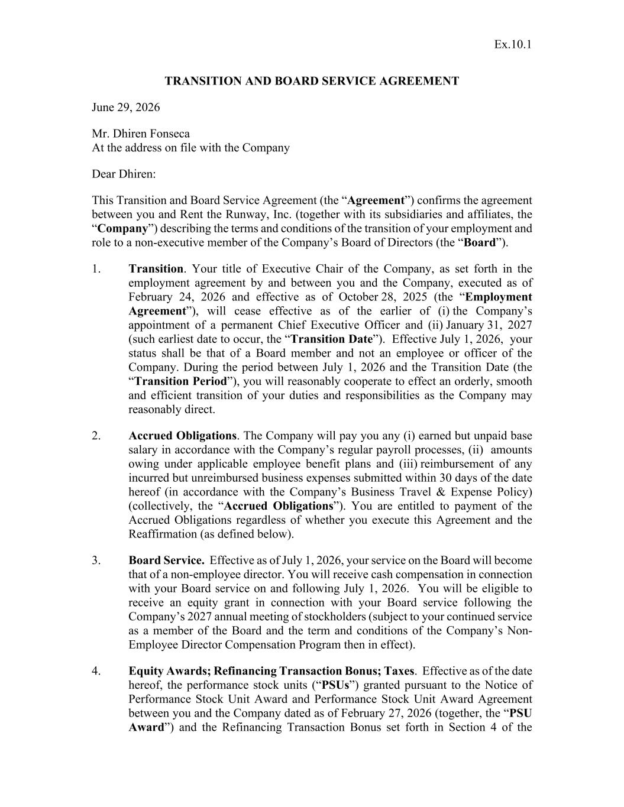
107
Ex.10.1 TRANSITION AND BOARD SERVICE AGREEMENT June 29, 2026 Mr. Dhiren Fonseca At the address on file with the Company Dear Dhiren: This Transition and Board Service Agreement (the “Agreement”) confirms the agreement between you and Rent the Runway, Inc. (together with its subsidiaries and affiliates, the “Company”) describing the terms and conditions of the transition of your employment and role to a non-executive member of the Company’s Board of Directors (the “Board”). 1. Transition. Your title of Executive Chair of the Company, as set forth in the employment agreement by and between you and the Company, executed as of February 24, 2026 and effective as of October 28, 2025 (the “Employment Agreement”), will cease effective as of the earlier of (i) the Company’s appointment of a permanent Chief Executive Officer and (ii) January 31, 2027 (such earliest date to occur, the “Transition Date”). Effective July 1, 2026, your status shall be that of a Board member and not an employee or officer of the Company. During the period between July 1, 2026 and the Transition Date (the “Transition Period”), you will reasonably cooperate to effect an orderly, smooth and efficient transition of your duties and responsibilities as the Company may reasonably direct. 2. Accrued Obligations. The Company will pay you any (i) earned but unpaid base salary in accordance with the Company’s regular payroll processes, (ii) amounts owing under applicable employee benefit plans and (iii) reimbursement of any incurred but unreimbursed business expenses submitted within 30 days of the date hereof (in accordance with the Company’s Business Travel & Expense Policy) (collectively, the “Accrued Obligations”). You are entitled to payment of the Accrued Obligations regardless of whether you execute this Agreement and the Reaffirmation (as defined below). 3. Board Service. Effective as of July 1, 2026, your service on the Board will become that of a non-employee director. You will receive cash compensation in connection with your Board service on and following July 1, 2026. You will be eligible to receive an equity grant in connection with your Board service following the Company’s 2027 annual meeting of stockholders (subject to your continued service as a member of the Board and the term and conditions of the Company’s Non- Employee Director Compensation Program then in effect). 4. Equity Awards; Refinancing Transaction Bonus; Taxes. Effective as of the date hereof, the performance stock units (“PSUs”) granted pursuant to the Notice of Performance Stock Unit Award and Performance Stock Unit Award Agreement between you and the Company dated as of February 27, 2026 (together, the “PSU Award”) and the Refinancing Transaction Bonus set forth in Section 4 of the

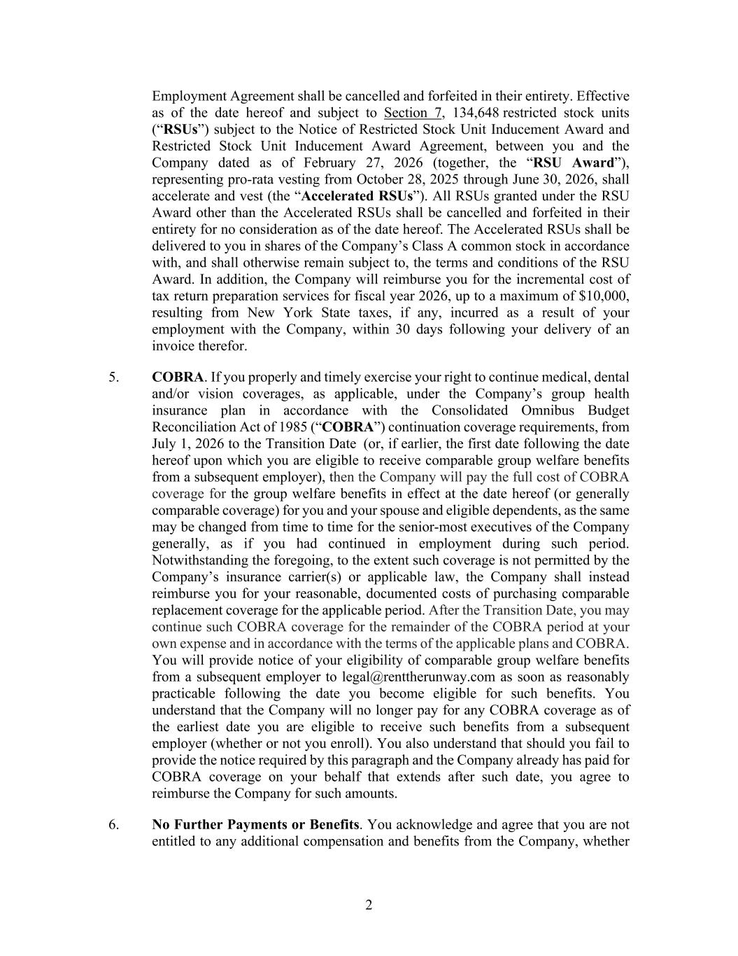
2 Employment Agreement shall be cancelled and forfeited in their entirety. Effective as of the date hereof and subject to Section 7, 134,648 restricted stock units (“RSUs”) subject to the Notice of Restricted Stock Unit Inducement Award and Restricted Stock Unit Inducement Award Agreement, between you and the Company dated as of February 27, 2026 (together, the “RSU Award”), representing pro-rata vesting from October 28, 2025 through June 30, 2026, shall accelerate and vest (the “Accelerated RSUs”). All RSUs granted under the RSU Award other than the Accelerated RSUs shall be cancelled and forfeited in their entirety for no consideration as of the date hereof. The Accelerated RSUs shall be delivered to you in shares of the Company’s Class A common stock in accordance with, and shall otherwise remain subject to, the terms and conditions of the RSU Award. In addition, the Company will reimburse you for the incremental cost of tax return preparation services for fiscal year 2026, up to a maximum of $10,000, resulting from New York State taxes, if any, incurred as a result of your employment with the Company, within 30 days following your delivery of an invoice therefor. 5. COBRA. If you properly and timely exercise your right to continue medical, dental and/or vision coverages, as applicable, under the Company’s group health insurance plan in accordance with the Consolidated Omnibus Budget Reconciliation Act of 1985 (“COBRA”) continuation coverage requirements, from July 1, 2026 to the Transition Date (or, if earlier, the first date following the date hereof upon which you are eligible to receive comparable group welfare benefits from a subsequent employer), then the Company will pay the full cost of COBRA coverage for the group welfare benefits in effect at the date hereof (or generally comparable coverage) for you and your spouse and eligible dependents, as the same may be changed from time to time for the senior-most executives of the Company generally, as if you had continued in employment during such period. Notwithstanding the foregoing, to the extent such coverage is not permitted by the Company’s insurance carrier(s) or applicable law, the Company shall instead reimburse you for your reasonable, documented costs of purchasing comparable replacement coverage for the applicable period. After the Transition Date, you may continue such COBRA coverage for the remainder of the COBRA period at your own expense and in accordance with the terms of the applicable plans and COBRA. You will provide notice of your eligibility of comparable group welfare benefits from a subsequent employer to legal@renttherunway.com as soon as reasonably practicable following the date you become eligible for such benefits. You understand that the Company will no longer pay for any COBRA coverage as of the earliest date you are eligible to receive such benefits from a subsequent employer (whether or not you enroll). You also understand that should you fail to provide the notice required by this paragraph and the Company already has paid for COBRA coverage on your behalf that extends after such date, you agree to reimburse the Company for such amounts. 6. No Further Payments or Benefits. You acknowledge and agree that you are not entitled to any additional compensation and benefits from the Company, whether

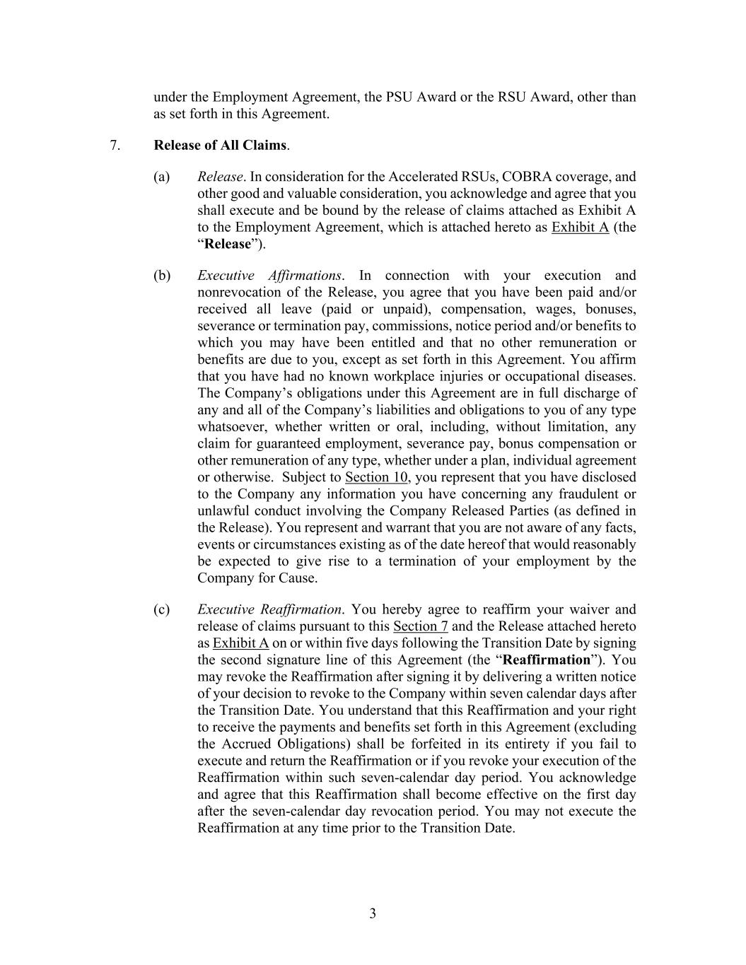
3 under the Employment Agreement, the PSU Award or the RSU Award, other than as set forth in this Agreement. 7. Release of All Claims. (a) Release. In consideration for the Accelerated RSUs, COBRA coverage, and other good and valuable consideration, you acknowledge and agree that you shall execute and be bound by the release of claims attached as Exhibit A to the Employment Agreement, which is attached hereto as Exhibit A (the “Release”). (b) Executive Affirmations. In connection with your execution and nonrevocation of the Release, you agree that you have been paid and/or received all leave (paid or unpaid), compensation, wages, bonuses, severance or termination pay, commissions, notice period and/or benefits to which you may have been entitled and that no other remuneration or benefits are due to you, except as set forth in this Agreement. You affirm that you have had no known workplace injuries or occupational diseases. The Company’s obligations under this Agreement are in full discharge of any and all of the Company’s liabilities and obligations to you of any type whatsoever, whether written or oral, including, without limitation, any claim for guaranteed employment, severance pay, bonus compensation or other remuneration of any type, whether under a plan, individual agreement or otherwise. Subject to Section 10, you represent that you have disclosed to the Company any information you have concerning any fraudulent or unlawful conduct involving the Company Released Parties (as defined in the Release). You represent and warrant that you are not aware of any facts, events or circumstances existing as of the date hereof that would reasonably be expected to give rise to a termination of your employment by the Company for Cause. (c) Executive Reaffirmation. You hereby agree to reaffirm your waiver and release of claims pursuant to this Section 7 and the Release attached hereto as Exhibit A on or within five days following the Transition Date by signing the second signature line of this Agreement (the “Reaffirmation”). You may revoke the Reaffirmation after signing it by delivering a written notice of your decision to revoke to the Company within seven calendar days after the Transition Date. You understand that this Reaffirmation and your right to receive the payments and benefits set forth in this Agreement (excluding the Accrued Obligations) shall be forfeited in its entirety if you fail to execute and return the Reaffirmation or if you revoke your execution of the Reaffirmation within such seven-calendar day period. You acknowledge and agree that this Reaffirmation shall become effective on the first day after the seven-calendar day revocation period. You may not execute the Reaffirmation at any time prior to the Transition Date.

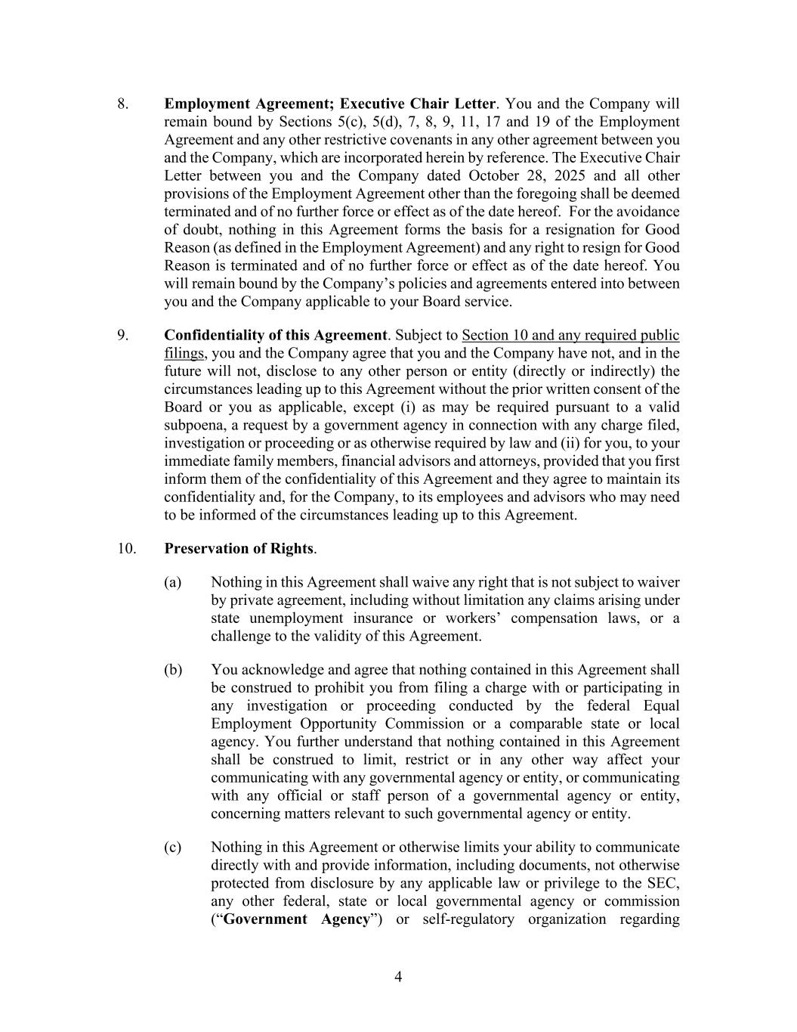
4 8. Employment Agreement; Executive Chair Letter. You and the Company will remain bound by Sections 5(c), 5(d), 7, 8, 9, 11, 17 and 19 of the Employment Agreement and any other restrictive covenants in any other agreement between you and the Company, which are incorporated herein by reference. The Executive Chair Letter between you and the Company dated October 28, 2025 and all other provisions of the Employment Agreement other than the foregoing shall be deemed terminated and of no further force or effect as of the date hereof. For the avoidance of doubt, nothing in this Agreement forms the basis for a resignation for Good Reason (as defined in the Employment Agreement) and any right to resign for Good Reason is terminated and of no further force or effect as of the date hereof. You will remain bound by the Company’s policies and agreements entered into between you and the Company applicable to your Board service. 9. Confidentiality of this Agreement. Subject to Section 10 and any required public filings, you and the Company agree that you and the Company have not, and in the future will not, disclose to any other person or entity (directly or indirectly) the circumstances leading up to this Agreement without the prior written consent of the Board or you as applicable, except (i) as may be required pursuant to a valid subpoena, a request by a government agency in connection with any charge filed, investigation or proceeding or as otherwise required by law and (ii) for you, to your immediate family members, financial advisors and attorneys, provided that you first inform them of the confidentiality of this Agreement and they agree to maintain its confidentiality and, for the Company, to its employees and advisors who may need to be informed of the circumstances leading up to this Agreement. 10. Preservation of Rights. (a) Nothing in this Agreement shall waive any right that is not subject to waiver by private agreement, including without limitation any claims arising under state unemployment insurance or workers’ compensation laws, or a challenge to the validity of this Agreement. (b) You acknowledge and agree that nothing contained in this Agreement shall be construed to prohibit you from filing a charge with or participating in any investigation or proceeding conducted by the federal Equal Employment Opportunity Commission or a comparable state or local agency. You further understand that nothing contained in this Agreement shall be construed to limit, restrict or in any other way affect your communicating with any governmental agency or entity, or communicating with any official or staff person of a governmental agency or entity, concerning matters relevant to such governmental agency or entity. (c) Nothing in this Agreement or otherwise limits your ability to communicate directly with and provide information, including documents, not otherwise protected from disclosure by any applicable law or privilege to the SEC, any other federal, state or local governmental agency or commission (“Government Agency”) or self-regulatory organization regarding

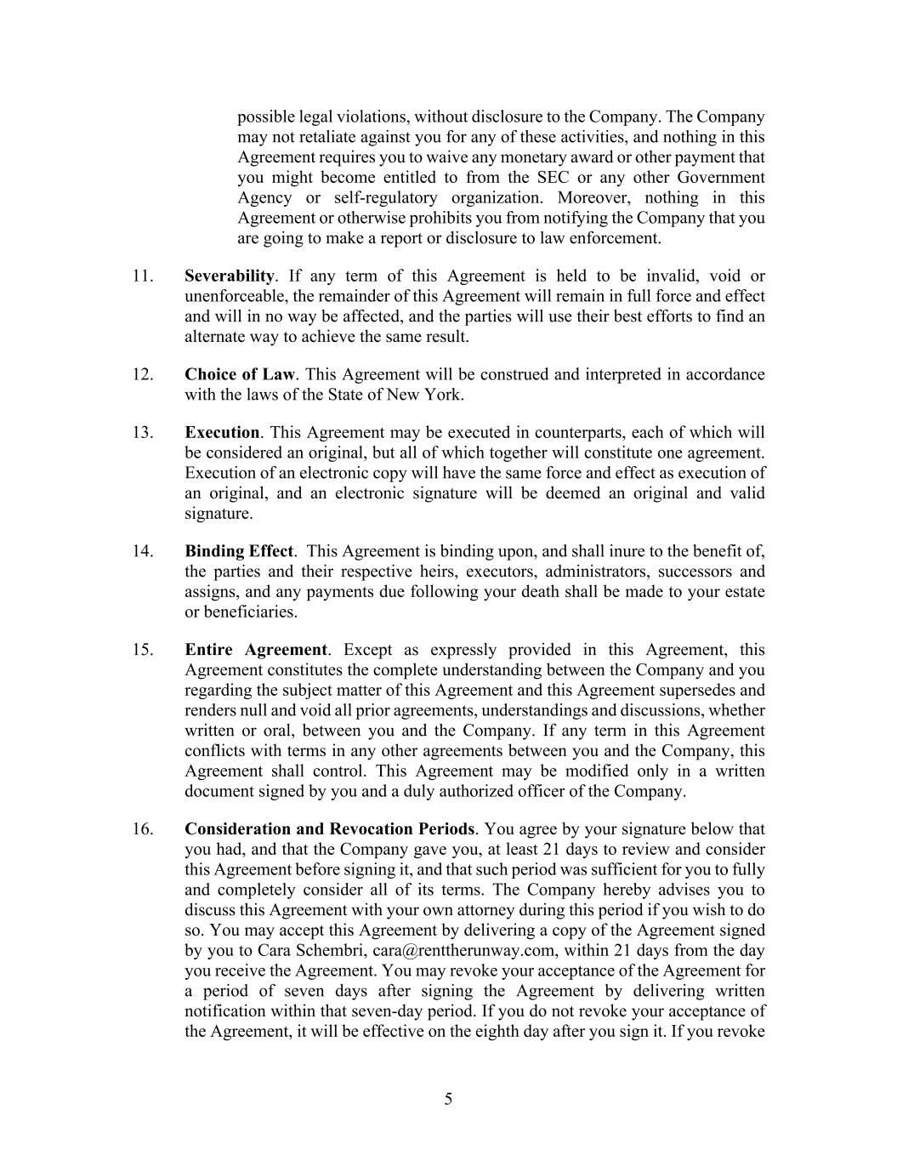
5 possible legal violations, without disclosure to the Company. The Company may not retaliate against you for any of these activities, and nothing in this Agreement requires you to waive any monetary award or other payment that you might become entitled to from the SEC or any other Government Agency or self-regulatory organization. Moreover, nothing in this Agreement or otherwise prohibits you from notifying the Company that you are going to make a report or disclosure to law enforcement. 11. Severability. If any term of this Agreement is held to be invalid, void or unenforceable, the remainder of this Agreement will remain in full force and effect and will in no way be affected, and the parties will use their best efforts to find an alternate way to achieve the same result. 12. Choice of Law. This Agreement will be construed and interpreted in accordance with the laws of the State of New York. 13. Execution. This Agreement may be executed in counterparts, each of which will be considered an original, but all of which together will constitute one agreement. Execution of an electronic copy will have the same force and effect as execution of an original, and an electronic signature will be deemed an original and valid signature. 14. Binding Effect. This Agreement is binding upon, and shall inure to the benefit of, the parties and their respective heirs, executors, administrators, successors and assigns, and any payments due following your death shall be made to your estate or beneficiaries. 15. Entire Agreement. Except as expressly provided in this Agreement, this Agreement constitutes the complete understanding between the Company and you regarding the subject matter of this Agreement and this Agreement supersedes and renders null and void all prior agreements, understandings and discussions, whether written or oral, between you and the Company. If any term in this Agreement conflicts with terms in any other agreements between you and the Company, this Agreement shall control. This Agreement may be modified only in a written document signed by you and a duly authorized officer of the Company. 16. Consideration and Revocation Periods. You agree by your signature below that you had, and that the Company gave you, at least 21 days to review and consider this Agreement before signing it, and that such period was sufficient for you to fully and completely consider all of its terms. The Company hereby advises you to discuss this Agreement with your own attorney during this period if you wish to do so. You may accept this Agreement by delivering a copy of the Agreement signed by you to Cara Schembri, cara@renttherunway.com, within 21 days from the day you receive the Agreement. You may revoke your acceptance of the Agreement for a period of seven days after signing the Agreement by delivering written notification within that seven-day period. If you do not revoke your acceptance of the Agreement, it will be effective on the eighth day after you sign it. If you revoke


6 your acceptance of this Agreement, you will not be entitled to the compensation, benefits and other consideration provided for herein. You agree that you have carefully read this Agreement, fully understand what it means and are entering into it voluntarily without duress, coercion, fraud, misrepresentation or threat to withdraw or alter the offer prior to the expiration of the 21-day consideration period. [Signature Page Follows]

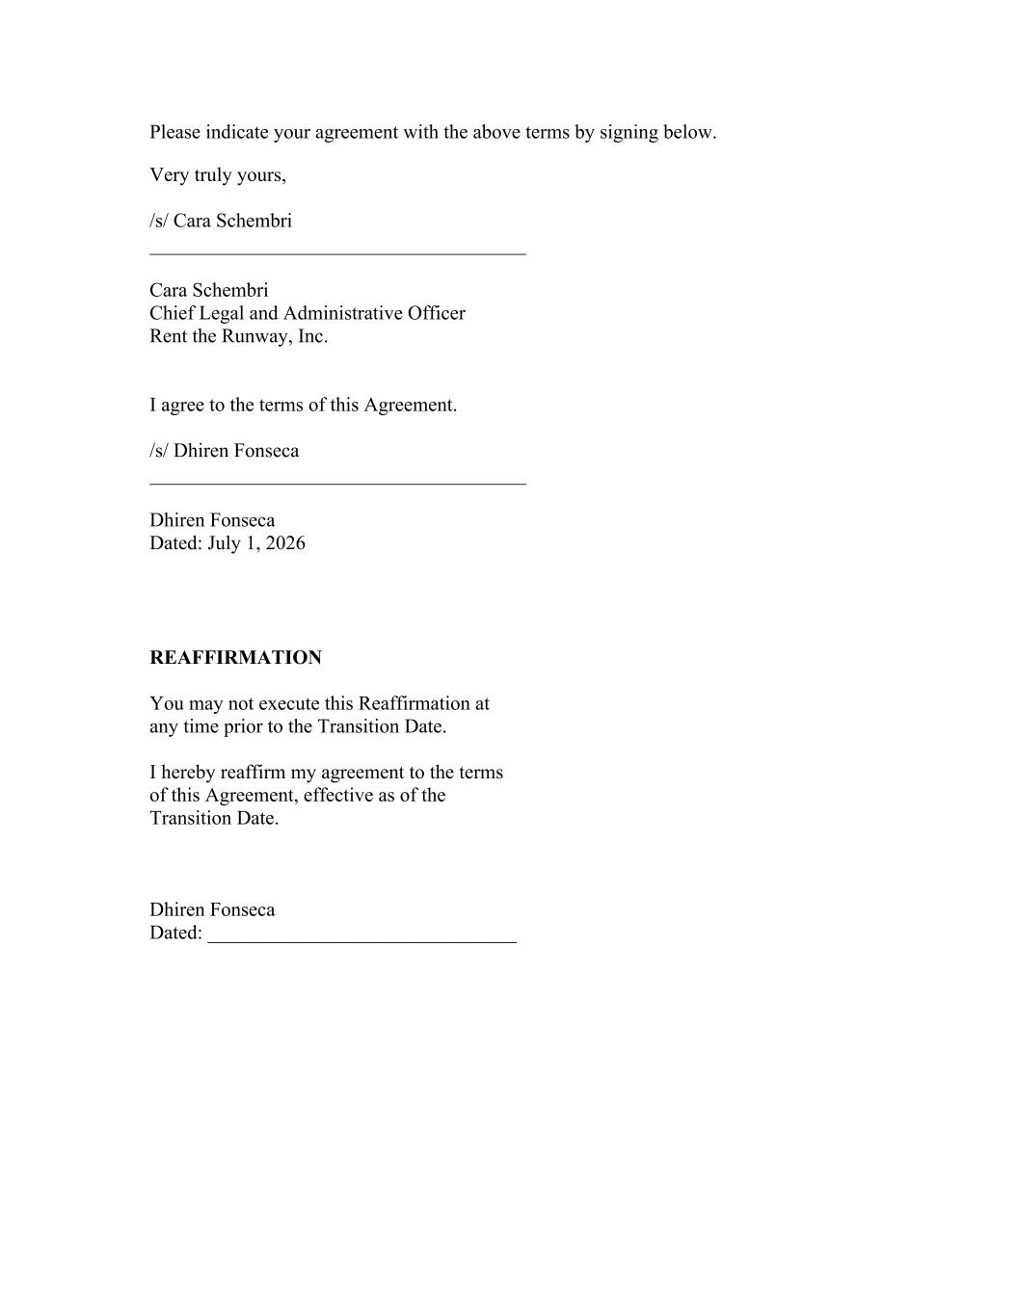
Please indicate your agreement with the above terms by signing below. Very truly yours, /s/ Cara Schembri Cara Schembri Chief Legal and Administrative Officer Rent the Runway, Inc. I agree to the terms of this Agreement. /s/ Dhiren Fonseca Dhiren Fonseca Dated: July 1, 2026 REAFFIRMATION You may not execute this Reaffirmation at any time prior to the Transition Date. I hereby reaffirm my agreement to the terms of this Agreement, effective as of the Transition Date. Dhiren Fonseca Dated: _______________________________

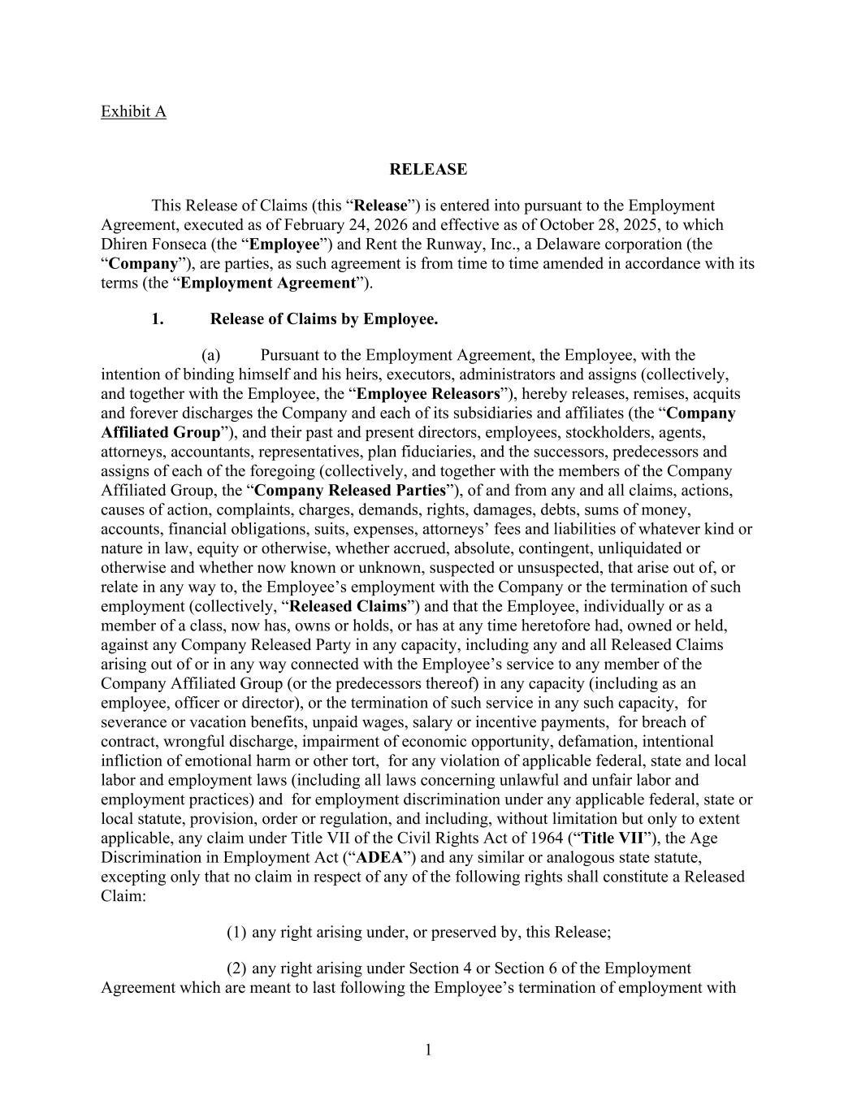
1 Exhibit A RELEASE This Release of Claims (this “Release”) is entered into pursuant to the Employment Agreement, executed as of February 24, 2026 and effective as of October 28, 2025, to which Dhiren Fonseca (the “Employee”) and Rent the Runway, Inc., a Delaware corporation (the “Company”), are parties, as such agreement is from time to time amended in accordance with its terms (the “Employment Agreement”). 1. Release of Claims by Employee. (a) Pursuant to the Employment Agreement, the Employee, with the intention of binding himself and his heirs, executors, administrators and assigns (collectively, and together with the Employee, the “Employee Releasors”), hereby releases, remises, acquits and forever discharges the Company and each of its subsidiaries and affiliates (the “Company Affiliated Group”), and their past and present directors, employees, stockholders, agents, attorneys, accountants, representatives, plan fiduciaries, and the successors, predecessors and assigns of each of the foregoing (collectively, and together with the members of the Company Affiliated Group, the “Company Released Parties”), of and from any and all claims, actions, causes of action, complaints, charges, demands, rights, damages, debts, sums of money, accounts, financial obligations, suits, expenses, attorneys’ fees and liabilities of whatever kind or nature in law, equity or otherwise, whether accrued, absolute, contingent, unliquidated or otherwise and whether now known or unknown, suspected or unsuspected, that arise out of, or relate in any way to, the Employee’s employment with the Company or the termination of such employment (collectively, “Released Claims”) and that the Employee, individually or as a member of a class, now has, owns or holds, or has at any time heretofore had, owned or held, against any Company Released Party in any capacity, including any and all Released Claims arising out of or in any way connected with the Employee’s service to any member of the Company Affiliated Group (or the predecessors thereof) in any capacity (including as an employee, officer or director), or the termination of such service in any such capacity, for severance or vacation benefits, unpaid wages, salary or incentive payments, for breach of contract, wrongful discharge, impairment of economic opportunity, defamation, intentional infliction of emotional harm or other tort, for any violation of applicable federal, state and local labor and employment laws (including all laws concerning unlawful and unfair labor and employment practices) and for employment discrimination under any applicable federal, state or local statute, provision, order or regulation, and including, without limitation but only to extent applicable, any claim under Title VII of the Civil Rights Act of 1964 (“Title VII”), the Age Discrimination in Employment Act (“ADEA”) and any similar or analogous state statute, excepting only that no claim in respect of any of the following rights shall constitute a Released Claim: (1) any right arising under, or preserved by, this Release; (2) any right arising under Section 4 or Section 6 of the Employment Agreement which are meant to last following the Employee’s termination of employment with

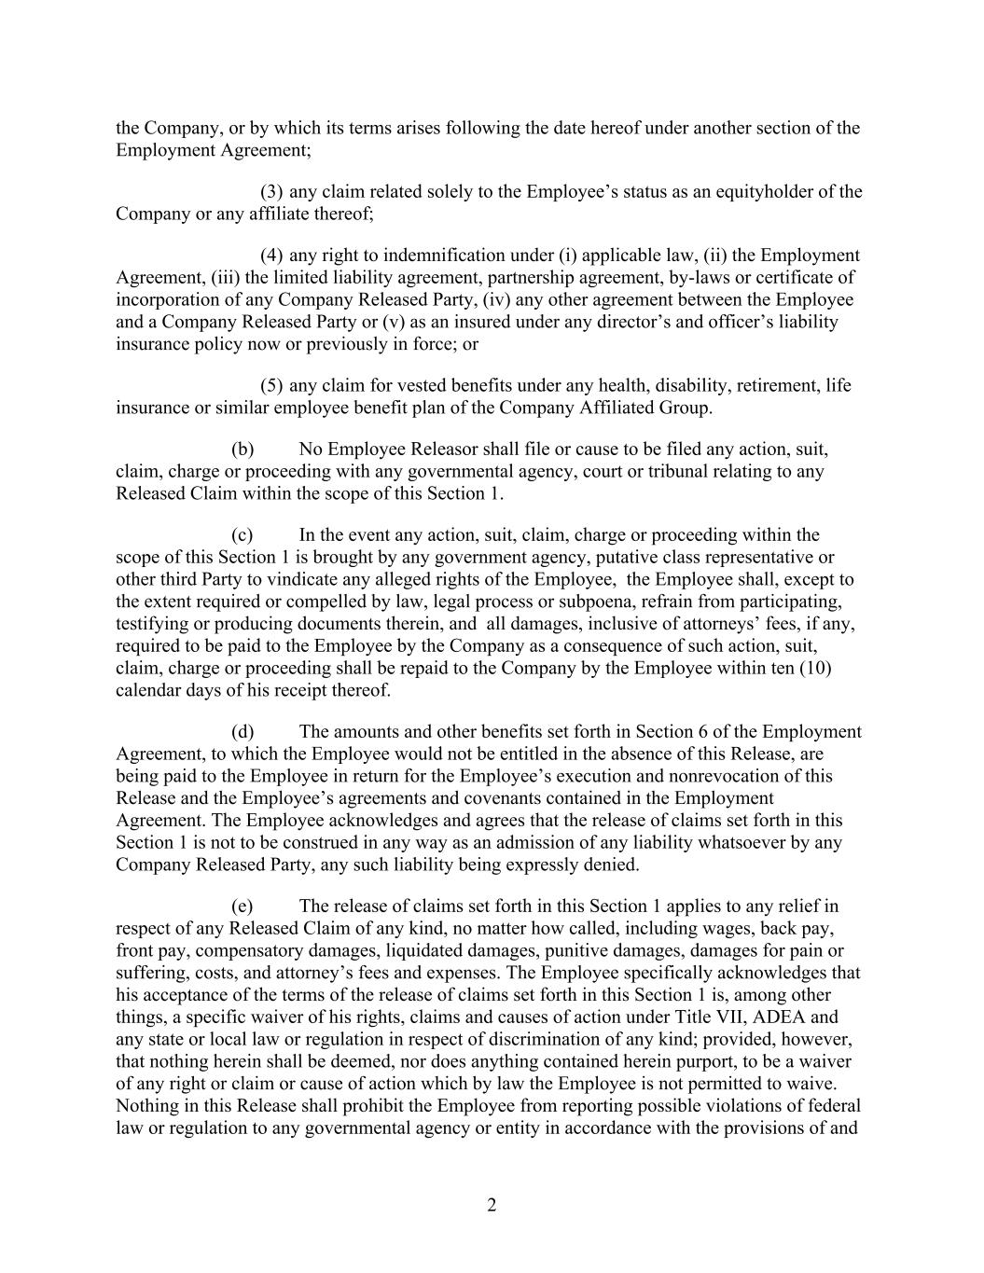
2 the Company, or by which its terms arises following the date hereof under another section of the Employment Agreement; (3) any claim related solely to the Employee’s status as an equityholder of the Company or any affiliate thereof; (4) any right to indemnification under (i) applicable law, (ii) the Employment Agreement, (iii) the limited liability agreement, partnership agreement, by-laws or certificate of incorporation of any Company Released Party, (iv) any other agreement between the Employee and a Company Released Party or (v) as an insured under any director’s and officer’s liability insurance policy now or previously in force; or (5) any claim for vested benefits under any health, disability, retirement, life insurance or similar employee benefit plan of the Company Affiliated Group. (b) No Employee Releasor shall file or cause to be filed any action, suit, claim, charge or proceeding with any governmental agency, court or tribunal relating to any Released Claim within the scope of this Section 1. (c) In the event any action, suit, claim, charge or proceeding within the scope of this Section 1 is brought by any government agency, putative class representative or other third Party to vindicate any alleged rights of the Employee, the Employee shall, except to the extent required or compelled by law, legal process or subpoena, refrain from participating, testifying or producing documents therein, and all damages, inclusive of attorneys’ fees, if any, required to be paid to the Employee by the Company as a consequence of such action, suit, claim, charge or proceeding shall be repaid to the Company by the Employee within ten (10) calendar days of his receipt thereof. (d) The amounts and other benefits set forth in Section 6 of the Employment Agreement, to which the Employee would not be entitled in the absence of this Release, are being paid to the Employee in return for the Employee’s execution and nonrevocation of this Release and the Employee’s agreements and covenants contained in the Employment Agreement. The Employee acknowledges and agrees that the release of claims set forth in this Section 1 is not to be construed in any way as an admission of any liability whatsoever by any Company Released Party, any such liability being expressly denied. (e) The release of claims set forth in this Section 1 applies to any relief in respect of any Released Claim of any kind, no matter how called, including wages, back pay, front pay, compensatory damages, liquidated damages, punitive damages, damages for pain or suffering, costs, and attorney’s fees and expenses. The Employee specifically acknowledges that his acceptance of the terms of the release of claims set forth in this Section 1 is, among other things, a specific waiver of his rights, claims and causes of action under Title VII, ADEA and any state or local law or regulation in respect of discrimination of any kind; provided, however, that nothing herein shall be deemed, nor does anything contained herein purport, to be a waiver of any right or claim or cause of action which by law the Employee is not permitted to waive. Nothing in this Release shall prohibit the Employee from reporting possible violations of federal law or regulation to any governmental agency or entity in accordance with the provisions of and

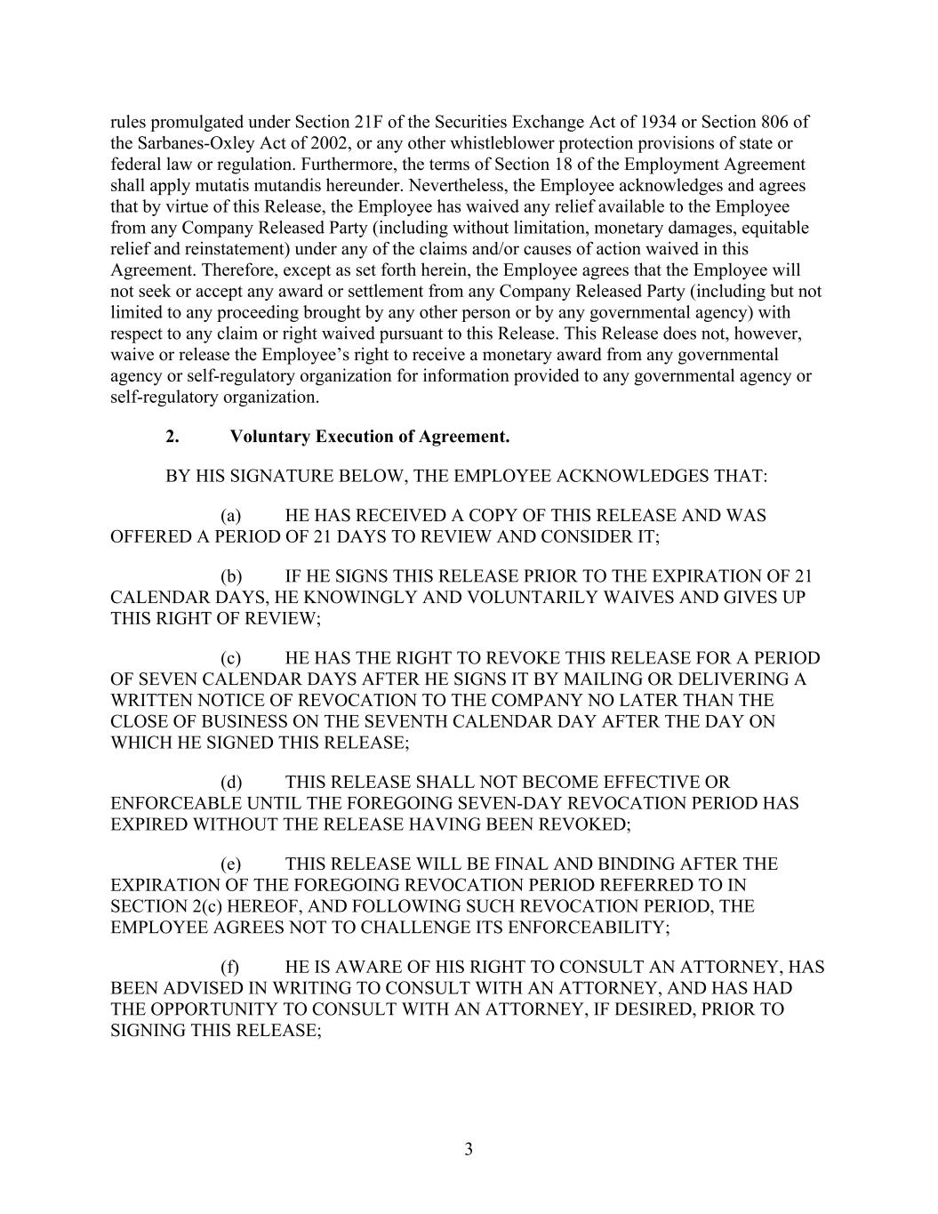
3 rules promulgated under Section 21F of the Securities Exchange Act of 1934 or Section 806 of the Sarbanes-Oxley Act of 2002, or any other whistleblower protection provisions of state or federal law or regulation. Furthermore, the terms of Section 18 of the Employment Agreement shall apply mutatis mutandis hereunder. Nevertheless, the Employee acknowledges and agrees that by virtue of this Release, the Employee has waived any relief available to the Employee from any Company Released Party (including without limitation, monetary damages, equitable relief and reinstatement) under any of the claims and/or causes of action waived in this Agreement. Therefore, except as set forth herein, the Employee agrees that the Employee will not seek or accept any award or settlement from any Company Released Party (including but not limited to any proceeding brought by any other person or by any governmental agency) with respect to any claim or right waived pursuant to this Release. This Release does not, however, waive or release the Employee’s right to receive a monetary award from any governmental agency or self-regulatory organization for information provided to any governmental agency or self-regulatory organization. 2. Voluntary Execution of Agreement. BY HIS SIGNATURE BELOW, THE EMPLOYEE ACKNOWLEDGES THAT: (a) HE HAS RECEIVED A COPY OF THIS RELEASE AND WAS OFFERED A PERIOD OF 21 DAYS TO REVIEW AND CONSIDER IT; (b) IF HE SIGNS THIS RELEASE PRIOR TO THE EXPIRATION OF 21 CALENDAR DAYS, HE KNOWINGLY AND VOLUNTARILY WAIVES AND GIVES UP THIS RIGHT OF REVIEW; (c) HE HAS THE RIGHT TO REVOKE THIS RELEASE FOR A PERIOD OF SEVEN CALENDAR DAYS AFTER HE SIGNS IT BY MAILING OR DELIVERING A WRITTEN NOTICE OF REVOCATION TO THE COMPANY NO LATER THAN THE CLOSE OF BUSINESS ON THE SEVENTH CALENDAR DAY AFTER THE DAY ON WHICH HE SIGNED THIS RELEASE; (d) THIS RELEASE SHALL NOT BECOME EFFECTIVE OR ENFORCEABLE UNTIL THE FOREGOING SEVEN-DAY REVOCATION PERIOD HAS EXPIRED WITHOUT THE RELEASE HAVING BEEN REVOKED; (e) THIS RELEASE WILL BE FINAL AND BINDING AFTER THE EXPIRATION OF THE FOREGOING REVOCATION PERIOD REFERRED TO IN SECTION 2(c) HEREOF, AND FOLLOWING SUCH REVOCATION PERIOD, THE EMPLOYEE AGREES NOT TO CHALLENGE ITS ENFORCEABILITY; (f) HE IS AWARE OF HIS RIGHT TO CONSULT AN ATTORNEY, HAS BEEN ADVISED IN WRITING TO CONSULT WITH AN ATTORNEY, AND HAS HAD THE OPPORTUNITY TO CONSULT WITH AN ATTORNEY, IF DESIRED, PRIOR TO SIGNING THIS RELEASE;

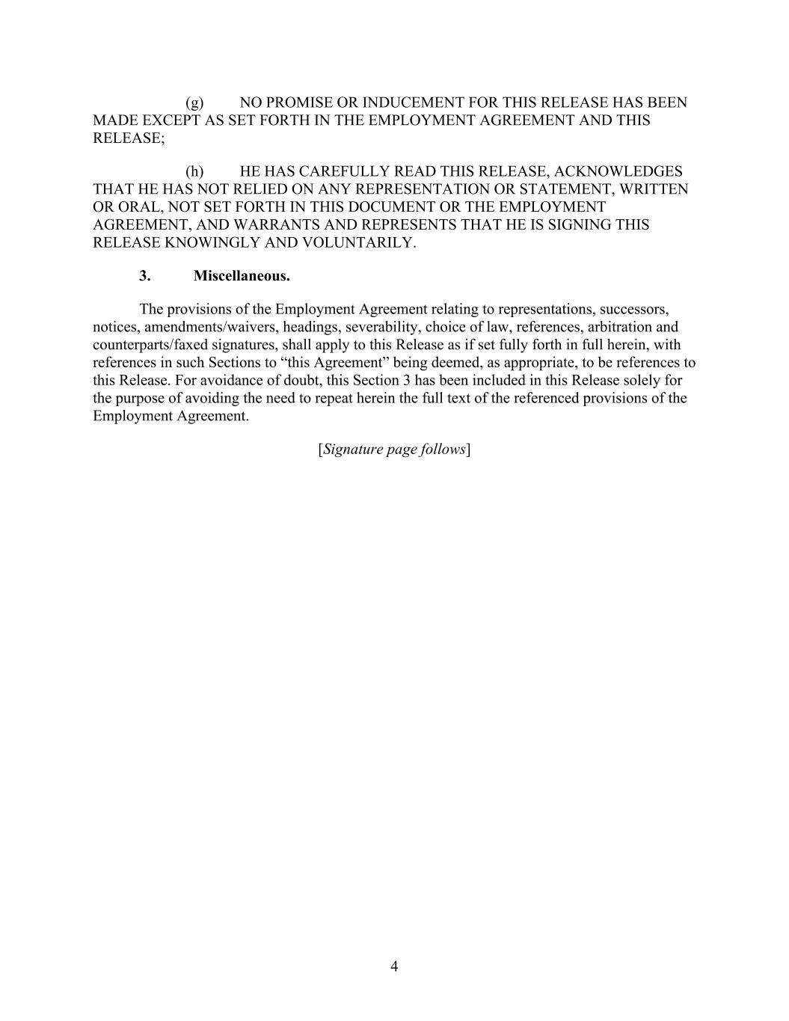
4 (g) NO PROMISE OR INDUCEMENT FOR THIS RELEASE HAS BEEN MADE EXCEPT AS SET FORTH IN THE EMPLOYMENT AGREEMENT AND THIS RELEASE; (h) HE HAS CAREFULLY READ THIS RELEASE, ACKNOWLEDGES THAT HE HAS NOT RELIED ON ANY REPRESENTATION OR STATEMENT, WRITTEN OR ORAL, NOT SET FORTH IN THIS DOCUMENT OR THE EMPLOYMENT AGREEMENT, AND WARRANTS AND REPRESENTS THAT HE IS SIGNING THIS RELEASE KNOWINGLY AND VOLUNTARILY. 3. Miscellaneous. The provisions of the Employment Agreement relating to representations, successors, notices, amendments/waivers, headings, severability, choice of law, references, arbitration and counterparts/faxed signatures, shall apply to this Release as if set fully forth in full herein, with references in such Sections to “this Agreement” being deemed, as appropriate, to be references to this Release. For avoidance of doubt, this Section 3 has been included in this Release solely for the purpose of avoiding the need to repeat herein the full text of the referenced provisions of the Employment Agreement. [Signature page follows]

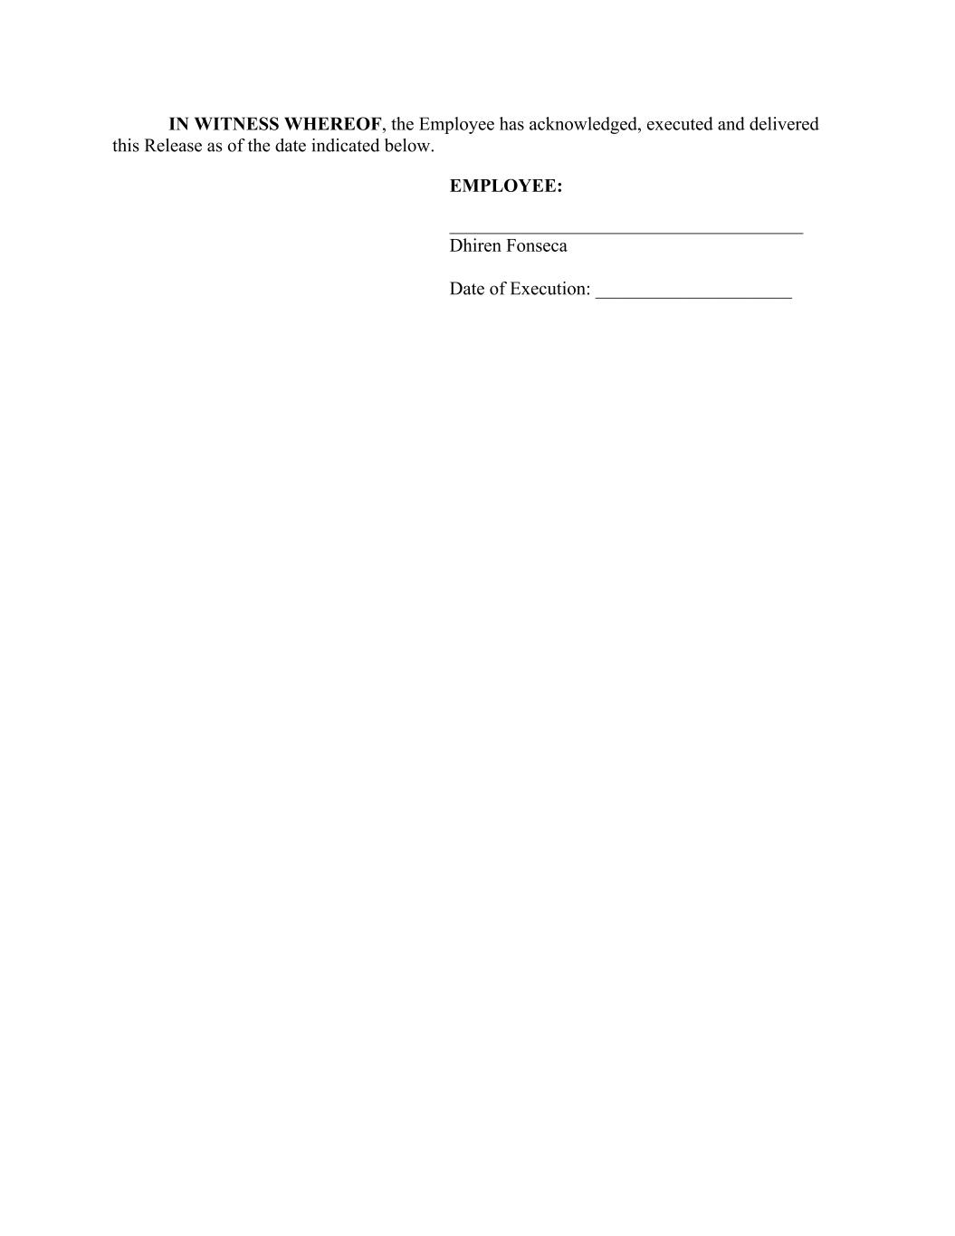
IN WITNESS WHEREOF, the Employee has acknowledged, executed and delivered this Release as of the date indicated below. EMPLOYEE: Dhiren Fonseca Date of Execution: _____________________

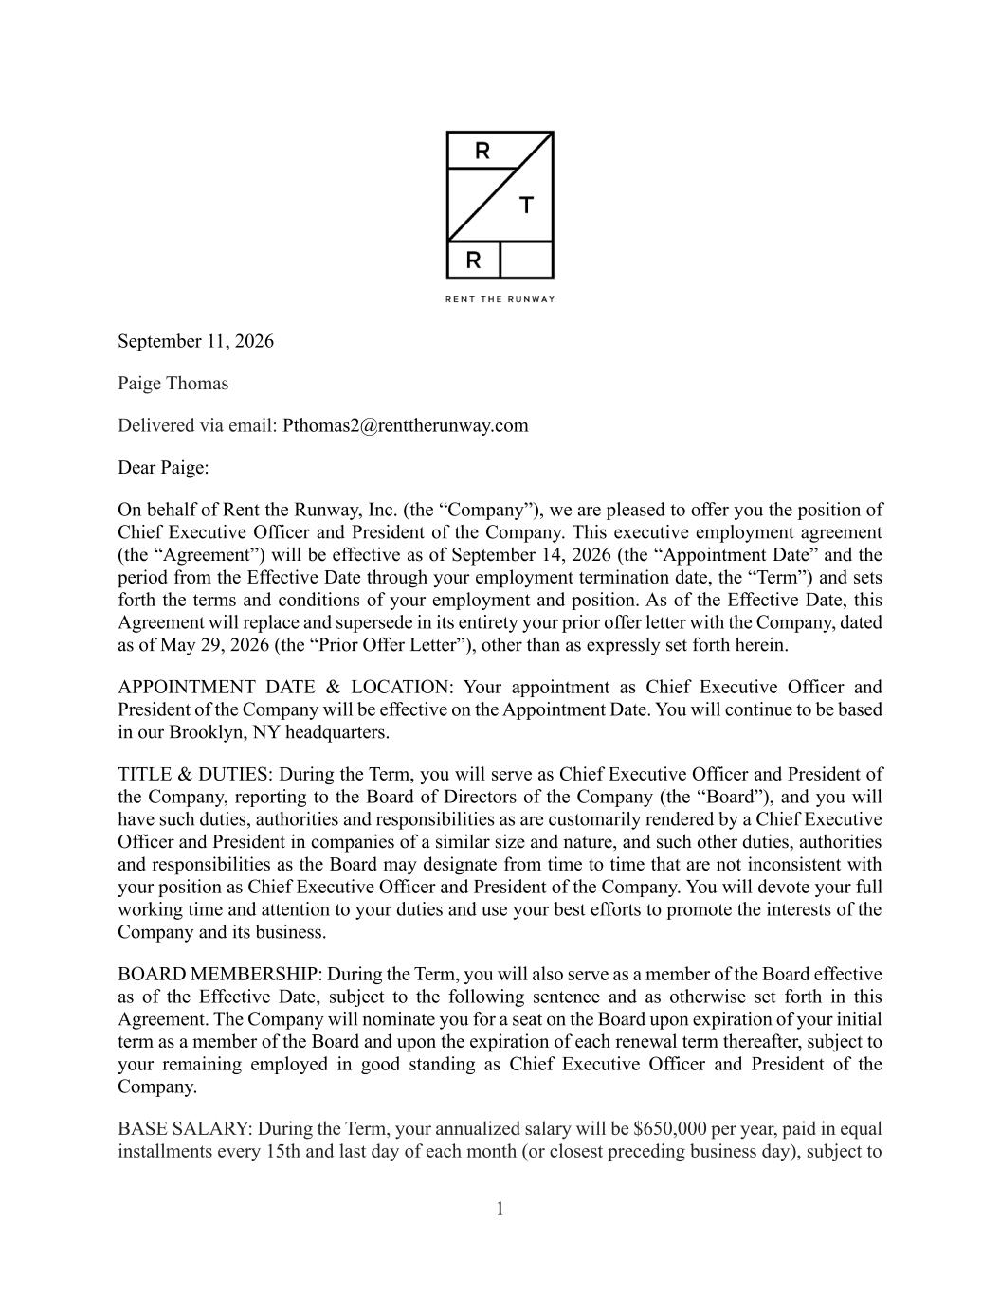
1 September 11, 2026 Paige Thomas Delivered via email: Pthomas2@renttherunway.com Dear Paige: On behalf of Rent the Runway, Inc. (the “Company”), we are pleased to offer you the position of Chief Executive Officer and President of the Company. This executive employment agreement (the “Agreement”) will be effective as of September 14, 2026 (the “Appointment Date” and the period from the Effective Date through your employment termination date, the “Term”) and sets forth the terms and conditions of your employment and position. As of the Effective Date, this Agreement will replace and supersede in its entirety your prior offer letter with the Company, dated as of May 29, 2026 (the “Prior Offer Letter”), other than as expressly set forth herein. APPOINTMENT DATE & LOCATION: Your appointment as Chief Executive Officer and President of the Company will be effective on the Appointment Date. You will continue to be based in our Brooklyn, NY headquarters. TITLE & DUTIES: During the Term, you will serve as Chief Executive Officer and President of the Company, reporting to the Board of Directors of the Company (the “Board”), and you will have such duties, authorities and responsibilities as are customarily rendered by a Chief Executive Officer and President in companies of a similar size and nature, and such other duties, authorities and responsibilities as the Board may designate from time to time that are not inconsistent with your position as Chief Executive Officer and President of the Company. You will devote your full working time and attention to your duties and use your best efforts to promote the interests of the Company and its business. BOARD MEMBERSHIP: During the Term, you will also serve as a member of the Board effective as of the Effective Date, subject to the following sentence and as otherwise set forth in this Agreement. The Company will nominate you for a seat on the Board upon expiration of your initial term as a member of the Board and upon the expiration of each renewal term thereafter, subject to your remaining employed in good standing as Chief Executive Officer and President of the Company. BASE SALARY: During the Term, your annualized salary will be $650,000 per year, paid in equal installments every 15th and last day of each month (or closest preceding business day), subject to

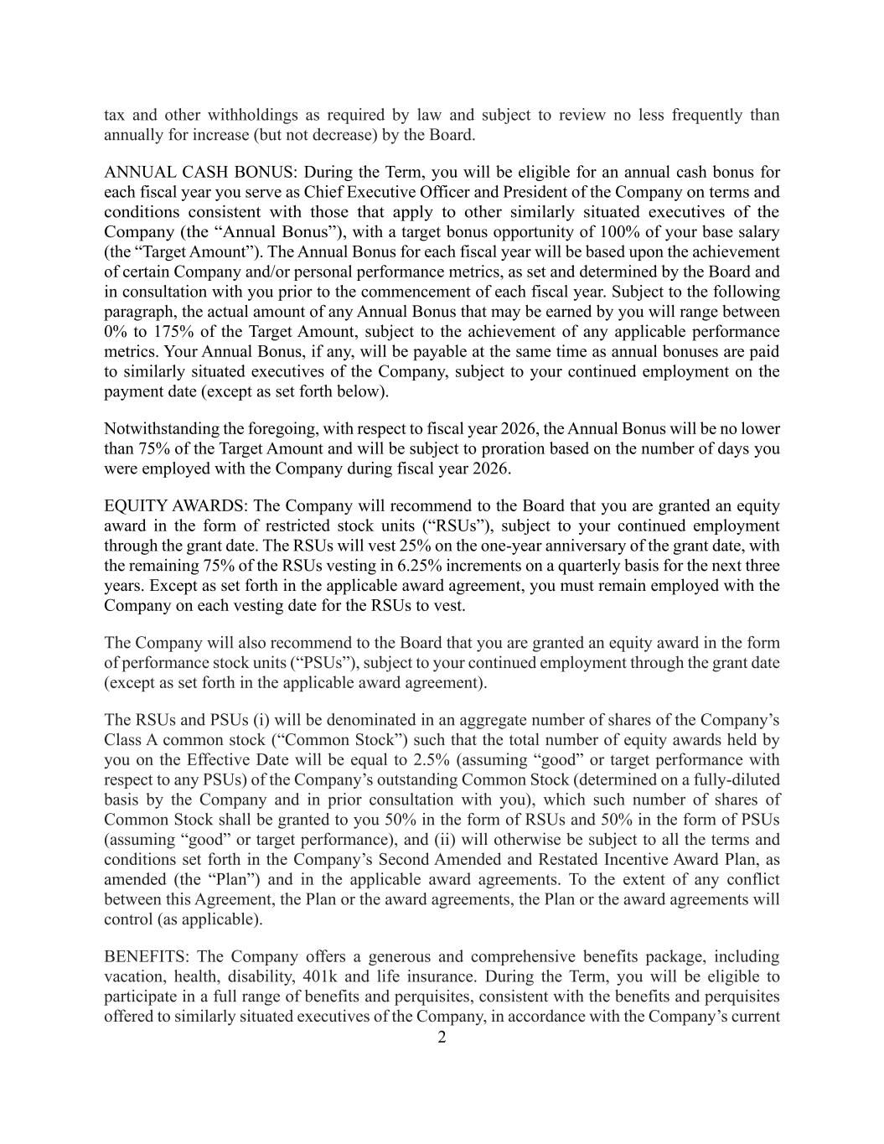
2 tax and other withholdings as required by law and subject to review no less frequently than annually for increase (but not decrease) by the Board. ANNUAL CASH BONUS: During the Term, you will be eligible for an annual cash bonus for each fiscal year you serve as Chief Executive Officer and President of the Company on terms and conditions consistent with those that apply to other similarly situated executives of the Company (the “Annual Bonus”), with a target bonus opportunity of 100% of your base salary (the “Target Amount”). The Annual Bonus for each fiscal year will be based upon the achievement of certain Company and/or personal performance metrics, as set and determined by the Board and in consultation with you prior to the commencement of each fiscal year. Subject to the following paragraph, the actual amount of any Annual Bonus that may be earned by you will range between 0% to 175% of the Target Amount, subject to the achievement of any applicable performance metrics. Your Annual Bonus, if any, will be payable at the same time as annual bonuses are paid to similarly situated executives of the Company, subject to your continued employment on the payment date (except as set forth below). Notwithstanding the foregoing, with respect to fiscal year 2026, the Annual Bonus will be no lower than 75% of the Target Amount and will be subject to proration based on the number of days you were employed with the Company during fiscal year 2026. EQUITY AWARDS: The Company will recommend to the Board that you are granted an equity award in the form of restricted stock units (“RSUs”), subject to your continued employment through the grant date. The RSUs will vest 25% on the one-year anniversary of the grant date, with the remaining 75% of the RSUs vesting in 6.25% increments on a quarterly basis for the next three years. Except as set forth in the applicable award agreement, you must remain employed with the Company on each vesting date for the RSUs to vest. The Company will also recommend to the Board that you are granted an equity award in the form of performance stock units (“PSUs”), subject to your continued employment through the grant date (except as set forth in the applicable award agreement). The RSUs and PSUs (i) will be denominated in an aggregate number of shares of the Company’s Class A common stock (“Common Stock”) such that the total number of equity awards held by you on the Effective Date will be equal to 2.5% (assuming “good” or target performance with respect to any PSUs) of the Company’s outstanding Common Stock (determined on a fully-diluted basis by the Company and in prior consultation with you), which such number of shares of Common Stock shall be granted to you 50% in the form of RSUs and 50% in the form of PSUs (assuming “good” or target performance), and (ii) will otherwise be subject to all the terms and conditions set forth in the Company’s Second Amended and Restated Incentive Award Plan, as amended (the “Plan”) and in the applicable award agreements. To the extent of any conflict between this Agreement, the Plan or the award agreements, the Plan or the award agreements will control (as applicable). BENEFITS: The Company offers a generous and comprehensive benefits package, including vacation, health, disability, 401k and life insurance. During the Term, you will be eligible to participate in a full range of benefits and perquisites, consistent with the benefits and perquisites offered to similarly situated executives of the Company, in accordance with the Company’s current

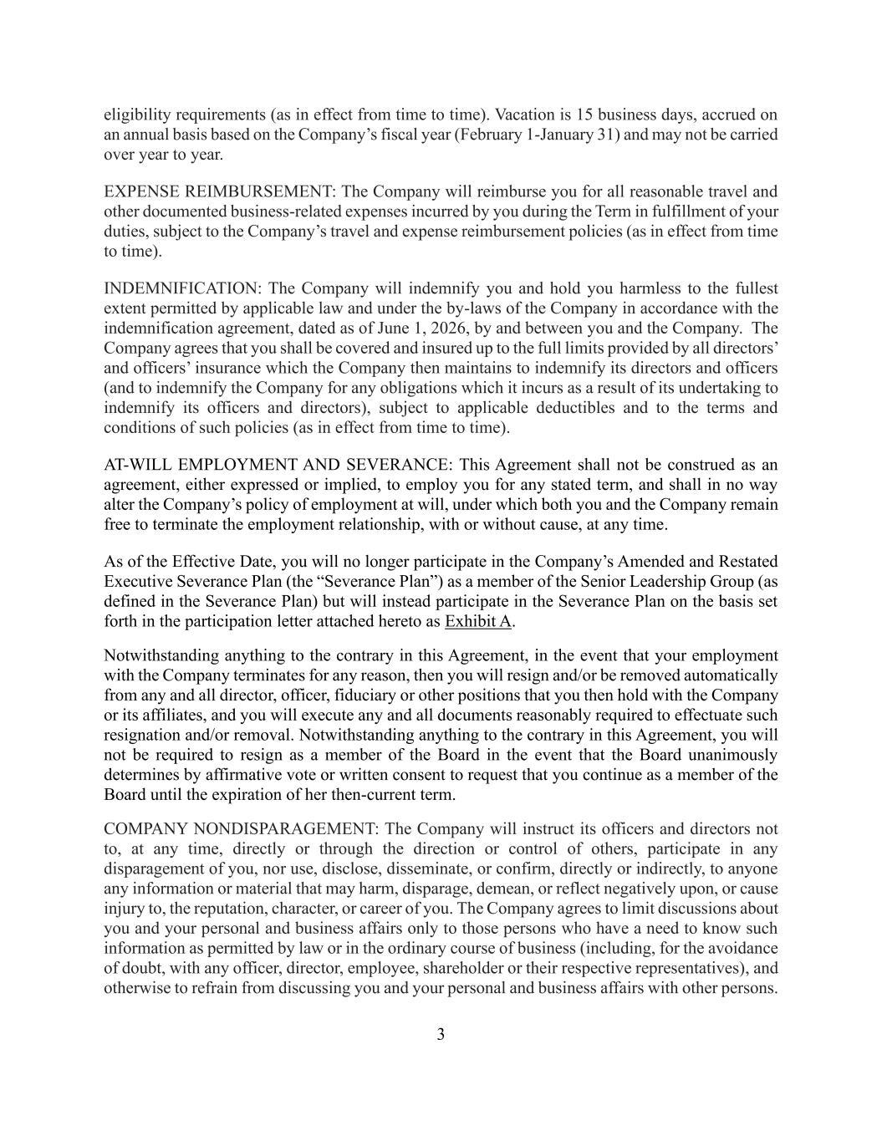
3 eligibility requirements (as in effect from time to time). Vacation is 15 business days, accrued on an annual basis based on the Company’s fiscal year (February 1-January 31) and may not be carried over year to year. EXPENSE REIMBURSEMENT: The Company will reimburse you for all reasonable travel and other documented business-related expenses incurred by you during the Term in fulfillment of your duties, subject to the Company’s travel and expense reimbursement policies (as in effect from time to time). INDEMNIFICATION: The Company will indemnify you and hold you harmless to the fullest extent permitted by applicable law and under the by-laws of the Company in accordance with the indemnification agreement, dated as of June 1, 2026, by and between you and the Company. The Company agrees that you shall be covered and insured up to the full limits provided by all directors’ and officers’ insurance which the Company then maintains to indemnify its directors and officers (and to indemnify the Company for any obligations which it incurs as a result of its undertaking to indemnify its officers and directors), subject to applicable deductibles and to the terms and conditions of such policies (as in effect from time to time). AT-WILL EMPLOYMENT AND SEVERANCE: This Agreement shall not be construed as an agreement, either expressed or implied, to employ you for any stated term, and shall in no way alter the Company’s policy of employment at will, under which both you and the Company remain free to terminate the employment relationship, with or without cause, at any time. As of the Effective Date, you will no longer participate in the Company’s Amended and Restated Executive Severance Plan (the “Severance Plan”) as a member of the Senior Leadership Group (as defined in the Severance Plan) but will instead participate in the Severance Plan on the basis set forth in the participation letter attached hereto as Exhibit A. Notwithstanding anything to the contrary in this Agreement, in the event that your employment with the Company terminates for any reason, then you will resign and/or be removed automatically from any and all director, officer, fiduciary or other positions that you then hold with the Company or its affiliates, and you will execute any and all documents reasonably required to effectuate such resignation and/or removal. Notwithstanding anything to the contrary in this Agreement, you will not be required to resign as a member of the Board in the event that the Board unanimously determines by affirmative vote or written consent to request that you continue as a member of the Board until the expiration of her then-current term. COMPANY NONDISPARAGEMENT: The Company will instruct its officers and directors not to, at any time, directly or through the direction or control of others, participate in any disparagement of you, nor use, disclose, disseminate, or confirm, directly or indirectly, to anyone any information or material that may harm, disparage, demean, or reflect negatively upon, or cause injury to, the reputation, character, or career of you. The Company agrees to limit discussions about you and your personal and business affairs only to those persons who have a need to know such information as permitted by law or in the ordinary course of business (including, for the avoidance of doubt, with any officer, director, employee, shareholder or their respective representatives), and otherwise to refrain from discussing you and your personal and business affairs with other persons.

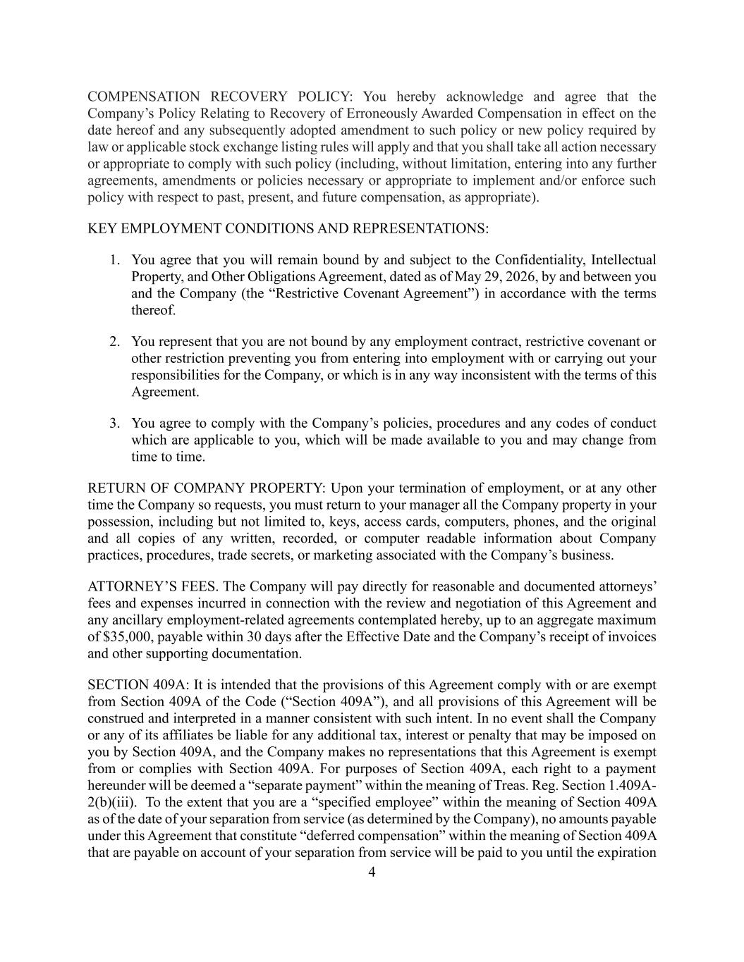
4 COMPENSATION RECOVERY POLICY: You hereby acknowledge and agree that the Company’s Policy Relating to Recovery of Erroneously Awarded Compensation in effect on the date hereof and any subsequently adopted amendment to such policy or new policy required by law or applicable stock exchange listing rules will apply and that you shall take all action necessary or appropriate to comply with such policy (including, without limitation, entering into any further agreements, amendments or policies necessary or appropriate to implement and/or enforce such policy with respect to past, present, and future compensation, as appropriate). KEY EMPLOYMENT CONDITIONS AND REPRESENTATIONS: 1. You agree that you will remain bound by and subject to the Confidentiality, Intellectual Property, and Other Obligations Agreement, dated as of May 29, 2026, by and between you and the Company (the “Restrictive Covenant Agreement”) in accordance with the terms thereof. 2. You represent that you are not bound by any employment contract, restrictive covenant or other restriction preventing you from entering into employment with or carrying out your responsibilities for the Company, or which is in any way inconsistent with the terms of this Agreement. 3. You agree to comply with the Company’s policies, procedures and any codes of conduct which are applicable to you, which will be made available to you and may change from time to time. RETURN OF COMPANY PROPERTY: Upon your termination of employment, or at any other time the Company so requests, you must return to your manager all the Company property in your possession, including but not limited to, keys, access cards, computers, phones, and the original and all copies of any written, recorded, or computer readable information about Company practices, procedures, trade secrets, or marketing associated with the Company’s business. ATTORNEY’S FEES. The Company will pay directly for reasonable and documented attorneys’ fees and expenses incurred in connection with the review and negotiation of this Agreement and any ancillary employment-related agreements contemplated hereby, up to an aggregate maximum of $35,000, payable within 30 days after the Effective Date and the Company’s receipt of invoices and other supporting documentation. SECTION 409A: It is intended that the provisions of this Agreement comply with or are exempt from Section 409A of the Code (“Section 409A”), and all provisions of this Agreement will be construed and interpreted in a manner consistent with such intent. In no event shall the Company or any of its affiliates be liable for any additional tax, interest or penalty that may be imposed on you by Section 409A, and the Company makes no representations that this Agreement is exempt from or complies with Section 409A. For purposes of Section 409A, each right to a payment hereunder will be deemed a “separate payment” within the meaning of Treas. Reg. Section 1.409A- 2(b)(iii). To the extent that you are a “specified employee” within the meaning of Section 409A as of the date of your separation from service (as determined by the Company), no amounts payable under this Agreement that constitute “deferred compensation” within the meaning of Section 409A that are payable on account of your separation from service will be paid to you until the expiration

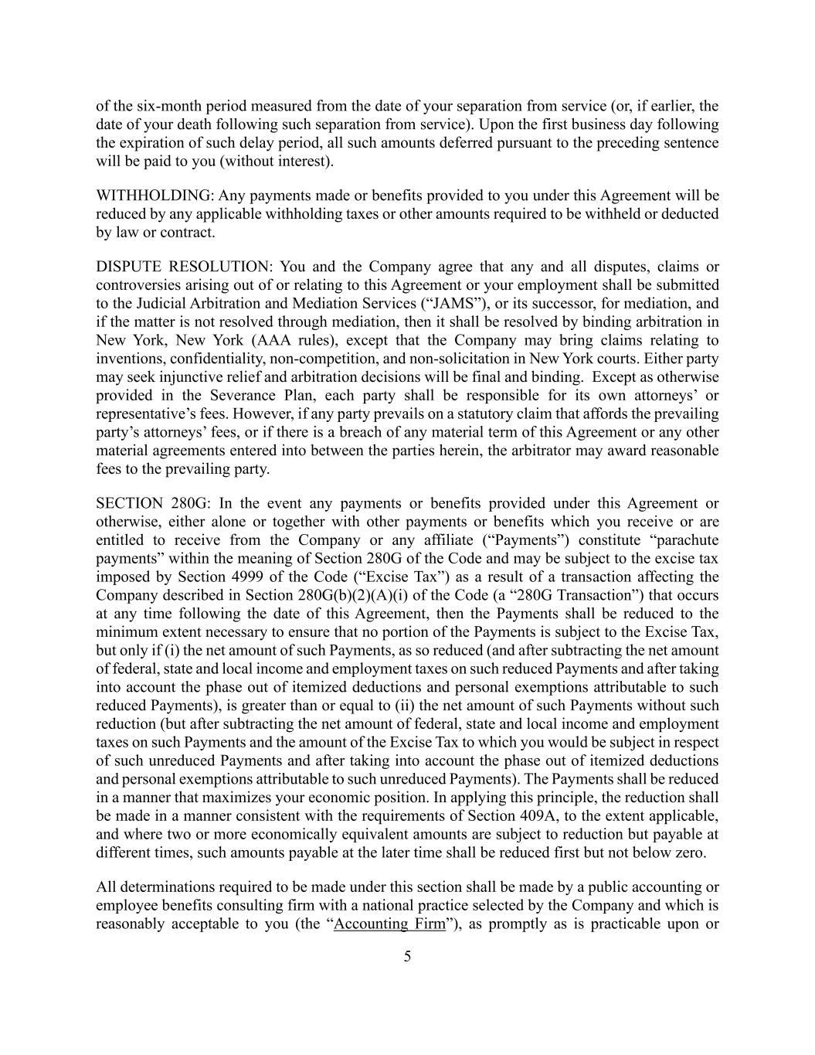
5 of the six-month period measured from the date of your separation from service (or, if earlier, the date of your death following such separation from service). Upon the first business day following the expiration of such delay period, all such amounts deferred pursuant to the preceding sentence will be paid to you (without interest). WITHHOLDING: Any payments made or benefits provided to you under this Agreement will be reduced by any applicable withholding taxes or other amounts required to be withheld or deducted by law or contract. DISPUTE RESOLUTION: You and the Company agree that any and all disputes, claims or controversies arising out of or relating to this Agreement or your employment shall be submitted to the Judicial Arbitration and Mediation Services (“JAMS”), or its successor, for mediation, and if the matter is not resolved through mediation, then it shall be resolved by binding arbitration in New York, New York (AAA rules), except that the Company may bring claims relating to inventions, confidentiality, non-competition, and non-solicitation in New York courts. Either party may seek injunctive relief and arbitration decisions will be final and binding. Except as otherwise provided in the Severance Plan, each party shall be responsible for its own attorneys’ or representative’s fees. However, if any party prevails on a statutory claim that affords the prevailing party’s attorneys’ fees, or if there is a breach of any material term of this Agreement or any other material agreements entered into between the parties herein, the arbitrator may award reasonable fees to the prevailing party. SECTION 280G: In the event any payments or benefits provided under this Agreement or otherwise, either alone or together with other payments or benefits which you receive or are entitled to receive from the Company or any affiliate (“Payments”) constitute “parachute payments” within the meaning of Section 280G of the Code and may be subject to the excise tax imposed by Section 4999 of the Code (“Excise Tax”) as a result of a transaction affecting the Company described in Section 280G(b)(2)(A)(i) of the Code (a “280G Transaction”) that occurs at any time following the date of this Agreement, then the Payments shall be reduced to the minimum extent necessary to ensure that no portion of the Payments is subject to the Excise Tax, but only if (i) the net amount of such Payments, as so reduced (and after subtracting the net amount of federal, state and local income and employment taxes on such reduced Payments and after taking into account the phase out of itemized deductions and personal exemptions attributable to such reduced Payments), is greater than or equal to (ii) the net amount of such Payments without such reduction (but after subtracting the net amount of federal, state and local income and employment taxes on such Payments and the amount of the Excise Tax to which you would be subject in respect of such unreduced Payments and after taking into account the phase out of itemized deductions and personal exemptions attributable to such unreduced Payments). The Payments shall be reduced in a manner that maximizes your economic position. In applying this principle, the reduction shall be made in a manner consistent with the requirements of Section 409A, to the extent applicable, and where two or more economically equivalent amounts are subject to reduction but payable at different times, such amounts payable at the later time shall be reduced first but not below zero. All determinations required to be made under this section shall be made by a public accounting or employee benefits consulting firm with a national practice selected by the Company and which is reasonably acceptable to you (the “Accounting Firm”), as promptly as is practicable upon or

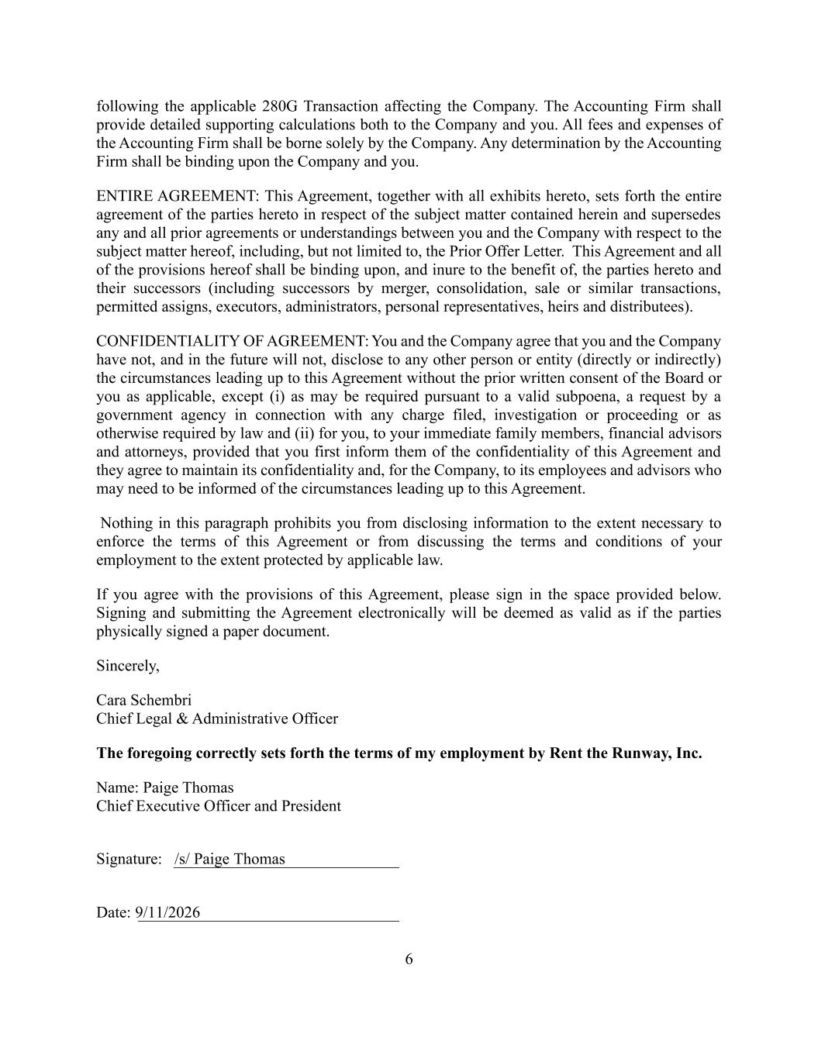
following the applicable 280G Transaction affecting the Company. The Accounting Firm shall provide detailed supporting calculations both to the Company and you. All fees and expenses of the Accounting Firm shall be borne solely by the Company. Any determination by the Accounting Firm shall be binding upon the Company and you. ENTIRE AGREEMENT: This Agreement, together with all exhibits hereto, sets forth the entire agreement of the parties hereto in respect of the subject matter contained herein and supersedes any and all prior agreements or understandings between you and the Company with respect to the subject matter hereof, including, but not limited to, the Prior Offer Letter. This Agreement and all of the provisions hereof shall be binding upon, and inure to the benefit of, the parties hereto and their successors (including successors by merger, consolidation, sale or similar transactions, permitted assigns, executors, administrators, personal representatives, heirs and distributees). CONFIDENTIALITY OF AGREEMENT: You and the Company agree that you and the Company have not, and in the future will not, disclose to any other person or entity (directly or indirectly) the circumstances leading up to this Agreement without the prior written consent of the Board or you as applicable, except (i) as may be required pursuant to a valid subpoena, a request by a government agency in connection with any charge filed, investigation or proceeding or as otherwise required by law and (ii) for you, to your immediate family members, financial advisors and attorneys, provided that you first inform them of the confidentiality of this Agreement and they agree to maintain its confidentiality and, for the Company, to its employees and advisors who may need to be informed of the circumstances leading up to this Agreement. Nothing in this paragraph prohibits you from disclosing information to the extent necessary to enforce the terms of this Agreement or from discussing the terms and conditions of your employment to the extent protected by applicable law. If you agree with the provisions of this Agreement, please sign in the space provided below. Signing and submitting the Agreement electronically will be deemed as valid as if the parties physically signed a paper document. Sincerely, Cara Schembri Chief Legal & Administrative Officer The foregoing correctly sets forth the terms of my employment by Rent the Runway, Inc. Name: Paige Thomas Chief Executive Officer and President Signature: /s/ Paige Thomas Date: 9/11/2026 6


7 Exhibit A Severance Plan Participation Letter

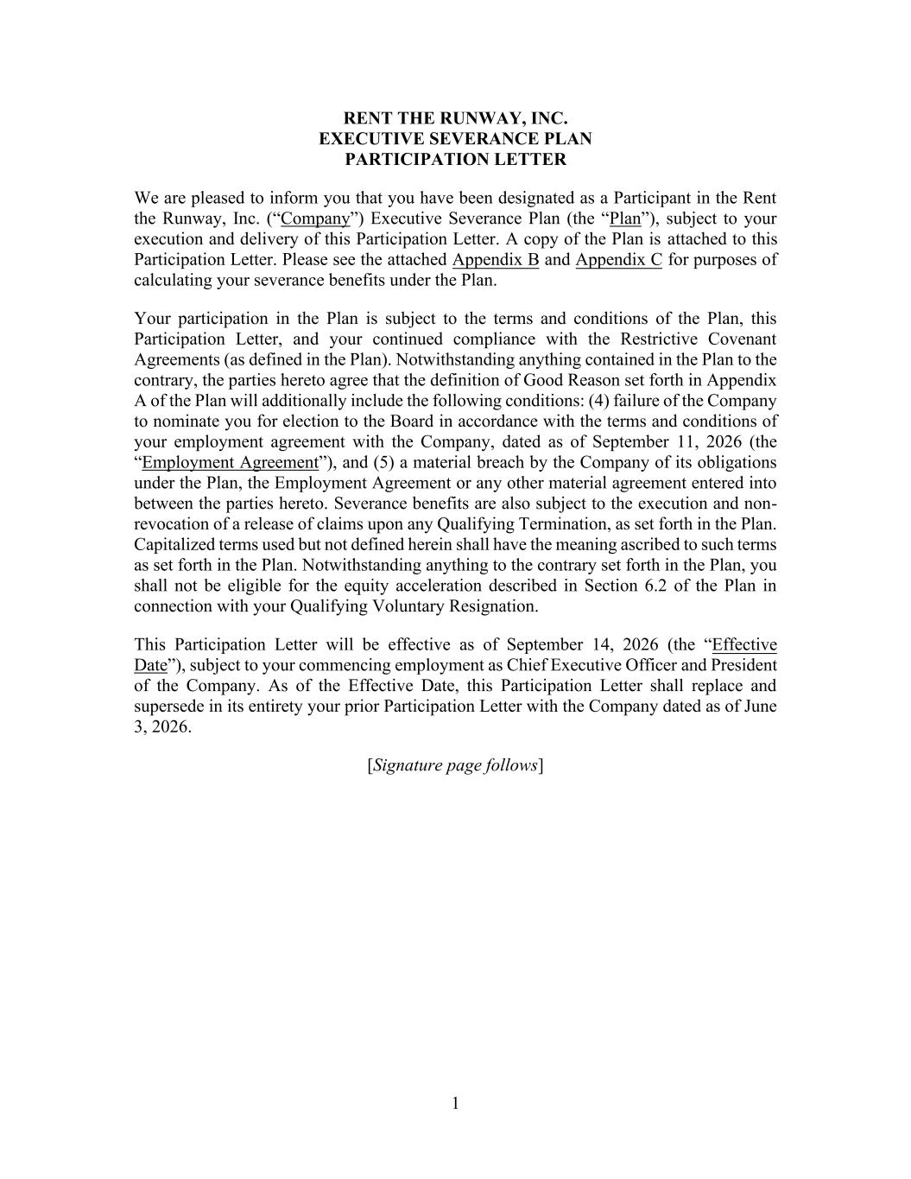
1 RENT THE RUNWAY, INC. EXECUTIVE SEVERANCE PLAN PARTICIPATION LETTER We are pleased to inform you that you have been designated as a Participant in the Rent the Runway, Inc. (“Company”) Executive Severance Plan (the “Plan”), subject to your execution and delivery of this Participation Letter. A copy of the Plan is attached to this Participation Letter. Please see the attached Appendix B and Appendix C for purposes of calculating your severance benefits under the Plan. Your participation in the Plan is subject to the terms and conditions of the Plan, this Participation Letter, and your continued compliance with the Restrictive Covenant Agreements (as defined in the Plan). Notwithstanding anything contained in the Plan to the contrary, the parties hereto agree that the definition of Good Reason set forth in Appendix A of the Plan will additionally include the following conditions: (4) failure of the Company to nominate you for election to the Board in accordance with the terms and conditions of your employment agreement with the Company, dated as of September 11, 2026 (the “Employment Agreement”), and (5) a material breach by the Company of its obligations under the Plan, the Employment Agreement or any other material agreement entered into between the parties hereto. Severance benefits are also subject to the execution and non- revocation of a release of claims upon any Qualifying Termination, as set forth in the Plan. Capitalized terms used but not defined herein shall have the meaning ascribed to such terms as set forth in the Plan. Notwithstanding anything to the contrary set forth in the Plan, you shall not be eligible for the equity acceleration described in Section 6.2 of the Plan in connection with your Qualifying Voluntary Resignation. This Participation Letter will be effective as of September 14, 2026 (the “Effective Date”), subject to your commencing employment as Chief Executive Officer and President of the Company. As of the Effective Date, this Participation Letter shall replace and supersede in its entirety your prior Participation Letter with the Company dated as of June 3, 2026. [Signature page follows]

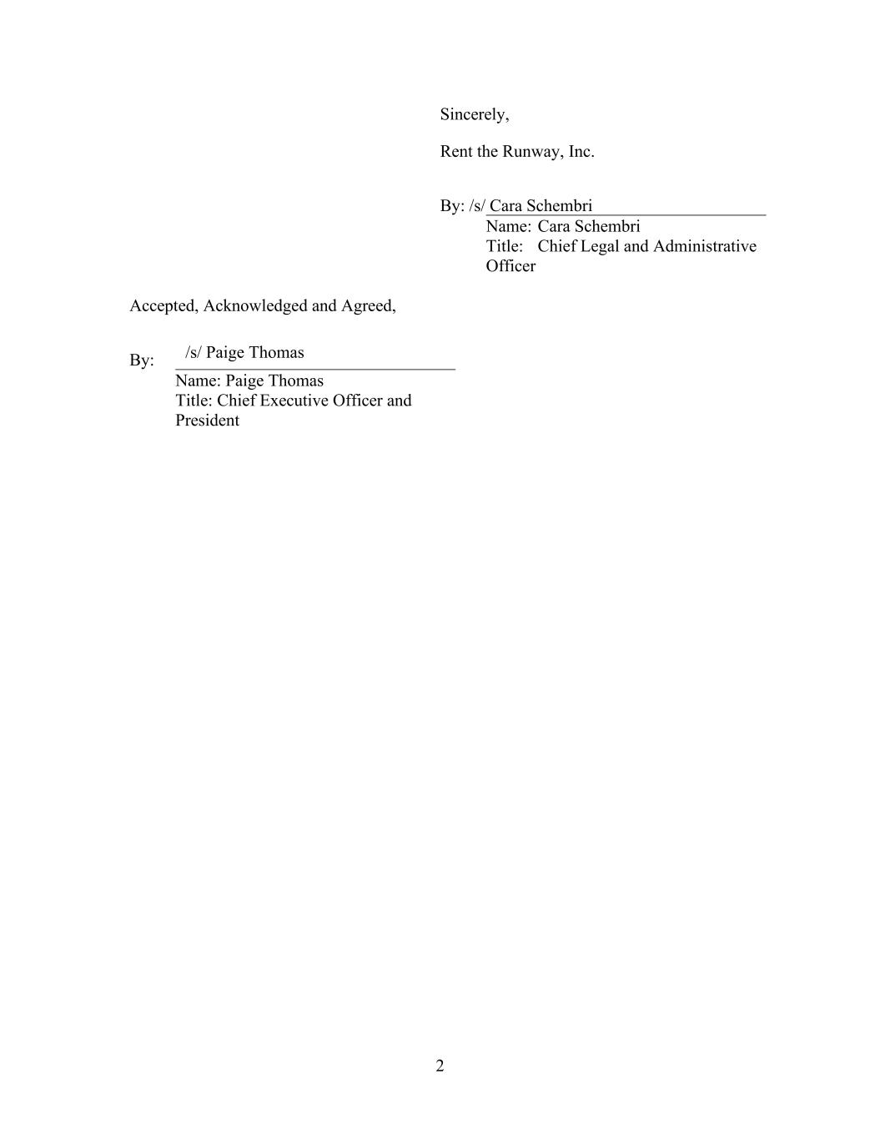
2 Sincerely, Rent the Runway, Inc. By: /s/ Cara Schembri Name: Cara Schembri Title: Chief Legal and Administrative Officer Accepted, Acknowledged and Agreed, By: Name: Paige Thomas Title: Chief Executive Officer and President /s/ Paige Thomas

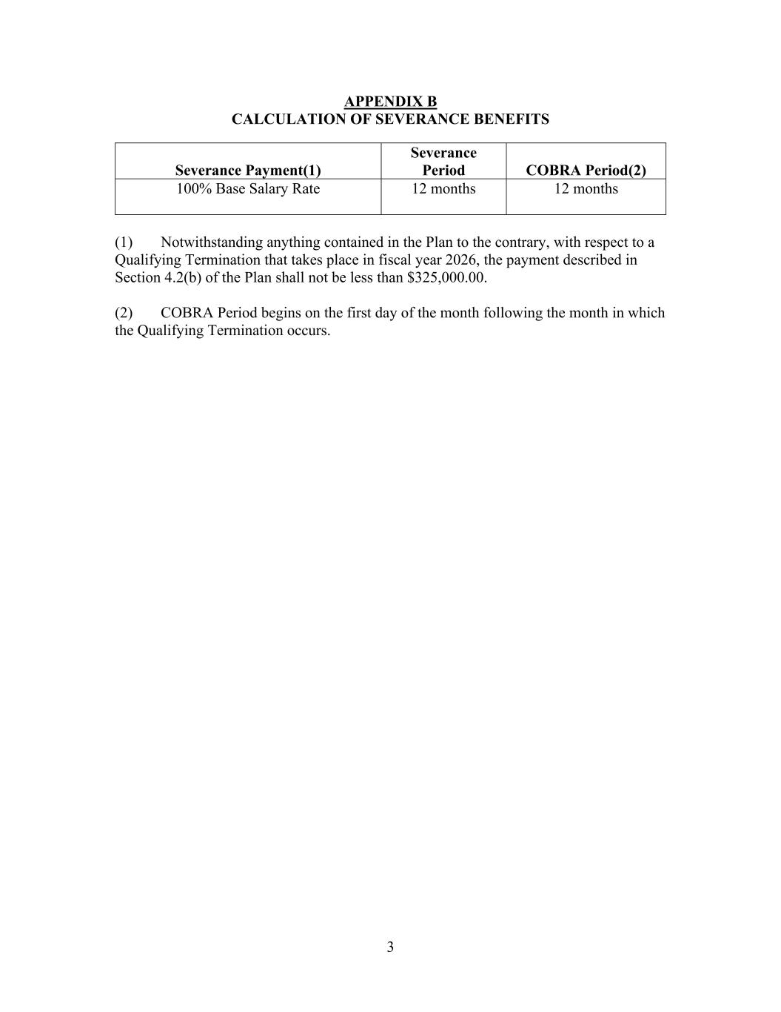
3 APPENDIX B CALCULATION OF SEVERANCE BENEFITS Severance Payment(1) Severance Period COBRA Period(2) 100% Base Salary Rate 12 months 12 months (1) Notwithstanding anything contained in the Plan to the contrary, with respect to a Qualifying Termination that takes place in fiscal year 2026, the payment described in Section 4.2(b) of the Plan shall not be less than $325,000.00. (2) COBRA Period begins on the first day of the month following the month in which the Qualifying Termination occurs.

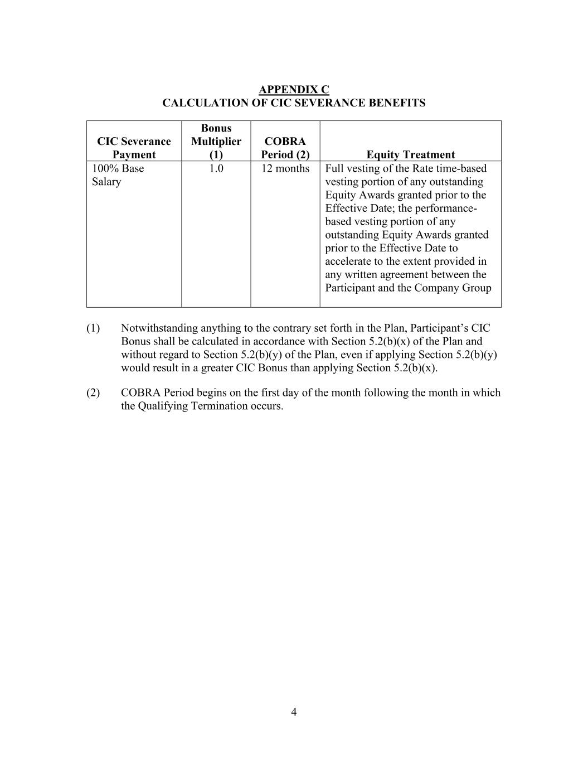
4 APPENDIX C CALCULATION OF CIC SEVERANCE BENEFITS CIC Severance Payment Bonus Multiplier (1) COBRA Period (2) Equity Treatment 100% Base Salary 1.0 12 months Full vesting of the Rate time-based vesting portion of any outstanding Equity Awards granted prior to the Effective Date; the performance- based vesting portion of any outstanding Equity Awards granted prior to the Effective Date to accelerate to the extent provided in any written agreement between the Participant and the Company Group (1) Notwithstanding anything to the contrary set forth in the Plan, Participant’s CIC Bonus shall be calculated in accordance with Section 5.2(b)(x) of the Plan and without regard to Section 5.2(b)(y) of the Plan, even if applying Section 5.2(b)(y) would result in a greater CIC Bonus than applying Section 5.2(b)(x). (2) COBRA Period begins on the first day of the month following the month in which the Qualifying Termination occurs.

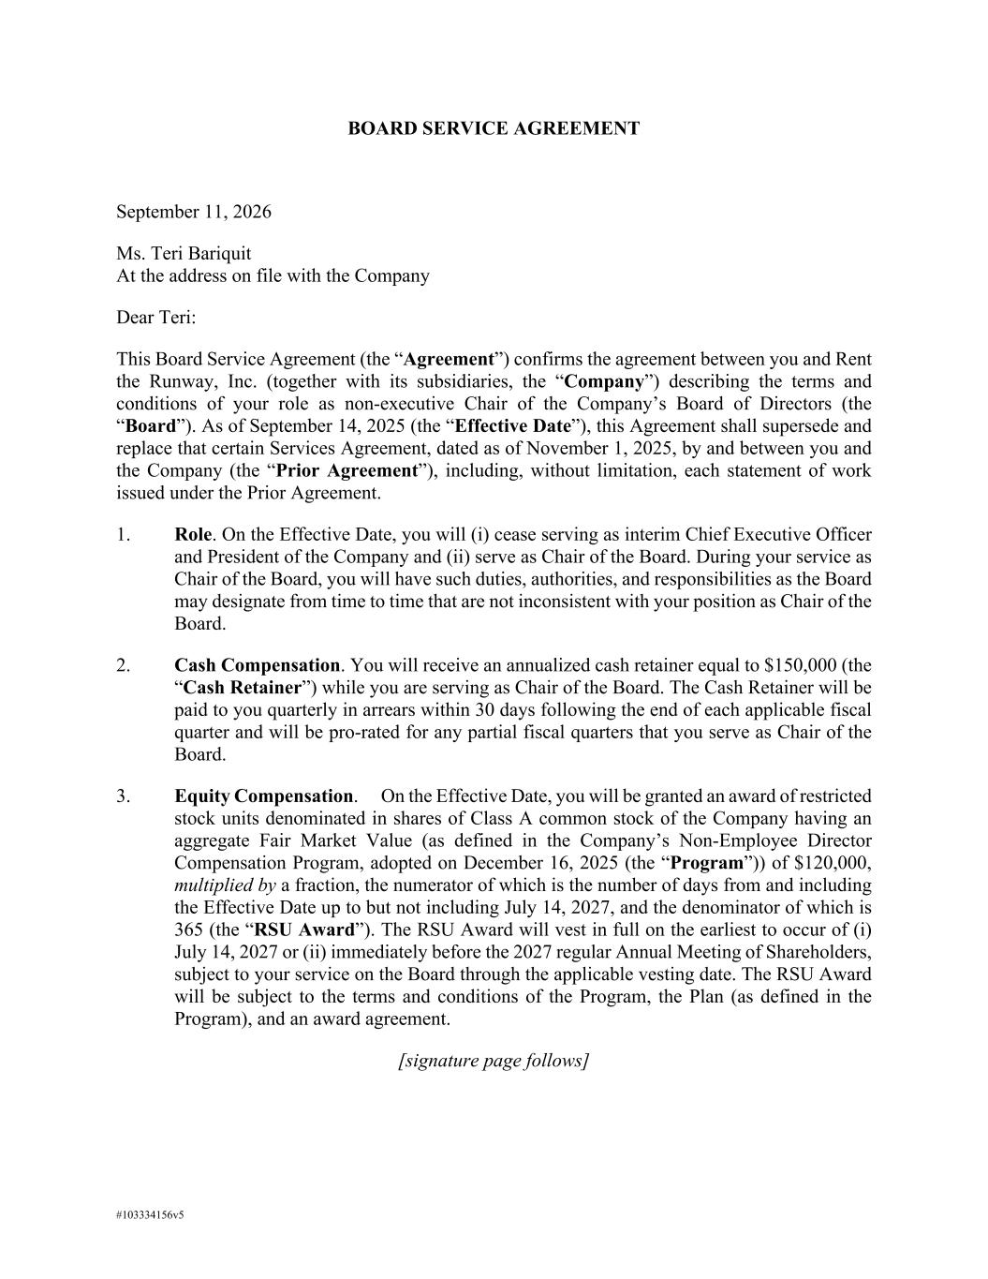
#103334156v5 BOARD SERVICE AGREEMENT September 11, 2026 Ms. Teri Bariquit At the address on file with the Company Dear Teri: This Board Service Agreement (the “Agreement”) confirms the agreement between you and Rent the Runway, Inc. (together with its subsidiaries, the “Company”) describing the terms and conditions of your role as non-executive Chair of the Company’s Board of Directors (the “Board”). As of September 14, 2025 (the “Effective Date”), this Agreement shall supersede and replace that certain Services Agreement, dated as of November 1, 2025, by and between you and the Company (the “Prior Agreement”), including, without limitation, each statement of work issued under the Prior Agreement. 1. Role. On the Effective Date, you will (i) cease serving as interim Chief Executive Officer and President of the Company and (ii) serve as Chair of the Board. During your service as Chair of the Board, you will have such duties, authorities, and responsibilities as the Board may designate from time to time that are not inconsistent with your position as Chair of the Board. 2. Cash Compensation. You will receive an annualized cash retainer equal to $150,000 (the “Cash Retainer”) while you are serving as Chair of the Board. The Cash Retainer will be paid to you quarterly in arrears within 30 days following the end of each applicable fiscal quarter and will be pro-rated for any partial fiscal quarters that you serve as Chair of the Board. 3. Equity Compensation. On the Effective Date, you will be granted an award of restricted stock units denominated in shares of Class A common stock of the Company having an aggregate Fair Market Value (as defined in the Company’s Non-Employee Director Compensation Program, adopted on December 16, 2025 (the “Program”)) of $120,000, multiplied by a fraction, the numerator of which is the number of days from and including the Effective Date up to but not including July 14, 2027, and the denominator of which is 365 (the “RSU Award”). The RSU Award will vest in full on the earliest to occur of (i) July 14, 2027 or (ii) immediately before the 2027 regular Annual Meeting of Shareholders, subject to your service on the Board through the applicable vesting date. The RSU Award will be subject to the terms and conditions of the Program, the Plan (as defined in the Program), and an award agreement. [signature page follows]


#103334156v5 Please indicate your agreement with the above terms by signing below. Very truly yours, /s/ Cara Schembri Cara Schembri Chief Legal and Administrative Officer Rent the Runway, Inc. I agree to the terms of this Agreement. /s/ Teri Bariquit Teri Bariquit

Exhibit 31.1
CERTIFICATION

I, Teri Bariquit, certify that:

1. I have reviewed this Quarterly Report on Form 10-Q of Rent the Runway, Inc.;

2.Based on my knowledge, this report does not contain any untrue statement of a material fact or omit to state a material fact necessary to make the statements made, in light of the circumstances under which such statements were made, not misleading with respect to the period covered by this report;

3.Based on my knowledge, the financial statements, and other financial information included in this report, fairly present in all material respects the financial condition, results of operations and cash flows of the registrant as of, and for, the periods presented in this report;

4.The registrant's other certifying officer and I are responsible for establishing and maintaining disclosure controls and procedures (as defined in Exchange Act Rules 13a-15(e) and 15d-15(e)) and internal control over financial reporting (as defined in Exchange Act Rules 13a-15(f) and 15d-15(f)) for the registrant and have:

a.Designed such disclosure controls and procedures, or caused such disclosure controls and procedures to be designed under our supervision, to ensure that material information relating to the registrant, including its consolidated subsidiaries, is made known to us by others within those entities, particularly during the period in which this report is being prepared;

b.Designed such internal control over financial reporting, or caused such internal control over financial reporting to be designed under our supervision, to provide reasonable assurance regarding the reliability of financial reporting and the preparation of financial statements for external purposes in accordance with generally accepted accounting principles;

c.Evaluated the effectiveness of the registrant's disclosure controls and procedures and presented in this report our conclusions about the effectiveness of the disclosure controls and procedures, as of the end of the period covered by this report based on such evaluation; and

d.Disclosed in this report any change in the registrant's internal control over financial reporting that occurred during the registrant's most recent fiscal quarter (the registrant's fourth fiscal quarter in the case of an annual report) that has materially affected, or is reasonably likely to materially affect, the registrant's internal control over financial reporting; and

5.The registrant's other certifying officer and I have disclosed, based on our most recent evaluation of internal control over financial reporting, to the registrant's auditors and the audit committee of the registrant's board of directors (or persons performing the equivalent functions):

a.All significant deficiencies and material weaknesses in the design or operation of internal control over financial reporting which are reasonably likely to adversely affect the registrant's ability to record, process, summarize and report financial information; and

b.Any fraud, whether or not material, that involves management or other employees who have a significant role in the registrant's internal control over financial reporting.

Exhibit 31.1

Date: September 11, 2026 |  |  |  |  |  | By: |  |  | /s/ Teri Bariquit
 |  |  |  |  |  |  |  |  | Teri Bariquit
 |  |  |  |  |  |  |  |  | Interim Chief Executive Officer

Exhibit 31.2

CERTIFICATION

I, David Loretta, certify that:

1. I have reviewed this Quarterly Report on Form 10-Q of Rent the Runway, Inc.;

2.Based on my knowledge, this report does not contain any untrue statement of a material fact or omit to state a material fact necessary to make the statements made, in light of the circumstances under which such statements were made, not misleading with respect to the period covered by this report;

3.Based on my knowledge, the financial statements, and other financial information included in this report, fairly present in all material respects the financial condition, results of operations and cash flows of the registrant as of, and for, the periods presented in this report;

4.The registrant's other certifying officer and I are responsible for establishing and maintaining disclosure controls and procedures (as defined in Exchange Act Rules 13a-15(e) and 15d-15(e)) and internal control over financial reporting (as defined in Exchange Act Rules 13a-15(f) and 15d-15(f)) for the registrant and have:

a.Designed such disclosure controls and procedures, or caused such disclosure controls and procedures to be designed under our supervision, to ensure that material information relating to the registrant, including its consolidated subsidiaries, is made known to us by others within those entities, particularly during the period in which this report is being prepared;

b.Designed such internal control over financial reporting, or caused such internal control over financial reporting to be designed under our supervision, to provide reasonable assurance regarding the reliability of financial reporting and the preparation of financial statements for external purposes in accordance with generally accepted accounting principles;

c.Evaluated the effectiveness of the registrant's disclosure controls and procedures and presented in this report our conclusions about the effectiveness of the disclosure controls and procedures, as of the end of the period covered by this report based on such evaluation; and

d.Disclosed in this report any change in the registrant's internal control over financial reporting that occurred during the registrant's most recent fiscal quarter (the registrant's fourth fiscal quarter in the case of an annual report) that has materially affected, or is reasonably likely to materially affect, the registrant's internal control over financial reporting; and

5.The registrant's other certifying officer and I have disclosed, based on our most recent evaluation of internal control over financial reporting, to the registrant's auditors and the audit committee of the registrant's board of directors (or persons performing the equivalent functions):

a.All significant deficiencies and material weaknesses in the design or operation of internal control over financial reporting which are reasonably likely to adversely affect the registrant's ability to record, process, summarize and report financial information; and

b.Any fraud, whether or not material, that involves management or other employees who have a significant role in the registrant's internal control over financial reporting.

Exhibit 31.2

Date: September 11, 2026 |  |  |  |  |  | By: |  |  | /s/ David Loretta
 |  |  |  |  |  |  |  |  | David Loretta
 |  |  |  |  |  |  |  |  | Interim Chief Financial Officer and Treasurer

Exhibit 32.1

CERTIFICATION PURSUANT TO
18 U.S.C. SECTION 1350, AS ADOPTED PURSUANT TO
SECTION 906 OF THE SARBANES-OXLEY ACT OF 2002

I, Teri Bariquit, the Interim Chief Executive Officer of Rent the Runway, Inc., certify, pursuant to 18 U.S.C. Section 1350, as adopted pursuant to Section 906 of the Sarbanes-Oxley Act of 2002, that the Quarterly Report on Form 10-Q of Rent the Runway, Inc. for the quarterly period ended July 31, 2026, fully complies with the requirements of Section 13(a) or 15(d) of the Securities Exchange Act of 1934, as amended, and that the information contained in such Quarterly Report on Form 10-Q fairly presents, in all material respects, the financial condition and results of operations of Rent the Runway, Inc.

Date: September 11, 2026 |  |  |  |  |  | By: |  |  | /s/ Teri Bariquit
 |  |  |  |  |  |  |  |  | Teri Bariquit
 |  |  |  |  |  |  |  |  | Interim Chief Executive Officer

Exhibit 32.2

CERTIFICATION PURSUANT TO
18 U.S.C. SECTION 1350, AS ADOPTED PURSUANT TO
SECTION 906 OF THE SARBANES-OXLEY ACT OF 2002

I, David Loretta, the Interim Chief Financial Officer and Treasurer of Rent the Runway, Inc., certify, pursuant to 18 U.S.C. Section 1350, as adopted pursuant to Section 906 of the Sarbanes-Oxley Act of 2002, that the Quarterly Report on Form 10-Q of Rent the Runway, Inc. for the quarterly period ended July 31, 2026, fully complies with the requirements of Section 13(a) or 15(d) of the Securities Exchange Act of 1934, as amended, and that the information contained in such Quarterly Report on Form 10-Q fairly presents, in all material respects, the financial condition and results of operations of Rent the Runway, Inc.

Date: September 11, 2026 |  |  |  |  |  | By: |  |  | /s/ David Loretta
 |  |  |  |  |  |  |  |  | David Loretta
 |  |  |  |  |  |  |  |  | Interim Chief Financial Officer and Treasurer

